CourseMate
Project Report
Submitted by: [Shubham Mevada]
Date: July 19, 2025

Abstract
CourseMate is a full-stack web application designed to simplify course management for students and instructors. It enables users to register, manage courses, assignments, track progress, and handle free course content visually using an intuitive dashboard. The system is built with a modern tech stack and follows a modular architecture to ensure scalability and maintainability.

Technologies Used
- Frontend: React.js (Vite)
- Backend: Node.js with Express.js
- Database: MongoDB
- Authentication: bcrypt
- File Uploads: multer / FormData
- Styling: Bootstrap 5
- PDF Export: jsPDF

System Architecture
The system uses a client-server architecture where the frontend is developed with React and interacts with a RESTful API built in Express.js. MongoDB serves as the primary data store. The backend also handles authentication and course logic.

Features
- Admin can add courses, modules, lessons, and assignments
- Students can enroll in free courses of their semester
- Assignments can be uploaded directly by students
- Timetable export in PDF format
- User authentication and role-based access
- Dynamic content rendering via React Router

Database Schema
Below is the logical structure of the main collections in the MongoDB database:
- Users: Contains student/admin data with personal and login details
- Courses: Holds course info, including modules, schedule, and assignments
- Roles: Describes the role (admin or student)
- Assignments: Related to each course and user submission tracking

Screenshots

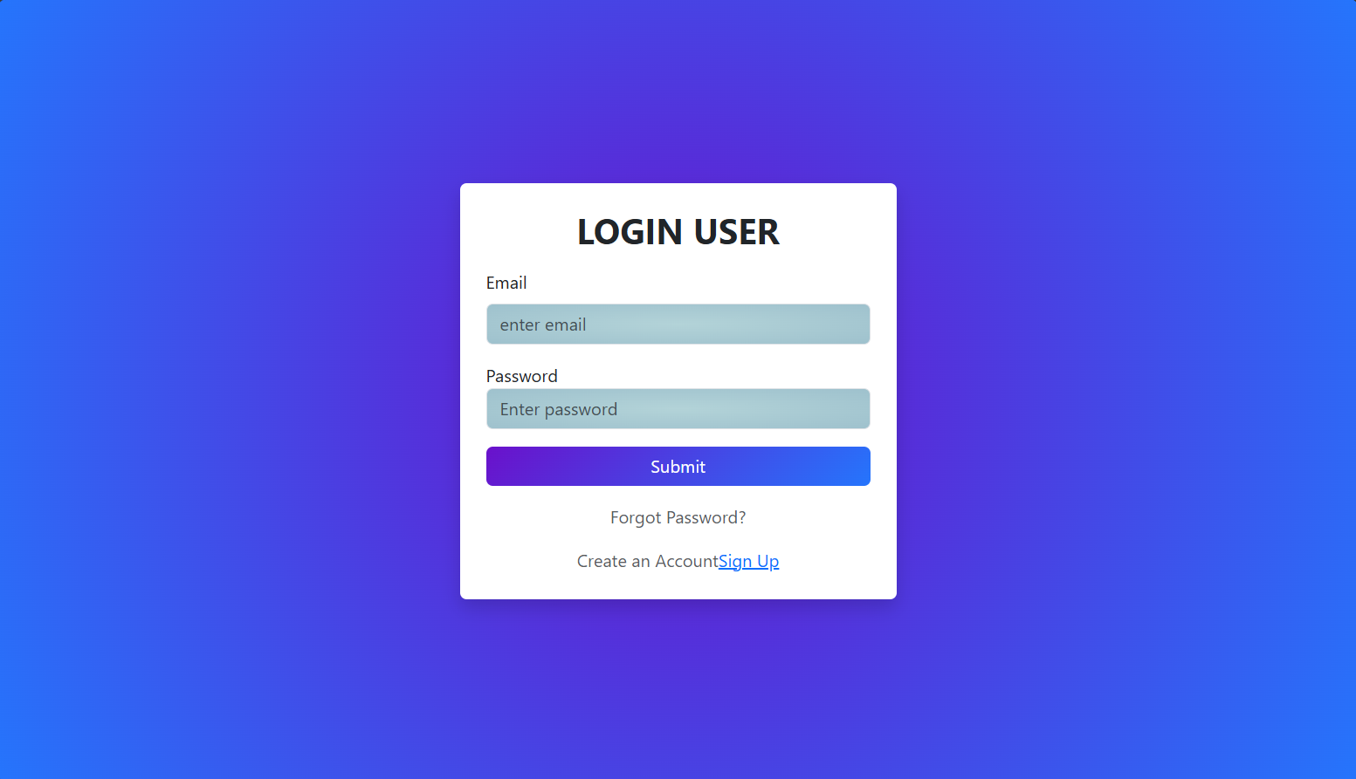
Login:

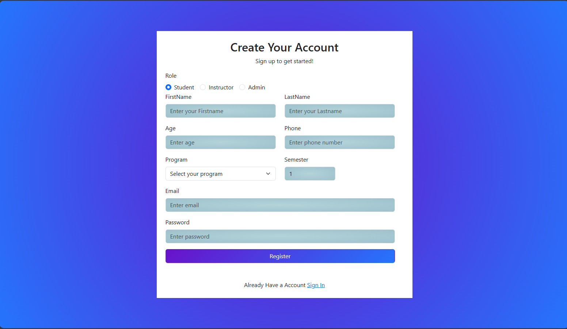
Signup:

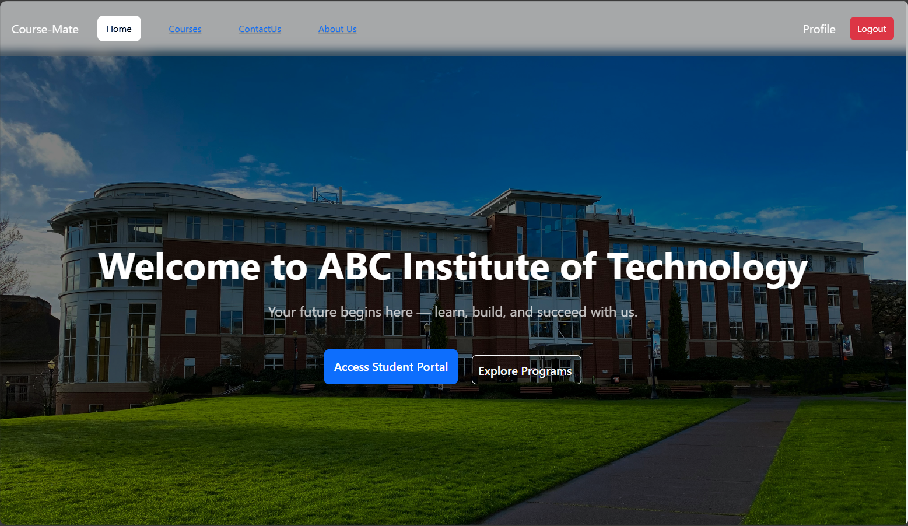
LandingPage:

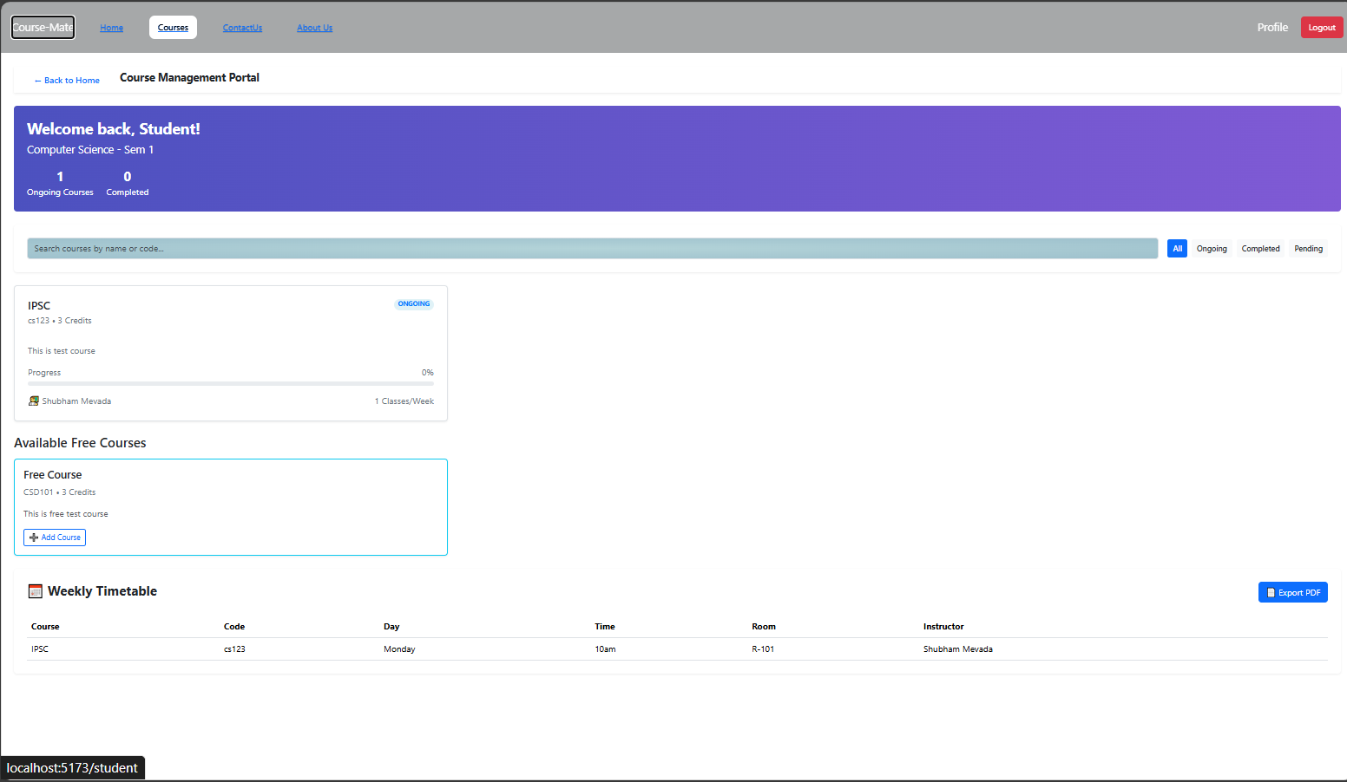
CoursePage:

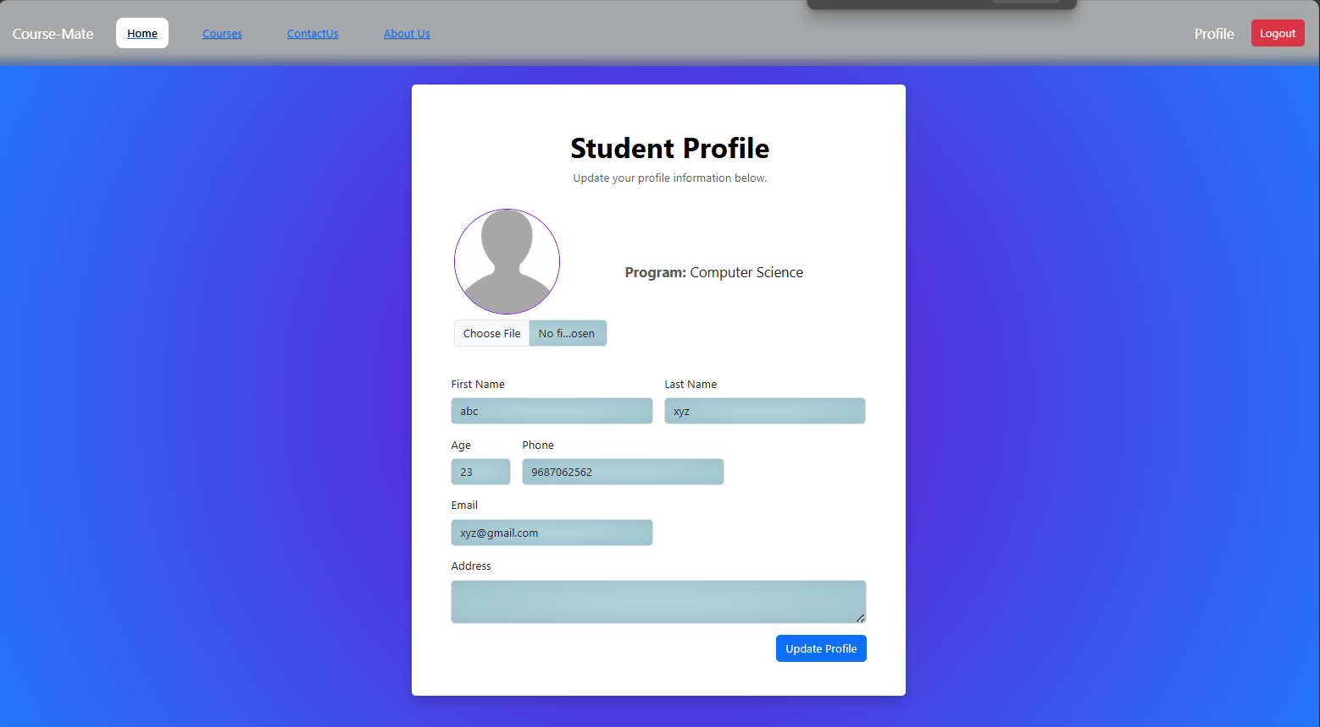
userProfile:
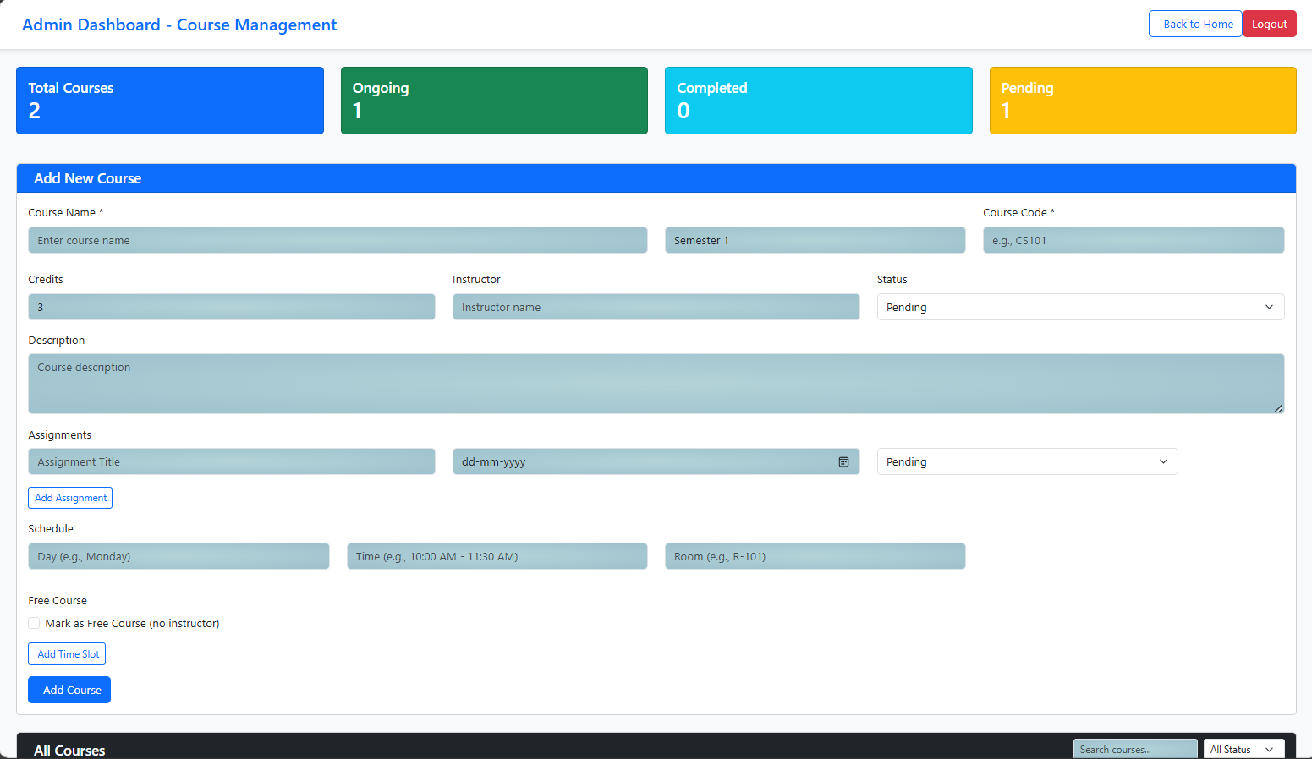
Admin & Instructor Page:

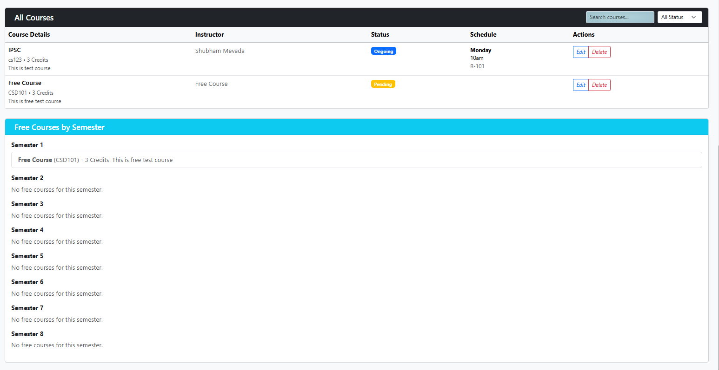
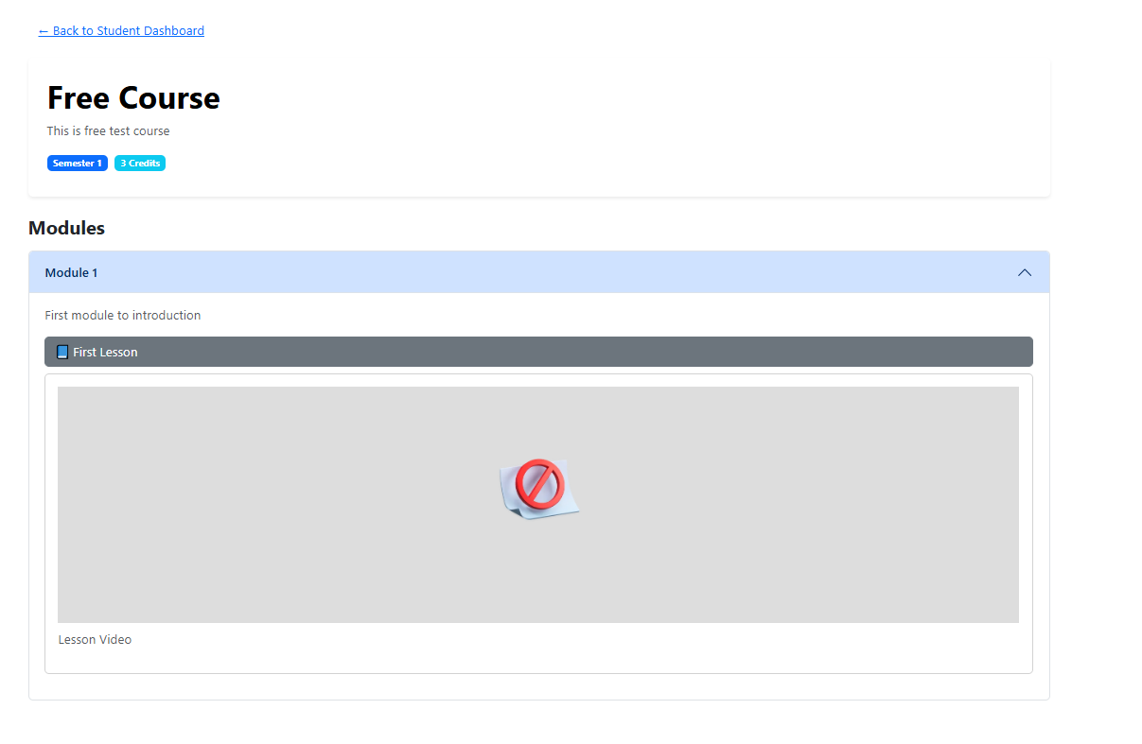
Free Course Page:

Conclusion
CourseMate is a practical, responsive, and modular platform for managing academic content. It simplifies interactions between students and administrators by offering visual tools and seamless data integration.

