

**EN3030- CIRCUITS AND SYSTEMS DESIGN**

**FPGA BASED PROCESSOR DESIGN**

**FINAL REPORT**

**Group members**

Shan Anjana 160027U

Nipuna Leelarathne 160348E

Isuru Rajapakshe 160505J Mevan Wijewardena 160716G

**Supervisor**

Dr. Jayathu Samarawickrama

This report is submitted in partial fulfillment of the requirements

for the module EN 3030: Circuits and Systems Design.

**ABSTRACT**

Custom processors are widely used in the modern technical world. Even if a general CPU in a computer could perform the tasks of a custom processor the speed and the power efficiency of custom processors have marked their significance in electronics.

In this report we describe our method of designing a custom processor for image processing. We used Field-Programmable Gate Array (FPGA) for our task. The report contains detailed descriptions on our implementation, design procedure and the functionality of our processor.

**TABLE OF CONTENTS**

**INTRODUCTION 04**

**PROBLEM STATEMENT 05**

**OUR SOLUTION 05**

**DETAILED DESCRIPTION OF THE PROCESS 06**

**IMPORTANT FACTS ABOUT OUR DESIGN 07**

**THE PROCESSOR DATAPATH 08**

**THE INSTRUCTION SET 09**

**MICRO INSTRUCTIONS 10**

**HOW THE CLOCK IS UTILIZED IN OUR DESIGN 11**

**THE MAIN MEMORY 11**

**THE TRANSMITTER AND THE RECEIVER 12**

**THE INSTRUCTION UNIT 13**

**THE GENERAL PURPOSE AND SPECIAL PURPOSE REGISTERS 13**

**ALU OPERATIONS 14**

**THE DIFFERENT MODULES IN OUR DESIGN 15**

**THE DOWNSAMPLING ALGORITHM 17**

**THE ASSEMBLY CODE FOR DOWNSAMPING 19**

**THE RESULTS OF OUR DOWNSAMPLING ALGORITHM 23**

**THE COMPLETE RTL VIEW OF THE PROCESSOR 25**

**THE VIEW OF THE DIFFERENT MODULES 26**

**TIMING ANALYSIS FOR A SAMPLE PROGRAMME 27**

**THE COMPILATION REPORT IN QUARTUS PRIME 28**

**REFERENCES 28**

**APPENDIX 29**

**INTRODUCTION**

In this project we designed a custom processor to down sample a given image. The processor is implemented in Verilog which is a Hardware Description Language. The implementation of the processor is done using Quartz Prime Lite Edition along with Altera DE2-115 Education and Development board with Cyclone IV FPGA.

**About CPUs**

CPU carries out the instructions of a given computer program by performing the arithmetic, logic, control, input and output operations which are specified by the instructions in the program.

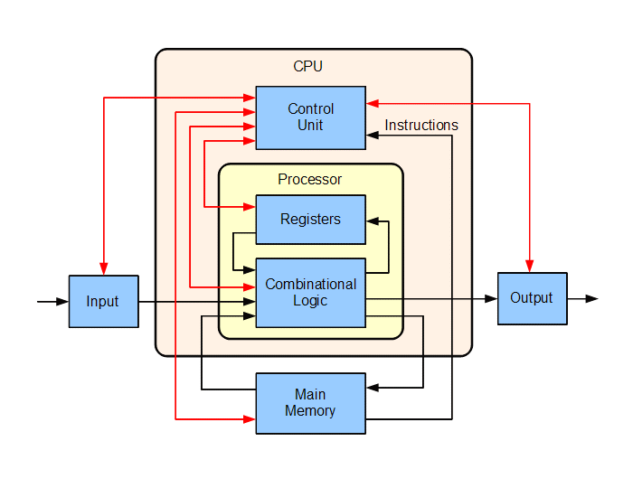

Block diagram of a CPU

**PROBLEM STATEMENT**

The task of this project is to down sample a given image. The down sampling factor is two and following are some of the parameters,

* Down sampling factor- 2
* Image dimensions- 500×500 pixels
* Color/ Black and white

**OUR SOLUTION**

We came up with a solution to the above problem using the tools mentioned in the INTRODUCTION. Before moving onto implementing the processor we decided the basic steps in the algorithm we were to implement. Accordingly we listed the basic steps to achieve out task.

1. Transmitting the image from PC to FPGA.
2. Storing the image in FPGA.
3. Processing the image / down sampling and storing the down sampled image.
4. Sending the down sampled image back to the PC and displaying it.

We identified above as the steps which could be handled separately and we divided them among our members.

For each of the above steps we identified many solutions.

**Transmitting the image from PC to FPGA**- The first decision we had to make was the language we are using for handling the image, receiving and sending tasks from the PC side. We had two options, Python and MATLAB. Since Python is open source and PySerial package offers easier ways for serial communication we preferred python over MATLAB.

**Storing the image in FPGA-** Again we had several solutions. First was to store the whole image in the FPGA first and then processing it. The next was to obtain the required pixels from the PC, process them and send them back to the computer. The second method consumes much less storage space in FPGA compared to the first. But it is implementation wise complex. Moreover we will have to transmit the same pixel multiple times for processing. Compared to the other operations transmission takes much longer time. Hence the second method is more time consuming. Hence we adopted the first.

**Processing the image / down sampling and storing the down sampled image.**

**Sending the down sampled image back to the PC and displaying it** - For these two steps (3 and 4) we didn’t come up with multiple solutions.

Above mentioned are just the basic summary of different approaches we took for each process. Our method will be explained in detail.

**DETAILED DESCRIPTION OF THE PROCESS**

**Transmitting and storing the image**

We will consider the case of down sampling a color image so that steps for black and white images can be described similarly. First the image is loaded in python using opencv package. Then each one of the color planes is taken. First all the 25000(500×500) pixels in that plane are sent to the FPGA. We use UART for the communication process and the package we use in python is PySerial. PySerial allows the transmission of bytes and hence conversion of pixel values to bit stream is not necessary.

The transmitter receiver unit in the processor receives the data and it stores each pixel in its memory (For this purpose the memory unit of the processor is enabled).

**Processing the stored data**

Processing the data is mainly done under three steps.

1. Filtering the image to smoothen the image and to remove random noise

This is necessary before down sampling. Following is a gray scale image which comprises of alternate 255’s and 0’s. Hence it is gray in color to a human eye. But if we down sample this image without filtering the resulting image will either be completely black or white. The next image is obtained by first filtering and then down sampling the first image**.**

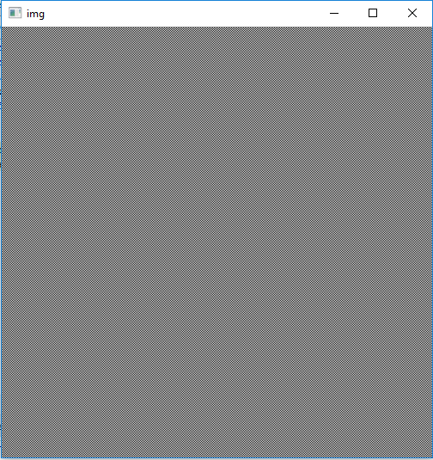

1. After filtering the next step is down sampling the image. Since our goal is to down sample by a factor of two and since we already filtered the image, in this step we simply chose alternate bits.
2. Final step is storing the down sampled image. In step 1 we did not calculate the filtered value of each pixel. Hence storing the final image became much easier and efficient. The down sampling algorithm will be explained later.

After the above three steps we have the down sampled image stored in the memory unit.

**Sending the down sampled image back to the PC.**

In this step we again use the UART transmitter unit of the processor to send the down sampled image back to the PC.

The above steps are repeated three times for the three color planes of the image and then the final image is reproduced and displayed in the PC using opencv.

**IMPORTANT FACTS ABOUT OUR DESIGN**

* We used 50MHz built in clock for synchronization
* Most of the time is taken for transmission of the image (UART). In fact a very small time is taken for processing.
* The memory unit has enough memory to store a 512×512 pixel image (256kB) at once.

**THE PROCESSOR DATAPATH**

uInstruction which provides enables for all the registers, memory, AC and UART unit. Connections are not shown for simplicity

Main memory

256KB

uIns Unit

Instruction Unit

PC- 10bits

Ins- 8bits

ALU

All the connected registers are connected separately to AC which means they can be assigned independently from AC. Separate connections are not shown for simplicity

Memory Unit

Address_reg- 18bits

Next_address_reg- 18bits

Cols- 32bits

Rows- 32bits

Num_cols- 32bits

Num_rows- 32bits

AC- 32bits

R- 32bits

SP3- 32bits

SP2- 32bits

SP1- 32bits

Data_reg- 8bits

Instruction Unit

Operands-8 bits

Transmitter and Receiver Unit (UART)

**THE INSTRUCTION SET**

To suit our purpose we created our own instruction set which comprised of 39 instructions. Following are the instructions and there description.

|  |  |  |  |  |
| --- | --- | --- | --- | --- |
| No | OpCode |  | Instruction Code/No operands | Instruction Description |
| 1 | 8'b | 0 | NOP /0 | No operation |
| 2 | 8'b | 1 | RCV /3 | Receive t number of bytes where t is specified by the operands |
| 3 | 8'b | 10 | TRN /3 | Transmit t number of bytes where t is specified by the operands |
| 4 | 8'b | 11 | LOADAC /3 | Load the byte in the memory location t (t specified by operands) to AC |
| 5 | 8'b | 100 | STOREAC /3 | Store the byte in AC to the memory location t (t specified by operands) |
| 6 | 8'b | 101 | SHIFTR8 /0 | Shift AC by one byte to the right |
| 7 | 8'b | 110 | SHIFTR1 /0 | Shift AC by one bit to the right |
| 8 | 8'b | 111 | SHIFTL8 /0 | Shift AC by one byte to the left |
| 9 | 8'b | 1000 | SHIFTL1 0 | Shift AC by one bit to the left |
| 10 | 8'b | 1001 | RAC /0 | R<=AC |
| 11 | 8'b | 1010 | ROWAC /0 | Rows<=AC |
| 12 | 8'b | 1011 | ACROW /0 | AC<=Rows |
| 13 | 8'b | 1100 | COLAC /0 | Cols<=AC |
| 14 | 8'b | 1101 | ACCOL /0 | AC<=Cols |
| 15 | 8'b | 1110 | ACNCOL /0 | AC<=Ncols |
| 16 | 8'b | 1111 | NCOLAC /0 | Ncols<=AC |
| 17 | 8'b | 10000 | ACNROW /0 | AC<=Nrows |
| 18 | 8'b | 10001 | NROWAC /0 | Nrows<=AC |
| 19 | 8'b | 10010 | ACNXTADD /0 | AC<=NxtAddress |
| 20 | 8'b | 10011 | STONXTADD /0 | Store the last byte of AC to the memory location specified by NxtAddress |
| 21 | 8'b | 10100 | LOADNXTADD /0 | Load the byte in the memory location specified by NextAddress to AC |
| 22 | 8'b | 10101 | ACXOR /0 | AC<=AC xor R |
| 23 | 8'b | 10110 | ACR /0 | AC<=R |
| 24 | 8'b | 10111 | ACINC /0 | AC<=AC+1 |
| 25 | 8'b | 11000 | ACDEC /0 | AC<=AC-1 |
| 26 | 8'b | 11001 | ACZERO /0 | AC<=0 |
| 27 | 8'b | 11010 | JMPNZ /2 | if(Z=0) Jump to instruction t specified by operand |
| 28 | 8'b | 11011 | JMP /2 | Jump to instruction t specified by operands |
| 29 | 8'b | 11100 | JMPZ /2 | if(Z=1) Jump to instruction t specified by operand |
| 30 | 8'b | 11101 | ACADD /0 | AC<=AC+R |
| 31 | 8'b | 11110 | ACSUB /0 | AC<=AC-R |
| 32 | 8'b | 11111 | SP1AC /0 | SP1<=AC |
| 33 | 8'b | 100000 | ACSP1 /0 | AC<=SP1 |
| 34 | 8'b | 100001 | NXTADDAC /0 | NextAddress<=AC |
| 35 | 8'b | 100010 | ACSP2 /0 | AC<=SP2 |
| 36 | 8'b | 100011 | ACSP3 /0 | AC<=SP3 |
| 37 | 8'b | 100100 | SP2AC /0 | SP2<=AC |
| 38 | 8'b | 100101 | SP3AC /0 | SP3<=AC |
| 39 | 8'b | 100110 | STOP /0 | stop process |

Here most of the instructions take single clock cycle except for a few. Instructions 2, 3, 4, 5, 20, 21, 27, 28 and 29 are the only ones which consume more than one clock cycle.

RCV- This instruction consists of 4 bytes three of which are operands. This instruction is to receive Ω number of bytes from the PC where Ω is specified by the operands. Due to the limitations of the memory Ω can go up to 512×512. We designed a careful protocol for transmission. In order to minimize errors we are first sending 11110000 from UART to PC. PC is only allowed to transmit after receiving this. This is why our transmission is bit slower. But on the other hand it ensures error free communication with perfect synchronization between PC and processor.

TRN- This is similar to RCV but we do not specify a specific protocol here. Once the processor starts transmitting the PC should be ready to receive from the other side.

Other instructions do not have specific details and the explanation in the table explain their functionality.

**MICRO INSTRUCTIONS**

We implemented a structure similar to CISC architecture. Hence each of the above instruction comprises of several Micro-Instructions. Following is the Micro-Instruction format.

|  |  |  |  |  |  |  |  |  |  |  |  |  |  |
| --- | --- | --- | --- | --- | --- | --- | --- | --- | --- | --- | --- | --- | --- |
| SP3  28 | SP2  27 | IU  26 | 25 | 24 | SP1  23 | Tr  22 | R_Next  21 | 20 | T_Next  19 | 18 | Baud rate  17 | RAM  16 | 15 |

|  |  |  |  |  |  |  |  |  |  |  |  |  |  |  |
| --- | --- | --- | --- | --- | --- | --- | --- | --- | --- | --- | --- | --- | --- | --- |
| NextAddress  14 | AC  13 | 12 | 11 | 10 | 9 | Address_reg  8 | 7 | R  6 | Rows  5 | Cols  4 | Num_rows  3 | Num_cols  2 | Data_reg  1 | 0 |

A single micro instruction is 29 bits and shown above are each of the 29 bits. A Microinstruction is a state of the processor in a given clock cycle. It is important to note that a Micro-Instruction is a single clock cycle operation. A Microinstruction defines the set of enables to each of the registers and units including Instruction Unit and Memory Unit.

A single instruction is a collection of Microinstructions. For example STONXTADD comprises of,

1. 29'b00000000000010000000010000001
2. 29'b00000000000000000000000000000
3. 29'b00000000000000000000000000000
4. 29'b00000000000000000000000000000

**HOW THE CLOCK IS UTILIZED IN OUR DESIGN**

We used 50MHz clock throughout our design. Only for transmitter and receiver we had to sample the clock through a different module.

Negative edge-

The uInstructions are decoded at each unit (registers etc.) and this is triggered by the negative edge

Positive edge-

The uInstructions settle in the positive edge. Hence the relevant units are enabled using uInstructions and this is triggered at the positive edge

**THE MAIN MEMORY**

We used the altsyncram megafunction to create an SDRAM. One byte of memory can be stored in each location and there are 262,144 such locations making it easily possible to process a 500×500 image.

The memory we used is synchronous. In case of a write operation when the enables are provided at the positive edge of one clock cycle the value on the data register is written to the location specified by the address register at the positive edge of the next clock cycle.

In case of a read operation when the enables are provided at the positive edge of one clock cycle the value on the memory location specified by the address register is written to the q bus(data bus) at the positive edge of the next clock cycle. For safety we are providing one more clock cycle for memory read and write operations.

There are four instructions for memory operations. Namely STOREC, LOADAC, STONXTADD, LOADNXTADD. NextAddress register is used when a sequence of bytes are stored in or retrieved from the memory. All instructions are used to store or update the value of AC but NXTADD instructions use the NxtAddress register as the address register whereas in other two the address can be provided as an operand.

**THE TRANSMITTER AND THE RECEIVER**

Transmission is done using UART protocol. The transmission is governed by the instruction TRN and the receiver by RCV the functionalities of which are explained above. Even if all the other modules use the 50MHz clock for transmitter and the receiver we sampled the clock.

For receiver the 50MHz clock is divided by 25 = 32 whereas for transmitter it is divided by 29= 512. We are using the baud rate 115200 which means there are 5000000/115200 =435 clocks for one bit. Due to this when the TRN instruction is called, when the transmitter clock enabled the transmitter goes through the four states.

* TX_STATE_IDLE
* TX_STATE_START
* TX_STATE_DATA
* TX_STATE_STOP

AT the stage TX_STATE_DATA bits are transmitted during each transmitter clock cycle (which is 1/512 of the processor clock).

The receiver’s functionality is different. When the RCV instruction is called, when the receiver clock is enabled receiver goes through four states again.

* RX_STATE_START
* RX_STATE_DATA
* RX_STATE_STOP
* RX_STATE_IDLE

In RX_STATE_DATA we do not receive a bit in each receiver clock (which is 1/32 of the processor clock). If this was to be done the baud rates of the two sides will not match. Hence one bit is received for 16 receiver clock cycles (Now 16×32=512 clocks per bit which will match with the baud rate of 435 clocks per bit). Moreover for the error free receiving of the bit, the value of the receiver after the 8th receiver clock cycle is considered.

The objective of the TRN and RCV instructions is to transmit or receive a given number of bytes to or from the PC which will be necessary when transferring an image to or from the PC. RX_TX registers are used to keep track of the number of bytes transferred.

**THE INSTRUCTION UNIT**

The instruction unit consists of an instruction memory, PC, Instruction register and the operands register. The processor goes through the three cycles fetch, decode and execute. The instruction unit comes into play in the fetch cycle. Once an instruction is completed a new instruction is fetched (Instruction indicated by PC) and the PC is incremented by one. In Jump instructions (JMP, JMPZ, JMPNZ) the value of the PC is updated during the execution cycle of the instruction. In fact these are the only instructions in which the PC can be controlled externally rather than being increased by one. JMP is unconditional jump which is used for loops and JMZ and JMPNZ are conditional jumps which are used for if clauses.

Instruction memory stores all the instructions to be executed in order. Our instruction memory is 1024 bytes in size which means our processor can handle any task with less than 1024 instructions and which could be done using our instruction set.

Some of the instruction memory locations may not be actual Instructions but can be operands of another instruction. There is an instruction register to store the currently executing instruction and a separate operands register to store such operands.

**THE GENERAL PURPOSE AND SPECIAL PURPOSE REGISTERS**

Due to the implementation of our processor we have much general purpose and special purpose registers. AC is the accumulator which is responsible for all the ALU instructions. There are 3 registers SP1, SP2, SP3 which are 32 bits in size and can be loaded directly to/ from AC. There are also 32 bit registers Num_cols, Num_rows, Rows and Cols which are again same as the previous ones. The names are used to distinguish there purpose which is to handle row and column operations during image processing. R is also like the above registers except for which it can combine with AC in ALU operations (ACADD, ACSUB etc.)

Apart from the above we implemented PC, Instruction register, Address register, Next_address register, RX_TX registers whose functionalities are explained in previous sections.

**ALU OPERATIONS**

5'b1 AC<=R_to_AC Assigns R to AC

5'b10010 AC<=ncols_to_AC Assigns Num_cols to AC

5'b10 AC<=nrows_to_AC Assigns Num_rows to AC

5'b11 AC<=cols_to_AC Assigns cols to AC

5'b100 AC<=rows_to_AC Assigns rows to AC

5'b101 AC<=(AC<<8) Shifts AC to left by one byte

5'b110 AC<=(AC>>8) Shifts AC to right by one byte

5'b111 AC<=(AC<<1) Shifts AC to left by one bit

5'b1000 AC<=(AC>>1) Shifts AC to right by one byte

5'b1001 AC<=AC+R_to_AC Adds R to AC and stores the result in AC

5'b1010 AC<=AC^R_to_AC Bitwise XORS R to AC and stores the result in

AC

5'b1011 AC<=0 Sets AC to zero

5'b1100 AC<=AC+1 Increments AC by 1

5'b1101 AC<=AC-1 Decrements AC by 1

5'b1110 AC[7:0]<=memory_to_AC Assigns the value in memory bus to lower 8

bits of AC

5'b1111 AC[7:0]<=Ins_to_AC Assigns the value in instruction register to

Lower 8 bits of AC

5'b10000 AC<=SP1_to_AC Assigns SP1 to AC

5'b10001 AC[17:0]<=NA_to_AC Assigns NextAddress reg to lower 18 bits of

AC

5'b10011 AC<=AC-R_to_AC Subtracts R from AC and stores in AC

5'b10100 AC<=SP2_to_AC Assigns SP2 to AC

5'b10101 AC<=SP3_to_AC Assigns SP3 to AC

**THE DIFFERENT MODULES IN OUR DESIGN**

**Main module**

MAIN MODULE

Rx Tx

ready_clr ready

en

dis

This is the main module which combines all the other modules such as the Instruction Unit, Memory Unit and the registers. This contains,

* AC- Connects directly to ALU and performs all the arithmetic operations. There are many instructions to control this register. For example we can store or load directly into this register from the memory.
* R- This is the other register which is directly connected to ALU.
* SP1, SP2, SP3- special purpose registers which are directly connected to AC through separate buses
* Rows, Cols, Nrows, Ncols- These registers are specifically designed to keep track of row numbers and column numbers of images in image processing.

(All the above mentioned registers are 32 bit)

* NextAddress- Used to keep track of the next address when addresses are accessed sequentially.(This is 18 bit)
* Address reg- Used for memory operations. (18 bits)
* Data reg- Used for memory operations. (8 bits)

**Instruction Unit**

Instruction Unit

Clock Operands

Enables Instruction

This unit handles all the instruction related tasks. It takes the enables as the input and sends out the Instruction or the Operands depending on whether the respective location of the Instruction memory is an Instruction or an operand. The module contains,

* PC (10 bits) - Program counter. Stores the address of the next instruction to be performed.
* Instruction memory (1kB) Stores the instructions to be performed.

**Memory Unit**

Memory Unit

Address

Enables Output Bus

Clock

Data

This is the main memory inside the processor. The memory is 256kB in size. When the address is written into the address bus and when the write is enabled the value in the Data bus is written to the respective memory location. Similarly when read is enabled the value in the memory location is read to the output bus.

**Transmitter**

Transmitter

Data_in

Enable Tx

Clock Tx_busy

Clock_enable

This is the module which is used to transmit data to the PC. When transmitter clock is enabled the data in Data_in is sent to Tx using UART communication protocol. This data is received by the PC. The instruction TRN is used to transmit data to the PC. Ω number of bytes can be transmitted where Ω is specified by the operands.

**Receiver**

Clock

Receiver

Clock_enable ready

Ready_clear Rx_busy

Rx data

This module is used to receive data from the PC. When receiver clock is enabled this module receives data from the PC from Rx and once one byte arrives it is written into data. The instruction RCV is used to receive data. Ω number of bytes can be received where Ω is specified by the operands.

**Baud Rate Controller**

Baud Rate Controller

Clock Rxclk_en

Rx_allowed Txclk_en

This module is used to provide the clock enable for the transmitter and receiver modules. Since they should enable at different times and should operate much slower than the original clock rate this module enables the clock in two different ways.

**THE DOWNSAMPLING ALGORITHM**

A sketch of the algorithm we used for downsampling is provided at the beginning. In this section we provide a detailed description of the algorithm we used for downsampling.

After loading the image pixels are stored sequentially in the memory.

1. Filtering the image and downsampling.

|  |  |  |  |  |  |  |  |  |  |
| --- | --- | --- | --- | --- | --- | --- | --- | --- | --- |
|  |  |  |  |  |  |  |  |  |  |
|  |  |  |  |  |  |  |  |  |  |
|  |  |  |  |  |  |  |  |  |  |
|  |  |  |  |  |  |  |  |  |  |
|  |  |  |  |  |  |  |  |  |  |
|  |  |  |  |  |  |  |  |  |  |
|  |  |  |  |  |  |  |  |  |  |
|  |  |  |  |  |  |  |  |  |  |

Consider the above image (8×10) for an example. On each of the black squares we used a Gaussian filer. Consider the Gaussian kernel.

We used a 3×3 kernel for filtering. The shown filter is a close approximation of a 3×3 Gaussian kernel.

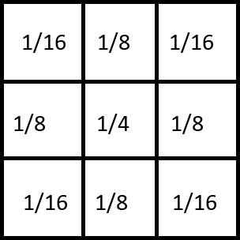

Index the above image staring from the top left corner square as (0, 0) and top right as (0, 9). Now first we use the Gaussian filter on (1, 1) and store it in the location where we had (0, 0). This won’t be a problem since we will never need (0, 0) again. Next we use Gaussian filter centering (1, 3) and store the result in (0, 1). We cannot use Gaussian filter on (1, 9). Hence we use that pixel as it is and store it in (0, 4). Next we use a Gaussian filter centered at (3, 1) and store it at (1, 0). The only exception is we do not use Gaussian filter on red squares and we use them as they are. This way we won’t we do not have to downsample again. The downsampled image is stored sequentially in the memory now. Now we just have to transmit the image to PC.

Doing the above for all the three color planes and reconstructing the image in opencv in python we can display the downsampled image in python.

The method we used is both efficient in memory and time.

* We are only using filters on the required pixels. This saves time.
* We are not using extra storage to store the downsampled image. This way we maximized the size of the image we chose.
* We did not have to use division due to the nature of the kernel. It contains powers of two as divisors which could be handled using shift operations which is much faster.

**THE ASSEMBLY CODE FOR DOWNSAMPING**

|  |
| --- |
| ACZERO |
| SP1AC |
| NXTADDAC |
| RCV |
| 0 |
| 0 |
| 100 |
| ACZERO |
| NXTADDAC |
| ACZERO |
| LOADNXTADD |
| SHIFTR8 |
| RAC |
| ACZERO |
| ACINC |
| NXTADDAC |
| ACR |
| LOADNXTADD |
| NCOLAC |
| ACZERO |
| ACINC |
| SHIFTR1 |
| NXTADDAC |
| ACZERO |
| LOADNXTADD |
| SHIFTR8 |
| RAC |
| ACZERO |
| ACINC |
| ACINC |
| ACINC |
| NXTADDAC |
| ACR |
| LOADNXTADD |
| NROWAC |
| ACZERO |
| STOREAC |
| 11 |
| 11010000 |
| 10010001 |
| ACZERO |
| ACINC |
| ACINC |
| ACINC |
| RAC |
| LOADAC |
| 11 |
| 11010000 |
| 10010001 |
| SP2AC |
| ACXOR |
| JMPZ |
| 1 |
| 101011 |
| ACSP2 |
| ACINC |
| STOREAC |
| 11 |
| 11010000 |
| 10010001 |
| ACZERO |
| ACINC |
| ROWAC |
| COLAC |
| ACZERO |
| SP1AC |
| SP2AC |
| SP3AC |
| NXTADDAC |
| RCV |
| 11 |
| 11010000 |
| 10010000 |
| ACZERO |
| NXTADDAC |
| ACNXTADD |
| ACINC |
| RAC |
| ACNCOL |
| ACADD |
| NXTADDAC |
| ACZERO |
| SP2AC |
| ACNROW |
| ACDEC |
| RAC |
| ACROW |
| ACXOR |
| JMPZ |
| 0 |
| 11111111 |
| ACNCOL |
| ACDEC |
| RAC |
| ACCOL |
| ACXOR |
| JMPZ |
| 0 |
| 11100010 |
| ACNCOL |
| RAC |
| ACZERO |
| ACNXTADD |
| ACDEC |
| ACSUB |
| NXTADDAC |
| ACZERO |
| LOADNXTADD |
| SP1AC |
| ACZERO |
| ACNXTADD |
| ACINC |
| NXTADDAC |
| ACZERO |
| LOADNXTADD |
| SHIFTR1 |
| RAC |
| ACSP1 |
| ACADD |
| SP1AC |
| ACZERO |
| ACNXTADD |
| ACINC |
| NXTADDAC |
| ACZERO |
| LOADNXTADD |
| RAC |
| ACSP1 |
| ACADD |
| SP1AC |
| ACZERO |
| ACNXTADD |
| RAC |
| ACNCOL |
| ACADD |
| NXTADDAC |
| ACZERO |
| LOADNXTADD |
| SHIFTR1 |
| RAC |
| ACSP1 |
| ACADD |
| SP1AC |
| ACZERO |
| ACNXTADD |
| ACDEC |
| NXTADDAC |
| ACZERO |
| LOADNXTADD |
| SHIFTR1 |
| SHIFTR1 |
| RAC |
| ACSP1 |
| ACADD |
| SP1AC |
| ACZERO |
| ACNXTADD |
| ACDEC |
| NXTADDAC |
| ACZERO |
| LOADNXTADD |
| SHIFTR1 |
| RAC |
| ACSP1 |
| ACADD |
| SP1AC |
| ACZERO |
| ACNXTADD |
| RAC |
| ACNCOL |
| ACADD |
| NXTADDAC |
| ACZERO |
| LOADNXTADD |
| RAC |
| ACSP1 |
| ACADD |
| SP1AC |
| ACZERO |
| ACNXTADD |
| ACINC |
| NXTADDAC |
| ACZERO |
| LOADNXTADD |
| SHIFTR1 |
| RAC |
| ACSP1 |
| ACADD |
| SP1AC |
| ACZERO |
| ACNXTADD |
| ACINC |
| NXTADDAC |
| ACZERO |
| LOADNXTADD |
| RAC |
| ACSP1 |
| ACADD |
| SHIFTL1 |
| SHIFTL1 |
| SHIFTL1 |
| SHIFTL1 |
| SP1AC |
| ACZERO |
| ACNXTADD |
| SP3AC |
| ACSP2 |
| NXTADDAC |
| ACINC |
| SP2AC |
| ACSP1 |
| STONXTADD |
| ACNCOL |
| RAC |
| ACZERO |
| ACSP3 |
| ACSUB |
| ACINC |
| NXTADDAC |
| ACCOL |
| ACINC |
| ACINC |
| COLAC |
| JMP |
| 0 |
| 1011011 |
| ACZERO |
| ACINC |
| COLAC |
| ACROW |
| ACINC |
| ACINC |
| ROWAC |
| ACZERO |
| LOADNXTADD |
| RAC |
| ACZERO |
| ACNXTADD |
| SP3AC |
| ACSP2 |
| NXTADDAC |
| ACINC |
| SP2AC |
| ACR |
| STONXTADD |
| ACNCOL |
| RAC |
| ACSP3 |
| ACADD |
| ACINC |
| ACINC |
| NXTADDAC |
| JMP |
| 0 |
| 1010011 |
| ACZERO |
| ACINC |
| COLAC |
| ACCOL |
| RAC |
| ACNCOL |
| ACINC |
| ACSUB |
| JMPZ |
| 1 |
| 100010 |
| ACZERO |
| LOADNXTADD |
| RAC |
| ACZERO |
| ACNXTADD |
| SP3AC |
| ACSP2 |
| NXTADDAC |
| ACINC |
| SP2AC |
| ACR |
| STONXTADD |
| ACZERO |
| ACSP3 |
| ACINC |
| ACINC |
| NXTADDAC |
| ACCOL |
| ACINC |
| ACINC |
| COLAC |
| JMP |
| 1 |
| 10 |
| ACZERO |
| NXTADDAC |
| TRN |
| 0 |
| 11110100 |
| 100100 |
| JMP |
| 0 |
| 101000 |
| STOP |

**THE RESULTS OF OUR DOWNSAMPLING ALGORITHM**

**Following are the results after downsampling a 500×500 image from our processor.**

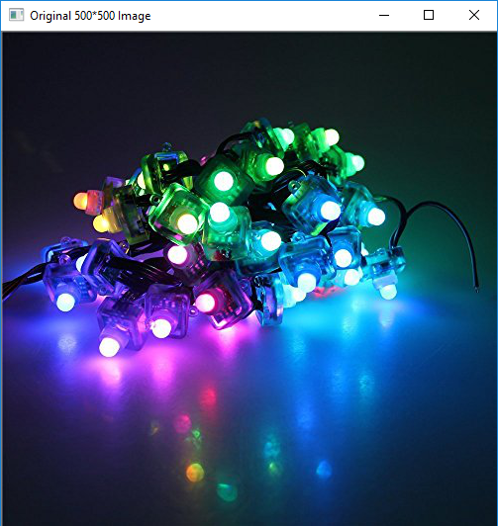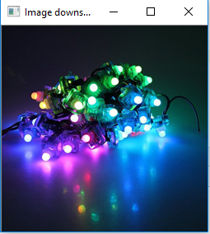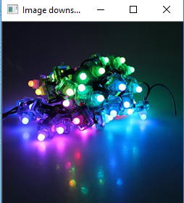

Original image top, Image downsampled from PC bottom left and Image downsampled from FPGA bottom right

It is notable that most of the time for processing is taken for the transmission of the image. To transmit all the three color planes and to process them it took around 7 minutes but for processing it took only 1 second. This is due to the protocol we used in transmitting. In PC to downsample the image it took around 3 seconds.

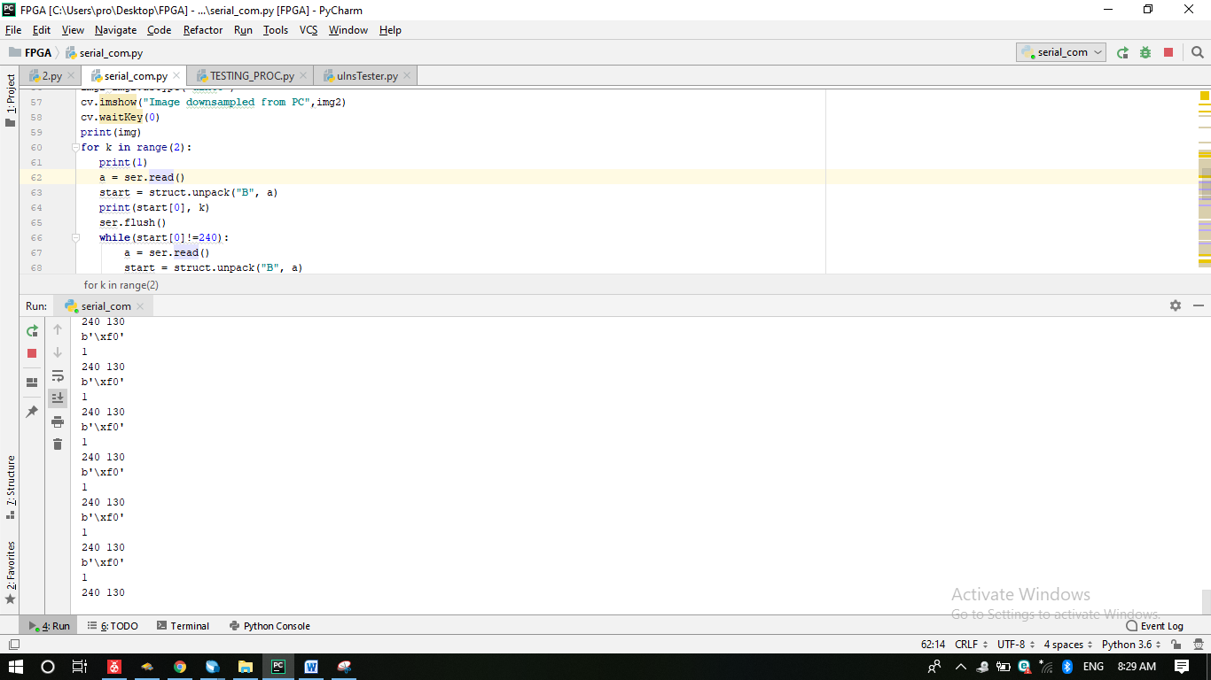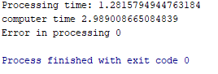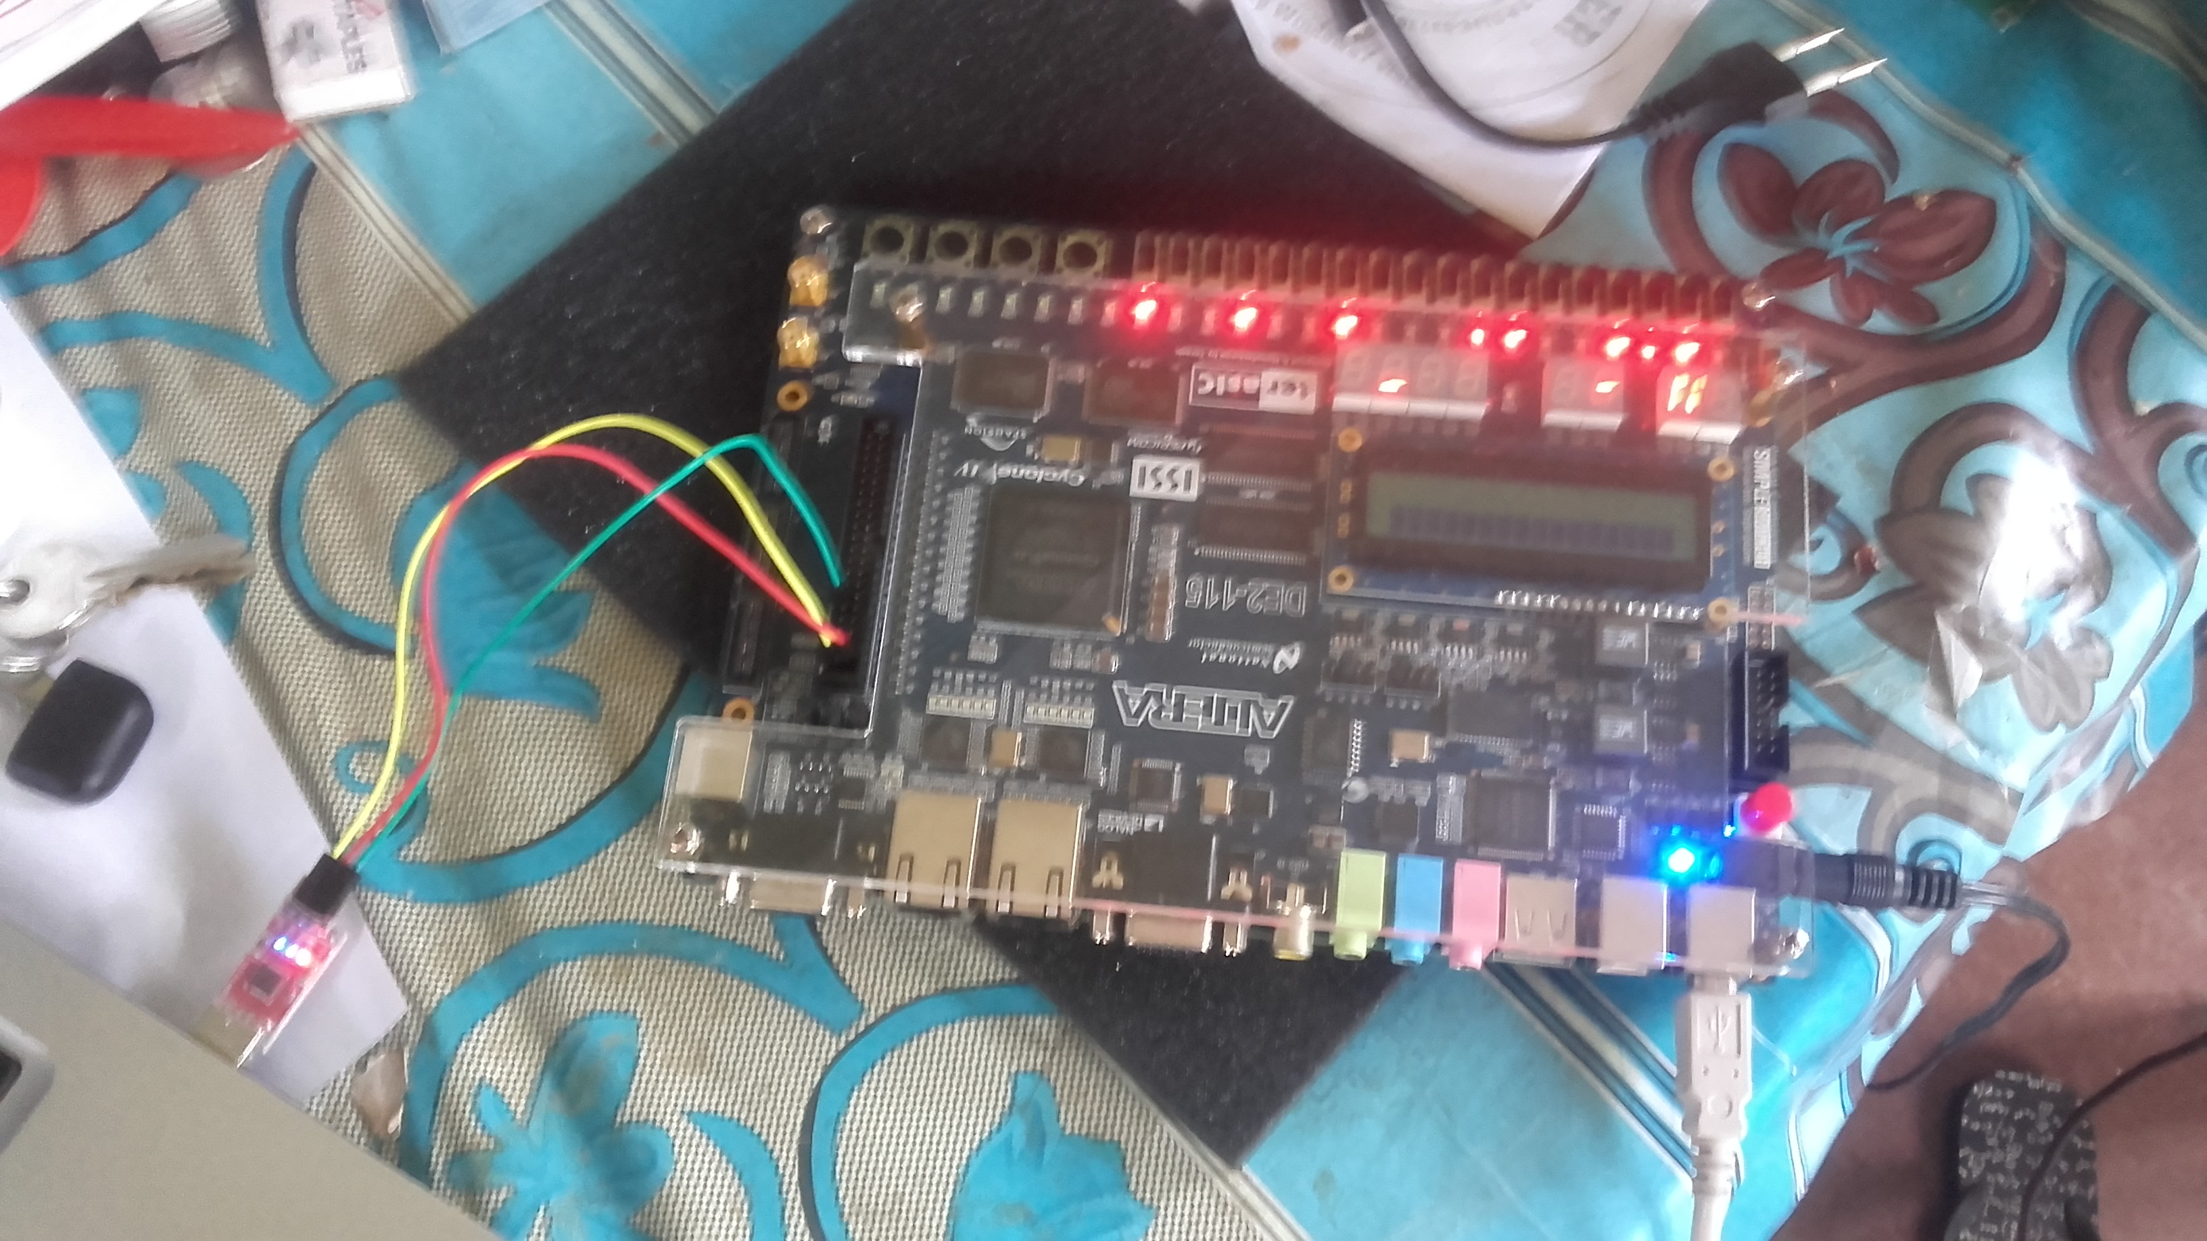

Screenshot of python IDE during transmission top, Picture of the FPGA during transmission bottom left and statistics of processing bottom right

Observe the stats of the processing. The FPGA was much faster in processing the image. More importantly the error between the image downsampled from the PC and from the FPGA is zero which means they are identical. Here we used

Error =

**THE COMPLETE RTL VIEW OF THE PROCESSOR**

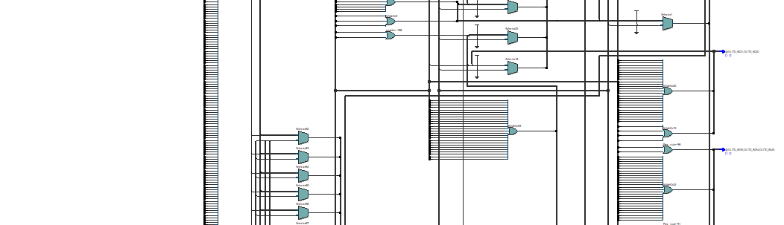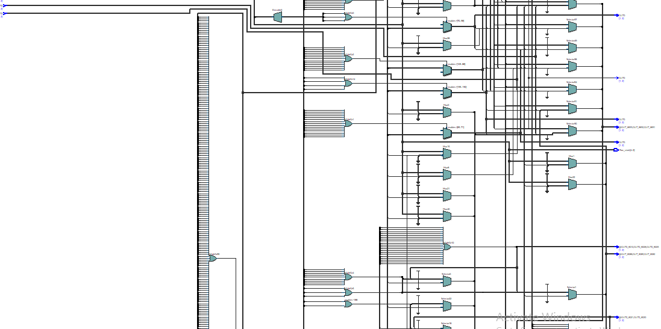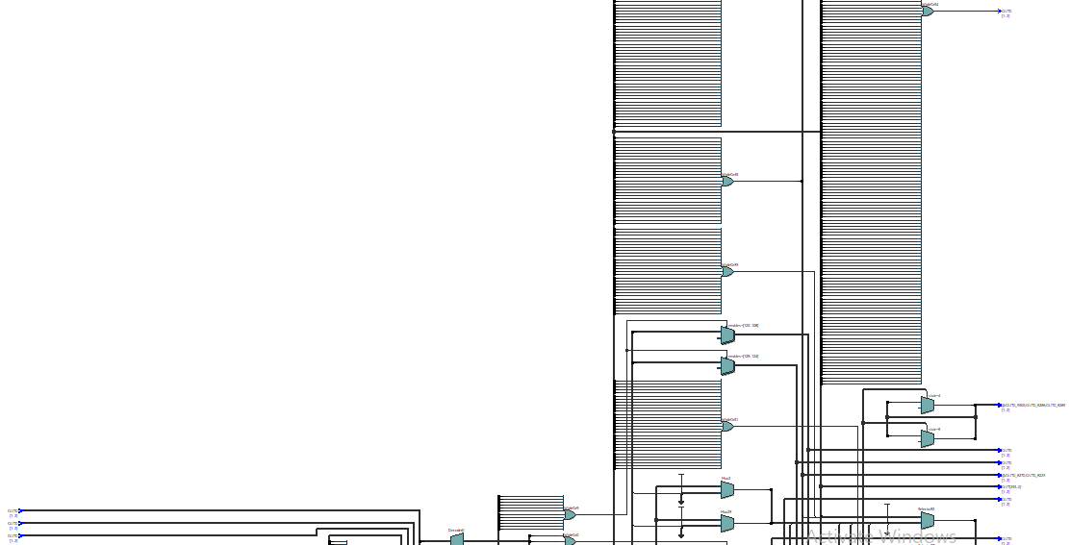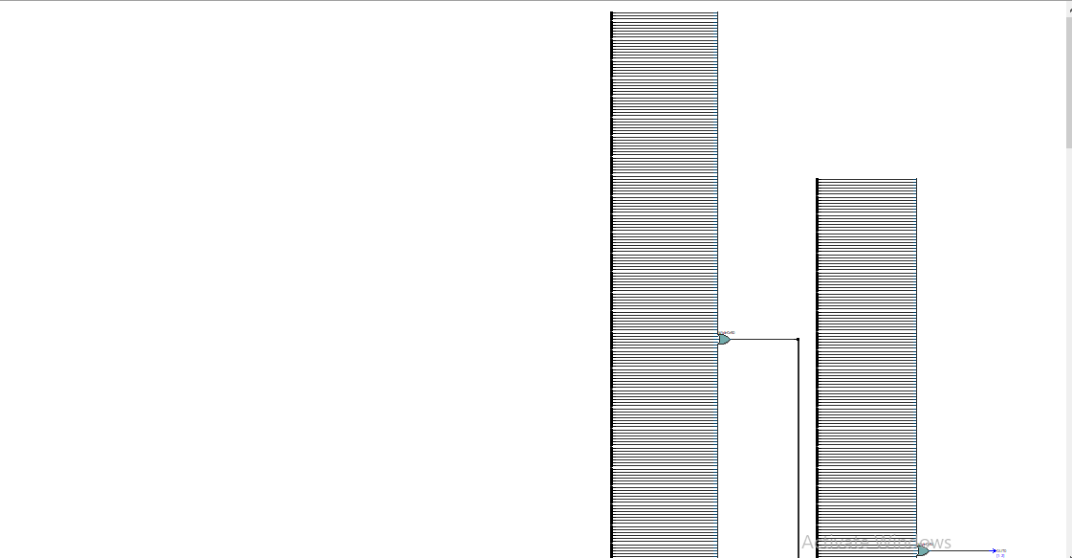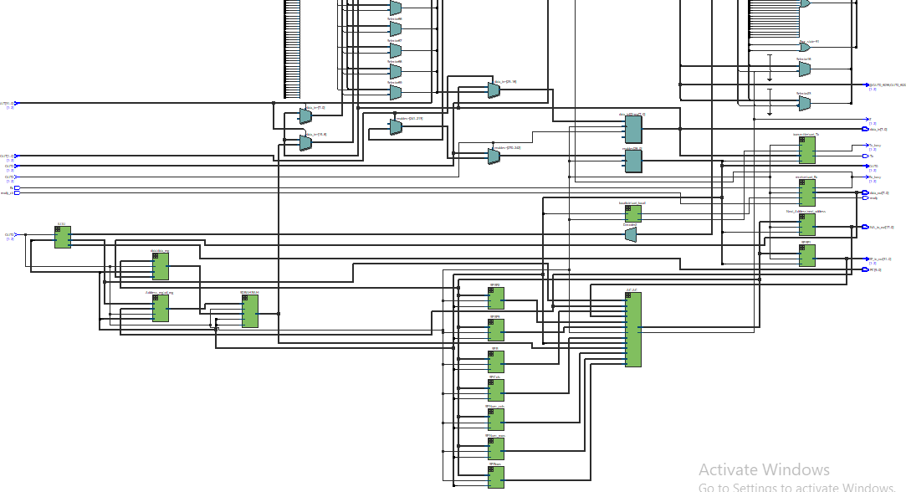

**THE VIEW OF THE DIFFERENT MODULES**



Shown in green is the RTL view of different modules

**TIMING ANALYSIS FOR A SAMPLE PROGRAMME**

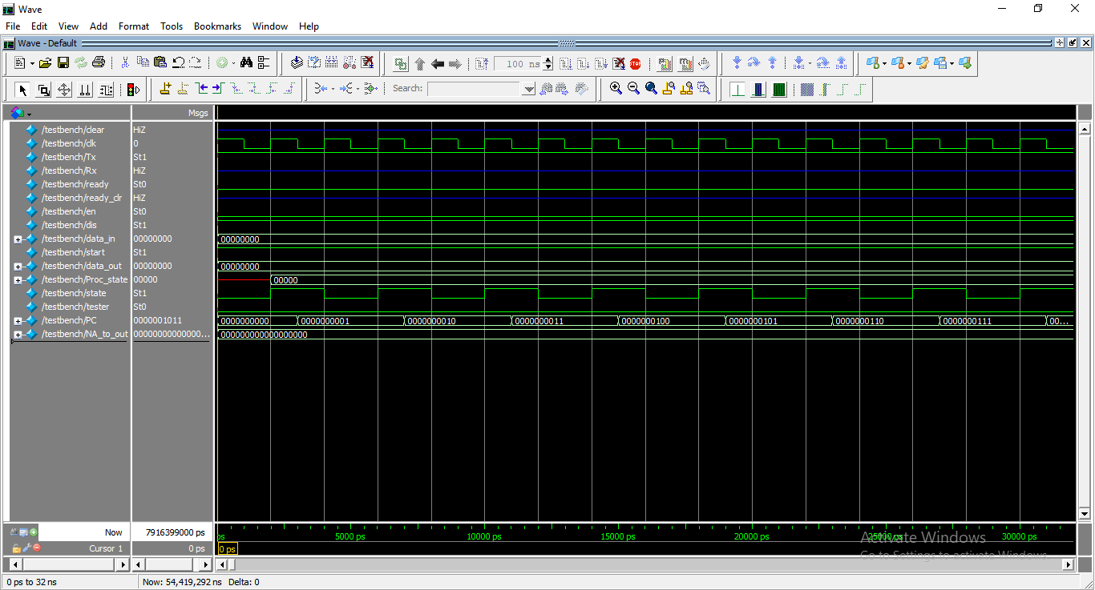

The sample program is given below,

ACZERO

NOP

ACINC

ACINC

RAC

ACZERO

ACINC

ACINC

SHIFTL1

ACADD

Due to the complexity of the original program we did not use it for timing analysis. Instead we used the above program for it. Diagram is a simulation of the above program. The test bench used is provided in the appendix. We can see how the PC and the other signals change with the clock.

**THE COMPILATION REPORT IN QUARTUS PRIME**

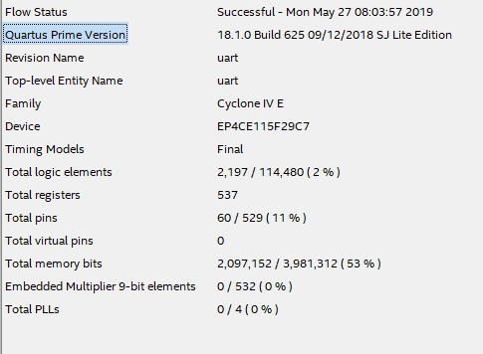

**REFERENCES**

* Ecs.umass.edu. (2019). [online] Available at: http://www.ecs.umass.edu/ece354/ECE354HomePageFiles/Labs_files/Quartus_II_Introduction.pdf [Accessed 28 May 2019].
* Asic-world.com. (2019). *Verilog Tutorial*. [online] Available at: http://www.asic-world.com/verilog/veritut.html [Accessed 28 May 2019].
* Alchitry. (2019). *Basic CPU*. [online] Available at: https://alchitry.com/blogs/tutorials/basic-cpu [Accessed 28 May 2019].

**APPENDIX**

**Python codes**

1. **Serial communication**

import serial

import sys

import glob

import serial

import struct

import cv2 as cv

import time

import numpy as np

import time

def serial_ports():

""" Lists serial port names

:raises EnvironmentError:

On unsupported or unknown platforms

:returns:

A list of the serial ports available on the system

"""

if sys.platform.startswith('win'):

ports = ['COM%s' % (i + 1) for i in range(256)]

elif sys.platform.startswith('linux') or sys.platform.startswith('cygwin'):

# this excludes your current terminal "/dev/tty"

ports = glob.glob('/dev/tty[A-Za-z]*')

elif sys.platform.startswith('darwin'):

ports = glob.glob('/dev/tty.*')

else:

raise EnvironmentError('Unsupported platform')

result = []

for port in ports:

try:

s = serial.Serial(port)

s.close()

result.append(port)

except (OSError, serial.SerialException):

pass

return result

#print(serial_ports())

#initialize serial object

ser = serial.Serial('COM30',115200,timeout=10,bytesize=8,stopbits=1)

#loading the image

img1=cv.imread("7.jpg")

img=img1

#dispalying the original image

cv.imshow("Original 500*500 Image",img)

cv.waitKey(0)

print(img.shape)

#downsampling the original image using pyhton

img2=np.zeros((250,250,3))

t3=time.time()

for i in range(3):

for t in range(1,500,2):

for tt in range(1,500,2):

if(t!=499 and tt!=499):

g=(img[t,tt,i]*4)+(img[t-1,tt,i]*2)+(img[t,tt-1,i]*2)+(img[t+1,tt,i]*2)+(img[t,tt+1,i]*2)+(img[t-1,tt-1,i])+(img[t-1,tt+1,i])+(img[t+1,tt-1,i])+(img[t+1,tt+1,i])

g=g//16

img2[t//2,tt//2,i]=g

else:

img2[t//2,tt//2,i]=img[t,tt,i]

t4=time.time()

img2=img2.astype('uint8')

# dispalying the image downsampled from python

cv.imshow("Image downsampled from PC",img2)

cv.waitKey(0)

print(img)

#starting serial communication with FPGA

for k in range(2):

print(1)

a = ser.read()

start = struct.unpack("B", a)

print(start[0], k)

ser.flush()

while(start[0]!=240):

a = ser.read()

start = struct.unpack("B", a)

ser.flush()

print(a,k)

if(start[0]==240):

ser.write(struct.pack('>B', 1))

ser.flush()

print(1)

a = ser.read()

start = struct.unpack("B", a)

print(start[0], k)

ser.flush()

while (start[0] != 240):

a = ser.read()

start = struct.unpack("B", a)

ser.flush()

print(a, k)

if (start[0] == 240):

ser.write(struct.pack('>B', 244))

ser.flush()

s=0

tx=0

picture=np.zeros((250,250,3))

for i in range(3):

# Sending each color plane of the original image to FPGA

for k in range(500):

for kk in range(500):

print(1)

a = ser.read()

start = struct.unpack("B", a)

print(start[0], k)

ser.flush()

while(start[0]!=240):

a = ser.read()

start = struct.unpack("B", a)

ser.flush()

print(a)

if(start[0]==240):

ser.write(struct.pack('>B', img[k,kk,i]))

ser.flush()

t0=time.time()

#Receiving each color plane of image downsampled form FPGA

for k in range(250):

for kk in range(250):

b=ser.read()

g=struct.unpack("B", b)

if(k+kk==0):

t1=time.time()

print(g[0])

if(g[0]!=k%256):

s=s+1

picture[k,kk,i]=g[0]

ser.flush()

tx=tx+t1-t0

picture=picture.astype('uint8')

ser.close()

print(picture.shape)

#displaying the image downsampled from FPGA

cv.imshow("Image downsampled from FPGA",picture)

cv.waitKey(0)

cv.destroyAllWindows()

print("Processing time:",tx)

print("computer time",t4-t3)

print("Error in processing",sum(sum(sum(abs(picture-img2)))))

1. **uInstruction tester**

a=int(input("Enter the number of Uinstrauctions to be tested:").strip())

for k in range(a):

b=input("Enter the uInstruction:").strip()

c=b[4:]

print("IU",c[2:5])

print("SP1",c[5])

print("Transmit",c[6])

print("rnext",c[7:9])

print("tnext",c[9:11])

print("Rxallowed",c[11])

print("wren",c[12])

print("rden",c[13])

print("Next Add",c[14])

print("AC",c[15:20])

print("Address",c[20:22])

print("Rreg",c[22])

print("rows",c[23])

print("cols",c[24])

print("next row",c[25])

print("next col",c[26])

print("data",c[27:29])

**3)Compiler**

import pandas as pd

filename="Instructions_edited_final.csv"

data=pd.read_csv(filename,encoding='utf-8')

a=list(map(int,(data['Unnamed: 2'][:39]).values.tolist()))

b=(data['Instruction Code'][:39]).values.tolist()

d={}

for g in range(len(a)):

d[b[g].strip()]="8'b"+str(a[g])

num=int(input("Number of Instructions:").strip())

for k in range(num):

p=input().strip()

if(p in d.keys()):

print("ins_mem["+str(k)+"]="+d[p]+";")

else:

print("ins_mem["+str(k)+"]=8'b"+str(p)+";")

**TestBench**

`timescale 1ns/1ps

module testbench();

wire clear;

reg clk;

wire Tx;

wire Rx;

wire ready;

wire ready_clr;

wire en=0;

wire dis=1;

wire [7:0] data_in;

wire start;

wire[7:0] data_out;

wire [4:0] Proc_state;

wire state;

wire tester;

wire [9:0] PC;

wire[17:0] NA_to_out;

uart uart1(clear,clk,Tx,Rx,ready,ready_clr,en,dis, data_in,start,data_out, Proc_state,state, tester,PC,NA_to_out);

always // no sensitivity list, so it always executes

begin

clk = 1; #1; clk = 0; #1; // 10ns period

end

endmodule

**Verilog modules**

**1)Top module- uart.v**

module uart(input wire clear,

input wire clk_50m,

output wire Tx,

input wire Rx,

output wire ready,

input wire ready_clr,

input wire en,

input wire dis,

output reg [7:0] data_in,

output reg start,

output wire[7:0] data_out,

output reg [4:0] Proc_state,

output reg state,

output reg tester,

output wire[9:0] PC,

output wire[17:0] NA_to_out

);

initial begin

start=1'b0;

data_in=8'b0;

state=1'b0;

tester=0;

end

wire [31:0] rows_to_out;

wire[7:0] Ins_to_out;

wire [31:0] SP1_to_out;

wire [31:0] ncols_to_out;

wire [31:0] AC_to_out;

wire [31:0] R_to_out;

wire [31:0] nrows_to_out;

wire [31:0] RNext_to_out;

wire [31:0] TNext_to_out;

wire [31:0] cols_to_out;

wire [31:0] SP2_to_out;

wire [31:0] SP3_to_out;

wire [17:0] Ad_to_out;

wire [ 7:0] data_to_out;

wire [ 7:0] operands;

wire [ 7:0] q;

wire Z;

wire Tx_busy;

wire Rx_busy;

wire Rxclk_en;

wire Txclk_en;

reg [17:0] address;

reg [28:0] enables=29'b0;

wire clk;

clock clk1(clk,clk_50m);

AC AC(enables[13:9] ,AC_to_out, Z,R_to_out,ncols_to_out,nrows_to_out,rows_to_out,cols_to_out,SP1_to_out,SP2_to_out,SP3_to_out,q,operands,NA_to_out,clk_50m);

SP Num_cols(clk_50m,enables[2] ,AC_to_out,ncols_to_out);

SP Num_rows(clk_50m,enables[3] ,AC_to_out,nrows_to_out);

SP Rows(clk_50m, enables[5],AC_to_out,rows_to_out);

SP Cols(clk_50m, enables[4],AC_to_out,cols_to_out);

Next_Address next_address(clk_50m, enables[14], AC_to_out, NA_to_out);

Rx_TX_regs r_next(clk_50m,enables[21:20], RNext_to_out);

Rx_TX_regs t_next(clk_50m,enables[19:18], TNext_to_out);

IU IU(clk_50m,Ins_to_out,operands,enables[26:24],PC);

SP SP1(clk_50m,enables[23],AC_to_out,SP1_to_out);

SP SP2(clk_50m,enables[27],AC_to_out,SP2_to_out);

SP SP3(clk_50m,enables[28],AC_to_out,SP3_to_out);

SP R(clk_50m,enables[6],AC_to_out,R_to_out);

baudrate uart_baud(clk_50m,enables[17],Rxclk_en, Txclk_en);

transmitter uart_Tx( data_in,enables[22],clk_50m,Txclk_en, Tx,Tx_busy);

receiver uart_Rx( Rx,ready,ready_clr,clk_50m,Rxclk_en, data_out,Rx_busy);

Address_reg ad_reg(clk_50m,operands,NA_to_out,enables[8:7], Ad_to_out);

SDRAM RAM(Ad_to_out,clk_50m,data_to_out,enables[16],enables[15],q);

data data_reg(clk_50m,AC_to_out,data_out,enables[1:0],data_to_out);

always@ (posedge clk_50m) begin

if(~dis) begin

start<=0;

enables<=29'b00100000000000000000000000000;

state<=0;

end

if(~en) begin

start<=1'b1;

enables<=29'b00000000000000000000000000000;

end

if(start==1'b1) begin

case(state)

1'b0: begin

enables<=29'b00001000000000000000000000000;

Proc_state<=0;

state<=1'b1;

end

1'b1: begin

case(Ins_to_out)

0:begin

enables<=29'b00000000000000000000000000000;

state<=1'b0;

end

8'b1: begin

case(Proc_state)

5'b0: begin

enables<=29'b00011001000000001011000000000;

Proc_state<=5'b1;

end

5'b1: begin

enables<=29'b00000000000000001111000000000;

Proc_state<=5'b10;

end

5'b10: begin

enables<=29'b00000000000000000101000000000;

Proc_state<=5'b11;

end

5'b11: begin

enables<=29'b00011000000000000000000000000;

Proc_state<=5'b100;

end

5'b100: begin

enables<=29'b00000000000000001111000000000;

Proc_state<=5'b101;

end

5'b101: begin

enables<=29'b00000000000000000101000000000;

Proc_state<=5'b110;

end

5'b110: begin

enables<=29'b00011000000000000000000000000;

Proc_state<=5'b111;

end

5'b111: begin

enables<=29'b00000000000000001111000000000;

Proc_state<=5'b1000;

end

5'b1000: begin

enables<=29'b00000100000000000000000000000;

Proc_state<=5'b1001;

end

5'b1001: begin

if(SP1_to_out>RNext_to_out) begin

Proc_state<=5'b1010;

enables<=29'b00000000000000000000000000000;

end

else begin

enables<=29'b00000001000000000000000000000;

Proc_state<=5'b10011;

end

end

5'b1010: begin

data_in<=8'd240;

enables<=29'b00000010100000000000000000000;

Proc_state<=5'b1011;

end

5'b1011: begin

enables<=29'b00000010000000000000000000000;

if(Tx_busy==1'b1)

Proc_state<=5'b1100;

end

5'b1100: begin

enables<=29'b00000000000000000000000000000;

if(Tx_busy==0)

Proc_state<=5'b1101;

end

5'b1101: begin

enables<=29'b00000000000100000000000000000;

Proc_state<=5'b1110;

end

5'b1110:begin

if(Rx_busy==1'b1) begin

Proc_state<=5'b1111;

enables<=29'b00000000000100001011000000000;

end

else

enables<=29'b00000000000100000000000000000;

end

5'b1111:begin

if(Rx_busy==0) begin

enables<=29'b00000000000010010001010000010;

Proc_state<=5'b10000;

end

else

enables<=29'b00000000000100000000000000000;

end

5'b10000:begin

enables<=29'b00000000000000001100000000000;

Proc_state<=5'b10001;

end

5'b10001: begin

enables<=29'b00000000000000100000000000000;

Proc_state<=5'b10010;

end

5'b10010: begin

enables<=29'b00000000000000000000000000000;

Proc_state<=5'b1001;

end

5'b10011: begin

enables<=29'b00000000000000000000000000000;

state<=0;

end

endcase

end

8'b10: begin

case(Proc_state)

5'b0: begin

enables<=29'b00011000010000001011000000000;

Proc_state<=5'b1;

end

5'b1: begin

enables<=29'b00000000000000001111000000000;

Proc_state<=5'b10;

end

5'b10: begin

enables<=29'b00000000000000000101000000000;

Proc_state<=5'b11;

end

5'b11: begin

enables<=29'b00011000000000000000000000000;

Proc_state<=5'b100;

end

5'b100: begin

enables<=29'b00000000000000001111000000000;

Proc_state<=5'b101;

end

5'b101: begin

enables<=29'b00000000000000000101000000000;

Proc_state<=5'b110;

end

5'b110: begin

enables<=29'b00011000000000000000000000000;

Proc_state<=5'b111;

end

5'b111: begin

enables<=29'b00000000000000001111000000000;

Proc_state<=5'b1000;

end

5'b1000: begin

enables<=29'b00000100000000000000000000000;

Proc_state<=5'b1001;

end

5'b1001: begin

if(SP1_to_out>TNext_to_out) begin

Proc_state<=5'b1010;

enables<=29'b00000000000000000000000000000;

end

else begin

enables<=29'b00000000010000001011000000000;

Proc_state<=5'b10000;

end

end

5'b1010: begin

enables<=29'b00000000000001010001010000000;

Proc_state<=5'b1011;

end

5'b1011: begin

enables<=29'b00000000000000001100000000000;

Proc_state<=5'b1100;

end

5'b1100:begin

enables<=29'b00000000000000100000000000000;

Proc_state<=5'b1101;

end

5'b1101: begin

enables<=29'b00000010001000000000000000000;

data_in<=q;

Proc_state<=5'b1110;

end

5'b1110: begin

enables<=29'b00000010000000000000000000000;

if(Tx_busy==1'b1)

Proc_state<=5'b1111;

end

5'b1111: begin

enables<=29'b00000000000000000000000000000;

if(Tx_busy==0)

Proc_state<=5'b1001;

end

5'b10000:begin

enables<=29'b00000000000000000000000000000;

state<=0;

end

endcase

end

8'b11: begin

case(Proc_state)

5'b0: begin

enables<=29'b00011000000000001011000000000;

Proc_state<=5'b1;

end

5'b1: begin

enables<=29'b00000000000000000000100000000;

Proc_state<=5'b10;

end

5'b10: begin

enables<=29'b00000000000000000000110000000;

Proc_state<=5'b11;

end

5'b11: begin

enables<=29'b00011000000000000000000000000;

Proc_state<=5'b100;

end

5'b100: begin

enables<=29'b00000000000000000000100000000;

Proc_state<=5'b101;

end

5'b101: begin

enables<=29'b00000000000000000000110000000;

Proc_state<=5'b110;

end

5'b110: begin

enables<=29'b00011000000000000000000000000;

Proc_state<=5'b111;

end

5'b111: begin

enables<=29'b00000000000000000000100000000;

Proc_state<=5'b1000;

end

5'b1000: begin

enables<=29'b00000000000001000000000000000;

Proc_state<=5'b1001;

end

5'b1001: begin

enables<=29'b00000000000000000000000000000;

Proc_state<=5'b1111;

end

5'b1111:begin

enables<=29'b00000000000000000000000000000;

Proc_state<=5'b1010;

end

5'b1010:begin

enables<=29'b00000000000000001110000000000;

Proc_state<=5'b1011;

end

5'b1011:begin

enables<=29'b00000000000000000000000000000;

state<=0;

end

endcase

end

8'b100: begin

case(Proc_state)

5'b0: begin

enables<=29'b00011000000000000000000000000;

Proc_state<=5'b1;

end

5'b1: begin

enables<=29'b00000000000000000000100000000;

Proc_state<=5'b10;

end

5'b10: begin

enables<=29'b00000000000000000000110000000;

Proc_state<=5'b11;

end

5'b11: begin

enables<=29'b00011000000000000000000000000;

Proc_state<=5'b100;

end

5'b100: begin

enables<=29'b00000000000000000000100000000;

Proc_state<=5'b101;

end

5'b101: begin

enables<=29'b00000000000000000000110000000;

Proc_state<=5'b110;

end

5'b110: begin

enables<=29'b00011000000000000000000000000;

Proc_state<=5'b111;

end

5'b111: begin

enables<=29'b00000000000000000000100000000;

Proc_state<=5'b1000;

end

5'b1000: begin

enables<=29'b00000000000010000000000000001;

Proc_state<=5'b1001;

end

5'b1001: begin

enables<=29'b00000000000000000000000000000;

Proc_state<=5'b1010;

end

5'b1010:begin

enables<=29'b00000000000000000000000000000;

Proc_state<=5'b1011;

end

5'b1011:begin

enables<=29'b00000000000000000000000000000;

state<=0;

end

endcase

end

8'b101: begin

enables<=29'b00000000000000000101000000000;

state<=0;

end

8'b110: begin

enables<=29'b00000000000000000111000000000;

state<=0;

end

8'b111: begin

enables<=29'b00000000000000000110000000000;

state<=0;

end

8'b1000:begin

enables<=29'b00000000000000001000000000000;

state<=0;

end

8'b1001: begin

enables<=29'b00000000000000000000001000000;

state<=0;

end

8'b1010: begin

enables<=29'b00000000000000000000000100000;

state<=0;

end

8'b1011: begin

enables<=29'b00000000000000000100000000000;

state<=0;

end

8'b1100: begin

enables<=29'b00000000000000000000000010000;

state<=0;

end

8'b1101: begin

enables<=29'b00000000000000000011000000000;

state<=0;

end

8'b1110: begin

enables<=29'b00000000000000010010000000000;

state<=0;

end

8'b1111: begin

enables<=29'b00000000000000000000000000100;

state<=0;

end

8'b10000: begin

enables<=29'b00000000000000000010000000000;

state<=0;

end

8'b10001:begin

enables<=29'b00000000000000000000000001000;

state<=0;

end

8'b10010:begin

enables<=29'b00000000000000010001000000000;

state<=0;

end

8'b10011:begin

case(Proc_state)

5'b0: begin

enables<=29'b00000000000010000000010000001;

Proc_state<=5'b1;

end

5'b1: begin

enables<=29'b00000000000000000000000000000;

Proc_state<=5'b10;

end

5'b10: begin

enables<=29'b00000000000000000000000000000;

Proc_state<=5'b11;

end

5'b11:begin

enables<=29'b00000000000000000000000000000;

state<=0;

end

endcase

end

8'b10100:begin

case(Proc_state)

5'b0: begin

enables<=29'b00000000000001000000010000000;

Proc_state<=5'b1;

end

5'b1: begin

enables<=29'b00000000000000000000000000000;

Proc_state<=5'b10;

end

5'b10: begin

enables<=29'b00000000000000000000000000000;

Proc_state<=5'b11;

end

5'b11:begin

enables<=29'b00000000000000001110000000000;

Proc_state<=5'b100;

end

5'b100:begin

enables<=29'b00000000000000000000000000000;

state<=0;

end

endcase

end

8'b10101:begin

enables<=29'b00000000000000001010000000000;

state<=0;

end

8'b10110:begin

enables<=29'b00000000000000000001000000000;

state<=0;

end

8'b10111: begin

enables<=29'b00000000000000001100000000000;

state<=0;

end

8'b11000: begin

enables<=29'b00000000000000001101000000000;

state<=0;

end

8'b11001:begin

enables<=29'b00000000000000001011000000000;

state<=0;

end

8'b11010:begin

case(Proc_state)

5'b0: begin

if(Z==0) begin

enables<=29'b00010000000000000000000000000;

Proc_state<=5'b1;

end

else begin

enables<=29'b00011000000000000000000000000;

Proc_state<=5'b101;

end

end

5'b1:begin

enables<=29'b00000000000000000000000000000;

Proc_state<=5'b10;

end

5'b10:begin

enables<=29'b00000000000000000000000000000;

Proc_state<=5'b11;

end

5'b11:begin

enables<=29'b00000000000000000000000000000;

Proc_state<=5'b100;

end

5'b100: begin

enables<=29'b00000000000000000000000000000;

state<=0;

end

5'b101:begin

enables<=29'b00011000000000000000000000000;

Proc_state<=5'b100;

end

endcase

end

8'b11011:begin

case(Proc_state)

5'b0:begin

enables<=29'b00010000000000000000000000000;

Proc_state<=5'b1;

end

5'b1:begin

enables<=29'b00000000000000000000000000000;

Proc_state<=5'b10;

end

5'b10:begin

enables<=29'b00000000000000000000000000000;

Proc_state<=5'b11;

end

5'b11:begin

enables<=29'b00000000000000000000000000000;

Proc_state<=5'b100;

end

5'b100: begin

enables<=29'b00000000000000000000000000000;

state<=0;

end

endcase

end

8'b11100:begin

case(Proc_state)

5'b0:begin

if(Z==1'b1) begin

enables<=29'b00010000000000000000000000000;

Proc_state<=5'b1;

end

else begin

enables<=29'b00011000000000000000000000000;

Proc_state<=5'b101;

end

end

5'b1:begin

enables<=29'b00000000000000000000000000000;

Proc_state<=5'b10;

end

5'b10:begin

enables<=29'b00000000000000000000000000000;

Proc_state<=5'b11;

end

5'b11:begin

enables<=29'b00000000000000000000000000000;

Proc_state<=5'b100;

end

5'b100: begin

enables<=29'b00000000000000000000000000000;

state<=0;

end

5'b101:begin

enables<=29'b00011000000000000000000000000;

Proc_state<=5'b100;

end

endcase

end

8'b11101: begin

enables<=29'b00000000000000001001000000000;

state<=0;

end

8'b11110: begin

enables<=29'b00000000000000010011000000000;

state<=0;

end

8'b11111: begin

enables<=29'b00000100000000000000000000000;

state<=0;

end

8'b100000:begin

enables<=29'b00000000000000010000000000000;

state<=0;

end

8'b100001:begin

enables<=29'b00000000000000100000000000000;

state<=0;

end

8'b100010:begin

enables<=29'b00000000000000010100000000000;

state<=0;

end

8'b100011:begin

enables<=29'b00000000000000010101000000000;

state<=0;

end

8'b100100:begin

enables<=29'b01000000000000000000000000000;

state<=0;

end

8'b100101:begin

enables<=29'b10000000000000000000000000000;

state<=0;

end

8'b100110:begin

enables<=29'b00000000000000000000000000000;

start<=0;

end

endcase

end

endcase

end

end

endmodule

**2) AC**

module AC (input wire [ 4:0] enables,

output wire [31:0] AC_to_out,

output wire Z,

input wire [31:0] R_to_AC,

input wire [31:0] ncols_to_AC,

input wire [31:0] nrows_to_AC,

input wire [31:0] rows_to_AC,

input wire [31:0] cols_to_AC,

input wire [31:0] SP1_to_AC,

input wire [31:0] SP2_to_AC,

input wire [31:0] SP3_to_AC,

input wire [7:0 ] memory_to_AC,

input wire [7:0 ] Ins_to_AC,

input wire [17:0] NA_to_AC,

input wire clk

);

reg [31:0] AC;

always@(negedge clk) begin

case(enables)

5'b1: begin

AC<=R_to_AC;

end

5'b10010: begin

AC<=ncols_to_AC;

end

5'b10: begin

AC<=nrows_to_AC;

end

5'b11: begin

AC<=cols_to_AC;

end

5'b100:begin

AC<=rows_to_AC;

end

5'b101:begin

AC<=(AC<<8);

end

5'b110:begin

AC<=(AC>>8);

end

5'b111:begin

AC<=(AC<<1);

end

5'b1000:begin

AC<=(AC>>1);

end

5'b1001:begin

AC<=AC+R_to_AC;

end

5'b1010:begin

AC<=AC^R_to_AC;

end

5'b1011:begin

AC<=0;

end

5'b1100:begin

AC<=AC+1;

end

5'b1101:begin

AC<=AC-1;

end

5'b1110:begin

AC[7:0]<=memory_to_AC;

end

5'b1111:begin

AC[7:0]<=Ins_to_AC;

end

5'b10000:begin

AC<=SP1_to_AC;

end

5'b10001:begin

AC[17:0]<=NA_to_AC;

end

5'b10011:begin

AC<=AC-R_to_AC;

end

5'b10100:begin

AC<=SP2_to_AC;

end

5'b10101:begin

AC<=SP3_to_AC;

end

default: begin

end

endcase

end

assign AC_to_out=AC;

assign Z=(AC==0);

endmodule

**3)Receiver**

module receiver (input wire Rx,

output reg ready,

input wire ready_clr,

input wire clk_50m,

input wire clken,

output reg [7:0] data,

output wire Rx_busy

);

initial begin

ready = 1'b0; // initialize ready = 0

data = 8'b0; // initialize data as 00000000

end

// Define the 4 states using 00,01,10 signals

parameter RX_STATE_START = 2'b00;

parameter RX_STATE_DATA = 2'b01;

parameter RX_STATE_STOP = 2'b10;

parameter RX_STATE_IDLE = 2'b11;

// This is a 4-bit register

reg [3:0] bit_pos = 0; // bit position is a 4-bit register/vector, initially equal to 000

reg [7:0] scratch = 8'b0; // An 8-bit register assigned to 00000000

reg [3:0] sample=0;

reg [1:0] state=2'b11;

always @(posedge clk_50m) begin

if (ready_clr)

ready <= 1'b0; // This resets ready to 0

if (clken ) begin

case (state) // Let us consider the 4 states of the receiver

RX_STATE_IDLE: begin

state<=RX_STATE_START;

end

RX_STATE_START: begin

// We define condtions for starting the receiver

if (!Rx || sample != 0) // start counting from the first low sample

sample <= sample + 4'b1; // increment by 0001

if (sample == 15) begin // once a full bit has been sampled

state <= RX_STATE_DATA; // start collecting data bits

bit_pos <= 0;

sample <= 0;

scratch <= 0;

end

end

RX_STATE_DATA: begin // We define conditions for starting the data colleting

sample <= sample + 4'b1; // increment by 0001

if (sample == 4'h8) begin // we keep assigning Rx data until all bits have 01 to 7

scratch[bit_pos[2:0]] <= Rx;

bit_pos <= bit_pos + 4'b1; // increment by 0001

end

if (bit_pos == 8 && sample == 15) // when a full bit has been sampled and

state <= RX_STATE_STOP; // bit position has finally reached 7, assign state to stop

end

RX_STATE_STOP: begin

/*

* Our baud clock may not be running at exactly the

* same rate as the transmitter. If we thing that

* we're at least half way into the stop bit, allow

* transition into handling the next start bit.

*/

if (sample == 15 || (sample >= 8 && !Rx)) begin

state <= RX_STATE_IDLE;

data <= scratch;

ready <= 1'b1;

sample <= 0;

end

else begin

sample <= sample + 4'b1;

end

end

default: begin

state <= RX_STATE_IDLE; // always begin with state assigned to START

end

endcase

end

end

assign Rx_busy=(state!=RX_STATE_IDLE);

endmodule

**4)Transmitter**

module transmitter( input wire [7:0] data_in, //input data as an 8-bit regsiter/vector

input wire wr_en, //enable wire to start

input wire clk_50m,

input wire clken, //clock signal for the transmitter

output reg Tx, //a single 1-bit register variable to hold transmitting bit

output wire Tx_busy //transmitter is busy signal

);

initial begin

Tx = 1'b1; //initialize Tx = 1 to begin the transmission

end

//Define the 4 states using 00,01,10,11 signals

parameter TX_STATE_IDLE = 2'b00;

parameter TX_STATE_START = 2'b01;

parameter TX_STATE_DATA = 2'b10;

parameter TX_STATE_STOP = 2'b11;

reg [7:0] data = 8'h00; //set an 8-bit register/vector as data,initially equal to 00000000

reg [2:0] bit_pos = 3'h0; //bit position is a 3-bit register/vector, initially equal to 000

reg [1:0] state=2'b00;

//state is a 2 bit register/vector,initially equal to 00

always @(posedge clk_50m) begin

case (state) //Let us consider the 4 states of the transmitter

TX_STATE_IDLE: begin //We define the conditions for idle or NOT-BUSY state

if(wr_en) begin

state <= TX_STATE_START; //assign the start signal to state

data <= data_in; //we assign input data vector to the current data

bit_pos <= 3'h0; //we assign the bit position to zero

end

end

TX_STATE_START: begin //We define the conditions for the transmission start state

if (clken) begin

Tx <= 1'b0; //set Tx = 0 after transmission has started

state <= TX_STATE_DATA;

end

end

TX_STATE_DATA: begin

if (clken) begin

if (bit_pos == 3'h7) begin//we keep assigning Tx with the data until all bits have been transmitted from 0 to 7

state <= TX_STATE_STOP; // when bit position has finally reached 7, assign state to stop transmission

end

else

bit_pos <= bit_pos + 3'h1; //increment the bit position by 001

Tx <= data[bit_pos]; //Set Tx to the data value of the bit position ranging from 0-7

end

end

TX_STATE_STOP: begin

if (clken) begin

Tx <= 1'b1; //set Tx = 1 after transmission has ended

state <= TX_STATE_IDLE; //Move to IDLE state once a transmission has been completed

end

end

default: begin

Tx <= 1'b1; // always begin with Tx = 1 and state assigned to IDLE

state <= TX_STATE_IDLE;

end

endcase

end

assign Tx_busy = (state != TX_STATE_IDLE); //We assign the BUSY signal when the transmitter is not idle

endmodule

**5)SP**

module SP(input wire clk,

input wire enable,

input wire [31:0] AC_to_SP,

output wire [31:0] SP_to_out

);

reg [31:0] SP=0;

always@(negedge clk) begin

if(enable==1'b1)

SP<=AC_to_SP;

end

assign SP_to_out=SP;

endmodule

**6)RX_TX regs**

module Rx_TX_regs(input wire clk,

input wire [1:0] enables,

output wire [31:0] RT_to_out

);

reg [31:0] RT=0;

always@(negedge clk) begin

case(enables)

2'b1: begin

RT<=RT+1;

end

2'b10: begin

RT<=0;

end

default: begin

end

endcase

end

assign RT_to_out=RT;

endmodule

**7)Baudrate**

//This is a baud rate generator to divide a 50MHz clock into a 115200 baud Tx/Rx pair.

//The Rx clock oversamples by 16x.

module baudrate (input wire clk_50m,

input wire Rx_allowed,

output wire Rxclk_en,

output wire Txclk_en

);

//Our Testbench uses a 50 MHz clock.

//Want to interface to 115200 baud UART for Tx/Rx pair

//Hence, 50000000 / 115200 = 435 Clocks Per Bit.

parameter RX_ACC_MAX = 50000000 / (115200 * 16);

parameter TX_ACC_MAX = 50000000 / 115200;

parameter RX_ACC_WIDTH = $clog2(RX_ACC_MAX);

parameter TX_ACC_WIDTH = $clog2(TX_ACC_MAX);

reg [RX_ACC_WIDTH - 1:0] rx_acc = 0;

reg [TX_ACC_WIDTH - 1:0] tx_acc = 0;

assign Rxclk_en = (rx_acc == 5'd0) & Rx_allowed;

assign Txclk_en = (tx_acc == 9'd0) ;

always @(posedge clk_50m) begin

if (rx_acc == RX_ACC_MAX[RX_ACC_WIDTH - 1:0])

rx_acc <= 0;

else

rx_acc <= rx_acc + 5'b1; //increment by 00001

end

always @(posedge clk_50m) begin

if (tx_acc == TX_ACC_MAX[TX_ACC_WIDTH - 1:0])

tx_acc <= 0;

else

tx_acc <= tx_acc + 9'b1; //increment by 000000001

end

endmodule

**8)Address regs**

module Address_reg(input wire clk,

input wire [7:0] Ins,

input wire [17:0] Na,

input wire[1:0] enables,

output wire[17:0] Add_to_out

);

reg [17:0] Address_reg;

always@(negedge clk) begin

case(enables)

2'b1: begin

Address_reg<=Na;

end

2'b10:begin

Address_reg[7:0]<=Ins;

end

2'b11:begin

Address_reg<=(Address_reg<<8);

end

default: begin

end

endcase

end

assign Add_to_out=Address_reg;

endmodule

**9)Next Address reg**

module Next_Address(input wire clk,

input wire enables,

input wire[31:0] AC_to_NA,

output wire[17:0] NA_to_out

);

reg [17:0] NA=0;

always@(negedge clk) begin

case(enables)

1'b1: begin

NA<=AC_to_NA[17:0];

end

default: begin

end

endcase

end

assign NA_to_out=NA;

endmodule

**10)Instruction Unit**

module IU(input wire clk,

output wire [7:0] Ins_to_out,

output reg [7:0] Operands,

input wire [2:0] enable,

output reg[9:0] PC

);

initial begin

PC=0;

end

reg [9:0] temp;

reg [7:0] Ins=8'b0;

reg [7:0] ins_mem[1023:0];

initial begin

ins_mem[0]=8'b11001;

ins_mem[1]=8'b11111;

ins_mem[2]=8'b100001;

ins_mem[3]=8'b1;

ins_mem[4]=8'b0;

ins_mem[5]=8'b0;

ins_mem[6]=8'b100;

ins_mem[7]=8'b11001;

ins_mem[8]=8'b100001;

ins_mem[9]=8'b11001;

ins_mem[10]=8'b10100;

ins_mem[11]=8'b101;

ins_mem[12]=8'b1001;

ins_mem[13]=8'b11001;

ins_mem[14]=8'b10111;

ins_mem[15]=8'b100001;

ins_mem[16]=8'b10110;

ins_mem[17]=8'b10100;

ins_mem[18]=8'b1111;

ins_mem[19]=8'b11001;

ins_mem[20]=8'b10111;

ins_mem[21]=8'b110;

ins_mem[22]=8'b100001;

ins_mem[23]=8'b11001;

ins_mem[24]=8'b10100;

ins_mem[25]=8'b101;

ins_mem[26]=8'b1001;

ins_mem[27]=8'b11001;

ins_mem[28]=8'b10111;

ins_mem[29]=8'b10111;

ins_mem[30]=8'b10111;

ins_mem[31]=8'b100001;

ins_mem[32]=8'b10110;

ins_mem[33]=8'b10100;

ins_mem[34]=8'b10001;

ins_mem[35]=8'b11001;

ins_mem[36]=8'b100;

ins_mem[37]=8'b11;

ins_mem[38]=8'b11010000;

ins_mem[39]=8'b10010001;

ins_mem[40]=8'b11001;

ins_mem[41]=8'b10111;

ins_mem[42]=8'b10111;

ins_mem[43]=8'b10111;

ins_mem[44]=8'b1001;

ins_mem[45]=8'b11;

ins_mem[46]=8'b11;

ins_mem[47]=8'b11010000;

ins_mem[48]=8'b10010001;

ins_mem[49]=8'b100100;

ins_mem[50]=8'b10101;

ins_mem[51]=8'b11100;

ins_mem[52]=8'b1;

ins_mem[53]=8'b101011;

ins_mem[54]=8'b100010;

ins_mem[55]=8'b10111;

ins_mem[56]=8'b100;

ins_mem[57]=8'b11;

ins_mem[58]=8'b11010000;

ins_mem[59]=8'b10010001;

ins_mem[60]=8'b11001;

ins_mem[61]=8'b10111;

ins_mem[62]=8'b1010;

ins_mem[63]=8'b1100;

ins_mem[64]=8'b11001;

ins_mem[65]=8'b11111;

ins_mem[66]=8'b100100;

ins_mem[67]=8'b100101;

ins_mem[68]=8'b100001;

ins_mem[69]=8'b1;

ins_mem[70]=8'b11;

ins_mem[71]=8'b11010000;

ins_mem[72]=8'b10010000;

ins_mem[73]=8'b11001;

ins_mem[74]=8'b100001;

ins_mem[75]=8'b10010;

ins_mem[76]=8'b10111;

ins_mem[77]=8'b1001;

ins_mem[78]=8'b1110;

ins_mem[79]=8'b11101;

ins_mem[80]=8'b100001;

ins_mem[81]=8'b11001;

ins_mem[82]=8'b100100;

ins_mem[83]=8'b10000;

ins_mem[84]=8'b11000;

ins_mem[85]=8'b1001;

ins_mem[86]=8'b1011;

ins_mem[87]=8'b10101;

ins_mem[88]=8'b11100;

ins_mem[89]=8'b0;

ins_mem[90]=8'b11111111;

ins_mem[91]=8'b1110;

ins_mem[92]=8'b11000;

ins_mem[93]=8'b1001;

ins_mem[94]=8'b1101;

ins_mem[95]=8'b10101;

ins_mem[96]=8'b11100;

ins_mem[97]=8'b0;

ins_mem[98]=8'b11100010;

ins_mem[99]=8'b1110;

ins_mem[100]=8'b1001;

ins_mem[101]=8'b11001;

ins_mem[102]=8'b10010;

ins_mem[103]=8'b11000;

ins_mem[104]=8'b11110;

ins_mem[105]=8'b100001;

ins_mem[106]=8'b11001;

ins_mem[107]=8'b10100;

ins_mem[108]=8'b11111;

ins_mem[109]=8'b11001;

ins_mem[110]=8'b10010;

ins_mem[111]=8'b10111;

ins_mem[112]=8'b100001;

ins_mem[113]=8'b11001;

ins_mem[114]=8'b10100;

ins_mem[115]=8'b110;

ins_mem[116]=8'b1001;

ins_mem[117]=8'b100000;

ins_mem[118]=8'b11101;

ins_mem[119]=8'b11111;

ins_mem[120]=8'b11001;

ins_mem[121]=8'b10010;

ins_mem[122]=8'b10111;

ins_mem[123]=8'b100001;

ins_mem[124]=8'b11001;

ins_mem[125]=8'b10100;

ins_mem[126]=8'b1001;

ins_mem[127]=8'b100000;

ins_mem[128]=8'b11101;

ins_mem[129]=8'b11111;

ins_mem[130]=8'b11001;

ins_mem[131]=8'b10010;

ins_mem[132]=8'b1001;

ins_mem[133]=8'b1110;

ins_mem[134]=8'b11101;

ins_mem[135]=8'b100001;

ins_mem[136]=8'b11001;

ins_mem[137]=8'b10100;

ins_mem[138]=8'b110;

ins_mem[139]=8'b1001;

ins_mem[140]=8'b100000;

ins_mem[141]=8'b11101;

ins_mem[142]=8'b11111;

ins_mem[143]=8'b11001;

ins_mem[144]=8'b10010;

ins_mem[145]=8'b11000;

ins_mem[146]=8'b100001;

ins_mem[147]=8'b11001;

ins_mem[148]=8'b10100;

ins_mem[149]=8'b110;

ins_mem[150]=8'b110;

ins_mem[151]=8'b1001;

ins_mem[152]=8'b100000;

ins_mem[153]=8'b11101;

ins_mem[154]=8'b11111;

ins_mem[155]=8'b11001;

ins_mem[156]=8'b10010;

ins_mem[157]=8'b11000;

ins_mem[158]=8'b100001;

ins_mem[159]=8'b11001;

ins_mem[160]=8'b10100;

ins_mem[161]=8'b110;

ins_mem[162]=8'b1001;

ins_mem[163]=8'b100000;

ins_mem[164]=8'b11101;

ins_mem[165]=8'b11111;

ins_mem[166]=8'b11001;

ins_mem[167]=8'b10010;

ins_mem[168]=8'b1001;

ins_mem[169]=8'b1110;

ins_mem[170]=8'b11101;

ins_mem[171]=8'b100001;

ins_mem[172]=8'b11001;

ins_mem[173]=8'b10100;

ins_mem[174]=8'b1001;

ins_mem[175]=8'b100000;

ins_mem[176]=8'b11101;

ins_mem[177]=8'b11111;

ins_mem[178]=8'b11001;

ins_mem[179]=8'b10010;

ins_mem[180]=8'b10111;

ins_mem[181]=8'b100001;

ins_mem[182]=8'b11001;

ins_mem[183]=8'b10100;

ins_mem[184]=8'b110;

ins_mem[185]=8'b1001;

ins_mem[186]=8'b100000;

ins_mem[187]=8'b11101;

ins_mem[188]=8'b11111;

ins_mem[189]=8'b11001;

ins_mem[190]=8'b10010;

ins_mem[191]=8'b10111;

ins_mem[192]=8'b100001;

ins_mem[193]=8'b11001;

ins_mem[194]=8'b10100;

ins_mem[195]=8'b1001;

ins_mem[196]=8'b100000;

ins_mem[197]=8'b11101;

ins_mem[198]=8'b1000;

ins_mem[199]=8'b1000;

ins_mem[200]=8'b1000;

ins_mem[201]=8'b1000;

ins_mem[202]=8'b11111;

ins_mem[203]=8'b11001;

ins_mem[204]=8'b10010;

ins_mem[205]=8'b100101;

ins_mem[206]=8'b100010;

ins_mem[207]=8'b100001;

ins_mem[208]=8'b10111;

ins_mem[209]=8'b100100;

ins_mem[210]=8'b100000;

ins_mem[211]=8'b10011;

ins_mem[212]=8'b1110;

ins_mem[213]=8'b1001;

ins_mem[214]=8'b11001;

ins_mem[215]=8'b100011;

ins_mem[216]=8'b11110;

ins_mem[217]=8'b10111;

ins_mem[218]=8'b100001;

ins_mem[219]=8'b1101;

ins_mem[220]=8'b10111;

ins_mem[221]=8'b10111;

ins_mem[222]=8'b1100;

ins_mem[223]=8'b11011;

ins_mem[224]=8'b0;

ins_mem[225]=8'b1011011;

ins_mem[226]=8'b11001;

ins_mem[227]=8'b10111;

ins_mem[228]=8'b1100;

ins_mem[229]=8'b1011;

ins_mem[230]=8'b10111;

ins_mem[231]=8'b10111;

ins_mem[232]=8'b1010;

ins_mem[233]=8'b11001;

ins_mem[234]=8'b10100;

ins_mem[235]=8'b1001;

ins_mem[236]=8'b11001;

ins_mem[237]=8'b10010;

ins_mem[238]=8'b100101;

ins_mem[239]=8'b100010;

ins_mem[240]=8'b100001;

ins_mem[241]=8'b10111;

ins_mem[242]=8'b100100;

ins_mem[243]=8'b10110;

ins_mem[244]=8'b10011;

ins_mem[245]=8'b1110;

ins_mem[246]=8'b1001;

ins_mem[247]=8'b100011;

ins_mem[248]=8'b11101;

ins_mem[249]=8'b10111;

ins_mem[250]=8'b10111;

ins_mem[251]=8'b100001;

ins_mem[252]=8'b11011;

ins_mem[253]=8'b0;

ins_mem[254]=8'b1010011;

ins_mem[255]=8'b11001;

ins_mem[256]=8'b10111;

ins_mem[257]=8'b1100;

ins_mem[258]=8'b1101;

ins_mem[259]=8'b1001;

ins_mem[260]=8'b1110;

ins_mem[261]=8'b10111;

ins_mem[262]=8'b11110;

ins_mem[263]=8'b11100;

ins_mem[264]=8'b1;

ins_mem[265]=8'b100010;

ins_mem[266]=8'b11001;

ins_mem[267]=8'b10100;

ins_mem[268]=8'b1001;

ins_mem[269]=8'b11001;

ins_mem[270]=8'b10010;

ins_mem[271]=8'b100101;

ins_mem[272]=8'b100010;

ins_mem[273]=8'b100001;

ins_mem[274]=8'b10111;

ins_mem[275]=8'b100100;

ins_mem[276]=8'b10110;

ins_mem[277]=8'b10011;

ins_mem[278]=8'b11001;

ins_mem[279]=8'b100011;

ins_mem[280]=8'b10111;

ins_mem[281]=8'b10111;

ins_mem[282]=8'b100001;

ins_mem[283]=8'b1101;

ins_mem[284]=8'b10111;

ins_mem[285]=8'b10111;

ins_mem[286]=8'b1100;

ins_mem[287]=8'b11011;

ins_mem[288]=8'b1;

ins_mem[289]=8'b10;

ins_mem[290]=8'b11001;

ins_mem[291]=8'b100001;

ins_mem[292]=8'b10;

ins_mem[293]=8'b0;

ins_mem[294]=8'b11110100;

ins_mem[295]=8'b100100;

ins_mem[296]=8'b11011;

ins_mem[297]=8'b0;

ins_mem[298]=8'b101000;

ins_mem[299]=8'b100110;

end

assign Ins_to_out=Ins;

always@(negedge clk) begin

case(enable)

3'b1: begin

Ins=ins_mem[PC];

PC<=PC+1;

end

3'b10: begin

temp=PC;

PC[7:0]=ins_mem[temp];

temp=temp+1;

PC=PC<<8;

PC[7:0]<=ins_mem[temp];

end

3'b11: begin

Operands=ins_mem[PC];

PC<=PC+1;

end

3'b100:begin

PC<=0;

end

default: begin

end

endcase

end

endmodule

**11)Data reg**

module data(input wire clk,

input wire[31:0] AC_to_data,

input wire[7:0] tr_to_data,

input wire[1:0] enables,

output wire[7:0] data_to_out

);

reg [7:0] data;

always@ (negedge clk) begin

case(enables)

2'b1: begin

data<=AC_to_data[7:0];

end

2'b10:begin

data<=tr_to_data;

end

default:begin

end

endcase

end

assign data_to_out=data;

endmodule

**12)SDRAM**

// megafunction wizard: %RAM: 1-PORT%

// GENERATION: STANDARD

// VERSION: WM1.0

// MODULE: altsyncram

// ============================================================

// File Name: SDRAM.v

// Megafunction Name(s):

// altsyncram

//

// Simulation Library Files(s):

// altera_mf

// ============================================================

// ************************************************************

// THIS IS A WIZARD-GENERATED FILE. DO NOT EDIT THIS FILE!

//

// 18.1.0 Build 625 09/12/2018 SJ Lite Edition

// ************************************************************

//Copyright (C) 2018 Intel Corporation. All rights reserved.

//Your use of Intel Corporation's design tools, logic functions

//and other software and tools, and its AMPP partner logic

//functions, and any output files from any of the foregoing

//(including device programming or simulation files), and any

//associated documentation or information are expressly subject

//to the terms and conditions of the Intel Program License

//Subscription Agreement, the Intel Quartus Prime License Agreement,

//the Intel FPGA IP License Agreement, or other applicable license

//agreement, including, without limitation, that your use is for

//the sole purpose of programming logic devices manufactured by

//Intel and sold by Intel or its authorized distributors. Please

//refer to the applicable agreement for further details.

// synopsys translate_off

`timescale 1 ps / 1 ps

// synopsys translate_on

module SDRAM (

address,

clock,

data,

wren,

rden,

q);

input [17:0] address;

input clock;

input [7:0] data;

input wren;

input rden;

output [7:0] q;

`ifndef ALTERA_RESERVED_QIS

// synopsys translate_off

`endif

tri1 clock;

`ifndef ALTERA_RESERVED_QIS

// synopsys translate_on

`endif

wire [7:0] sub_wire0;

wire [7:0] q = sub_wire0[7:0];

altsyncram altsyncram_component (

.address_a (address),

.clock0 (clock),

.data_a (data),

.wren_a (wren),

.q_a (sub_wire0),

.aclr0 (1'b0),

.aclr1 (1'b0),

.address_b (1'b1),

.addressstall_a (1'b0),

.addressstall_b (1'b0),

.byteena_a (1'b1),

.byteena_b (1'b1),

.clock1 (1'b1),

.clocken0 (1'b1),

.clocken1 (1'b1),

.clocken2 (1'b1),

.clocken3 (1'b1),

.data_b (1'b1),

.eccstatus (),

.q_b (),

.rden_a (rden),

.rden_b (1'b1),

.wren_b (1'b0));

defparam

altsyncram_component.clock_enable_input_a = "BYPASS",

altsyncram_component.clock_enable_output_a = "BYPASS",

altsyncram_component.intended_device_family = "Cyclone IV E",

altsyncram_component.lpm_hint = "ENABLE_RUNTIME_MOD=NO",

altsyncram_component.lpm_type = "altsyncram",

altsyncram_component.numwords_a = 262144,

altsyncram_component.operation_mode = "SINGLE_PORT",

altsyncram_component.outdata_aclr_a = "NONE",

altsyncram_component.outdata_reg_a = "CLOCK0",

altsyncram_component.power_up_uninitialized = "FALSE",

altsyncram_component.read_during_write_mode_port_a = "NEW_DATA_NO_NBE_READ",

altsyncram_component.widthad_a = 18,

altsyncram_component.width_a = 8,

altsyncram_component.width_byteena_a = 1;

endmodule

// ============================================================

// CNX file retrieval info

// ============================================================

// Retrieval info: PRIVATE: ADDRESSSTALL_A NUMERIC "0"

// Retrieval info: PRIVATE: AclrAddr NUMERIC "0"

// Retrieval info: PRIVATE: AclrByte NUMERIC "0"

// Retrieval info: PRIVATE: AclrData NUMERIC "0"

// Retrieval info: PRIVATE: AclrOutput NUMERIC "0"

// Retrieval info: PRIVATE: BYTE_ENABLE NUMERIC "0"

// Retrieval info: PRIVATE: BYTE_SIZE NUMERIC "8"

// Retrieval info: PRIVATE: BlankMemory NUMERIC "1"

// Retrieval info: PRIVATE: CLOCK_ENABLE_INPUT_A NUMERIC "0"

// Retrieval info: PRIVATE: CLOCK_ENABLE_OUTPUT_A NUMERIC "0"

// Retrieval info: PRIVATE: Clken NUMERIC "0"

// Retrieval info: PRIVATE: DataBusSeparated NUMERIC "1"

// Retrieval info: PRIVATE: IMPLEMENT_IN_LES NUMERIC "0"

// Retrieval info: PRIVATE: INIT_FILE_LAYOUT STRING "PORT_A"

// Retrieval info: PRIVATE: INIT_TO_SIM_X NUMERIC "0"

// Retrieval info: PRIVATE: INTENDED_DEVICE_FAMILY STRING "Cyclone IV E"

// Retrieval info: PRIVATE: JTAG_ENABLED NUMERIC "0"

// Retrieval info: PRIVATE: JTAG_ID STRING "NONE"

// Retrieval info: PRIVATE: MAXIMUM_DEPTH NUMERIC "0"

// Retrieval info: PRIVATE: MIFfilename STRING ""

// Retrieval info: PRIVATE: NUMWORDS_A NUMERIC "262144"

// Retrieval info: PRIVATE: RAM_BLOCK_TYPE NUMERIC "0"

// Retrieval info: PRIVATE: READ_DURING_WRITE_MODE_PORT_A NUMERIC "3"

// Retrieval info: PRIVATE: RegAddr NUMERIC "1"

// Retrieval info: PRIVATE: RegData NUMERIC "1"

// Retrieval info: PRIVATE: RegOutput NUMERIC "1"

// Retrieval info: PRIVATE: SYNTH_WRAPPER_GEN_POSTFIX STRING "1"

// Retrieval info: PRIVATE: SingleClock NUMERIC "1"

// Retrieval info: PRIVATE: UseDQRAM NUMERIC "1"

// Retrieval info: PRIVATE: WRCONTROL_ACLR_A NUMERIC "0"

// Retrieval info: PRIVATE: WidthAddr NUMERIC "18"

// Retrieval info: PRIVATE: WidthData NUMERIC "8"

// Retrieval info: PRIVATE: rden NUMERIC "0"

// Retrieval info: LIBRARY: altera_mf altera_mf.altera_mf_components.all

// Retrieval info: CONSTANT: CLOCK_ENABLE_INPUT_A STRING "BYPASS"

// Retrieval info: CONSTANT: CLOCK_ENABLE_OUTPUT_A STRING "BYPASS"

// Retrieval info: CONSTANT: INTENDED_DEVICE_FAMILY STRING "Cyclone IV E"

// Retrieval info: CONSTANT: LPM_HINT STRING "ENABLE_RUNTIME_MOD=NO"

// Retrieval info: CONSTANT: LPM_TYPE STRING "altsyncram"

// Retrieval info: CONSTANT: NUMWORDS_A NUMERIC "262144"

// Retrieval info: CONSTANT: OPERATION_MODE STRING "SINGLE_PORT"

// Retrieval info: CONSTANT: OUTDATA_ACLR_A STRING "NONE"

// Retrieval info: CONSTANT: OUTDATA_REG_A STRING "CLOCK0"

// Retrieval info: CONSTANT: POWER_UP_UNINITIALIZED STRING "FALSE"

// Retrieval info: CONSTANT: READ_DURING_WRITE_MODE_PORT_A STRING "NEW_DATA_NO_NBE_READ"

// Retrieval info: CONSTANT: WIDTHAD_A NUMERIC "18"

// Retrieval info: CONSTANT: WIDTH_A NUMERIC "8"

// Retrieval info: CONSTANT: WIDTH_BYTEENA_A NUMERIC "1"

// Retrieval info: USED_PORT: address 0 0 18 0 INPUT NODEFVAL "address[17..0]"

// Retrieval info: USED_PORT: clock 0 0 0 0 INPUT VCC "clock"

// Retrieval info: USED_PORT: data 0 0 8 0 INPUT NODEFVAL "data[7..0]"

// Retrieval info: USED_PORT: q 0 0 8 0 OUTPUT NODEFVAL "q[7..0]"

// Retrieval info: USED_PORT: wren 0 0 0 0 INPUT NODEFVAL "wren"

// Retrieval info: CONNECT: @address_a 0 0 18 0 address 0 0 18 0

// Retrieval info: CONNECT: @clock0 0 0 0 0 clock 0 0 0 0

// Retrieval info: CONNECT: @data_a 0 0 8 0 data 0 0 8 0

// Retrieval info: CONNECT: @wren_a 0 0 0 0 wren 0 0 0 0

// Retrieval info: CONNECT: q 0 0 8 0 @q_a 0 0 8 0

// Retrieval info: GEN_FILE: TYPE_NORMAL SDRAM.v TRUE

// Retrieval info: GEN_FILE: TYPE_NORMAL SDRAM.inc FALSE

// Retrieval info: GEN_FILE: TYPE_NORMAL SDRAM.cmp FALSE

// Retrieval info: GEN_FILE: TYPE_NORMAL SDRAM.bsf FALSE

// Retrieval info: GEN_FILE: TYPE_NORMAL SDRAM_inst.v FALSE

// Retrieval info: GEN_FILE: TYPE_NORMAL SDRAM_bb.v FALSE

// Retrieval info: GEN_FILE: TYPE_NORMAL SDRAM_syn.v TRUE

// Retrieval info: LIB_FILE: altera_mf