Greetings:

Our book on ROS has been published. Please see the link

<https://www.packtpub.com/hardware-and-creative/ros-robotics-example>

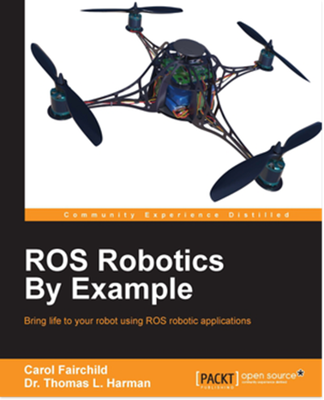

Carol Fairchild and

Dr. Thomas L. Harman   
 Professor and Chair of Engineering Division

 Faculty Senate President 2002-2003   
 Distinguished Professor 2005-2007, 2016-2017

 Member National Electrical Code Panel #2  
University of Houston/Clear Lake   
2700 Bay Area Boulevard   
Houston, TX 77058   
 [harman@uhcl.edu](mailto:harman@uhcl.edu)   
<http://sce.uhcl.edu/harman/>   
Phone: 281 283-3774   
 Fax:   281 283-3870