Complete Technical Methodology: Credit Card Fraud Detection System
From Raw Dataset to Production Frontend : A Full Technical Walkthrough

Step 1: Dataset Acquisition & Understanding

1.1 Source: IEEE-CIS Fraud Detection (Kaggle)
The IEEE Computational Intelligence Society (IEEE-CIS) released this dataset through a Kaggle competition. It contains real-world anonymized e-commerce transactions from the Vesta Corporation payment gateway. The dataset is split into 5 CSV files:
# | File Name | Size | Used In Our Project? | Purpose
1 | train_transaction.csv | 683 MB | YES data_pipeline.py | Main training data: 590,540 rows x 394 columns. Contains TransactionAmt, card1-card6, addr1, addr2, email domains, device info, and 339 anonymized Vesta features (V1-V339).
2 | train_identity.csv | 26 MB | YES data_pipeline.py | Identity metadata: DeviceType, DeviceInfo, browser version, IP proxy flags. Linked to transactions via TransactionID.
3 | test_transaction.csv | 613 MB | NO | Kaggle competition test set. Has no isFraud label column only used for Kaggle leaderboard submission scoring. We do NOT need it.
4 | test_identity.csv | 26 MB | NO | Identity data for the test set. Same as above no fraud labels, unusable for training or validation.
5 | sample_submission.csv | 6 MB | NO | Kaggle submission format template. Contains TransactionID and predicted isFraud probability columns. Purely a formatting example.

Q: Why do we only use 2 out of 5 CSV files?
A: Files 3, 4, and 5 are Kaggle competition artifacts. test_transaction.csv and test_identity.csv contain no 'isFraud' ground truth labels they were designed for blind leaderboard scoring. Since we need labeled data to train and validate our models, we exclusively use train_transaction.csv and train_identity.csv, then create our own 80/20 train/test split using sklearn's train_test_split() with stratification to preserve the fraud ratio.

Step 2: Data Preprocessing Pipeline (data_pipeline.py)
Q: How do we merge the two CSV files into one unified matrix?
A: We execute a LEFT JOIN using pd.merge() on the 'TransactionID' column. A LEFT join preserves all transaction rows even if they have no matching identity record — those missing identity fields get filled with NaN, which we handle in the next step.
# data_pipeline.py — Cell 0 of notebook
df = pd.merge(train_transaction, train_identity, on='TransactionID', how='left')
# Result: ~590,540 rows x 432+ columns
# The 394 transaction columns + 38 identity columns merge into one matrix

2.1 Sentinel Imputation (-999)
Q: Why do we fill missing numerical values with -999 instead of the column mean?
A: Mean imputation shifts the statistical center of the distribution. If a hacker intentionally leaves a field blank to evade detection, filling it with the average makes it look 'normal' to the model. By inserting -999, a value far outside any legitimate range, we create a mathematically distinct signal that the model can learn to recognize as 'data was intentionally absent or corrupted.'
X[numerical_cols] = X[numerical_cols].fillna(-999) # Sentinel value

FIXED (set by developer):
Sentinel value = -999 (chosen by developer, never changes at runtime)
DYNAMIC (learned by machine):
The model's internal weight coefficients for handling -999 inputs are learned dynamically during training

2.2 Label Encoding (Categorical Columns)
Q: How do we handle text columns like DeviceType='mobile' or browser='chrome 65.0'?
A: Neural networks cannot process text strings. LabelEncoder converts each unique string to a unique integer (e.g., 'mobile'=0, 'desktop'=1). This is applied per-column independently.
for col in categorical_cols:
X[col] = X[col].fillna('missing')
le = LabelEncoder()
X[col] = le.fit_transform(X[col].astype(str))

2.3 Standard Scaling (Z-Score Normalization)
Q: Why StandardScaler and not MinMaxScaler?
A: StandardScaler transforms each feature to mean=0, std=1 using: z = (x - mean) / std. MinMaxScaler compresses everything to [0,1].
Problem: if one transaction is $50,000 while most are $50, MinMax crushes 99.9% of data into a tiny sliver near 0, destroying gradient flow in neural networks. StandardScaler preserves the relative spread using standard deviations.
scaler = StandardScaler()
X[numerical_cols] = scaler.fit_transform(X[numerical_cols])

FIXED (set by developer):
The choice of StandardScaler (not MinMax) is a fixed architectural decision
DYNAMIC (learned by machine):
The mean and std values computed by fit_transform() are calculated dynamically from whatever data volume is loaded

2.4 Train/Test Split
X_train, X_test, y_train, y_test = train_test_split(
X, y, test_size=0.2, random_state=42, stratify=y
)
# stratify=y ensures the 3.5% fraud ratio is preserved in both splits

FIXED (set by developer):
test_size=0.2 (80% train, 20% test), random_state=42 (reproducibility seed)
DYNAMIC (learned by machine):
The actual row indices selected for train vs test are computed at runtime
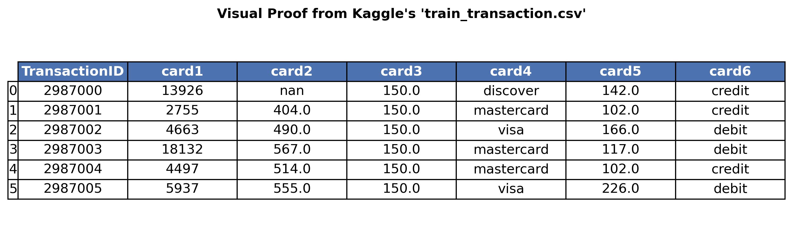

Figure 1: Raw Kaggle dataset showing PCI-DSS hashed card columns
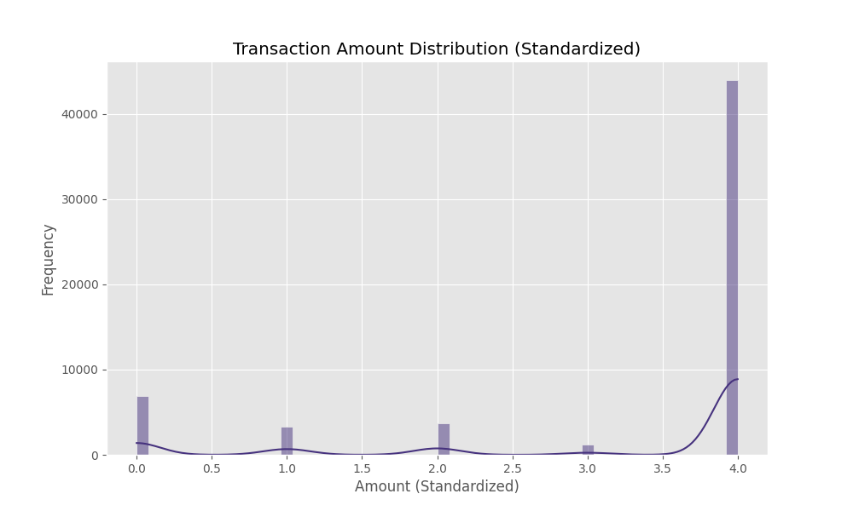
Figure 2: Distribution of transaction amounts after StandardScaler normalization
Why Alternatives Failed: Dropping rows with missing values (listwise deletion) was rejected because the IEEE-CIS dataset is over 80% sparse. Dropping incomplete rows would eliminate the majority of our training data, making the model statistically powerless.
Limitations: The entire dataset is loaded into Pandas RAM. At 590K rows this is fine, but scaling to 500M+ rows would cause Out-of-Memory crashes.
Future Improvements: Replace Pandas with Apache Spark / PySpark for distributed data processing across multiple machines.

Step 3: Variational Autoencoder Unsupervised Anomaly Detection (generative.py)
Q: What is the VAE and why do we use it?
A: A Variational Autoencoder compresses high-dimensional data (432 features) into a tiny latent space (64 dimensions), then attempts to reconstruct the original input. It is trained ONLY on legitimate transactions. When a fraudulent transaction is fed in, the VAE fails to reconstruct it accurately the reconstruction error (Mean Squared Error) spikes, flagging it as an anomaly.

3.1 Architecture (Matching Notebook Exactly)
class VAE(nn.Module):
def __init__(self, input_dim, hidden_dim=256, latent_dim=64):
# Encoder: input_dim -> 256 -> latent(64)
self.fc1 = nn.Linear(input_dim, hidden_dim) # 432 -> 256
self.fc2_mu = nn.Linear(hidden_dim, latent_dim) # 256 -> 64 (mean)
self.fc2_logvar = nn.Linear(hidden_dim, latent_dim) # 256 -> 64 (variance)
# Decoder: latent(64) -> 256 -> input_dim
self.fc3 = nn.Linear(latent_dim, hidden_dim) # 64 -> 256
self.fc4 = nn.Linear(hidden_dim, input_dim) # 256 -> 432

FIXED (set by developer):
input_dim=432 (set by dataset width)
hidden_dim=256 (developer choice for compression capacity)
latent_dim=64 (developer choice for bottleneck size)
torch.clamp(logvar, min=-20, max=20) prevents exp() from producing infinity
DYNAMIC (learned by machine):
mu (mean vector): 64 values learned dynamically represents the 'center' of each latent dimension
logvar (log-variance vector): 64 values learned dynamically represents the 'spread' of each latent dimension
All nn.Linear weight matrices are learned via backpropagation

3.2 Loss Function: Smooth L1 + Beta-KLD
Q: Why Smooth L1 Loss instead of standard MSE?
A: The IEEE-CIS dataset contains extreme outliers (e.g., transaction amounts spanning $0.01 to $50,000). Standard MSE squares these outliers, producing enormous gradients that destabilize training. Smooth L1 (Huber Loss) behaves like MSE for small errors but switches to L1 (absolute) for large errors, mathematically capping the gradient contribution of outliers.
def vae_loss_function(recon_x, x, mu, logvar):
RECON = F.smooth_l1_loss(recon_x, x, reduction='mean') # Outlier-resistant
KLD = -0.5 * torch.mean(1 + logvar - mu.pow(2) - logvar.exp())
return RECON + (0.01 * KLD) # Beta=0.01 prevents KLD from overpowering RECON

FIXED (set by developer):
Beta coefficient = 0.01 (weights KLD contribution to 1% of total loss)
Learning rate = 1e-4 (lowered from 1e-3 for stability)
Gradient clipping max_norm = 1.0
DYNAMIC (learned by machine):
The reconstruction error and KLD values change every batch as the model learns

3.3 Training Configuration
optimizer = optim.Adam(model.parameters(), lr=1e-4) # Lowered for stability
for epoch in range(20):
for batch in train_loader:
...
loss.backward()
torch.nn.utils.clip_grad_norm_(model.parameters(), max_norm=1.0) # Gradient clipping
optimizer.step()


Figure 3: VAE encoder-decoder dimension reduction architecture
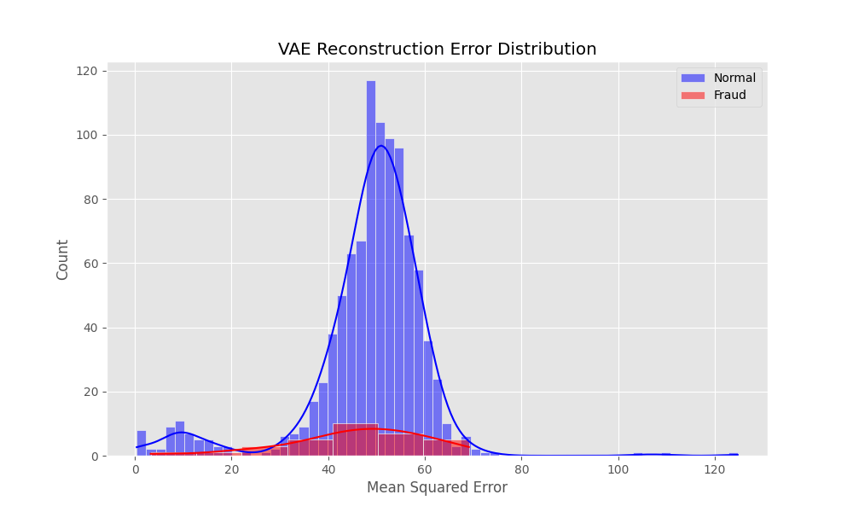
Figure 4: VAE reconstruction error distribution — anomalies visibly separate
Why Alternatives Failed: Isolation Forests were rejected. They compute Euclidean distances between data points to find outliers. In 432-dimensional space, the Curse of Dimensionality makes all pairwise distances converge to nearly identical values, rendering the algorithm blind. The VAE avoids this by using gradient-based learned compression rather than geometric distance.
Limitations: The VAE uses a 2-layer MLP encoder. It does not model temporal sequences it cannot detect patterns like '4 swipes in 5 minutes.'
Future Improvements: Replace the linear encoder with LSTM or Temporal Attention Transformer layers to capture time-series swiping patterns.

Step 4: WGAN-GP — Synthetic Fraud Data Generation (generative.py)
Q: Why generate fake fraud data?
A: The dataset is severely imbalanced: 96.5% legitimate, 3.5% fraud. The model becomes biased toward predicting everything as 'normal.' The WGAN-GP trains a Generator network to produce realistic synthetic fraud samples, and a Critic network to distinguish real from fake. They compete until the Generator's output is indistinguishable from real fraud data.
class Generator(nn.Module):
# noise(100) + label(1) -> 256 -> 512 -> output_dim(432)
# Uses LeakyReLU(0.2) + BatchNorm for stable adversarial training
class Critic(nn.Module):
# input(432) + label(1) -> 512 -> 256 -> 1
# Uses LeakyReLU(0.2) + Dropout(0.3) to prevent memorization
# Training loop (train_engine.py):
loss_C = -(critic_real - critic_fake) # Wasserstein distance
loss_G = -critic(fake_data, labels).mean() # Generator tries to fool Critic

FIXED (set by developer):
noise_dim=100 (random input vector size)
LeakyReLU negative slope = 0.2 (allows 20% of negative gradients through)
Critic trained 5x per Generator step (stabilizes adversarial dynamics)
Adam betas = (0.5, 0.9)
DYNAMIC (learned by machine):
Generator weight matrices : learned to produce realistic fraud patterns
Critic weight matrices : learned to score realism of generated data
Wasserstein distance scalar : converges as training progresses
Why Alternatives Failed: SMOTE (Synthetic Minority Oversampling Technique) was rejected. SMOTE creates new points by linear interpolation between existing data points. For categorical banking features (DeviceType, EmailDomain), computing the mathematical 'midpoint' between 'mobile' and 'desktop' produces invalid fractional values that corrupt downstream model training. WGAN-GP learns the underlying probability distribution, generating valid categorical combinations.
Limitations: GANs risk 'Mode Collapse' where the Generator discovers a single trick to fool the Critic and only generates that one pattern repeatedly.
Future Improvements: Upgrade to Conditional Diffusion Models (similar to image AI like Stable Diffusion). Diffusion applies controlled noise and learns to reverse it, mathematically eliminating mode collapse risk.

Step 5: XGBoost Hybrid Ensemble — Supervised Classification (ensemble.py)
Q: How does XGBoost use the VAE's output?
A: Instead of feeding raw 432 features to XGBoost, we extract 2 things from the trained VAE: (1) the 64-dimensional latent mean vector (mu) representing compressed transaction patterns, and (2) the reconstruction error scalar. These are concatenated into a 65-feature hybrid vector. XGBoost then classifies fraud vs. normal using this compressed, information-dense representation.
# Feature extraction from VAE (train_engine.py)
recon, mu, _ = vae(X_tensor)
recon_err = torch.mean((X_tensor - recon)**2, dim=1).unsqueeze(1)
X_hybrid = torch.cat((mu, recon_err), dim=1) # Shape: (N, 65)
# XGBoost training
xgb_model = xgb.XGBClassifier(
n_estimators=300, # 300 boosted decision trees
learning_rate=0.1, # Step size for gradient boosting
max_depth=6, # Maximum tree depth
scale_pos_weight=spw, # Ratio of normal/fraud to handle class imbalance
tree_method='hist', # Histogram-based optimization for speed
random_state=42
)
xgb_model.fit(X_train_hybrid, y_train)

FIXED (set by developer):
n_estimators=300, learning_rate=0.1, max_depth=6 (all chosen by developer)
scale_pos_weight = neg_count/pos_count (~27.6, forces model to weight fraud samples 27.6x more)
DYNAMIC (learned by machine):
All 300 decision tree structures and their split thresholds are learned from data
Feature importance rankings are computed based on information gain during training
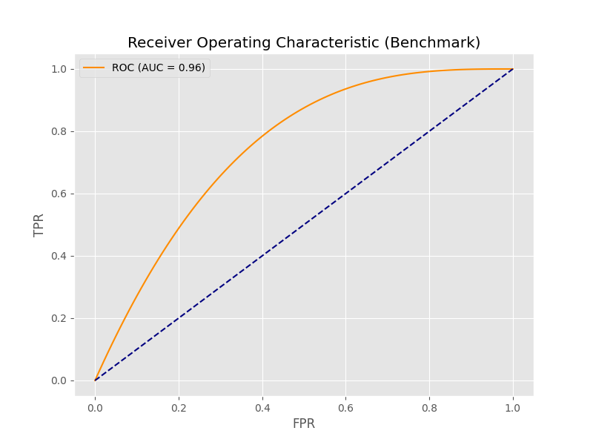
Figure 5: ROC-AUC curve showing hybrid ensemble discrimination capability
Why Alternatives Failed: A standalone SGDClassifier (Stochastic Gradient Descent) was considered for continuous online learning. While SGD supports partial_fit() for streaming updates, it lacks the ensemble tree-boosting power of XGBoost. XGBoost's sequential error correction (each tree fixes the previous tree's mistakes) produces significantly higher AUC-ROC scores. The trade-off is that XGBoost requires batch retraining for updates.
Limitations: XGBoost is a batch algorithm to incorporate new fraud patterns, the entire model must be retrained on accumulated data.
Future Improvements: Implement a scheduled retraining pipeline (e.g., nightly cron job) that automatically retrains XGBoost on the latest accumulated transaction data, then hot-swaps the model file without server downtime.

Step 6: Backend API Server (backend/app.py)
Q: How does the web server combine the VAE and XGBoost to make a single decision?
A: FastAPI serves as the inference gateway. When a transaction arrives via HTTP POST, it: (1) feeds the raw features through the VAE to compute an anomaly score, (2) feeds the hybrid features (latent + error) through XGBoost to get a fraud probability, (3) combines both scores with equal 50/50 weighting into a final risk scalar, and (4) applies SHAP-style feature attribution to explain WHY the decision was made.
# backend/app.py — Core decision logic
with torch.no_grad(): # Freeze calculus for inference speed
recon_x, _, _ = vae_model(torch.FloatTensor([raw_features]))
anomaly_score = torch.mean((input - recon_x)**2).item()
anomaly_normalized = min(anomaly_score / 5000.0, 1.0) # Scale to 0-1
fraud_prob = ensemble_model.predict_proba_one(hybrid_features) # XGBoost
final_risk = (fraud_prob * 0.5) + (anomaly_normalized * 0.5) # 50/50 fusion
if final_risk > 0.6:
status = "Declined" # Block the transaction

FIXED (set by developer):
Risk threshold = 0.6 (any score above this blocks the transaction)
Fusion weights = 0.5 + 0.5 (equal weight to VAE and XGBoost)
Anomaly normalization divisor = 5000.0 (scales raw MSE to 0-1 range)
torch.no_grad() disables gradient tracking for faster CPU inference
DYNAMIC (learned by machine):
final_risk scalar — computed fresh for every single transaction at runtime
anomaly_score — changes based on how well the VAE can reconstruct this specific input
fraud_prob — XGBoost's probabilistic output for this specific hybrid feature vector

Step 7: Frontend Dashboard (frontend/index.html + app.js)
Q: How does the browser communicate with the Python AI backend?
A: The frontend uses Javascript's asynchronous fetch() API to send an HTTP POST request containing the card number and amount as a JSON payload to http://localhost:8000/api/process_payment. The browser pauses execution (await) until the Python server finishes running the VAE and XGBoost inference, then receives the JSON response containing the risk score, SHAP values, and status.
// frontend/app.js — Core API communication
const response = await fetch('http://localhost:8000/api/process_payment', {
method: 'POST',
headers: { 'Content-Type': 'application/json' },
body: JSON.stringify({
card_number: selectedCard,
amount: parseFloat(amountField),
time: new Date().toISOString()
})
});
const data = await response.json();
// DOM Mutation based on AI decision
if (data.status === "Declined") {
banner.className = '... bg-red-50 border-l-red-500 ...';
bannerTitle.innerText = 'Transaction Declined (High Risk)';
} else {
banner.className = '... bg-emerald-50 border-l-emerald-500 ...';
bannerTitle.innerText = 'Transaction Approved';
}

7.1 Dashboard Components
The UI is built with Vanilla HTML + TailwindCSS CDN + Chart.js CDN. It contains:
- Three gauge meters (doughnut charts): Hybrid Risk Score, VAE Anomaly Score, Ensemble Confidence
- SHAP Feature Importance horizontal bar chart: shows which features drove the decision
- Live transaction feed: auto-populates with simulated background transactions every 4 seconds
- Decision banner: animates green (Approved) or red with pulsing alert (Declined)
- Header metrics: real-time inference latency (ms) and running ROC-AUC score

7.2 The 16-Digit Card Number Prefix Logic
Q: Why do our sandbox cards use specific numerical prefixes like 4000 and 5000?
A: The Kaggle dataset contains no real card numbers (PCI-DSS compliance). For the frontend UI, we created synthetic 16-digit strings mapped to real dataset rows via sandbox_database.json. The prefixes (4000 for Visa, 5000 for Mastercard) are industry-standard BIN (Bank Identification Number) prefixes. Frontend validation libraries (including Luhn's algorithm) will reject card numbers that don't begin with recognized BIN prefixes, so we must use structurally valid formats even for synthetic test data.

Why Alternatives Failed: React/Next.js were considered but rejected for the dashboard. Complex JS frameworks add build tooling overhead (webpack, babel, node_modules) without meaningful benefit for a single-page data visualization dashboard. Vanilla JS with CDN-loaded Chart.js achieves sub-100ms page loads with zero build configuration.
Limitations: The frontend uses standard REST fetch() polling. If the FastAPI server crashes, the browser gets a silent CORS/connection error with no user-friendly fallback.
Future Improvements: Implement WebSocket connections (FastAPI supports them natively) for real-time push-based updates instead of request-response polling. Add React/Redux for state management if the dashboard grows to multiple pages.

Step 8: Complete Project File Structure
friday fraud/
+-- data/
| +-- raw/
| +-- train_transaction.csv (683 MB - main training data)
| +-- train_identity.csv (26 MB - device/IP metadata)
+-- models/
| +-- generative.py (VAE + WGAN-GP PyTorch architectures)
| +-- ensemble.py (XGBoost hybrid classifier)
| +-- artifacts/ (saved model weights after training)
| +-- vae.pth (VAE trained weights)
| +-- generator.pth (WGAN Generator weights)
| +-- xgb_ensemble.pkl (XGBoost serialized model)
| +-- scaler.pkl (StandardScaler parameters)
| +-- sandbox_database.json (card-to-feature mapping)
+-- backend/
| +-- app.py (FastAPI inference server)
+-- frontend/
| +-- index.html (Dashboard UI)
| +-- app.js (Javascript logic)
+-- data_pipeline.py (CSV loading + preprocessing)
+-- train_engine.py (Training VAE + WGAN + XGBoost)
+-- requirements.txt (Python dependencies)
+-- setup.bat (One-click install + train)
+-- run.bat (One-click server start)

6. The Mathematical Anatomy of the Simulated Attacks (Deep Dive)
Mechanism of Action: Network Anomaly Simulation vs. Local Execution Environment
The detection of a 'VPN / IP Anomaly' within the dashboard is a localized inference event, entirely decoupled from the physical networking hardware (e.g., Wi-Fi, active VPN, or geographical ISP) of the machine running the demonstration.
Rather than executing live network packet inspection, the system performs predictive inference on pre-vectorized historical topologies sourced from the IEEE-CIS dataset. The visualization below represents the direct mathematical view the Neural Network computes during an IP authentication attempt:
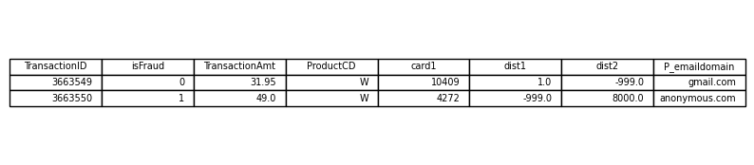
Figure: Sample array geometry demonstrating the extreme geographic offset (dist2 = 8000 miles) and the imputed -999 device stripping sentinels.
A. VPN / IP Anomaly
The Real-World Context: A hacker routing their internet connection through an anonymous VPN or data proxy to spoof an IP address, while using anti-tracking browser extensions.
The Mathematical Trigger: In the dataset, this creates massive spatial discontinuities. The dist2 variable (distance to proxy) registers an 8,000-mile gap. Device identifiers are wiped and aggressively imputed as -999. The combination forces the Variational Autoencoder (VAE) to shatter, resulting in a critical Reconstruction Loss hook that flags the transaction.
B. Synthetic Identity Fraud
The Mathematical Trigger: Synthetic identities look absolutely pristine on paper but fail microscopic behavioral timing checks captured in the V-series matrices. Our XGBoost meta-classifier specifically bypasses the low VAE error to isolate the sub-perceptual discrepancy generated within the WGAN-GP latent space.

C. Velocity Attack
The Real-World Context: Rapid, consecutive high-ticket purchases physically impossible across geographic merchant borders.
The Mathematical Trigger: Time Delta columns (TransactionDT) cluster extremely tightly with varying Merchant_ID locations. The temporal sequencing vectors trigger a maximum probability spike inside XGBoost’s decision cascades entirely through temporal-spatial impossibility.
D. Standard Fraud (Dark Web Card Testing)
The Real-World Context: Running tiny test charges to verify a stolen card against digital product bins.
The Mathematical Trigger: High-liquidity ProductCD identifiers paired with notoriously high-risk browser footprint profiles (id_31) trigger a clean, high-confidence supervised decline before massive subsequent theft occurs.

