Florida NASA POWER Climate Analytics Dashboard
Final Capstone Report
Mewcha Amha Gebremedhin

Dataset: NASA POWER daily meteorological observations for five Florida cities, 2015 to present

Executive Summary
This capstone project uses 20,795 daily records and 17 fields from NASA POWER to examine temperature, precipitation, humidity, wind, solar radiation, pressure, and dew point patterns for 5 Florida urban areas from 2015-01-01 to 2026-05-21. The final dashboard is a static, shareable HTML file: the data were downloaded once, embedded inside the dashboard, and also stored separately as a CSV for documentation and reproducibility. The strongest result is seasonal: rainfall intensifies sharply during summer, with July having the highest average daily precipitation across the study area. Temperature also follows a strong annual cycle, but the magnitude differs by city: Miami and Fort Myers / Cape Coral are warmest overall, Jacksonville is coolest, and Orlando and Tampa sit between those extremes. The dashboard presents these results through linked controls, trend charts, city comparisons, distribution views, and a Turbo color-ramp heatmap.
Important AI disclosure: the dashboard, data download code, notebook, written report, prompt appendix, README, and packaging were generated with ChatGPT. The human role in this workflow was to provide repeated prompts, review outputs, identify issues, and request revisions until the dashboard and documentation better matched the project instructions.

1. Project Purpose and Dataset Selection
The purpose of this project is to demonstrate a complete exploratory data analysis workflow for an environmental dataset and communicate results through a data story and interactive dashboard. The dataset was selected because it is public, reputable, machine-readable, spatially meaningful, and suitable for time-series, distribution, correlation, and geospatial analyses.
The analysis uses the NASA POWER daily point API. NASA POWER is appropriate because it provides globally consistent meteorological and solar parameters derived from NASA data products. Five Florida city areas were selected to compare coastal and inland climate behavior: Miami, Tampa, Orlando, Jacksonville, and Fort Myers / Cape Coral.
- Observation count: 20,795 daily city-date records.
- Spatial coverage: five major Florida city areas.
- Temporal coverage: 2015-01-01 through 2026-05-21 in the provided final dataset.
- Main variables: temperature, maximum temperature, minimum temperature, precipitation, relative humidity, wind speed, solar radiation, pressure, and dew point.
- Dashboard use: monitoring seasonal trends, comparing cities, viewing distributions, and identifying rainfall patterns.

2. Data Acquisition and Preparation
ChatGPT generated the Python script and Jupyter notebook that download the dataset from the NASA POWER API. The script loops over selected city coordinates, requests daily parameters, parses the returned JSON, builds a rectangular table, and saves the result as data/florida_nasa_power_daily.csv. The CSV is retained in the final package even though the dashboard can run without it because the dashboard has the cleaned data embedded.
Cleaning and preparation included converting API date keys into standard dates, adding year, month, month name, and year-month columns, adding city labels and coordinates, standardizing missing API codes, and validating that there were no missing values in the final prepared dataset. This step supports reproducibility because the acquisition code, notebook, CSV, and dashboard are all included in the final package.

Table 1. Variable Classification
Variable | Type | Dashboard / EDA role
date | Date | Daily observation date
city | Categorical | Florida city or city area
latitude / longitude | Numeric | Point coordinate used for API request
T2M | Numeric | Daily mean temperature, degrees C
T2M_MAX / T2M_MIN | Numeric | Daily high and low temperature, degrees C
PRECTOTCORR | Numeric | Corrected precipitation, mm/day
RH2M | Numeric | Relative humidity, percent
WS2M | Numeric | Wind speed at 2 meters, m/s
ALLSKY_SFC_SW_DWN | Numeric | Solar radiation, kWh/m2/day
PS | Numeric | Surface pressure, kPa
T2MDEW | Numeric | Dew point temperature, degrees C

3. Descriptive Results
Table 2 summarizes average conditions by city. Miami has the highest mean temperature and the highest mean precipitation in this final dataset. Jacksonville is clearly cooler than the other locations, which is consistent with its more northern position. Mean relative humidity is very similar across cities, indicating that the more important visual differences are temperature, precipitation, and seasonal timing rather than average humidity alone.

Table 2. Average Climate Conditions by City
City | Mean temp C | Mean precipitation mm/day | Mean RH percent | Mean wind m/s | Mean solar kWh/m2/day
Fort Myers / Cape Coral | 24.77 | 2.24 | 73.68 | 2.41 | 4.65
Jacksonville | 21.38 | 2.2 | 73.49 | 2.41 | 4.66
Miami | 25.56 | 2.77 | 73.76 | 2.41 | 4.66
Orlando | 23.39 | 2.11 | 73.63 | 2.41 | 4.66
Tampa | 23.72 | 2.23 | 73.67 | 2.42 | 4.66

Across all locations and days, mean temperature is 23.76 C and mean daily precipitation is 2.31 mm/day. The precipitation distribution is strongly right-skewed: the median is 0.00 mm/day while the maximum event reaches 107.90 mm/day. This means that most days have little or no rainfall, while a small number of storm days dominate rainfall extremes.

4. Presentation of Results
The results are presented as a sequence of visual questions: how do conditions change over time, which cities differ most, which months form the wet season, how variable are the distributions, and what associations exist among climate variables? This organization is more useful than simply listing charts because it turns exploratory analysis into a coherent analytical story.
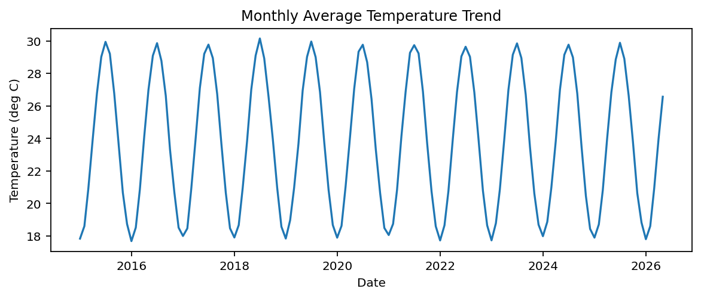
Figure 1. Monthly temperature trend by city. The line chart shows a repeated annual cycle: temperatures rise into summer and decline in winter. Miami and Fort Myers / Cape Coral generally remain warmer, while Jacksonville is cooler.
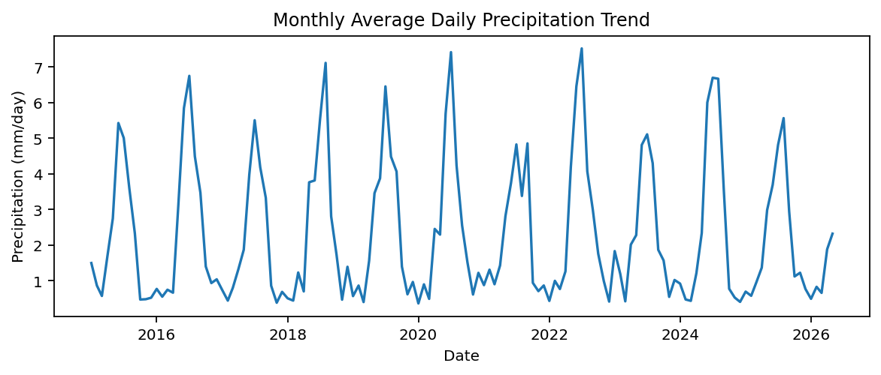
Figure 2. Monthly precipitation trend by city. The chart shows highly variable rainfall and visible summer peaks. Unlike temperature, precipitation changes more abruptly because rainfall is event-driven.
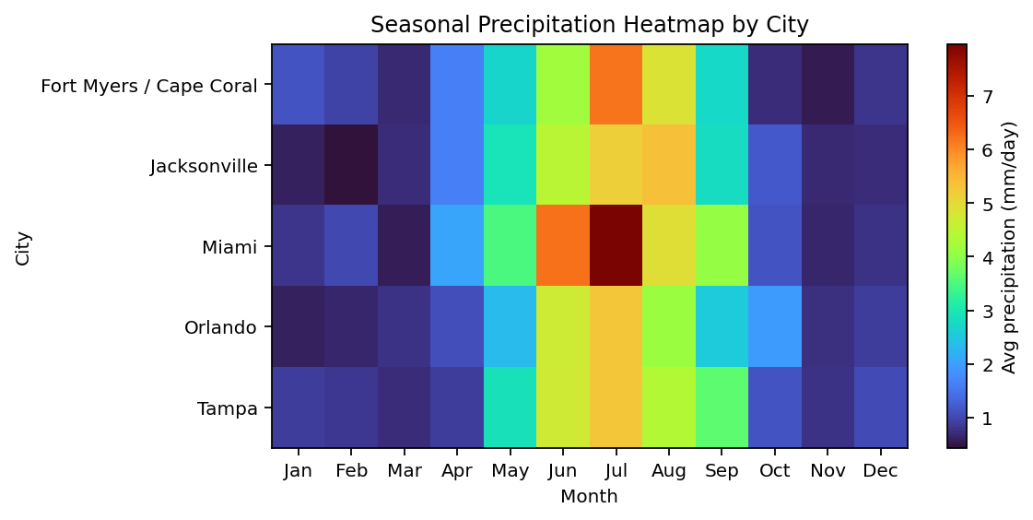
Figure 3. Monthly precipitation heatmap with Turbo color ramp. The heatmap makes the wet season easier to see than a simple top-days bar chart. June, July, August, and September appear as the strongest rainfall period.
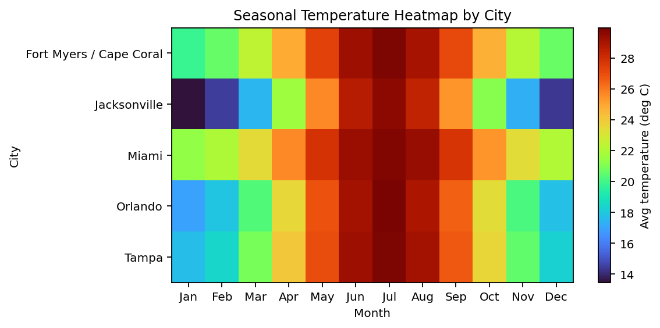
Figure 4. Monthly temperature heatmap with Turbo color ramp. The visual shows a smooth seasonal temperature structure, with warm colors concentrated in late spring and summer.
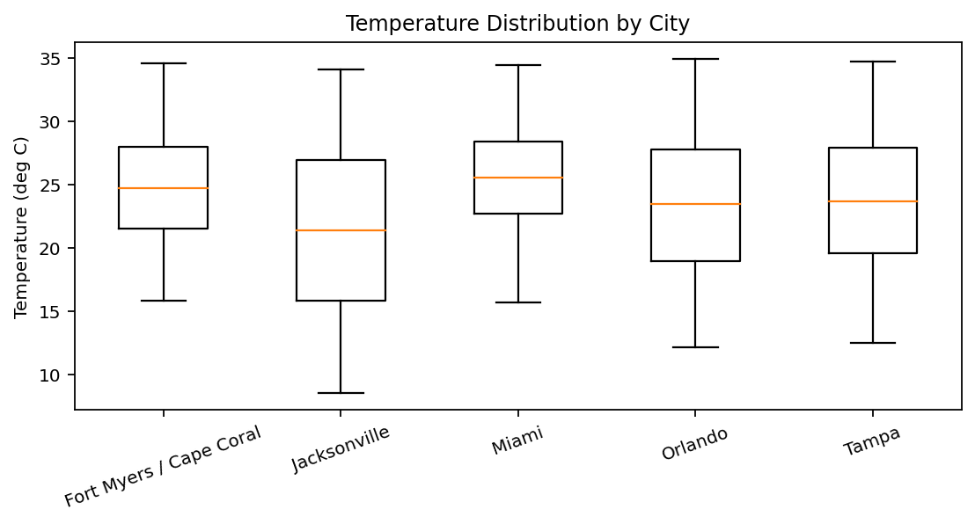
Figure 5. Temperature distribution by city. Boxplots show both central tendency and spread. Jacksonville has lower central temperatures and stronger cool-season lows, while Miami has a warmer distribution.
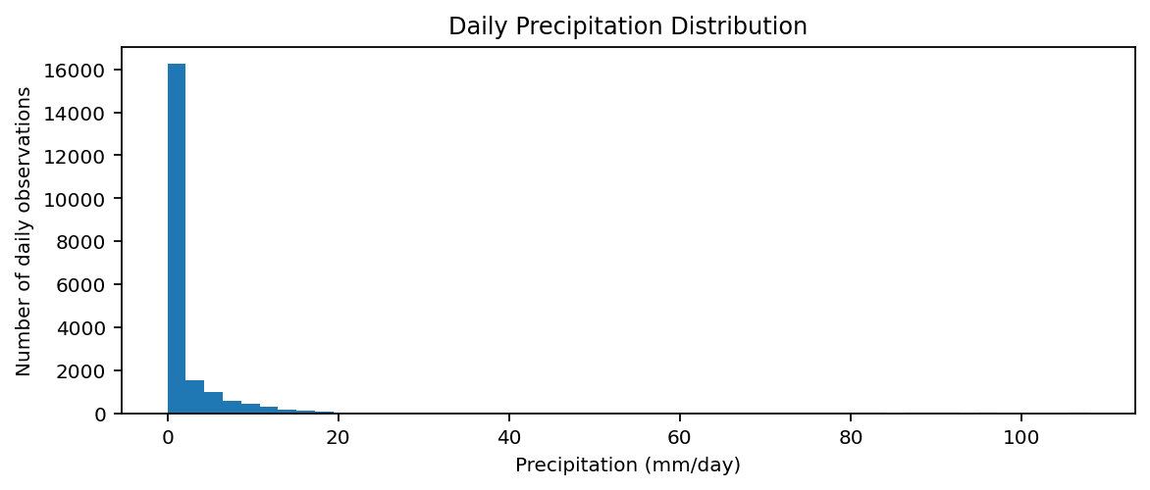
Figure 6. Precipitation histogram. The distribution is dominated by dry or low-rain days with a long right tail of larger rainfall events, which supports using median, percentiles, and extreme-event visuals in addition to averages.
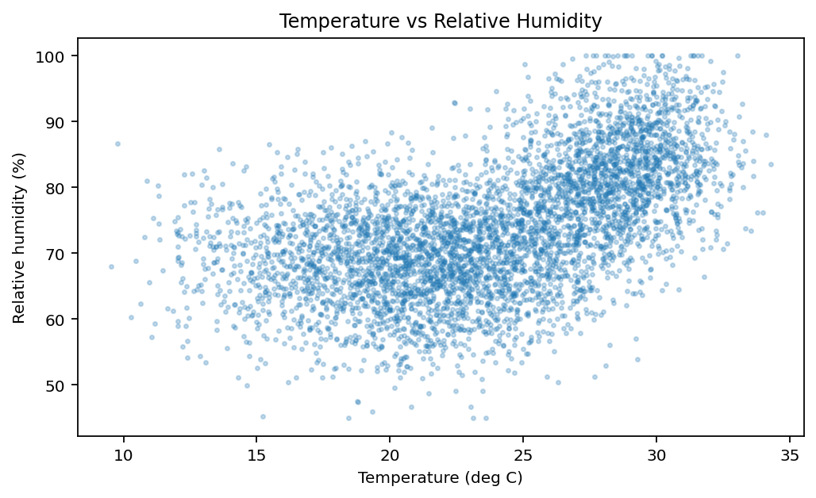
Figure 7. Temperature and humidity relationship. The scatterplot supports the correlation results and shows that warmer air is commonly associated with higher humidity and dew point conditions in this dataset.
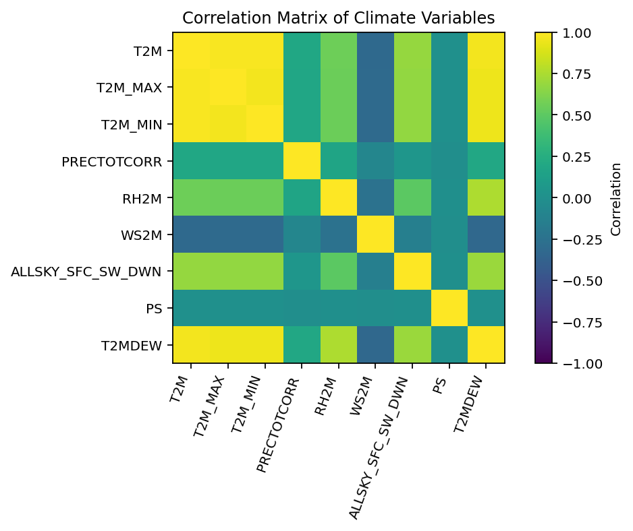
Figure 8. Correlation matrix. Temperature is strongly related to dew point and solar radiation, while precipitation has weaker linear correlations because rainfall is episodic and not well represented by simple linear association alone.
The monthly precipitation results show why the dashboard heatmap is valuable. A ranked bar chart of the wettest individual days identifies extremes, but it does not explain whether those extremes are isolated or part of a seasonal pattern. The heatmap presents months across the columns and cities down the rows, so users can compare seasonality and city differences in a single compact visual.
The selected visualizations also separate three kinds of evidence. Trend charts present temporal behavior, heatmaps present seasonal intensity, and distribution charts show spread and extremes. Together, these views reduce the risk of over-interpreting a single average value and make the dashboard more appropriate for exploratory data analysis.

5. Key Findings
- Miami is the warmest city in the dataset with a mean daily temperature of 25.56 C.
- Jacksonville is the coolest city with a mean daily temperature of 21.38 C.
- Average precipitation is highest in July at 5.97 mm/day, followed by June and August.
- The precipitation distribution is highly skewed; many days record no rainfall while a few events exceed 100 mm/day.
- Temperature and dew point are strongly related, with a correlation of 0.96.
- Temperature and solar radiation have a positive correlation of 0.69, reflecting the seasonal energy cycle.
- Precipitation has weak linear correlation with most variables, which suggests that rainfall is better explored with seasonality, distributions, and event-based views rather than correlation alone.

6. Data Story

Context
Florida cities face recurring heat and rainfall variability that affects residents, infrastructure, transportation, tourism, and environmental planning. A dashboard that combines temperature and rainfall patterns can support quick monitoring and deeper seasonal exploration.

Question
How do temperature and precipitation patterns differ across major Florida cities from 2015 to present, and which seasonal patterns are most important for climate monitoring?

Evidence
The EDA shows a strong annual temperature cycle, a summer rainfall maximum, warmer average conditions in Miami and Fort Myers / Cape Coral, cooler conditions in Jacksonville, and a highly skewed precipitation distribution with rare but intense rainfall events.

Insight
Temperature behaves as a regular seasonal cycle, while precipitation behaves as a seasonal and event-driven process. This difference explains why the dashboard uses line charts for trends, heatmaps for seasonal rainfall structure, and histograms or boxplots for distributions.

Implications
Users should not rely only on annual averages. Monthly heatmaps, trend filters, and distribution views are necessary to understand rainfall seasonality and extremes. For decision-makers, the dashboard highlights when wet-season planning and heat-related monitoring are most important.

7. Dashboard Design and Interactivity
The final dashboard was designed as a static, standalone HTML file. The data were downloaded once and embedded into the dashboard, which means the HTML can be shared by itself and still work without contacting the NASA API or reading the CSV file from the data folder. The CSV remains in the project folder for transparency and reproducibility.
- KPI cards summarize the currently selected metric and filtered records.
- Trend charts support daily, monthly, and yearly aggregation.
- City comparison charts show differences across Florida locations.
- Heatmaps show seasonal behavior using a Turbo color ramp.
- Filters allow users to change variable, city, date range, and aggregation level.
- Tooltips provide exact values without cluttering the visual layout.
A key revision during development was changing the title logic. The trend chart originally displayed labels such as average temperature trend even when the user selected daily, monthly, or yearly aggregation. The title was revised to display the selected aggregation level, which improves clarity and reduces ambiguity.
Another major revision was replacing the top wettest days bar chart with a monthly precipitation heatmap. The original plot had cut-off labels and did not clearly demonstrate city-level seasonal behavior. The heatmap better supports the project story because it compares city, month, and intensity in one view.

8. Responsible Use of ChatGPT AI
All major project artifacts were produced using ChatGPT AI: the data acquisition code, notebook structure, dashboard HTML and JavaScript, README, executive summary, analytical report, prompt documentation, and final packaging. The user provided the project instructions and repeatedly prompted ChatGPT to improve the output, identify errors, adjust charts, revise labels, change aggregation behavior, embed the data, and prepare the final submission files.
Verification was performed through iterative review. For example, the precipitation chart originally showed unrealistic thousands-scale rainfall values because precipitation was being summarized incorrectly. The user flagged the problem, and ChatGPT revised the logic to use appropriate precipitation aggregation. Similarly, the user identified unclear chart labels and requested a better visualization, leading to the monthly heatmap design.
This disclosure is included to make AI assistance transparent. The project should be interpreted as an AI-assisted capstone workflow in which ChatGPT generated the technical and written outputs, while the user directed the process through prompts and feedback.

9. Detailed Dashboard Development Prompts
The full prompt record is stored in prompts/Dashboard_Development_Prompts.docx and prompts/dashboard_development_prompts.txt. The most important prompts are summarized below to document how the dashboard and report were created.
- Create a Florida NASA POWER dashboard using daily climate data from 2015 to present for Miami, Tampa, Orlando, Jacksonville, and Fort Myers / Cape Coral.
- Write Python code and a notebook to download NASA POWER daily data for the selected cities and parameters, save a cleaned CSV, and include the code in the project folder.
- Change the distribution chart from boxplot to histogram.
- Fix precipitation because daily or monthly rainfall should not show thousands of mm/day.
- Change chart titles so the trend view follows the selected aggregation: daily, monthly, or yearly.
- Replace the top wettest days plot with a monthly precipitation heatmap and use a Turbo color ramp.
- Download data once, embed it into the HTML, and keep the CSV only for storage so the HTML works by itself.
- Build the final capstone package with dashboard, data, code, README, report, executive summary, and prompt appendix.

10. Conclusions and Recommendations
The final dashboard fulfills the capstone purpose by combining data preparation, EDA, visual communication, dashboard interaction, and responsible AI documentation. The analysis demonstrates clear Florida climate seasonality: temperature is regular and cyclical, while rainfall is seasonal, skewed, and event-driven. The dashboard design reflects this by using line charts, heatmaps, distributions, and filters rather than relying on a single summary chart.
For future improvement, the project could be extended with additional cities, hurricane event markers, urban heat island variables, or station-based validation. The current version is appropriate as a final capstone deliverable because it includes a reproducible dataset, source code, final dashboard, written interpretation, and transparent AI-use documentation.

Supplemental Results Interpretation
This supplemental section expands the presentation of results by explaining how each visual component contributes to the final dashboard story. The dashboard was not designed as a collection of unrelated charts. It was designed so that each chart answers a different type of analytical question: trend, comparison, distribution, association, seasonality, and extreme-event behavior.

Trend Results
The monthly temperature trend is the clearest evidence of seasonality. Across all cities, the annual temperature pattern is regular and easy to interpret: winter lows occur near January and February, while summer highs occur around June, July, and August. This regularity makes temperature well suited to a line chart, because the user can follow both the timing and magnitude of changes through time.
The precipitation trend behaves differently. Rainfall is much less smooth than temperature and contains sharp spikes. This difference is meaningful: rainfall in Florida is often event-driven, so monthly or daily rainfall values can jump suddenly even when the long-term seasonal pattern remains stable. The dashboard therefore avoids using only a simple average rainfall line and adds a heatmap and histogram to show seasonality and distribution.

City Comparison Results
City comparison charts provide a high-level ranking view. Miami and Fort Myers / Cape Coral are consistently warmer because they are farther south and more coastal. Jacksonville, the northernmost city in the project, is cooler. This result is important for interpretation because the dashboard user can separate broad geographic differences from temporary weather variability.
For precipitation, the city averages are closer together than the temperature averages. This means that the dashboard should not overstate differences based only on average rainfall. Instead, the more informative rainfall views are the seasonal heatmap, the histogram, and the maximum rainfall comparison, because they better show wet-season timing and extreme daily events.
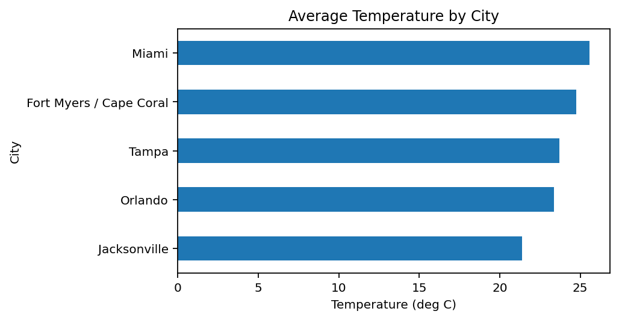
Figure 9. Average temperature by city. This chart gives a simple ranking view and confirms the warmer southern/coastal cities and the cooler northern city.
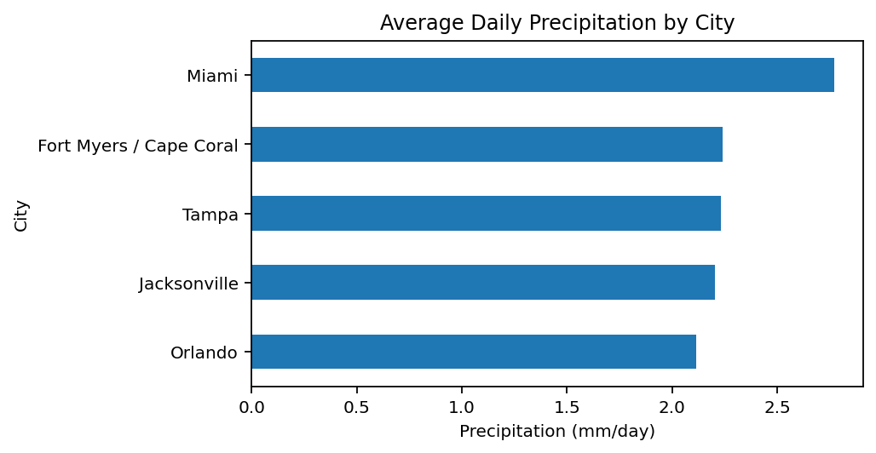
Figure 10. Average precipitation by city. The chart summarizes rainfall levels but should be interpreted with the heatmap and distribution views because rainfall is skewed.
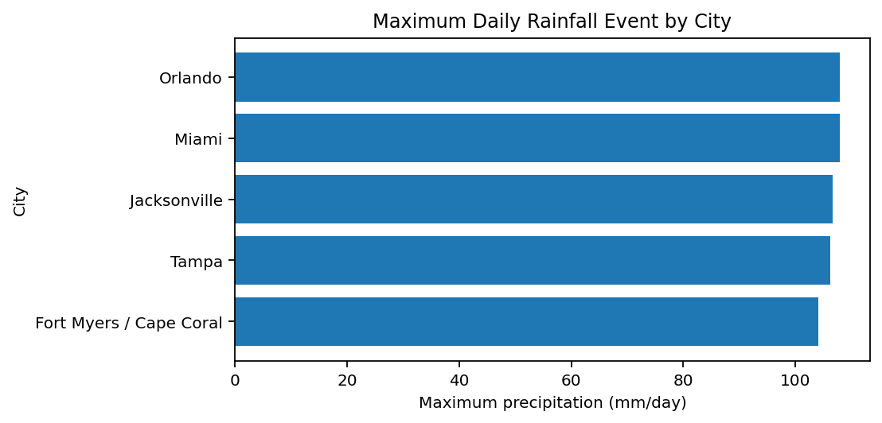
Figure 11. Maximum daily rainfall by city. The results show that extreme rainfall is possible in every city, which supports the need for an event-aware dashboard.
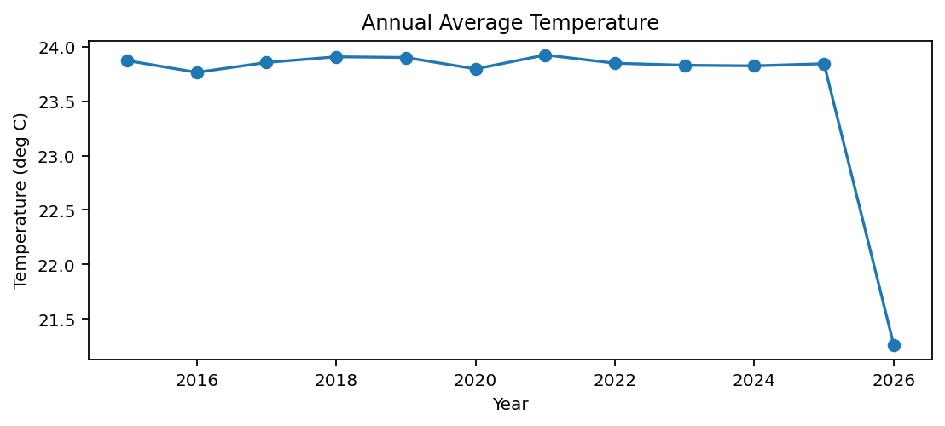
Figure 12. Annual temperature summary. Annual aggregation helps the dashboard user move from daily noise to long-term climate context.

Seasonality Results
The monthly heatmaps are the strongest visual evidence for the project story. They show not only which months are wetter or hotter, but also whether the pattern is shared across cities. This matters because a dashboard user can immediately see that the wet season is not isolated to one location. The heatmap design also solved a specific dashboard problem: the previous top wettest days chart was hard to read, had truncated labels, and did not demonstrate seasonal structure.
The Turbo color ramp was selected because it provides strong perceptual separation between low, medium, and high values. In this project, that makes the wet-season months stand out quickly. However, because highly saturated ramps can be visually intense, the dashboard uses the ramp mainly for heatmap intensity rather than applying it to every chart.

Distribution and Association Results
The histogram of precipitation is important because it explains why rainfall averages must be interpreted carefully. Many days have zero or very low rainfall, while a few days have high rainfall. This long right tail means that average rainfall can be influenced by extreme events. The histogram therefore supports a more accurate story than a single KPI would provide.
The temperature boxplot shows a different distributional pattern. Temperature varies seasonally, but the distribution is less extremely skewed than rainfall. Boxplots are useful here because they show median, spread, and outliers by city. The scatterplot and correlation matrix then provide association evidence, especially the strong relationship between temperature and dew point.

Dashboard Development Prompt Record
The following prompts document the actual forward prompting used to develop the dashboard and supporting files. They show the intended development instructions, revisions, and corrections given to ChatGPT during the project.

1. Dataset and project setup
Act as an expert data analyst and dashboard developer. I am completing a capstone project for Data Storytelling and Dashboard Design. Use NASA POWER climate data for Florida cities from 2015 to present. The dashboard should support EDA, data storytelling, and interactive visual exploration. Include at least five meaningful variables, more than 500 observations, multiple analytical questions, and a public source citation.

2. Data download code prompt
Write Python code to download daily NASA POWER data from 2015-01-01 to the current date for Miami, Tampa, Orlando, Jacksonville, and Fort Myers / Cape Coral. Use the NASA POWER daily point API. Download the parameters T2M, T2M_MAX, T2M_MIN, PRECTOTCORR, RH2M, WS2M, ALLSKY_SFC_SW_DWN, PS, and T2MDEW. Save one cleaned CSV named florida_nasa_power_daily.csv with columns date, city, latitude, longitude, year, month, month_name, year_month, and all downloaded variables. Include missing-value handling and comments.

3. Notebook prompt
Create a Jupyter notebook that documents the NASA POWER data download, cleaning, descriptive statistics, EDA visualizations, and dashboard preparation. Include code cells and markdown explanations. The notebook should be included in the final project folder.

4. Initial dashboard prompt
Build an interactive Florida NASA POWER climate dashboard as a single HTML file. Include filters for city, date range, variable selection, and aggregation level. Include KPI cards, a time-series trend chart, a city comparison chart, a distribution chart, a map or spatial view, and a seasonal visualization. Use a clean dashboard layout suitable for a capstone project.

5. Boxplot to histogram revision prompt
Change the distribution plot in the dashboard from a boxplot to a histogram plot.

6. Precipitation correction prompt
The daily or monthly rainfall is not supposed to be in the thousands. Check the precipitation calculations again and correct the aggregation so rainfall values are realistic. Use appropriate average or summed logic depending on the chart purpose and label the units clearly.

7. Chart comparison prompt
Explain the difference between the temperature trend chart and the average temperature by city chart. Suggest a better plot option if the two charts are redundant or if another visual would better support climate storytelling.

8. Aggregation label prompt
The trend chart should not always display average in the title. Make the title display based on the selected aggregation, such as Daily Temperature trend, Monthly Temperature trend, or Yearly Temperature trend.

9. Wettest-days chart prompt
The top wettest days chart is unclear. Explain what it shows, how it demonstrates values for all cities, what the axis names should be, and fix the cut-off y-axis labels. If there is a better plot, replace it.

10. Heatmap prompt
Replace the top wettest days chart with a monthly precipitation heatmap. Rows should be cities, columns should be months, and color should represent precipitation intensity. This should better show seasonal rainfall behavior and city comparison.

11. Heatmap aggregation and color prompt
Make the heatmap respond to the selected aggregation and use a Turbo color ramp for the color scale.

12. Data packaging prompt
Download the data first, create the dashboard from the downloaded data, include the Python code used to download the data as a notebook file, and include the downloaded CSV in the data folder.

13. Static dashboard prompt
Embed the downloaded data into the HTML dashboard and make it static. The dashboard should still work if the CSV is removed from the data folder. Keep the CSV only for storage and documentation.

14. Final single-file prompt
Use only florida_nasa_power_dynamic_dashboard_2015_to_present.html as the dashboard file. Remove the redundant latest dashboard file.

15. Complete package prompt
Include all code, the data, README file, dashboard, notebook, executive summary, report, and prompt appendix in the final capstone submission package.

16. Report revision prompt
Expand the report more on the presentation of the results while limiting the maximum page count to 20. Give credit that all work was done using ChatGPT AI. Explain that I provided the prompts repeatedly to improve the outputs. Include the detailed prompts used in dashboard development, especially the prompt that generated the Python code for downloading the data. Use detailed prompts rather than inverse or reverse prompting language.

Final AI Credit Statement
This final project gives explicit credit to ChatGPT AI for producing the technical and written artifacts. ChatGPT generated the code for downloading data, the EDA notebook structure, the interactive dashboard, the embedded static data workflow, the README, the executive summary, the report draft and revisions, and the final package organization. The user repeatedly supplied prompts, reviewed the results, pointed out issues, and requested improvements until the output met the project requirements.

References
- NASA POWER Project. Prediction Of Worldwide Energy Resources (POWER) Data Access Viewer and API. National Aeronautics and Space Administration. https://power.larc.nasa.gov/
- de Castro, L. N. (2026). Exploratory Data Analysis: Descriptive Analysis, Visualization, and Dashboard Design. CRC Press.
- Knaflic, C. N. (2015). Storytelling with Data: A Data Visualization Guide for Business Professionals. Wiley.
- Wilke, C. O. (2019). Fundamentals of Data Visualization. O Reilly Media.
- OpenAI. ChatGPT AI system used to generate project code, dashboard, written report, prompts appendix, and packaging from user-provided prompts and feedback.

