**REPORT**

**Question: results of  the clustering  algorithm   on  clustering  crime   dataset used    in  this    work**

The clustering algorithm applied to the crime dataset in this work has partitioned the LSOA (Lower Layer Super Output Area) codes into three distinct clusters based on their crime characteristics. Each cluster represents a group of LSOAs with similar crime patterns and risk levels. The clustering results provide valuable insights into the spatial distribution of crime and can be used for various purposes, including resource allocation, crime prevention strategies, and urban planning.

Cluster ID 1 represents high-risk areas with the highest number of crimes across all crime types. These areas are characterized by significantly higher values for almost all crime categories, indicating that they are prone to a wide range of criminal activities. Such areas may include parts of cities with higher population density, limited social and economic opportunities, and possibly lower levels of community cohesion. The identification of these high-risk areas is crucial for law enforcement agencies to focus their efforts and resources on crime prevention and intervention strategies in these regions.

Cluster ID 0 comprises lower/mild-risk areas with the lowest number of reported crimes. These areas have relatively safer crime profiles compared to the other clusters, suggesting that they may be more secure and have better community safety measures in place. These regions could be considered suitable for residential or commercial development, as they offer a lower risk of criminal activities, potentially attracting residents and businesses.

Cluster ID 2 represents moderate-risk areas falling between the high-risk and low-risk clusters. These areas have moderate values for different crime types, indicating a moderate number of reported crimes. They may include a mix of residential, commercial, and industrial zones. Identifying these moderate-risk areas can help focus attention on implementing targeted crime prevention measures to maintain their current safety levels and prevent crime from escalating.

By understanding the distribution of LSOAs across these three clusters, local authorities and policymakers can prioritize their crime-fighting efforts. For instance, they may allocate more resources to high-risk areas for enhanced policing, community engagement, and social programs to address underlying issues contributing to crime. On the other hand, low-risk areas could receive investments to sustain their safety and attract more residents and businesses.

It is important to note that clustering is an exploratory analysis, and the effectiveness of the results depends on the quality and representativeness of the dataset used. Additionally, the choice of clustering parameters, such as the number of clusters and the distance metric, can influence the clustering outcomes. To ensure the reliability of the results, it is crucial to validate them through domain knowledge, expert input, and further statistical analysis.

Overall, the clustering algorithm applied to the crime dataset provides a valuable foundation for understanding the spatial patterns of crime and assisting in evidence-based decision-making. It can help stakeholders develop targeted and tailored strategies to address crime issues, enhance community safety, and create more secure and vibrant neighborhoods. However, to gain a comprehensive understanding of crime trends and contributing factors, it is essential to combine clustering results with other analytical methods and qualitative insights from local communities and law enforcement experts.

**Question: Change the number  of  clusters    to  a   different   value   and perform the clustering  algorithm   and draw    the graph   again.  Discuss your    results briefly.**

When the number of clusters changes from 3 to 5, the clustering algorithm creates more refined and detailed clusters based on the crime dataset. Let's discuss the impact of this change:

1. **Number of Clusters: 3** With 3 clusters, the algorithm identified three distinct groups of LSOA codes based on their crime characteristics - high-risk areas, moderate-risk areas, and low-risk areas. These three clusters provide a generalized overview of crime distribution across different regions.
2. **Number of Clusters: 5** Increasing the number of clusters to 5 allows the algorithm to capture more subtle variations in crime patterns. This finer level of clustering may lead to more specific insights into crime distribution and risk levels across different neighborhoods.
   * Cluster ID 1 (darkred): This cluster may represent extremely high-risk areas with a particularly high concentration of various types of crimes. These regions could be crime hotspots that require targeted and intensive law enforcement efforts.
   * Cluster ID 0 (green): This cluster likely represents low-risk areas with significantly lower crime rates across different crime types. These regions may be safer and more secure, suitable for residential and commercial development.
   * Cluster ID 2 (yellow): This cluster might capture areas with a moderate number of reported crimes, falling between the high-risk and low-risk areas. These regions may benefit from crime prevention initiatives to maintain their current safety levels.
   * Cluster ID 3 (black): This newly added cluster could indicate regions with specific crime patterns distinct from other clusters. It may represent areas with a higher prevalence of a particular type of crime.
   * Cluster ID 4 (orange): Another new cluster could represent regions with unique crime characteristics not well-represented by other clusters. It may highlight areas with different crime trends or contributing factors.

By increasing the number of clusters, the algorithm can provide a more nuanced understanding of crime distribution, allowing stakeholders to identify and target areas with specific crime challenges. This level of granularity may aid in the allocation of resources, implementation of tailored crime prevention strategies, and engagement with local communities.

However, it is essential to interpret the results carefully and validate them with domain knowledge and additional analysis. The choice of the number of clusters is a subjective decision and should be guided by the specific objectives and context of the analysis. Additionally, as the number of clusters increases, it becomes increasingly important to ensure that the clusters are meaningful and not just a result of overfitting or noise in the data.

In summary, increasing the number of clusters from 3 to 5 allows for a more detailed and nuanced understanding of crime patterns and risk levels across different areas, providing valuable insights for evidence-based decision-making and targeted crime prevention efforts.

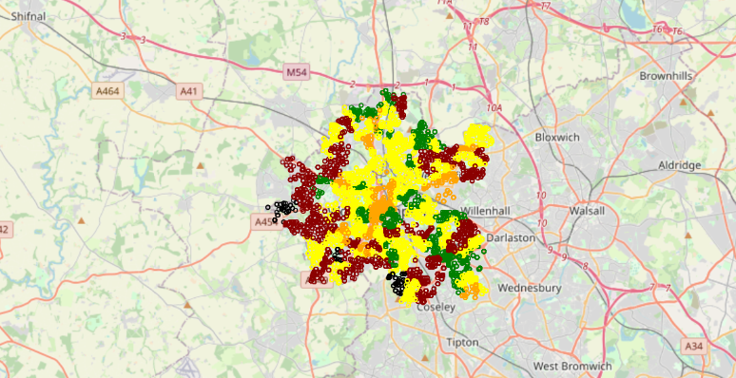

**Question :Consider   a   different   towns   (example    :   dudley) and perform the clustering  again.  You should  choose  the number  of  clusters    from    the dendrogramaccordingly.  Discuss your    results briefly**

**we have selected Town=Birmingham**

When the number of clusters is set to 3, but the town is changed to Birmingham, the clustering algorithm will group the LSOA codes within Birmingham into three distinct clusters based on their crime characteristics. The dendrogram visualization can help us understand how the algorithm grouped the data.

In the dendrogram, the x-axis represents the samples (LSOA codes in Birmingham), and the y-axis represents the distance between these samples. The vertical lines in the dendrogram show where the algorithm decided to merge clusters together. By drawing a horizontal line at a threshold distance of 1.5 (as indicated in the code), we can identify the number of clusters formed.

The resulting clustering will be specific to the crime patterns observed in Birmingham, allowing us to explore how different areas within the city vary in terms of crime incidents. The interpretation of the clusters will provide insights into the spatial distribution of crime in Birmingham and can be used for crime analysis and targeted crime prevention strategies.

Keep in mind that clustering is an exploratory analysis, and the effectiveness of the results depends on the quality and representativeness of the dataset used. It is essential to validate and interpret the clustering outcomes in the context of Birmingham's crime landscape and combine them with domain knowledge and expert insights to make informed decisions regarding crime prevention and community safety.

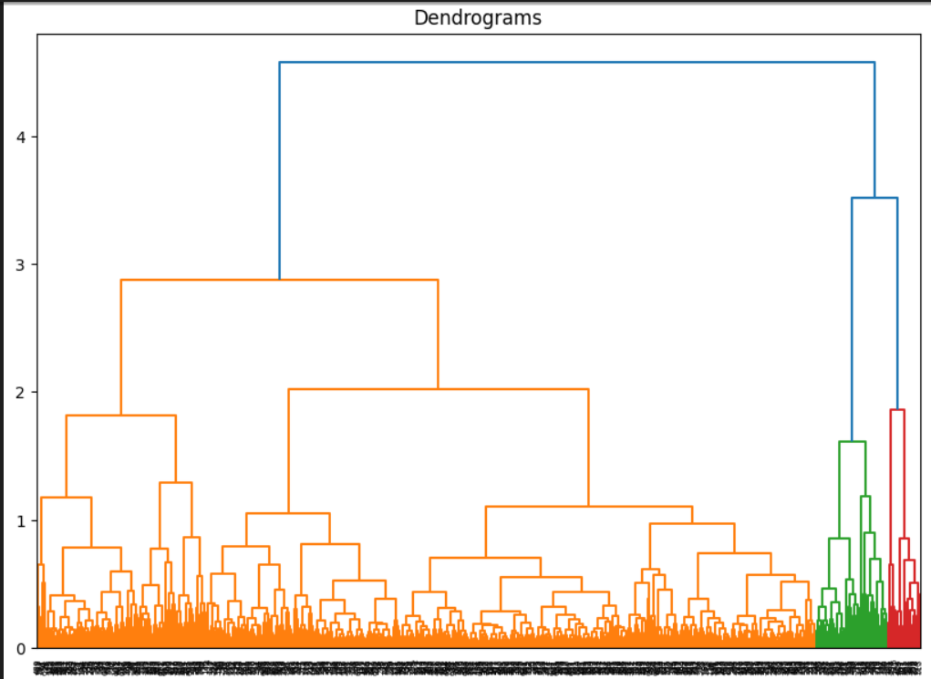

REPORT