DESIGN AND PRODUCTION OF DOCUMENTARY OF STUDENT INNOVATORS THE HIGHLAND WAY.

AMUSA SEMIU OLAMIDE
MATRIC NO: 248372

DEPARTMENT OF DIGITAL MULTIMEDIA

DECEMBER 2025

CERTIFICATION
This is to certify that this project was carried out by AMUSA SEMIU OLAMIDE with matriculation number 248372 of the DIGITAL MULTIMEDIA TECHNOLOGY department of HIGHLAND COLLEGE OF TECHNOLOGY, Samonda, Ibadan, under my supervision.

Mr. Moses Chetachukwu Kanu Date
Supervisor

H O D Date
Mr. Moses Chetachukwu Kanu

DEDICATION
This project is dedicated to the Almighty Allah, the beginning the end, the Ancient of days, He lead me through the journey from ND1 to ND2, He deserves all praises and adoration.

ACKNOWLEDGEMENT
I would like to begin by expressing my deepest gratitude to God, whose guidance, strength, and unfailing grace carried me through every stage of this project. Without His wisdom and patience, this work titled “Design and Production of a Documentary on Student Innovators: The Highland Way” would not have been possible. My sincere appreciation goes to my supervisor, Mr. Moses Chetachukwu Kanu for being more than just an academic guide. Thank you for your constant encouragement, honest feedback, and willingness to walk with me through every challenge I encountered during this research and production.
I am truly grateful to the management, staff, and students of HIGHLAND COLLEGE OF TECHNOLOGY for opening their doors and allowing me to bring this documentary to life. To the remarkable student innovators featured in this project—thank you for trusting me with your stories. Your passion, creativity, and perseverance inspired me every single day. Working with you reminded me of the power of young minds and the importance of giving space to ideas that can change the world.
To my lecturers, thank you for equipping me with the knowledge and skills I needed to complete this project. Your dedication to teaching and your belief in my ability pushed me to aim higher and think more critically.
I also want to appreciate my friends and colleagues, Asake Adejumo, Olanipekun Busayo, Adekanbi Faruq, Titilope, Abdulsamad, Feranmi, Daniel, Hamzat Daniel, Afolabi saheed, Akinkunmi Ireoluwa, Omolayo Eniola, Mr. Olugbenga Paul, Adewunmi Abdulrazaq, Callistus Emeka, Omolayo Inioluwa, Owesino Samuel, and Adeoluwa who supported me—whether by helping with equipment, offering ideas, assisting with editing, or simply encouraging me when the workload felt overwhelming. Your presence made the difficult moments easier and the successes more meaningful.
Finally, I owe endless gratitude to my family, Mr. and Mrs. Amusa, and my brothers. Thank you for your love, understanding, prayers, and for believing in me even on days when I doubted myself. Your support kept me grounded and motivated throughout this entire journey. To everyone who contributed, encouraged, guided, or even offered a kind word along the way, I say thank you from the bottom of my heart. This project is as much yours as it is mine.

ABSTRACT
This project focuses on the design and production of a documentary titled “Student Innovators: The Highland Way,” which explores the creativity, resilience, and problem-solving abilities of student innovators within a learning environment. The purpose of the project is to document the experiences of young individuals who apply critical thinking, creativity, and technical skills to develop solutions to real-world challenges. The documentary seeks to highlight their innovation process, from idea conception to prototype development, including the motivation, challenges, and support structures that shape their journeys.
The study adopted a comprehensive production methodology consisting of three major phases: pre-production, production, and post-production. Pre-production involved research, story development, script writing, planning, scheduling, and obtaining permissions. The production phase included conducting interviews, capturing live innovation activities, recording prototype construction, and gathering relevant B-roll footage. In the post-production phase, the recorded materials were edited into a cohesive and engaging narrative using audio-visual techniques such as sequencing, sound design, color correction, subtitles, and graphical elements.
The completed documentary provides valuable insights into the world of student innovators and portrays the importance of supporting creativity in educational institutions. It reveals how students navigate constraints such as limited resources, time pressure, and technical challenges while maintaining motivation to achieve their goals. The documentary also demonstrates the role of mentors, teachers, laboratories, clubs, and competitions in nurturing innovation.
The project concludes that documentary production is an effective medium for showcasing student achievements, inspiring others, and promoting an innovation culture within schools and communities. The documentary “The Highland Way” serves not only as an educational tool but also as a motivational resource for students, educators, policymakers, and anyone interested in youth-driven innovation.

TABLE OF CONTENT
CERTIFICATION 2
DEDICATION 3
ACKNOWLEDGEMENT 4
CHAPTER ONE 5
1.0 INTRODUCTION 5
1.1 BACKGROUND OF THE STUDY 6
1.2 STATEMENT OF THE PROBLEM 7
1.3 AIM AND OBJECTIVES 7
1.3.1 AIM 7
1.3.2 OBJECTIVES 7
1.4 SIGNIFICANCE OF THE STUDY 7
1.5 SCOPE OF THE STUDY 8
1.6 LIMITATIONS OF THE STUDY 8
1.7 DEFINITION OF TERMS 8
CHAPTER TWO 9
LITERATURE REVIEW 9
2.0 INTRODUCTION 9
2.1 HISTORICAL BACKGROUND OF DOCUMENTARIES. 10
1. ORIGINS OF DOCUMENTARY (LATE 1800S – EARLY 1900S) 10
2. THE BIRTH OF STRUCTURED DOCUMENTARY – 1920S 10
3. GRIERSONIAN ERA AND GOVERNMENTAL USE (1930S–1940S) 10
5. MODERN DOCUMENTARY EVOLUTION (1980S–2000S) 11
6. THE DIGITAL AGE AND STREAMING PLATFORMS (2010S–PRESENT) 11
2.2 IMPORTANCE OF DOCUMENTARIES 11
a. EDUCATIONAL VALUE 12
b. HISTORICAL DOCUMENTATION 12
c. SOCIAL CHANGE 12
d. ADVOCACY AND AWARENESS 12
e. CULTURAL PRESERVATION 12
f. JOURNALISM AND INVESTIGATIVE REPORTING 12
2.3 MODES OF DOCUMENTARIES (WITH ANALYSIS) 12
1. EXPOSITORY MODE 13
2. OBSERVATIONAL MODE 14
3. PARTICIPATORY MODE 14
4. REFLEXIVE MODE 14
5. POETIC MODE 15
6. PERFORMATIVE MODE 15
2.4 REFERENCES 16
CHAPTER THREE 16
METHODOLOGY 16
3.0 INTRODUCTION 16
3.1 TOOLS AND EQUIPMENT USED 17
3.2 PRE-PRODUCTION 17
3.2.1 DOCUMENTARY SCRIPT 17
3.2.2 INTERVIEW VOICEOVER 18
3.2.3 STORYBOARD 19
CHAPTER FOUR 23
IMPLEMENTATION 23
4.0 INTRODUCTION 23
4.1 PRE-PRODUCTION STAGE 23
4.1.1 CONCEPT DEVELOPMENT 23
4.1.2 RESEARCH AND PARTICIPANT SELECTION 23
4.1.3 SCRIPTING AND STORYBOARDING 24
4.1.4 EQUIPMENT PLANNING 24
4.1.5 SCHEDULING 24
4.2 PRODUCTION STAGE 24
4.2.1 FILMING INTERVIEWS 25
4.2.2 RECORDING B-ROLL FOOTAGE 25
4.2.3 SOUND AND LIGHTING SETUP 25
4.2.4 DIRECTOR AND CREW ROLES 25
4.3 POST-PRODUCTION STAGE 26
4.3.1 VIDEO EDITING 26
4.3.2 AUDIO MIXING 27
4.3.3 GRAPHICS AND TEXT 27
4.3.4 NARRATION AND VOICE-OVER 27
4.3.5 FINAL EXPORT AND FORMAT 28
4.4 DISTRIBUTION AND PRESENTATION 28
CHAPTER FIVE 29
5.0 SUMMARY, RECOMMENDATIONS AND CONCLUSION 29
5.1 SUMMARY 29
5.2 CONCLUSION 30
5.3 RECOMMENDATIONS 30

CHAPTER ONE

1.0 INTRODUCTION
In the 21st century, innovation and creativity have become the cornerstone of societal progress, especially in the realm of education and technology. As academic institutions strive to equip students with practical skills and global relevance, there is a growing need to spotlight the achievements and ingenuity of young innovators within these institutions. The Highland College of Technology, located in Samonda, Ibadan, is one such institution that fosters technical expertise and entrepreneurial thinking among its students. However, despite the wealth of talent and innovation within the student body, there exists a noticeable gap in documentation and public awareness of their contributions.
This project, titled "Design and Production of Documentary Series: Student Innovator," aims to create a series of documentary features that showcase the ingenuity, stories, and impact of student innovators at Highland College of Technology. By combining visual storytelling, interviews, and real-life projects, the series will highlight students who are not only excelling academically but also contributing solutions to real-world problems.
In an era where media has the power to educate, inspire, and influence public perception, this project seeks to bridge the visibility gap and create a platform that recognizes and celebrates student innovation. Through this documentary series, the Highland College of Technology can build a strong narrative of academic excellence, innovation, and community impact, attracting future students, industry partners, and investors.

1.1 BACKGROUND OF THE STUDY
Highland College of Technology has consistently provided education in technical and vocational fields aimed at producing graduates with practical and employable skills. In recent years, a growing number of students have embarked on independent innovations ranging from software development and robotics to green energy solutions and media production. Despite these developments, many of these projects remain undocumented or unrecognized outside the immediate college environment.
The absence of structured documentation limits the opportunities for external partnerships, mentorships, and investments. Moreover, students lack a formal medium to share their work, reflect on their growth, or receive constructive feedback. Documentary storytelling presents a compelling solution to this problem by combining information, emotion, and visual appeal to narrate the journey of these young innovators.
This project proposes a solution in the form of a professionally produced documentary series that will capture, curate, and promote the innovative efforts of students. The documentaries will serve multiple purposes: a record for the institution, inspiration for fellow students, a promotional tool for the college, and a reference for stakeholders in education and industry.

1.2 STATEMENT OF THE PROBLEM
Although Highland College of Technology harbors a thriving community of creative and technically skilled students, there is no established framework for showcasing their innovations to the public. The lack of such a platform results in:
- Minimal recognition for student-led initiatives
- Missed opportunities for external collaboration
- Low morale among creative students who feel their work is overlooked
- Limited archival content to represent the college’s academic and innovative capacity
The absence of an engaging and consistent storytelling medium prevents the college from effectively marketing its success stories and positioning itself as a hub of innovation.

1.3 AIM AND OBJECTIVES

1.3.1 AIM
To design and produce a documentary series that highlights and promotes student innovations at Highland College of Technology.

1.3.2 OBJECTIVES
- To identify and profile student innovators across various departments
- To document their journeys, projects, and motivations
- To produce high-quality video content with engaging narratives
- To create an accessible platform (online and offline) for viewing the documentaries

1.4 SIGNIFICANCE OF THE STUDY
This project holds significant value for multiple stakeholders. For the students, it provides validation, exposure, and a portfolio to showcase their work. For the institution, it enhances visibility, reinforces branding, and positions Highland College as a center for innovation. For external bodies, it presents opportunities to discover young talent for internships, mentorships, and funding. The documentary series will also contribute to a culture of storytelling, creativity, and collaboration within the college community.

1.5 SCOPE OF THE STUDY
The study covers the design, planning, and production of a pilot documentary series featuring selected student innovators at Highland College of Technology. It includes:
- Background research and selection of student participants
- Interview scripting and filming
- On-site video production and editing
- Creation of branding and promotional materials
- Distribution strategy and platform setup
The project is limited to a pilot series of 3 to 5 episodes with room for future expansion.

1.6 LIMITATIONS OF THE STUDY
- Time constraints may limit the number of students documented
- Budget limitations may affect the quality and scope of production equipment
- Some students may be unavailable or unwilling to participate
- Limited access to high-end production facilities.

1.7 DEFINITION OF TERMS
Documentary: A non-fictional film or video that documents real-life events, people, or innovations
Innovation: The process of developing new methods, ideas, or products
Pilot Series: An initial set of episodes intended to test and showcase a concept
Visual Storytelling: The art of using video, images, and audio to communicate a narrative
Student Innovator: A student who creates original solutions, projects, or products with real-world relevance
Content Production: The process of planning, recording, and editing media for communication or entertainment

CHAPTER TWO

LITERATURE REVIEW

2.0 INTRODUCTION
Documentary films hold a distinct position within the media landscape as visual narratives based on reality. Unlike fictional narratives, documentaries aim to depict actual events, people, and experiences in a truthful and informative manner. This chapter explores the concept of documentary films, their evolution over time, their types, and their significance in media, communication, education, and societal development.

2.1 HISTORICAL BACKGROUND OF DOCUMENTARIES.
The history of documentary filmmaking traces the evolution of visual storytelling rooted in the human desire to document reality, preserve history, and share knowledge. This genre, which blends fact with narrative, has gone through distinct phases of innovation, purpose, and expression.

1. ORIGINS OF DOCUMENTARY (LATE 1800S – EARLY 1900S)
The birth of documentary dates back to the invention of motion pictures in the late 19th century. Early films by the Lumière Brothers, such as Workers Leaving the Lumière Factory (1895), captured real-life scenes, laying the groundwork for non-fiction cinema. These short clips were not structured as narratives but simply documented real events and people.

2. THE BIRTH OF STRUCTURED DOCUMENTARY – 1920S
The first true documentary is widely considered to be Nanook of the North (1922) by Robert J. Flaherty. This ethnographic film followed the life of an Inuit family in the Arctic and combined real-life footage with storytelling elements. Although some scenes were staged, it marked a new era of using film to document and interpret the human experience.
Around the same time, Dziga Vertov, a Russian filmmaker, introduced the concept of cinéma vérité (cinema of truth) with Man with a Movie Camera (1929). He rejected scripted scenes in favor of spontaneous, real-life recordings that captured Soviet society in motion.

3. GRIERSONIAN ERA AND GOVERNMENTAL USE (1930S–1940S)
John Grierson, a Scottish filmmaker, coined the term “documentary” in 1926 and was instrumental in shaping the genre as a tool for social education. He believed in using film to inform and influence public opinion. Grierson’s film Drifters (1929) focused on North Sea herring fishermen and emphasized the dignity of labor.
In the 1930s and 40s, documentaries became essential governmental tools. During World War II, both the Allies and Axis powers used documentaries as propaganda, spreading messages through films such as Frank Capra’s Why We Fight series (USA) and Leni Riefenstahl’s Triumph of the Will (Germany).
4. POST-WAR PERIOD AND RISE OF TELEVISION (1950S–1970S)
After WWII, the use of portable cameras and lighter sound equipment allowed filmmakers to go into the field with greater ease. This era saw the rise of direct cinema and cinéma vérité, which emphasized minimal interference with subjects.
Documentaries began addressing social, civil, and political issues such as civil rights, poverty, war, and inequality. Landmark films like Salesman (1969) by the Maysles brothers and Chronicle of a Summer (1961) by Jean Rouch and Edgar Morin exemplified the unfiltered and observational style of this period.

5. MODERN DOCUMENTARY EVOLUTION (1980S–2000S)
The 1980s to early 2000s saw a boom in documentaries that were more personal, opinionated, and accessible. Michael Moore’s Bowling for Columbine (2002) and Fahrenheit 9/11 (2004) used confrontational styles and humor to challenge political systems. Ken Burns popularized long-form historical documentaries through series like The Civil War (1990), using archival footage and voiceovers.
The advent of digital video and home editing tools in the 1990s and 2000s dramatically lowered production costs, allowing independent creators to enter the scene.

6. THE DIGITAL AGE AND STREAMING PLATFORMS (2010S–PRESENT)
The rise of the internet, smartphones, and social media transformed documentary production and distribution. Platforms like YouTube, Netflix, and Vimeo democratized documentary access and allowed micro-narratives and personal stories to reach global audiences.
Contemporary documentaries now span various formats—short-form, episodic series, immersive 360° VR—and address a wide range of subjects, from global warming (An Inconvenient Truth) to social justice (13th by Ava DuVernay), food industry (Food, Inc.), and technology (The Social Dilemma).
Moreover, audiences now participate in the process by sharing and interacting with documentary content, blurring the lines between viewer, subject, and filmmaker.

2.2 IMPORTANCE OF DOCUMENTARIES
Documentaries are important tools for education, social awareness, and historical preservation. Their impact spans several dimensions:

a. EDUCATIONAL VALUE
Documentaries serve as instructional materials in schools and universities, providing visual representations of complex topics. They can simplify abstract theories, historical timelines, or cultural practices, thereby enhancing understanding and retention.

b. HISTORICAL DOCUMENTATION
A documentary can act as a primary source of historical information. Many conflicts, revolutions, and milestones have been captured and preserved through documentaries, offering future generations a glimpse into the past with visual evidence.

c. SOCIAL CHANGE
Documentaries such as An Inconvenient Truth (2006) and 13th (2016) have influenced public opinion and even policy. They highlight issues such as climate change, racism, inequality, and injustice, giving voice to marginalized groups and prompting community activism.

d. ADVOCACY AND AWARENESS
Many NGOs and international bodies use documentaries to communicate their mission, reach new audiences, and advocate for their causes. These films can present stories that conventional news outlets may ignore.

e. CULTURAL PRESERVATION
Documentaries play a crucial role in preserving languages, customs, and traditions, especially among indigenous or disappearing cultures. By visually archiving rituals, festivals, and everyday life, they contribute to global heritage.

f. JOURNALISM AND INVESTIGATIVE REPORTING
Modern documentary styles often cross into investigative journalism, such as The Panama Papers or Citizenfour. These works uncover hidden truths and present them with strong evidence.

2.3 MODES OF DOCUMENTARIES (WITH ANALYSIS)
Documentary films can be categorized based on their style, purpose, and method of storytelling. The most widely recognized classification was introduced by film theorist Bill Nichols, who identified six major documentary modes. In addition to these, other general modes also exist in media and production practice.
1. Expository Documentary
2. Observational Documentary
3. Participatory Documentary
4. Reflexive Documentary
5. Poetic Documentary
6. Performative Documentary
7. Educational Documentary
8. Biographical / Profile Documentary
9. Historical Documentary
10. Social Documentary
The six major modes include:

1. EXPOSITORY MODE
The expository mode is one of the oldest and most recognizable documentary styles. Its main purpose is to explain, inform, and persuade the audience. Expository documentaries rely heavily on verbal commentary—often delivered through a “voice-of-God” narrator who speaks directly to viewers and provides context, facts, or arguments. This narration guides the interpretation of the images, shaping how audiences should understand the subject matter. This mode frequently incorporates archival footage, interviews, photographs, charts, and re-enactments to support the central argument. The editing is typically logical and structured, ensuring that information is presented clearly and convincingly. Expository films often deal with historical events, scientific topics, social issues, and investigations. Their main strength lies in their ability to simplify complex information and present it in a coherent, authoritative manner. However, some critics argue that the expository mode can be overly didactic, limiting audience interpretation because the filmmaker’s position is strongly imposed. Despite this, it remains one of the most dominant modes because of its clarity and educational applicability.

2. OBSERVATIONAL MODE
The observational mode, often associated with the cinéma vérité and direct cinema movements of the 1960s, aims to capture reality as it unfolds with minimal interference. In this style, filmmakers operate as passive observers, allowing events to play out naturally without staging scenes or prompting participants. Observational documentaries typically avoid narration, interviews, and on-screen questions. Instead, they rely on long takes, synchronous sound, and handheld cameras to show authentic behavior in real time. The goal is to provide a window through which the audience witnesses life directly, almost as if present during the filming. This mode is valued for its sense of realism, intimacy, and authenticity. It allows viewers to form their own interpretations based on what they see rather than being guided by a narrator. However, observational documentaries can sometimes lack context or explanation because of their avoidance of commentary. They require careful editing to maintain coherence while preserving spontaneity.

3. PARTICIPATORY MODE
The participatory mode emphasizes interaction between the filmmaker and the subject. Here, the filmmaker is not a distant observer but an active participant whose presence influences the events recorded. This mode acknowledges that filmmaking is a form of social engagement, and it embraces the collaborative relationship between filmmaker and participants. Techniques common in this mode include interviews, conversations, on-screen questioning, and direct involvement in the unfolding events. The filmmaker may even appear on camera, allowing viewers to witness their role in shaping the narrative. Examples include investigative documentaries where the director confronts institutions, travels with subjects, or personally explores issues. The participatory mode strengthens transparency because it shows the process of inquiry rather than pretending that the filmmaker is invisible. It also fosters empathy, as viewers experience events alongside the filmmaker. However, it can introduce bias because the filmmaker’s personality and intentions shape the story.

4. REFLEXIVE MODE
The reflexive mode focuses not only on the subject being documented but also on the process of making the documentary itself. Unlike other modes that try to appear objective or invisible, reflexive documentaries draw attention to their own construction. They highlight how films represent truth through choices in framing, editing, and narration. Reflexive documentaries may show the cameras, crew, and equipment, or they may discuss the challenges of capturing reality accurately. This self-awareness encourages audiences to question how documentaries shape truth rather than merely presenting it. It also helps viewers understand that documentary filmmaking is a subjective and interpretive art, not simply a transparent recording of reality. This mode is often used in experimental or academic works where filmmakers critique conventional documentary assumptions. While reflexive films may seem less emotionally engaging, they offer valuable insights into media literacy by teaching viewers to analyze and question representation.

5. POETIC MODE
The poetic mode prioritizes mood, tone, and visual aesthetics over straightforward storytelling. Instead of focusing on logical arguments or linear narratives, poetic documentaries use artistic techniques such as montage, creative cinematography, symbolic imagery, and rhythmic editing to evoke emotions and create impressions. This mode is closely related to avant-garde and experimental cinema. It often reconstructs reality through fragmentation, abstraction, and stylization. Dialogue and narration may be minimal or absent; instead, imagery and sound design communicate meaning. The strength of the poetic mode lies in its ability to communicate experiences or emotions that may be difficult to express through traditional structure. It creates space for interpretation, allowing audiences to derive personal meaning from the visual and auditory experience. However, because it is less literal, some viewers may find it challenging to follow if they expect a conventional documentary narrative.

6. PERFORMATIVE MODE
The performative mode emphasizes the subjective, emotional, and personal experience of the filmmaker or subjects. Unlike the objective tone of expository documentaries, performative documentaries embrace personal truth, memory, and lived experience. The filmmaker often becomes a central figure, using their own story as a lens through which broader social issues are explored. Performative documentaries use expressive techniques such as reenactment, first-person narration, poetic imagery, and emotional appeal. They highlight feelings over facts and focus on how individuals experience events rather than how those events can be objectively verified. This mode is especially powerful for exploring themes such as identity, trauma, cultural experience, and social injustice. It allows marginalized voices to express their realities in authentic, emotionally resonant ways. The main criticism is that performative documentaries may sacrifice factual objectivity for emotional impact, but this is seen as an intentional choice reflecting the filmmaker’s perspective.

CHAPTER THREE

METHODOLOGY

3.0 INTRODUCTION
This chapter presents the systematic approach used in the design and production of the documentary series titled "Student Innovator: The Highland College of Technology." It covers the research design, data collection methods, sampling technique, tools used, production workflow, scriptwriting process, and storyboard development. These elements ensured the authenticity, clarity, and creative direction of the final production.

3.1 TOOLS AND EQUIPMENT USED
Tool | Description
DSLR Camera (Canon M50) | For high-quality video footage
Tripod & Gimbal | For stabilized shots
Lavalier Microphone | For clear interview audio
Adobe Premiere Pro | Video editing
Adobe Audition | Sound mixing
Canva | Poster and thumbnail designs
Trello | Project management and task tracking

3.2 PRE-PRODUCTION
Script: Documentary Interview Voiceover, Storyboard
The pre-production stage is crucial in the development of a documentary as it forms the foundation upon which the entire project is built. For Student Innovator: The Highland College of Technology, the pre-production phase was meticulously planned to ensure a seamless and impactful storytelling process. This section outlines the script preparation, interview voiceover development, and the storyboard framework.

3.2.1 DOCUMENTARY SCRIPT
The documentary script was written to reflect the core themes of innovation, student creativity, and academic growth within Highland College of Technology. The scripting process followed a clear structure:
- Opening Sequence: Establishing shots of the school environment – the gate, classrooms, laboratories, and library. This is accompanied by uplifting background music and a narrator's voice introducing the college.
- Introduction of the Theme: The narrator explains the focus of the documentary: spotlighting student-driven innovations and creative projects within the institution.
- Main Content:
  - Interviews with student innovators discussing their projects.
  - Testimonials from lecturers highlighting the school’s support for innovation.
  - Footage of students working on projects, attending workshops, and collaborating.
- Closing:
  - Summarizing the impact of student innovation.
  - A hopeful call to action encouraging continued creativity and support for youth-driven technological ideas.
DOCUMENTARY SCRIPT
TITLE: THE HIGHLAND WAY
DURATION: 5-10 Minutes
FORMAT: Narration + Interviews + B-roll

1. OPENING SCENE
B-roll:
• HCT Logo Reveal
⦁ Shots of Highland College of Technology (HCT) buildings
⦁ Shots of students working in class
NARRATOR (V.O.):
“In every generation, new thinkers arise—curious minds determined to solve problems, push boundaries, and shape the future. At Highland College of Technology, innovation is not just a goal… it is a culture. This is the story of young creators who dare to imagine, build, and transform. This… is The Highland Way.”

2. INTRODUCTION OF THE PROJECT
Cut to classroom.
NARRATOR (V.O):
“For our final year project, we explore the passion, resilience, and creativity of student innovators across different departments. From engineering prototypes to software solutions, from creative designs to breakthrough research—these students represent the heartbeat of Highland College of Technology.”
3A. INTRODUCTION OF STUDENT INNOVATORS
B-roll:
• Close-up shots of the student working
• Their interview
Motion Graphics:
“Meet (Student Name), a final-year student in the Department of (Department Name)."
3B. INTERVIEW (Student On-Camera)
Sample Interview Questions:
1. “Can you introduce yourself and your department?”
2. “Tell us about your project. What inspired it?”
3. “What problem does your project solve?”
4. “What challenges did you face during development?”

4. NARRATION TRANSITION
NARRATOR (V.O.):
“Across the campus, a new generation of innovators is emerging—students who are not waiting for the future… but building it with their own hands. Their ideas reflect creativity, resilience, and the determination that defines Highland College of Technology.”
B-roll:
• Different departments
• Tools in action
• Group discussions

5. MID-SECTION NARRATION
NARRATOR (V.O.):
“From theory to practice, from classroom concepts to real prototypes, these students show what is possible when passion meets opportunity. Their stories prove that innovation is not limited by age or background. It begins with curiosity—and thrives with the right guidance.”

7. STUDENT REFLECTION MONTAGE
Quick cuts of different students answering a single question.
Question:
“What advice do you have for future students who want to innovate?”

8. CLOSING NARRATION
Final B-roll:
• Shot of the school
• School crest or signboard
NARRATOR (V.O.):
“The future will always belong to those who dare to build it. At Highland College of Technology, these young minds have shown that innovation is not just a skill—it is a way of life. Their dreams, their creativity, their resilience… these are the foundations of tomorrow. This is their journey. This is their voice. This is The Highland Way. Highland College of Technology; Moving you technically higher”

9. ENDING TITLE CARD
Screen Text:
The Highland Way – A Documentary on Student Innovators
Produced by: AMUSA SEMIU OLAMIDE
Department of Digital Multimedia Technology
Highland College of Technology
Year: 2025

Soft inspirational background music fades out.

3.2.2 INTERVIEW VOICEOVER
The voiceover serves as both narration and an emotional guide for the audience. The script for the voiceover was crafted to be engaging, informative, and motivating. Key considerations for the voiceover included:
- Tone: Inspirational and warm, to connect emotionally with both students and external viewers.
- Content: Highlights of interviews with students and staff, showcasing quotes that reflect passion, determination, and excellence.
- Narration Flow:
- Voiceover introduces each segment before and after the interviews.
- Smooth transitions between student stories and institutional highlights.
Sample Voiceover Line:
“Within the heart of Highland College of Technology lies a generation of creators — students who are reshaping tomorrow with bold ideas, crafted today.”

3.2.3 STORYBOARD
The storyboard was developed to visualize the documentary scene-by-scene before filming began. It included hand-drawn sketches and annotations that detailed:
- Camera Angles: Close-ups for emotional impact during interviews, wide-angle shots for showcasing group projects.
- Transitions: Fade-ins and slide transitions between scenes to create a smooth visual experience.
- Scene Descriptions:
  - Scene 1: Opening drone shot of the campus.
  - Scene 2: Interview with student innovator.
  - Scene 3: Workshop footage showing practical work.
  - Scene 4: Lecturer discussing student support systems.
  - Scene 5: Closing remarks from the narrator with montage.
A storyboard image was produced during the pre-production phase and served as a visual guide for the filming crew and editors to follow during production and post-production phases.
- Capturing students in labs, classrooms, and presentations
- Recording narration/voiceovers
Script for the production
Scene 1: Opening montage with voiceover
- Video: Close-up shots of computer screens, hands assembling gadgets, drone flying, classroom presentations
- Voiceover:
“At Highland College of Technology, ideas do more than exist. They evolve, they compete, they win, and they inspire.”
Scene 2: Cut to Interview – Student 1
- Video: Seated student speaking on camera
- Audio:
“I started my first coding project in 100 level. By 300 level, I had built an AI chatbot that helps students access library books instantly.”
Scene 3: B-Roll
- Video: Students presenting at an innovation fair
- Voiceover:
“Through mentorship, teamwork, and passion, these students are building solutions for tomorrow.”
Scene 4: Cut to Staff Interview
- Video: Lecturer in tech lab
- Audio:
“We don’t just teach theory. We challenge our students to prototype and pitch real-world ideas.”
📽️ Storyboard (Key Scenes)
Scene No. | Scene Title | Description | Visuals | Audio
1 | Opening Montage | Quick cuts of innovation on campus | Drone shots, students working, gadgets, 3D models | Music + Narration
2 | Meet the Innovator | Student interview + project background | Medium close-up, background project on table | Live interview
3 | Innovation in Action | Observational footage of live coding or prototype testing | Over-the-shoulder angle, screen recording | Natural sound
4 | Campus Support | Interview with academic staff | Seated setup, lab or office background | Interview audio
5 | Student Pitch | Student presenting to panel | Wide shot of classroom, panelists taking notes | Ambient sound + Narration
6 | Success & Recognition | Footage from innovation award events | Students receiving awards, shaking hands | Background music
7 | Closing Remarks | Final interview clips + reflective thoughts from students | Mixed shots + slow fade transitions | Voiceover + Music
8 | End Credits / Call to Action | Credits and contact information | Logo animation, social media handles | Soft background music
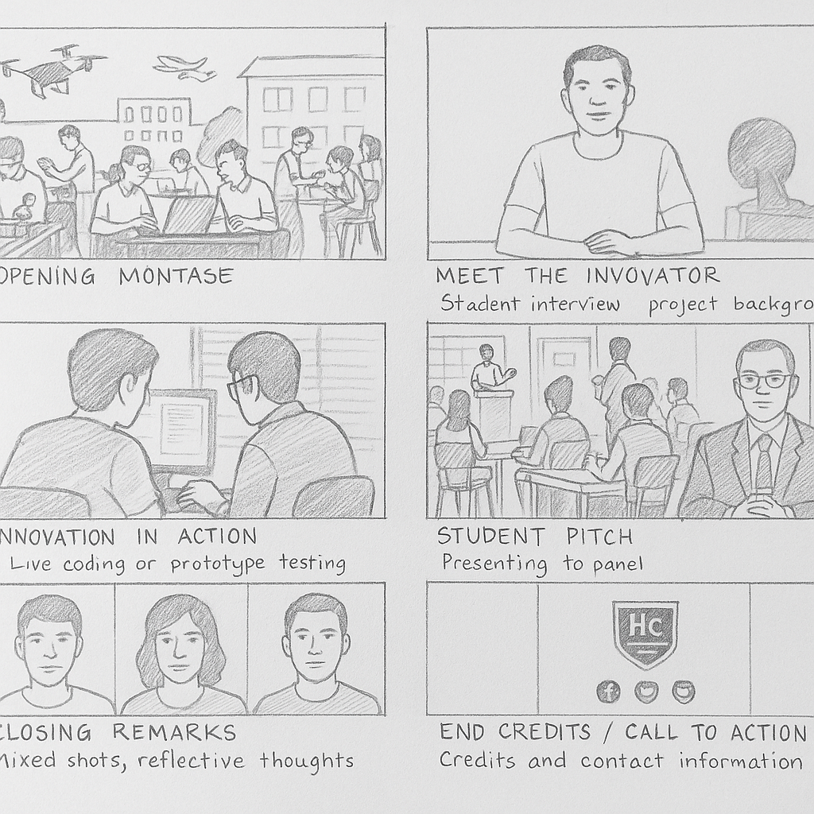

CHAPTER FOUR

IMPLEMENTATION

4.0 INTRODUCTION
This chapter discusses the practical steps involved in the design and production of the documentary series, “Student Innovators: The Highland Way.” It explains how the project was executed from the planning stage to the final production processes. The implementation phase includes pre-production, production, and post-production activities. Each stage highlights the tools, methods, and techniques used to ensure the successful creation of the documentary.

4.1 PRE-PRODUCTION STAGE
The pre-production stage involved all necessary planning and preparation before filming began. This stage ensured that the production process was well organized, cost-effective, and aligned with the project objectives.

4.1.1 CONCEPT DEVELOPMENT
The concept of the documentary was developed to highlight the achievements and innovative projects of selected students at Highland College of Technology. The idea was to create a narrative that inspires, educates, and promotes the institution’s culture of innovation.

4.1.2 RESEARCH AND PARTICIPANT SELECTION
Background research was conducted to identify departments and students actively engaged in innovative projects. Selection criteria includes
Relevance of innovation,
Originality of work,
Willingness to participate, and
Availability for interviews and demonstrations.
A list of 3–5 student innovators was compiled for the pilot series.

4.1.3 SCRIPTING AND STORYBOARDING
A documentary script outline was developed, including:
Introduction of each innovator, interview questions, narration guide, visual sequences, and transitions.
Storyboards were created to provide a visual plan for each scene, ensuring consistency in camera shots and storytelling.

4.1.4 EQUIPMENT PLANNING
The equipment selected for filming included
DSLR or HD video camera
Tripod stand
Lapel microphone and boom mic
LED lighting kit
Portable audio recorder
External hard drive for storag
This ensured clear visuals, stable shots, and high-quality sound.

4.1.5 SCHEDULING
Filming schedules were created based on student availability and location arrangements. Locations included classrooms, workshops, laboratories, and open spaces within the campus.

4.2 PRODUCTION STAGE
The production stage involved the actual filming of interviews, demonstrations, and supporting visuals.

4.2.1 FILMING INTERVIEWS
Each student innovator was interviewed using a semi-structured format. Questions covered: their background, inspiration behind the innovation, challenges faced, and impact of their work.
Interviews were recorded using two-camera angles for visual diversity.

4.2.2 RECORDING B-ROLL FOOTAGE
Additional footage was captured to support the documentary narrative. This included:
Students working on their projects,
Close-up shots of tools and materials,
Classroom and workshop scenes,
Campus environment shots.
B-roll footage was essential for smooth transitions and visual storytelling.

4.2.3 SOUND AND LIGHTING SETUP
Lapel microphones were used to capture clean dialogue, while LED lights improved the visual quality of indoor shots. Ambient noise was minimized to avoid audio interference.

4.2.4 DIRECTOR AND CREW ROLES
The implementation required basic crew roles such as:
Director
Camera operator
Sound technician
These roles ensured organization and smooth workflow during filming.

4.3 POST-PRODUCTION STAGE
This stage involved editing and assembling the recorded materials into a polished final documentary.

4.3.1 VIDEO EDITING
Editing was done using software such as Adobe Premiere Pro, DaVinci Resolve, or Final Cut Pro. The steps included:
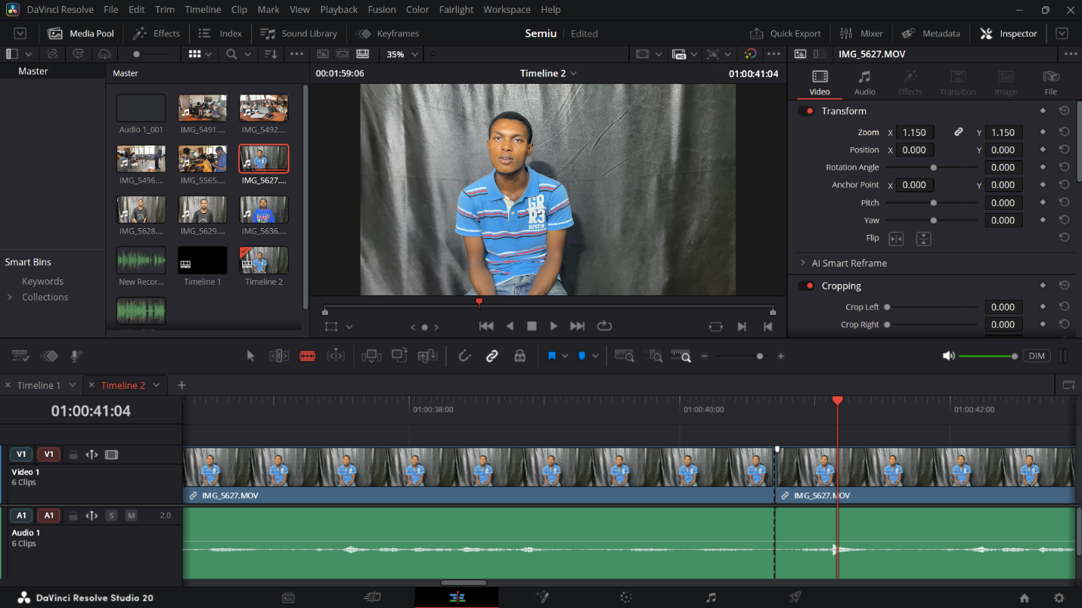
Importing and organizing clips, cutting unwanted scenes, arranging interviews, synchronizing audio, adding transitions, color correction and grading.

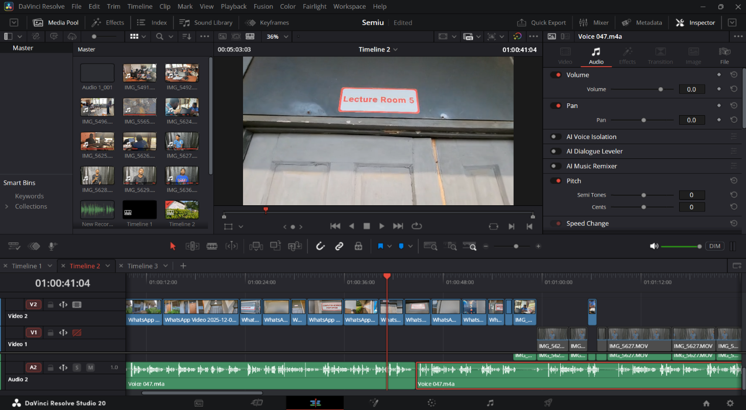
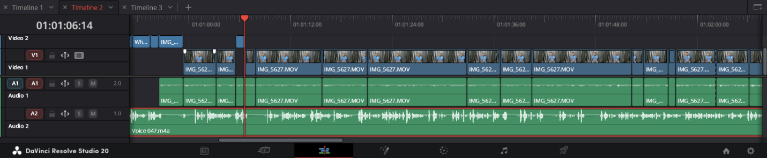

4.3.2 AUDIO MIXING
Background noise was reduced, and audio levels were balanced for clarity. A soft instrumental soundtrack was added to enhance emotional appeal while ensuring it does not overpower dialogue.

4.3.3 GRAPHICS AND TEXT
Lower-third titles were created to display:
Student names, department, project titles.
Intro and outro graphics were designed using tools such as Adobe AfterEffects or Canva.

4.3.4 NARRATION AND VOICE-OVER
A recorded narration was added to guide the documentary flow, introduce topics, and connect interview segments.

4.3.5 FINAL EXPORT AND FORMAT
The final video was exported in MP4 (H.264) format for compatibility with:
Online platforms, projectors, mobile devices, and institutional archives.
A HD resolution (1080p) output was chosen for quality viewing.

4.4 DISTRIBUTION AND PRESENTATION
The completed documentary was prepared for distribution through the school’s official website, social media platforms (YouTube, Facebook), and offline screening during academic events, and inclusion in student innovation exhibitions. This ensured accessibility to students, staff, parents, investors, and external stakeholders.

CHAPTER FIVE

5.0 SUMMARY, RECOMMENDATIONS AND CONCLUSION

5.1 SUMMARY
This project focused on the design and production of a documentary on students with the purpose of showcasing their daily experiences, academic activities, challenges, and achievements. The study began by establishing the need for documentaries as important tools for preserving information, educating viewers, and giving visibility to the realities of student life.
The project adopted a structured production process consisting of three major phases: pre-production, production, and post-production. Pre-production involved research, planning, scripting, interview design, scheduling, and obtaining relevant permissions. During the production stage, interviews were conducted with students, teachers, and school personnel, while various activities such as classroom interactions, extracurricular engagements, and campus environments were recorded. The post-production phase focused on editing, arranging clips into a cohesive storyline, applying background music, adding titles and subtitles, and finalizing the documentary.
The completed documentary successfully portrayed the school environment and highlighted important aspects of student life including academic pressures, motivation, peer interaction, talent display, and personal aspirations. It also revealed challenges faced by students such as inadequate facilities, stress, and the need for guidance and support systems.
The project demonstrated that documentaries can be powerful educational tools that inform, inspire, and promote understanding among stakeholders such as students, teachers, parents, and policymakers.

5.2 CONCLUSION
The design and production of a documentary on students proved to be an effective medium for capturing and presenting real-life experiences within the school environment. The documentary achieved its aim of providing an authentic representation of student life and created awareness of both the positive aspects and challenges students face. Through the use of interviews, visual storytelling, and observational footage, the project emphasized the value of giving students a platform to express their thoughts, struggles, and achievements.
The project concludes that documentary filmmaking is not only a creative art form but also a significant educational tool capable of influencing decision-making, promoting student welfare, and enhancing teaching and learning. With the right planning, teamwork, and technical execution, meaningful stories can be produced to support educational development.

5.3 RECOMMENDATIONS
Based on the outcome of the project, the following recommendations are made:
- Schools should encourage more documentary projects to promote creativity, media literacy, and student expression.
- Educational administrators should use documentaries as tools for understanding student needs and improving learning environments.
- Students should be given more opportunities to participate in media and storytelling activities to build communication and technological skills.
- Adequate resources and facilities should be provided to support similar media-related projects, including access to cameras, computers, and editing software.
- The documentary should be shared widely across schools and digital platforms to inspire and inform a larger audience.

REFERENCES
- Nichols, B. (2017). Introduction to Documentary (3rd ed.). Indiana University Press.
- Grierson, J. (1933). First Principles of Documentary.
- Aufderheide, P. (2007). Documentary Film: A Very Short Introduction. Oxford University Press.
- Renov, M. (1993). Theorizing Documentary. Routledge.
- Ellis, J., & McLane, B. A. (2005). A New History of Documentary Film. Continuum International.
- Winston, B. (1995). Claiming the Real: The Documentary Film Revisited. BFI.

