Satellites’ resolution

A satellite's resolution is defined as the size of the smallest individual component or dot (called a pixel) from which the image is constituted.

If a satellite's resolution is stated as "5 meters", this means that each pixel in the imagery is 5 meters by 5 meters in size.

Angular Resolution

The angular resolving power (or resolution) of a telescope is the smallest angle between close objects that can be seen clearly to be separate. <http://global.britannica.com/science/angular-resolution>

θ=1.220*λ/D where *θ* is the **angular resolution** ([radians](https://en.wikipedia.org/wiki/Radians)), *λ* is the [wavelength](https://en.wikipedia.org/wiki/Wavelength) of light, and *D* is the [diameter](https://en.wikipedia.org/wiki/Diameter) of the lens' aperture

Detector

CCD vs CMOS ? <http://www.specinst.com/What_Is_A_CCD.html>

Aperture

A much more important value is the size of the camera’s aperture, commonly listed as an f-number. The f-number is a ratio between the focal length and size of the hole, and tells you how much light can pass through to the sensor. An f-number of 2, expressed typically as f/2, means the focal length is twice the size of the aperture; f/4 would be a focal length 4 times the aperture, and so forth.

The lower the f-number, the wider the aperture and thus more light is able to pass through. Differences in f-number aren’t immediately obvious though, as double the f-number doesn’t equate to half the light gathering area (one stop less). Instead, due to the circular nature of an aperture, double the f-number is a two stop difference, providing one quarter the light gathering area. <http://www.techspot.com/guides/850-smartphone-camera-hardware/page3.html>

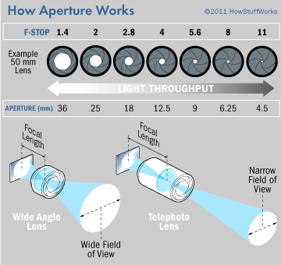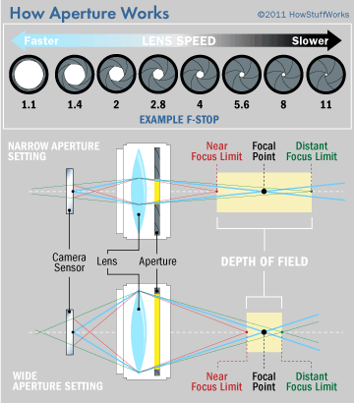

Aperture size affects more than exposure; it also impacts depth of field. In short, depth of field refers to how much of an image is in focus. When only one part of an image is sharp -- for instance, a single petal on a full flower blossom -- photographers say that the picture has a shallow depth of field. Alternately, deep depth of field is obvious in a sweeping, broad landscape, in which the flowery foreground and mountainous background are all relatively crisp.

Lenses with wide maximum apertures, such as f/1.4, are great for shallow depth of field. You can isolate one part of a subject, keeping it in focus while blurring the rest of the image. Many photographers use this technique to great artistic effect.

http://electronics.howstuffworks.com/cameras-photography/tips/aperture1.htm

Some landscape photographers automatically go to the other end of the aperture scale, selecting f22 or f32 (or f45 or f64 with large format). This, they correctly believe, produces the greatest amount of depth-of-field. Unfortunately, when the aperture is really small, the light waves diffract around the iris blades as they pass through the aperture and you get a loss of clarity in the image. So while depth-of-field improves, image sharpness overall decreases.

<http://www.betterphotography.com/index.php/online-memberships/mclandscapes-sp-6285/free-sample-masterclass/488-knowledge-what-is-the-best-aperture-to-use-article>

Aperture f/5.6 (intermédiaire entre tél f/2 et f/12)

<http://www.nikonusa.com/en/learn-and-explore/article/g3cu6o1r/understanding-maximum-aperture.html>

A typical aperture range may look like this:

f 1.4; f 2; f 2.8; f 4; f5.6; f 8; f 11; f 16; f 22; f 32. These increments are called "stops"

IFOV

IFOV = 2*tan-1(d/2f) avec d aperture diameter and f focal length

Shutter Speed

A typical shutter speed range may look like this;

1sec; 1/2sec; 1/4sec; 1/8th; 1/ 15th; 1/30th; 1/60th; 1/125th; 1/250th; 1/500th; 1/1000th; 1/2000th

Relationship between shutter speed and aperture: If you "double" one, halve the other to get the same amount of light to the film or sensor.

Integration time

The camera exposure time (integration time) can be increased to collect more photons and increase SNR. <http://www.microscopyu.com/tutorials/java/digitalimaging/signaltonoise/>

Relationship image irradiance and scene radiance (reflectance map)

E = L*pi/4*(d/f)^2*cos(alpha)^4

Where E image irradiance, L scene radiance, alpha (angle between image point-center of the lens and optical axis), f/d f-number

Lambertian surface = equally bright from all directions and reflects all incident light