ASSIGNMENT-3

STUDENT NAME: Meyyappan AL

REGISTER NO.: 732924CSR094

COURSE NAME: Database Management System
COURSE CODE: 22CST41

ASSIGNMENT TITLE: SQL Query Practice

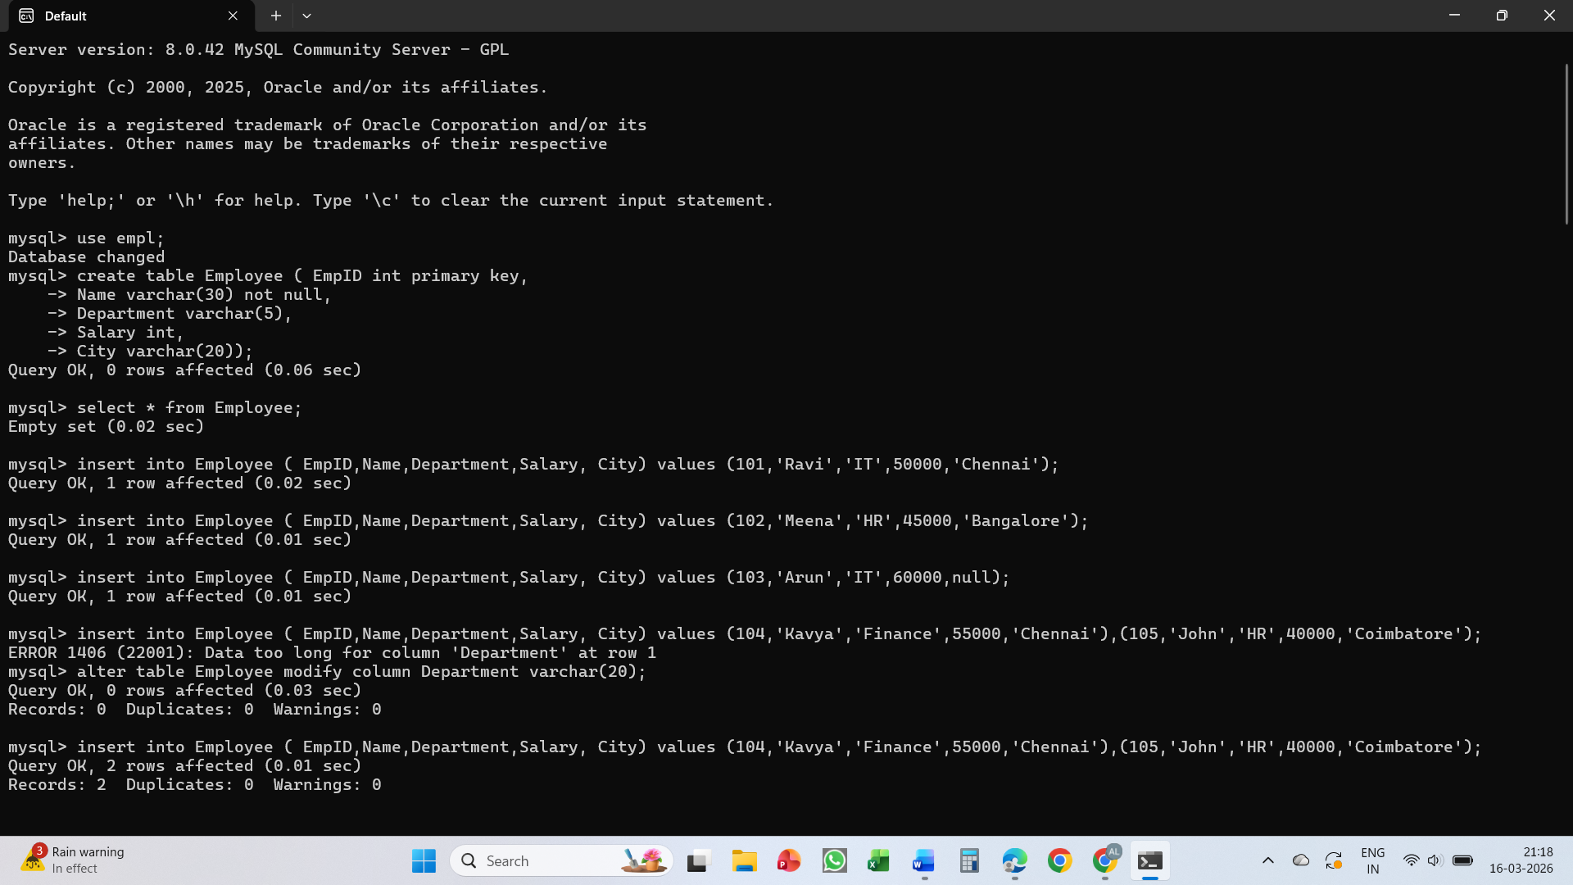

- Display all records from the Employee table.

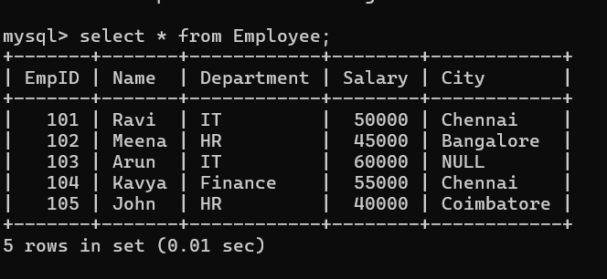

- Display only the Name and Salary of employees.
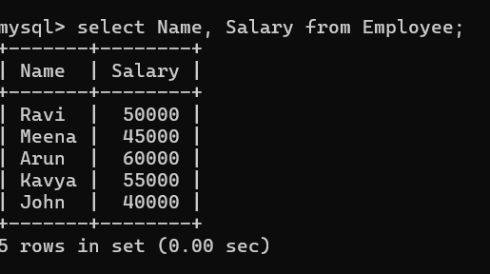
- Display employees whose salary is greater than 50,000.
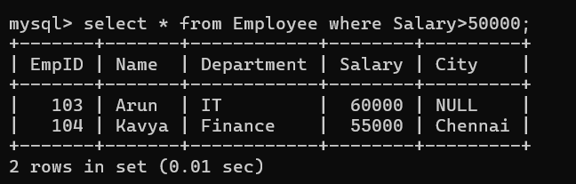
- Display employees who belong to the IT department.
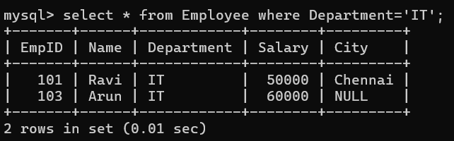
- Display employees whose city is Chennai.
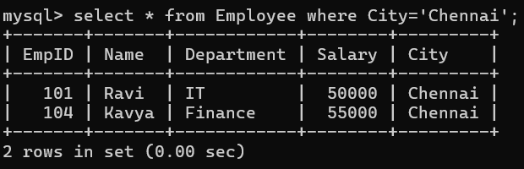

- Display employees whose salary is between 40,000 and 60,000.
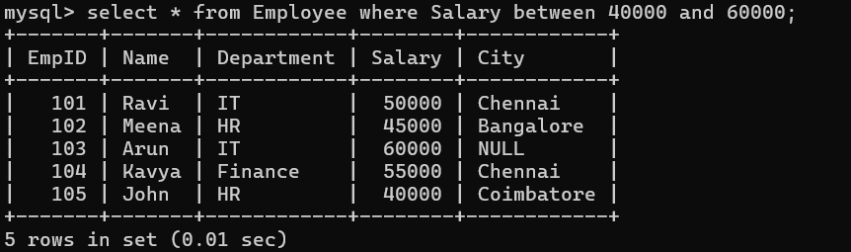

- Display employee names that start with the letter 'A' using the LIKE operator.
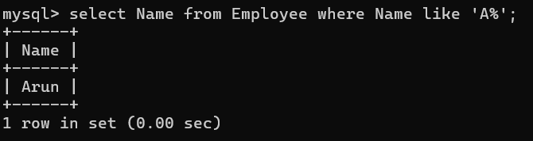

- Display distinct departments from the Employee table.
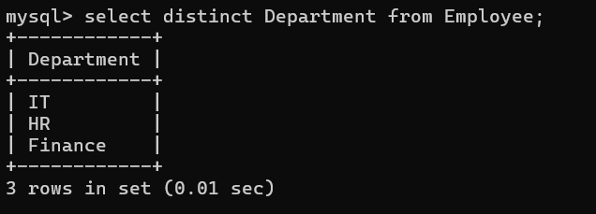

- Display employees whose City value is NULL.
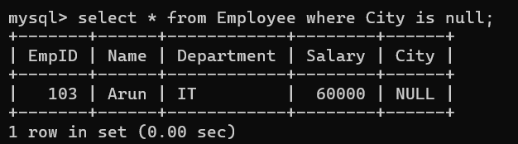

10. Find the total salary paid to all employees.
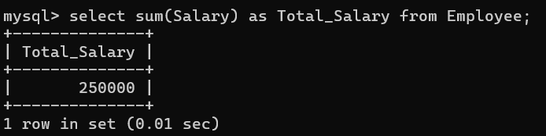
11. Find the average salary of employees in the IT department
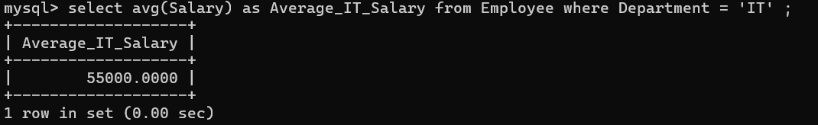

12. Count the number of employees in each department using GROUP BY.
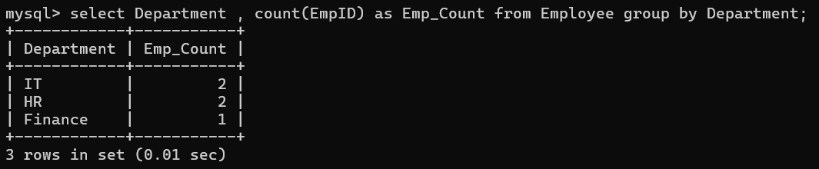

13. Display employees whose salary is greater than the average salary (nested subquery).
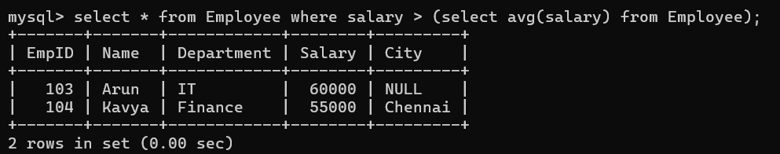

14. Write an SQL statement to insert a new employee record.

15. Write an SQL query to update the salary of employee with EmpID = 105 to 48000.

