**WORKSHOP 1: GETTING STARTED (part2)**

**PART 1: CREATE AND BUILD CALCULATOR [2h]**

* **Section 1: Create the project**

Make sure that you have installed Node and NPM by typing: **node -v** and **npm -v**.

Then start a new ionic project: **ionic start calculatrice blank**

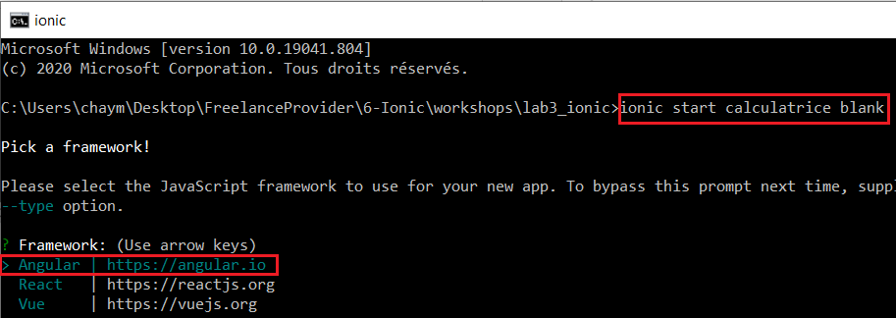

In this exercise, we will use cordova so type N (and not Capacitor)

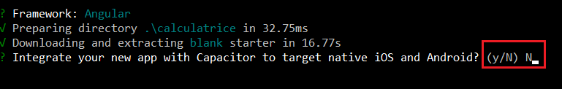

Then leave account to N



Next type **cd calculatrice**, open it with Visual Studio Code,

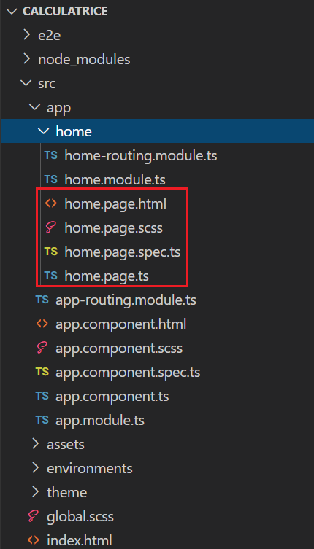

then type **ionic serve**

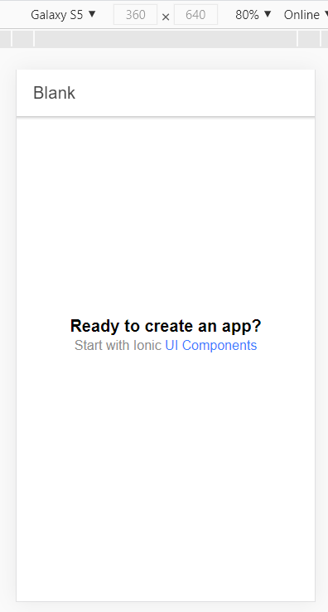

Add the following changes to the home.page.html

<ion-header [translucent]="true">

  <ion-toolbar>

    <ion-title>

      My First APP

    </ion-title>

  </ion-toolbar>

</ion-header>

<ion-content [fullscreen]="true">

  <ion-header collapse="condense">

    <ion-toolbar>

      <ion-title size="large">Blank</ion-title>

    </ion-toolbar>

  </ion-header>

  <div id="container">

    <strong>Hello Global Knowledge</strong>

    </div>

</ion-content>

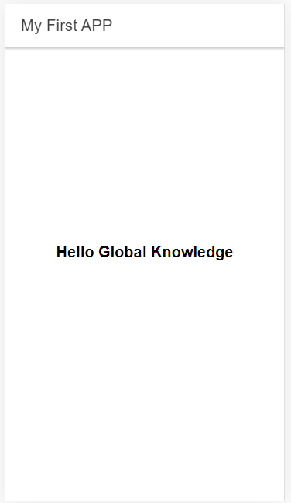

* **Section 2: Functions**
* **Update the** [**home.page.ts**](http://home.page.ts)

import { Component } from '@angular/core';

@Component({

  selector: 'app-home',

  templateUrl: 'home.page.html',

  styleUrls: ['home.page.scss'],

})

export class HomePage {

  display = '0';

  firstval: number = null;

  operator: any = null;

  newcursor = false;

  isc = false;

  iscomma = false;

  constructor() {}

  click(val: any) {

    switch (val) {

      case 'ac':

        this.display = '0';

        this.firstval = null;

        this.operator = null;

        this.newcursor = false;

        break;

      case 'c':

        this.display = '0';

        this.isc = false;

        break;

      case '+/-':

        if (Math.sign(parseInt(this.display, 0)) === 1) {

          const sign = -Math.abs(parseInt(this.display, 0));

          this.display = sign.toString();

        } else if (Math.sign(parseInt(this.display, 0)) === -1) {

          const sign = Math.abs(parseInt(this.display, 0));

          this.display = sign.toString();

        } else {

          this.display = this.display;

        }

        break;

      case '%':

        this.addpercent();

        break;

      case ':':

        this.addoperator(':');

        break;

      case 'X':

        this.addoperator('X');

        break;

      case '-':

        this.addoperator('-');

        break;

      case '+':

        this.addoperator('+');

        break;

      case '=':

        if (this.firstval !== null && this.operator !== null) {

          this.calclast();

        }

        this.operator = null;

        break;

      case '0':

        this.addnumber('0');

        break;

      case '1':

        this.addnumber('1');

        break;

      case '2':

        this.addnumber('2');

        break;

      case '3':

        this.addnumber('3');

        break;

      case '4':

        this.addnumber('4');

        break;

      case '5':

        this.addnumber('5');

        break;

      case '6':

        this.addnumber('6');

        break;

      case '7':

        this.addnumber('7');

        break;

      case '8':

        this.addnumber('8');

        break;

      case '9':

        this.addnumber('9');

        break;

      case ',':

        this.addcomma();

        break;

    }

  }

  addcomma() {

    if (this.iscomma === false) {

      this.iscomma = true;

    } else {

      this.iscomma = false;

    }

  }

  addnumber(nbr: string) {

    if (nbr === '0') {

      if (this.newcursor === true) {

        this.display = nbr;

        this.newcursor = false;

      } else if (this.display !== '0') {

        if (this.iscomma === true) {

          this.display = `${this.display.toString()}.${nbr}`;

        } else {

          this.display = this.display.toString() + nbr;

        }

      } else if (this.display === '0') {

        if (this.iscomma === true) {

          this.display = `${this.display.toString()}.${nbr}`;

        }

      }

    } else {

      if (this.newcursor === true) {

        this.display = nbr;

        this.newcursor = false;

      } else if (this.display === '0') {

        if (this.iscomma === true) {

          if (this.display.toString().indexOf('.') > -1) {

            this.display = this.display.toString() + nbr;

          } else {

            this.display = `${this.display.toString()}.${nbr}`;

          }

        } else {

          this.display = nbr;

        }

      } else {

        if (this.iscomma === true) {

          if (this.display.toString().indexOf('.') > -1) {

            this.display = this.display.toString() + nbr;

          } else {

            this.display = `${this.display.toString()}.${nbr}`;

          }

        } else {

          this.display = this.display.toString() + nbr;

        }

      }

    }

    this.isc = true;

  }

  addpercent() {

    this.iscomma = false;

    const dispval = parseInt(this.display, 0) / 100;

    this.display = dispval.toString();

  }

  addoperator(op: string) {

    if (this.newcursor === false) {

      if (this.firstval === null) {

        if (this.iscomma === true) {

          this.firstval = parseFloat(this.display);

        } else {

          this.firstval = parseInt(this.display, 0);

        }

      }

      if (this.firstval !== null && this.operator !== null) {

        this.calclast();

      }

    }

    this.iscomma = false;

    this.operator = op;

    this.newcursor = true;

  }

  calclast() {

    switch (this.operator) {

      case ':':

        if (this.iscomma === true) {

          this.firstval = (this.firstval / parseFloat(this.display));

        } else {

          this.firstval = (this.firstval / parseInt(this.display, 0));

        }

        break;

      case 'X':

        if (this.iscomma === true) {

          this.firstval = (this.firstval * parseFloat(this.display));

        } else {

          this.firstval = (this.firstval * parseInt(this.display, 0));

        }

        break;

      case '-':

        if (this.iscomma === true) {

          this.firstval = (this.firstval - parseFloat(this.display));

        } else {

          this.firstval = (this.firstval - parseInt(this.display, 0));

        }

        break;

      case '+':

        if (this.iscomma === true) {

          this.firstval = (this.firstval + parseFloat(this.display));

        } else {

          this.firstval = (this.firstval + parseInt(this.display, 0));

        }

        break;

    }

    this.display = this.firstval.toString();

  }

}

* **Section 3: Views(UI/UX)**
* **Update the** [**home.page.html**](http://home.page.html)

<ion-header [translucent]="true">

  <ion-toolbar>

    <ion-title>

      My First APP - Ma Calculatrice

    </ion-title>

  </ion-toolbar>

</ion-header>

<ion-content [fullscreen]="true">

  <div class="calc-main">

    <div class="calc-display">

      <ion-input type="number" [(ngModel)]="display" class="ion-text-end"></ion-input>

    </div>

    <ion-grid>

      <ion-row>

        <ion-col>

          <ion-button shape="round" color="light" *ngIf="!isc" (click)="click('ac')">AC</ion-button>

          <ion-button shape="round" color="light" *ngIf="isc" (click)="click('c')">C</ion-button>

        </ion-col>

        <ion-col>

          <ion-button shape="round" color="light" (click)="click('+/-')">+/-</ion-button>

        </ion-col>

        <ion-col>

          <ion-button shape="round" color="light" (click)="click('%')">%</ion-button>

        </ion-col>

        <ion-col>

          <ion-button shape="round" color="warning" (click)="click(':')">:</ion-button>

        </ion-col>

      </ion-row>

      <ion-row>

        <ion-col>

          <ion-button shape="round" color="dark" (click)="click('7')">7</ion-button>

        </ion-col>

        <ion-col>

          <ion-button shape="round" color="dark" (click)="click('8')">8</ion-button>

        </ion-col>

        <ion-col>

          <ion-button shape="round" color="dark" (click)="click('9')">9</ion-button>

        </ion-col>

        <ion-col>

          <ion-button shape="round" color="warning" (click)="click('X')">X</ion-button>

        </ion-col>

      </ion-row>

      <ion-row>

        <ion-col>

          <ion-button shape="round" color="dark" (click)="click('4')">4</ion-button>

        </ion-col>

        <ion-col>

          <ion-button shape="round" color="dark" (click)="click('5')">5</ion-button>

        </ion-col>

        <ion-col>

          <ion-button shape="round" color="dark" (click)="click('6')">6</ion-button>

        </ion-col>

        <ion-col>

          <ion-button shape="round" color="warning" (click)="click('-')">-</ion-button>

        </ion-col>

      </ion-row>

      <ion-row>

        <ion-col>

          <ion-button shape="round" color="dark" (click)="click('1')">1</ion-button>

        </ion-col>

        <ion-col>

          <ion-button shape="round" color="dark" (click)="click('2')">2</ion-button>

        </ion-col>

        <ion-col>

          <ion-button shape="round" color="dark" (click)="click('3')">3</ion-button>

        </ion-col>

        <ion-col>

          <ion-button shape="round" color="warning" (click)="click('+')">+</ion-button>

        </ion-col>

      </ion-row>

      <ion-row>

        <ion-col size="6">

          <ion-button shape="round" color="dark" (click)="click('0')" class="double-width">0</ion-button>

        </ion-col>

        <ion-col>

          <ion-button shape="round" color="dark" (click)="click(',')">,</ion-button>

        </ion-col>

        <ion-col>

          <ion-button shape="round" color="warning" (click)="click('=')">=</ion-button>

        </ion-col>

      </ion-row>

    </ion-grid>

  </div>

</ion-content>

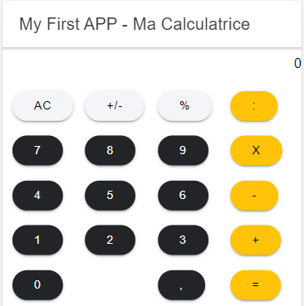

* **Update the** [**home.page.scss**](http://home.page.scss)

// #container {

//   text-align: center;

//   position: absolute;

//   left: 0;

//   right: 0;

//   top: 50%;

//   transform: translateY(-50%);

// }

// #container strong {

//   font-size: 20px;

//   line-height: 26px;

// }

// #container p {

//   font-size: 16px;

//   line-height: 22px;

//   color: #8c8c8c;

//   margin: 0;

// }

// #container a {

//   text-decoration: none;

// }

calc-main {

  background-color: #000000;

  height: 100%;

}

.calc-display {

  background-color: #000000;

  padding: 60px 15px 20px;

}

ion-input {

  color: #ffffff;

  font-size: 48px;

}

ion-col {

  padding: 0;

  margin: 0;

  text-align: center;

}

ion-button {

  height: 50px;

  width: 50px;

  border-radius: 50;

  font-size: 20px;

}

.double-width {

  width: 86%;

}

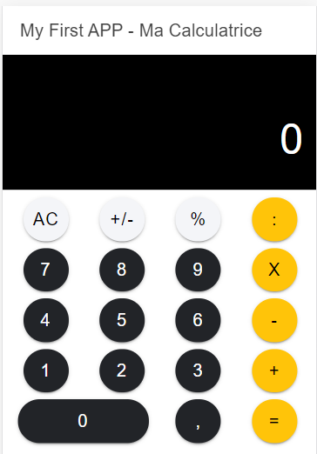

* **Section 4: Build Android App using Cordova**

You should install globaly cordova;

**npm install -g cordova**

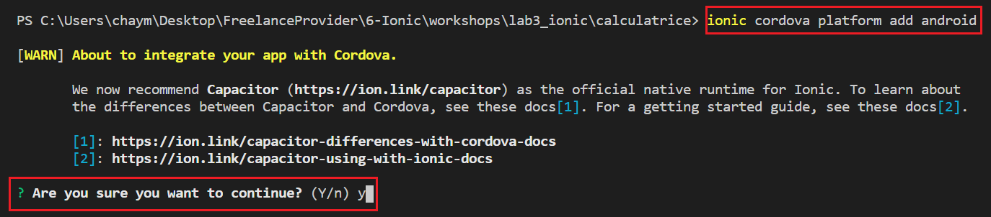

Then type

**ionic cordova run android**

**PART 2: CREATE AND BUILD LOGIN INTERFACE [2h]**

Create new project:

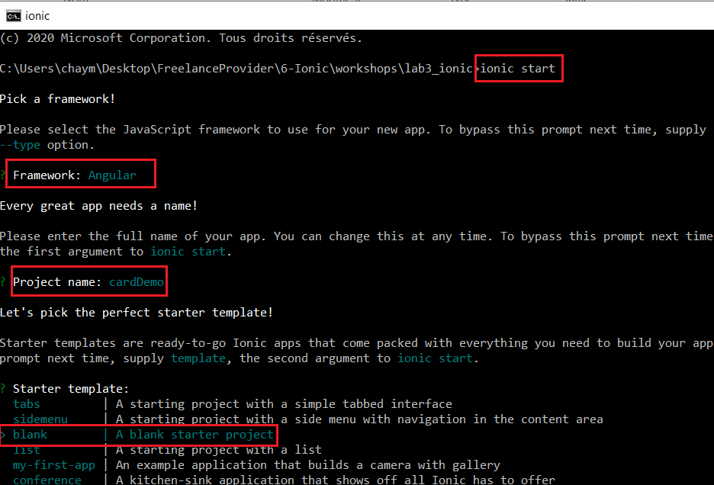

The go the Ionic documentation web site and add some UI web components : ion-card, ion-input …

<https://ionicframework.com/docs>

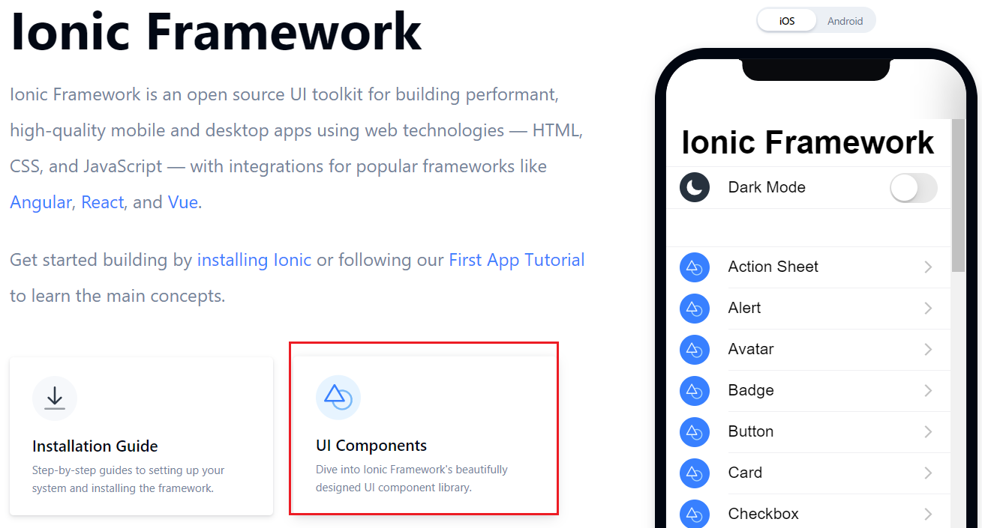

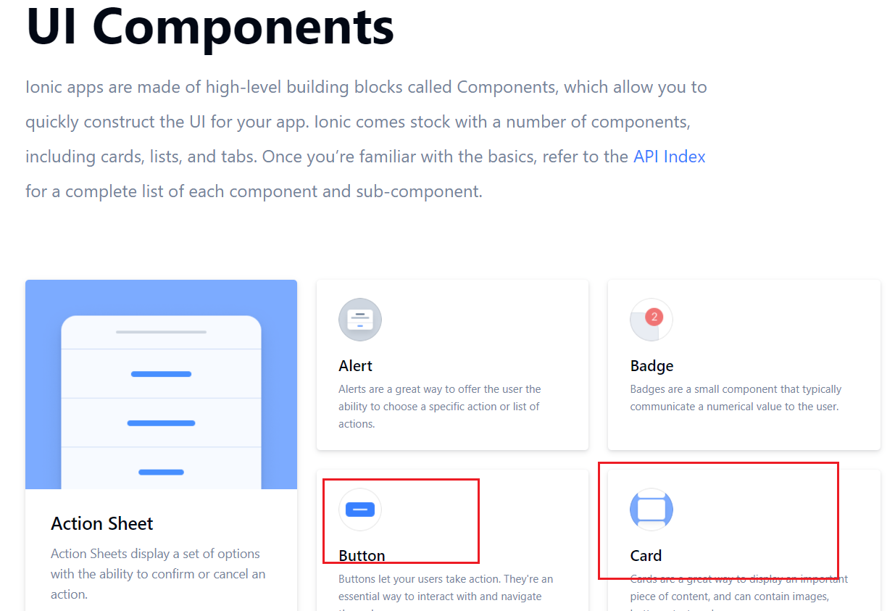

Choose to add ion-card

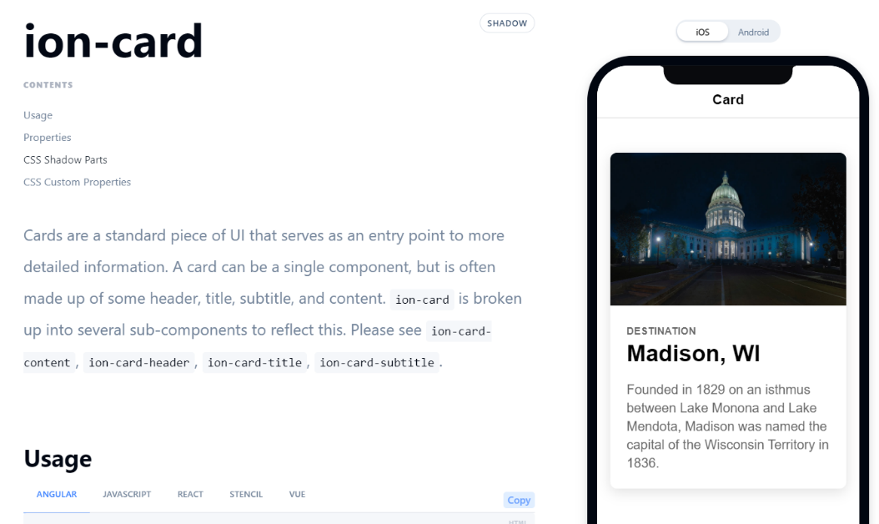

<ion-header [translucent]="true">

  <ion-toolbar>

    <ion-title>

      Bienvenue à Global Knowledge

    </ion-title>

  </ion-toolbar>

</ion-header>

<ion-content>

  <ion-card>

    <ion-card-header>

      <ion-card-subtitle>Développement Hybride avec IONIC</ion-card-subtitle>

      <ion-card-title>Ionic Course</ion-card-title>

    </ion-card-header>

    <ion-card-content>

      Required Tools : Angular, Ionic, Typescript, Component, Page, Service, Forms, Routing, Cordova, Capacitor

    </ion-card-content>

  </ion-card>

</ion-content>

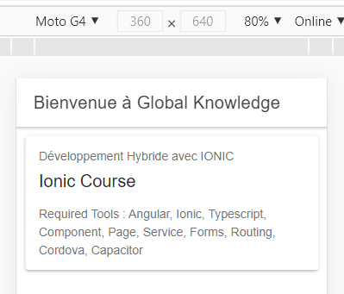



<ion-card-header>

      <img src="assets/gk.png" alt="logo of GK"/>

      <ion-card-subtitle>Développement Hybride avec IONIC</ion-card-subtitle>

      <ion-card-title>Ionic Course</ion-card-title>

    </ion-card-header>

Generate new ionic page using the following command: **ionic generate page login**

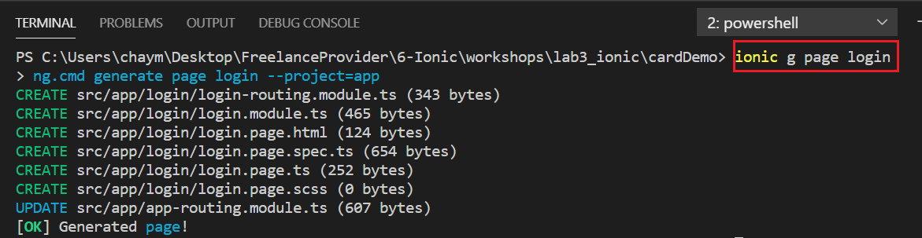

**Exercise 1 [30 min]**

1-Add a new image (Global Knowledge Logo) to your home page, place it in the assets folder

2-Add new page to you project, titled login

3-Create a new login form with a login button

4-Change the home page to be the login page

5-Finally we want to visit the home page only if we type the login button 😊

**Exercise 2 [60 min]**

Create new sidemenu ionic project, this project will display 4 teams. If we select to visit a given team, we will display the players (create 3 for each team) information in a ion-card [picture, number, name, country and a short biography] 😊