**WORKSHOP 1: GETTING STARTED (part3)**

* **Section 1: Create the project and add simple alert**

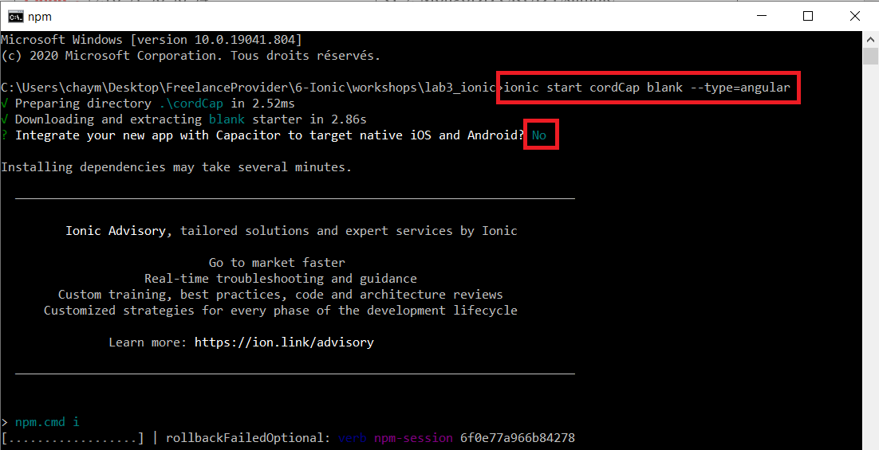

* [**Home.page.html**](http://Home.page.html)

<ion-header [translucent]="true">

  <ion-toolbar>

    <ion-title>

      IONIC BUILDING

    </ion-title>

  </ion-toolbar>

</ion-header>

<ion-content [fullscreen]="true">

  <ion-button (click)="openAlert()">Build</ion-button>

</ion-content>

* [**Home.page.ts**](http://Home.page.ts)

import { Component } from '@angular/core';

import { AlertController} from '@ionic/angular';

@Component({

  selector: 'app-home',

  templateUrl: 'home.page.html',

  styleUrls: ['home.page.scss'],

})

export class HomePage {

  constructor(public alertController: AlertController) { }

  async openAlert() {

    const alert = await this.alertController.create({

      cssClass: 'my-custom-class',

      header: 'Hello Ionic',

      message: 'Building for Android',

      buttons: ['Ok']

    });

    await alert.present();

  }

}

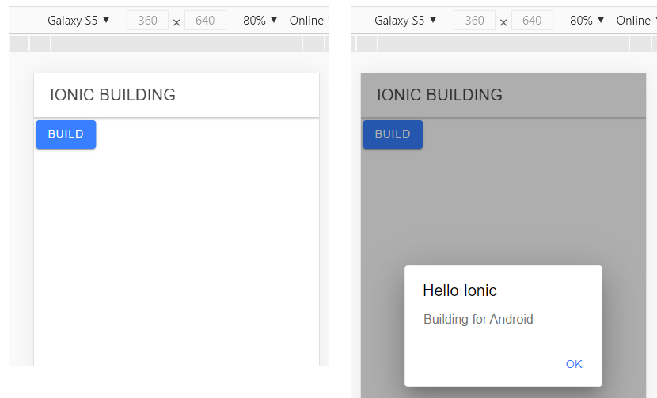

* <https://ionicframework.com/docs/developing/android>

**PART 1: BUILDING AND RUNNING USING CORDOVA [1h]**

You should have Installed: Android Studio, Java, Gradle

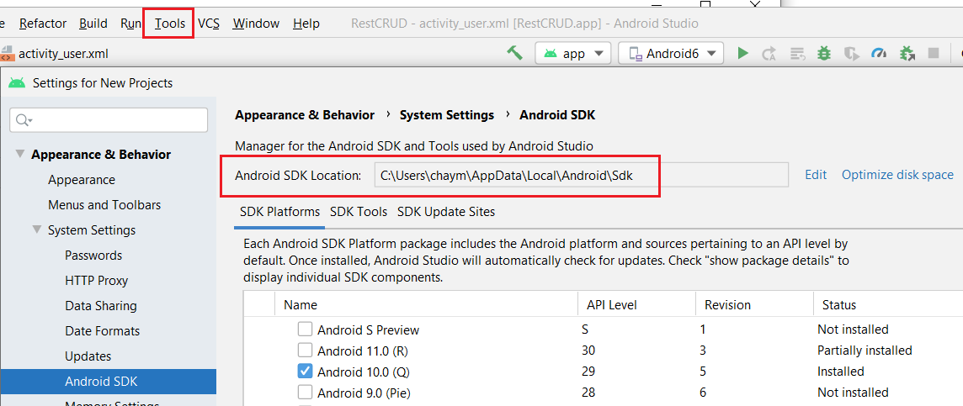

* For Gradle installation: <https://gradle.org/install/>

You should add it as a system environment variable

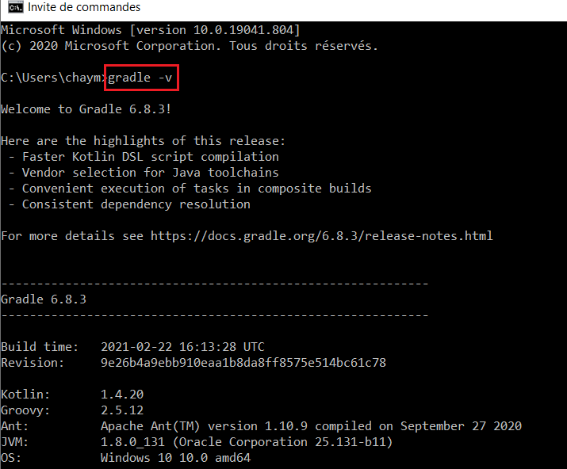

Next integrate Cordova to your project

<https://ionicframework.com/docs/developing/android#java>

The command is : ionic cordova prepare android

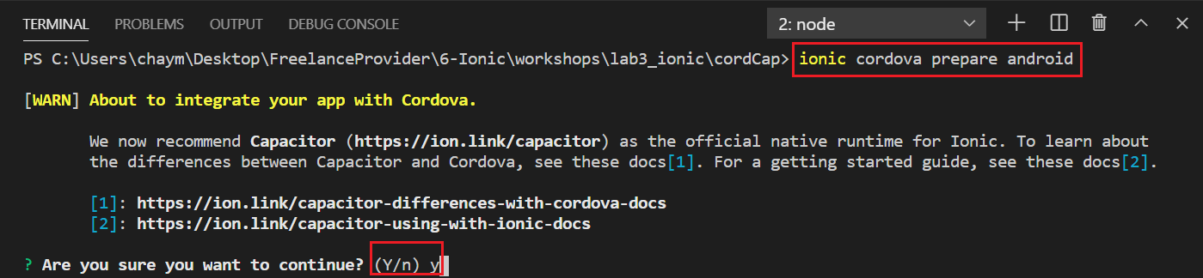

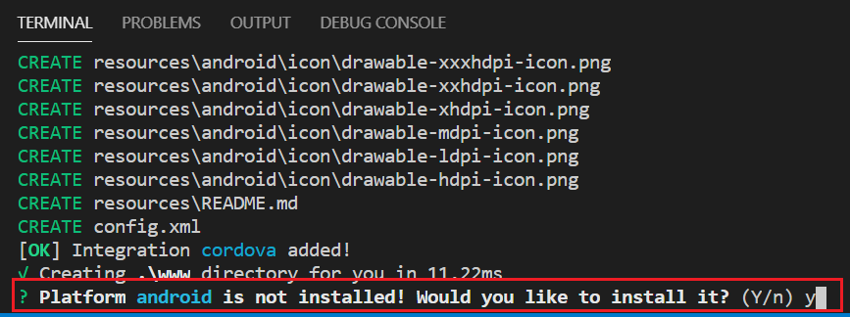

* Finally

**ionic cordova run android**

**PART 2: BUILDING AND RUNNING USING CAPACITOR**

**ionic capacitor add android**

For Capacitor, open the capacitor.config.json file and modify the appId property.

For Cordova, open the config.xml file and modify the id attribute of the root element, <widget>.

**ionic capacitor copy android**

**ionic capacitor run android**

Command to add Cordova and ionic

* For Window system
  + **npm install -g ionic**
  + **npm install -g cordova**

Command to remove Cordova and ionic

* For Window system
  + **npm uninstall -g ionic**
  + **npm uninstall -g cordova**