Designing and Implementing a Compiler Using Rightmost Derivation and Multi-Phase Processing

Abstract

A compiler is a fundamental component of modern computing systems, responsible for translating high-level programming languages into machine-executable code. This project presents the design and implementation of a compiler that incorporates all major compilation phases, including lexical analysis, syntax analysis using rightmost derivation, semantic analysis, intermediate code generation, code optimization, and target code generation. The compiler is implemented using a high-level programming language, with emphasis on modularity, clarity, and correctness. The study demonstrates how theoretical concepts such as parsing strategies and code optimization techniques can be applied in practice to build a functional compiler.

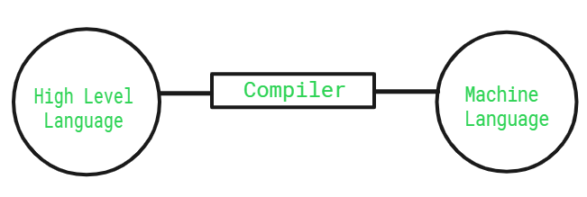

Introduction

Compilers play a critical role in software development by enabling programmers to write code in human-readable languages while allowing machines to execute instructions efficiently. The purpose of this project is to design and implement a compiler for a simplified programming language, focusing on the internal phases of compilation and their interaction.

This compiler follows a structured pipeline that includes lexical analysis, syntax analysis based on rightmost derivation, semantic checking, intermediate representation, and code optimization. The implementation aims to provide a clear understanding of compiler construction principles and their practical applications.

Compiler Architecture
The compiler is organized into multiple sequential phases, each responsible for a specific transformation of the source code. The overall architecture is illustrated as follows:

Source Code → Lexical Analysis → Syntax Analysis → Semantic Analysis → Intermediate Code Generation → Optimization → Target Code Generation → Final Output

Each phase processes the output of the previous stage, ensuring a systematic transformation from high-level source code to low-level executable instructions.

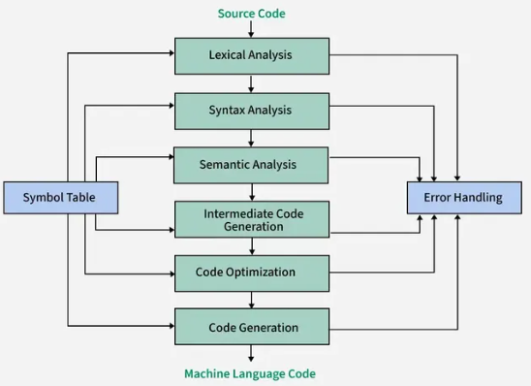

Lexical Analysis
Lexical analysis is the first phase of the compiler. It scans the source code and converts it into a sequence of tokens. Tokens represent meaningful elements such as identifiers, keywords, operators, and constants.

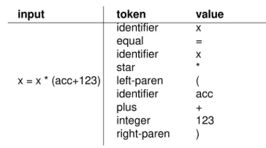

How to implement:
- Use regular expressions
- Loop through characters

Python tools:
- re module

Structure:

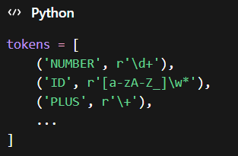

Syntax Analysis Using Rightmost Derivation

The syntax analyzer is implemented using explicit rightmost derivation, where the parser starts from the start symbol and expands the rightmost non-terminal at each step.

The parser is implemented using switch-case logic to determine actions based on the current state and input symbol.

How to implement this

  - Start with:
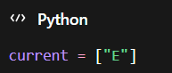

  - At each step:
- Find the rightmost non-terminal
- Replace it using grammar rules

  - Use backtracking (if needed)
Because:
- Some choices will fail
- You must try another rule

4. Use switch-case (as required)
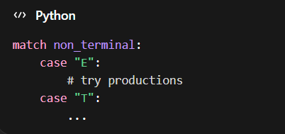

Implementation idea (simple structure)
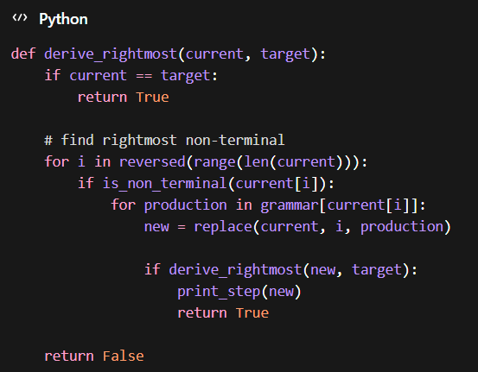

5. Semantic Analysis
Semantic analysis ensures that the program is logically consistent. It verifies rules that cannot be captured by syntax alone, such as type compatibility, variable declaration, and scope resolution.

How to implement:

-Use a symbol table

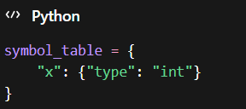

A symbol table is used to store information about identifiers, including their names, types, and scope levels. For example, assigning a string value to an integer variable would result in a semantic error.

Intermediate Code Generation

After successful semantic analysis, the compiler generates an intermediate representation of the program. In this project, Three Address Code (TAC) is used.
This representation simplifies further processing and optimization.

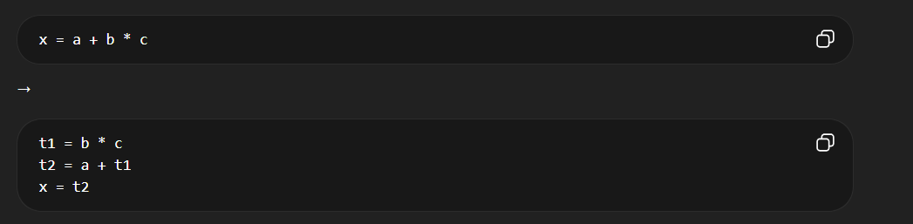

7. Intermediate Code Optimization
Optimization improves the efficiency of the generated code without altering its meaning. Several techniques are applied:
- Constant Folding: Evaluating constant expressions at compile time
- Dead Code Elimination: Removing unused or redundant instructions
- Common Subexpression Elimination: Avoiding repeated calculations
These optimizations reduce execution time and resource usage.

8. Target Code Generation
The optimized intermediate code is translated into target code, typically in an assembly-like language. This code represents instructions that can be executed by a machine or further assembled into machine code.

9. Target Code Optimization

Further optimizations are applied at the target code level to improve performance. These include minimizing memory access, removing redundant instructions, and improving instruction sequencing.

10. Programming Language Selection

The compiler is implemented using c++

☕ C / C++
Pros:
- Closest to real compilers
- Very fast
- Industry-level
Cons:
- Complex memory management
- Debugging is painful
- Slows your progress A LOT

🐍 Python
Pros:
- Very easy to write and debug
- Fast development
- Tons of libraries
- Great for prototyping compilers
Cons:
- Slower execution (not a problem here)
- Less “low-level”

☕ Java
Pros:
- Structured
- Strong typing (helps semantic analysis)
Cons:
- Verbose
- Slower to develop than Python

11. Graphical User Interface Design
A graphical user interface can enhance usability by allowing users to input source code and visualize compiler outputs. The interface may include:
- A text editor for writing source code
- Buttons to execute compilation phases
- Output panels for tokens, parse trees, and errors
- Visualization of intermediate and target code
The GUI can be implemented using Python libraries such as Tkinter or web-based frameworks.

GUI Ideas
1. Derivation Step Viewer
The derivation step viewer is a core component of the system, designed to explicitly demonstrate the process of rightmost derivation. At each step, the current sentential form is displayed, and the rightmost non-terminal is highlighted to indicate the production being applied.
The system supports both step-by-step execution and automatic playback, allowing users to observe how the input string is generated from the start symbol.
Example:
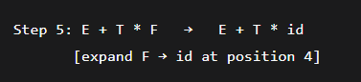
🔧 Implementation idea
- Store derivation steps in a list:
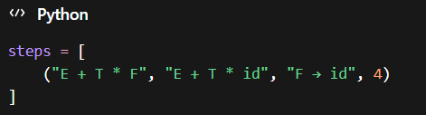
- Highlight index using GUI (color or bold)

2. Parse Tree and Derivation View
The interface provides a dual visualization:
- A parse tree representing the hierarchical structure of the input
- A derivation sequence showing the rightmost derivation steps
Selecting a derivation step highlights the corresponding node in the parse tree, enabling a clear mapping between derivation and structure.
🔧 Implementation idea
- Represent tree as nested objects:
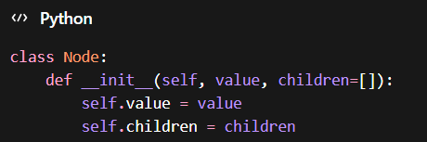
- Link each derivation step to a node ID

3. Three-Column Phase Trace
To illustrate the transformation across compiler phases, the system displays three synchronized columns:
- Source Code (with token highlighting)
- Intermediate Code (Three Address Code and optimized code)
- Target Assembly Code
Each line in the source corresponds to its transformed representation, and selecting a line highlights its evolution across phases.
🔧 Implementation idea
- Store mapping:
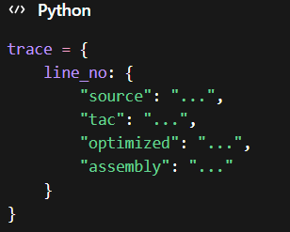
4. Symbol Table Explorer
The symbol table is visualized as a hierarchical structure representing nested scopes. Users can inspect identifiers, their types, and their usage locations.
Errors such as type mismatches are highlighted dynamically.
🔧 Implementation idea
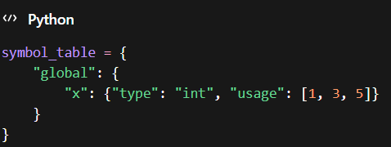
5. Optimization Control Panel
The system allows users to enable or disable specific optimization techniques, including:
- Constant Folding
- Dead Code Elimination
- Common Subexpression Elimination
The effects of each optimization are displayed through side-by-side comparisons of code before and after transformation.
🔧 Implementation idea
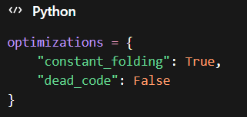
6. Error Propagation Visualization
When an error is detected, the system traces its origin across multiple phases, linking:
- The source code location
- The grammar rule involved
- The derivation step that led to the error
This provides a deeper understanding of how errors propagate through the compilation process.

7. Execution Trace (Optional Enhancement)
An optional interpreter simulates execution of the generated target code. The system displays the state of registers and memory after each instruction, allowing users to observe runtime behavior.

8. Grammar Rule Explorer
The system includes a module that tracks grammar rule usage during derivation. It records:
- Applied rules
- Backtracking occurrences
- Frequency of rule usage
This information is useful for both debugging and analysis.

What should ACTUALLY be implemented (priority)

MUST HAVE
- Derivation Step Viewer ⭐ (most important)
- Basic Parse Tree
- Symbol Table
- TAC generation

NICE TO HAVE
- Three-column trace
- Optimization toggles

OPTIONAL
- Error propagation visualization
- Execution trace
- Grammar statistics

12. Implementation Plan
The project is developed incrementally in the following stages:
- Define the grammar and tokens of the language
- Implement the lexical analyzer
- Develop the syntax analyzer using rightmost derivation
- Add semantic analysis with a symbol table
- Generate intermediate code
- Apply optimization techniques
- Produce target code
- Design and integrate the user interface

13. Conclusion
This project demonstrates the complete process of compiler construction, from source code analysis to target code generation. By implementing each phase, the project provides a comprehensive understanding of how programming languages are translated and executed. The use of rightmost derivation in syntax analysis highlights the importance of parsing strategies in compiler design.

The final system serves as both an educational tool and a practical implementation of compiler theory, bridging the gap between academic concepts and real-world applications.

