## Low Moderate High

## 0.00000 16.21622 83.78378

|  |  |  |
| --- | --- | --- |
| ## Kaiser-Meyer-Olkin factor adequacy ## Call: KMO(r = cor(data2[, 1:32])) ## Overall MSA = 0.19  ## MSA for each item =  ## angry frustrated | understood | respected |
| ## 0.12 0.23 | 0.23 | 0.20 |
| ## pleased satisfied | equal | talking |
| ## 0.22 0.16 | 0.12 | 0.36 |
| ## correct change_ttt | pat_saftey | pat_care |
| ## 0.15 0.16 | 0.23 | 0.10 |
| ## schedule exch_info | tired | help |
| ## 0.30 0.26 | 0.29 | 0.30 |
| ## listen corr_info | non_compliance | Negligence |
| ## 0.22 0.16 | 0.14 | 0.19 |
| ## abuse poor_att | uncooperative | gender_diff |
| ## 0.10 0.25 | 0.32 | 0.18 |
| ## unfavor_att poor_commun | disruptive | differential_ttt |
| ## 0.33 0.25 | 0.12 | 0.21 |
| ## absc_forum shar_vision | malfunctioning | suppl_short |
| ## 0.37 0.07 | 0.11 | 0.19 |

Sort descending

|  |  |  |  |  |
| --- | --- | --- | --- | --- |
| ## | absc_forum | talking | unfavor_att | uncooperative |
| ## | 0.37070330 | 0.36242139 | 0.33247179 | 0.32364245 |
| ## | schedule | help | tired | exch_info |
| ## | 0.30254907 | 0.30133434 | 0.29438181 | 0.25508480 |
| ## | poor_commun | poor_att | understood | pat_saftey |
| ## | 0.24732506 | 0.24575059 | 0.23497311 | 0.23348955 |
| ## | frustrated | listen | pleased | differential_ttt |
| ## | 0.22972569 | 0.22187492 | 0.22087302 | 0.21350741 |
| ## | respected | Negligence | suppl_short | gender_diff |
| ## | 0.20262245 | 0.19441938 | 0.19067583 | 0.17797786 |
| ## | corr_info | satisfied | change_ttt | correct |
| ## | 0.16492751 | 0.16217740 | 0.15558426 | 0.15182796 |
| ## | non_compliance | disruptive | equal | angry |
| ## | 0.14274365 | 0.12459440 | 0.11855172 | 0.11557180 |
| ## | malfunctioning | abuse | pat_care | shar_vision |
| ## | 0.11290674 | 0.10267060 | 0.09935746 | 0.06656210 |

## Bartlett's Test of Sphericity

##

## Call: bart_spher(x = cor(data2[, 1:32]), use = "everything") ##

## X2 = 2131.944

## df = 496

## p-value < 2.22e-16

Openness

|  |  |  |  |
| --- | --- | --- | --- |
| ## |  | | |
| ## | Low | Moderate | High |
| ## | 0.000000 | 2.702703 | 97.297297 |

Demographic data

|  |  |
| --- | --- |
| Participants Characteristics | N = 37**1** |
| Nurse | 18 (49%) |
| Physician | 19 (51%) |
| **2. Working hospital** |  |
| district/ non-teaching hospital | 22 (59%) |
| Teaching/referral hospital | 15 (41%) |
| **3. Parcticipants Gender** |  |
| Female | 28 (76%) |
| Male | 9 (24%) |
| **4. Age Intervals (years)** |  |
| 30-35 | 2 (5.4%) |
| 35-40 | 14 (38%) |
| 40-45 | 19 (51%) |
| 45-50 | 2 (5.4%) |
| **5. Marital status** |  |
| Ever married | 3 (8.1%) |
| Married | 34 (92%) |
| **6. Last Educational Qualification** |  |
| Bachelor | 1 (2.7%) |
| Master | 18 (49%) |
| PhD | 3 (8.1%) |
| Post graduate diploma | 15 (41%) |
| **7. Professional Training** |  |
| America | 2 (5.4%) |
| Arab country | 9 (24%) |

|  |  |
| --- | --- |
| Participants Characteristics | N = 37**1** |
| Ausrilia | 3 (8.1%) |
| Canada | 5 (14%) |
| India | 18 (49%) |
| Philipin | 0 (0%) |
| **9. Salary category in AED** |  |
| 15000 to 20000 | 4 (11%) |
| 20000 to 25000 | 14 (38%) |
| 25000 to 30000 | 18 (49%) |
| 30000 to 35000 | 1 (2.7%) |
| **10. Position presently hold in the hospital** |  |
| consultant physician | 3 (8.1%) |
| GP physician | 7 (19%) |
| Head nurse | 1 (2.7%) |
| Head of department physician | 0 (0%) |
| Medical director physician | 1 (2.7%) |
| Registered nurse | 7 (19%) |
| Specialist physician | 7 (19%) |
| Supervisor nurse | 11 (30%) |
| **11. Service (in years)** | 7.00 (3.00, 9.00) |
| **8. Working unit category** |  |
| dental | 4 (11%) |
| Emergency department | 3 (8.1%) |
| ICU | 8 (22%) |
| Medical department | 3 (8.1%) |

|  |  |
| --- | --- |
| Participants Characteristics | N = 37**1** |
| Obstetrics and gynaecology department | 5 (14%) |
| Ophthalmology departemnt | 2 (5.4%) |
| Paediatrics department | 5 (14%) |
| Surgical departement | 7 (19%) |
| **12. Parcticipants Race** |  |
| Arab & Iranian | 9 (24%) |
| East Asians | 0 (0%) |
| South Asians | 18 (49%) |
| Westerners | 10 (27%) |
| *1* Median (IQR) or Frequency (%) |  |

Association between nurse and physician

**Table 1. Participants' Characteristics By Profession (n = 50)**

|  |  |  |  |
| --- | --- | --- | --- |
| Participants Characteristics | Nurse**, N = 181** | Physician**, N = 191** | p-value**2** |
| **2. Working hospital** |  |  | **0.027** |
| district/ non-teaching hospital | 14 (78%) | 8 (42%) |  |
| Teaching/referral hospital | 4 (22%) | 11 (58%) |  |
| **3. Parcticipants Gender** |  |  | **0.001** |
| Female | 18 (100%) | 10 (53%) |  |
| Male | 0 (0%) | 9 (47%) |  |

|  |  |  |  |
| --- | --- | --- | --- |
| Participants Characteristics | Nurse**, N = 181** | Physician**, N = 191** | p-value**2** |
| **4. Age Intervals (years)** |  |  | **0.019** |
| 30-35 | 2 (11%) | 0 (0%) |  |
| 35-40 | 3 (17%) | 11 (58%) |  |
| 40-45 | 11 (61%) | 8 (42%) |  |
| 45-50 | 2 (11%) | 0 (0%) |  |
| **5. Marital status** |  |  | 0.23 |
| Ever married | 0 (0%) | 3 (16%) |  |
| Married | 18 (100%) | 16 (84%) |  |
| **6. Last Educational Qualification** |  |  | 0.38 |
| Bachelor | 1 (5.6%) | 0 (0%) |  |
| Master | 10 (56%) | 8 (42%) |  |
| PhD | 2 (11%) | 1 (5.3%) |  |
| Post graduate diploma | 5 (28%) | 10 (53%) |  |
| **7. Professional Training** |  |  | **0.002** |
| America | 2 (11%) | 0 (0%) |  |
| Arab country | 2 (11%) | 7 (37%) |  |
| Ausrilia | 3 (17%) | 0 (0%) |  |
| Canada | 5 (28%) | 0 (0%) |  |
| India | 6 (33%) | 12 (63%) |  |
| Philipin | 0 (0%) | 0 (0%) |  |
| **9. Salary category in AED** |  |  | 0.55 |
| 15000 to 20000 | 1 (5.6%) | 3 (16%) |  |
| 20000 to 25000 | 8 (44%) | 6 (32%) |  |
| 25000 to 30000 | 8 (44%) | 10 (53%) |  |

|  |  |  |  |
| --- | --- | --- | --- |
| Participants Characteristics | Nurse**, N = 181** | Physician**, N = 191** | p-value**2** |
| 30000 to 35000 | 1 (5.6%) | 0 (0%) |  |
| **10. Position presently hold in the hospital** |  |  | **<0.001** |
| consultant physician | 0 (0%) | 3 (16%) |  |
| GP physician | 0 (0%) | 7 (37%) |  |
| Head nurse | 1 (5.6%) | 0 (0%) |  |
| Head of department physician | 0 (0%) | 0 (0%) |  |
| Medical director physician | 0 (0%) | 1 (5.3%) |  |
| Registered nurse | 7 (39%) | 0 (0%) |  |
| Specialist physician | 0 (0%) | 7 (37%) |  |
| Supervisor nurse | 10 (56%) | 1 (5.3%) |  |
| **service** | 9.00 (7.25, 10.00) | 4.00 (2.00, 6.00) | **<0.001** |
| **8. Working unit category** |  |  | 0.90 |
| dental | 3 (17%) | 1 (5.3%) |  |
| Emergency department | 1 (5.6%) | 2 (11%) |  |
| ICU | 4 (22%) | 4 (21%) |  |
| Medical department | 2 (11%) | 1 (5.3%) |  |
| Obstetrics and gynaecology department | 3 (17%) | 2 (11%) |  |
| Ophthalmology departemnt | 1 (5.6%) | 1 (5.3%) |  |
| Paediatrics department | 2 (11%) | 3 (16%) |  |
| Surgical departement | 2 (11%) | 5 (26%) |  |
| **12. Parcticipants Race** |  |  | **<0.001** |
| Arab & Iranian | 2 (11%) | 7 (37%) |  |
| East Asians | 0 (0%) | 0 (0%) |  |
| South Asians | 6 (33%) | 12 (63%) |  |

|  |  |  |  |
| --- | --- | --- | --- |
| Participants Characteristics | Nurse**, N = 181** | Physician**, N = 191** | p-value**2** |
| Westerners | 10 (56%) | 0 (0%) |  |
| 1. Median (IQR) or Frequency (%) 2. Pearson's Chi-squared test; Fisher's exact test; Wilcoxon rank sum test | | |  |

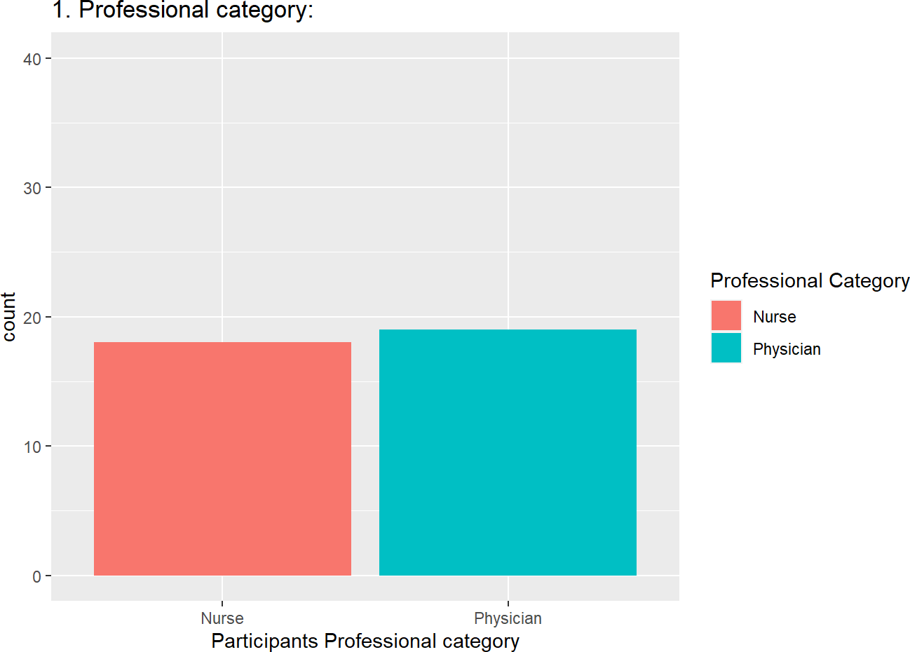

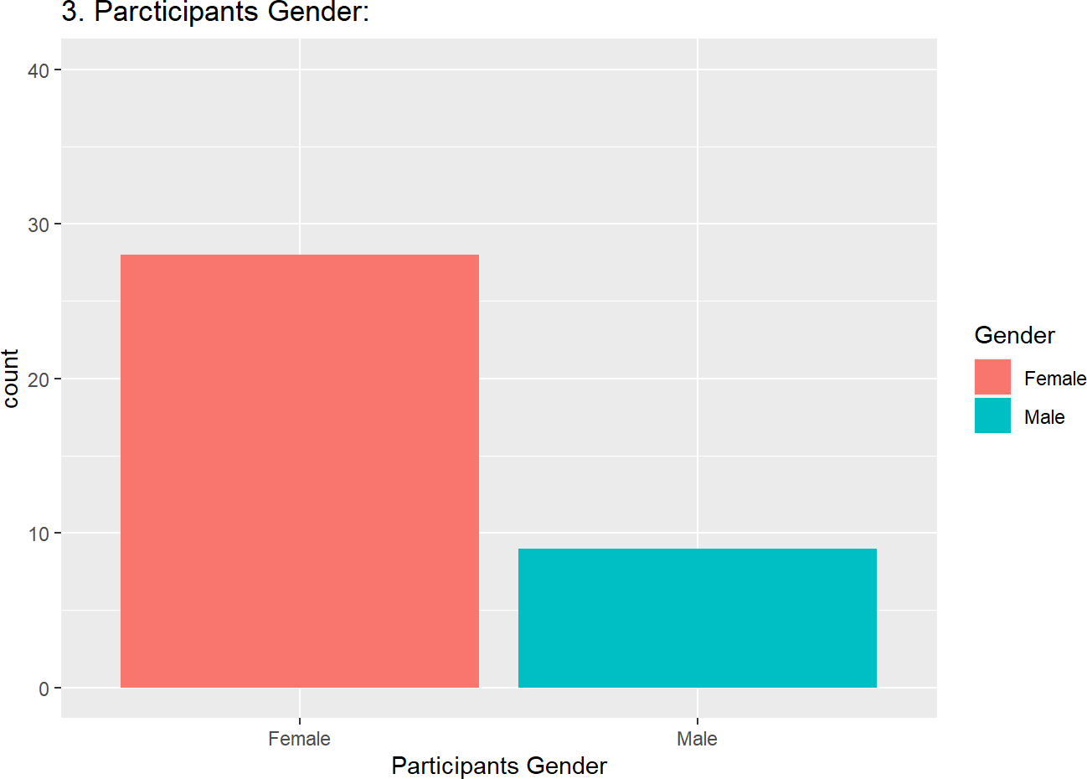

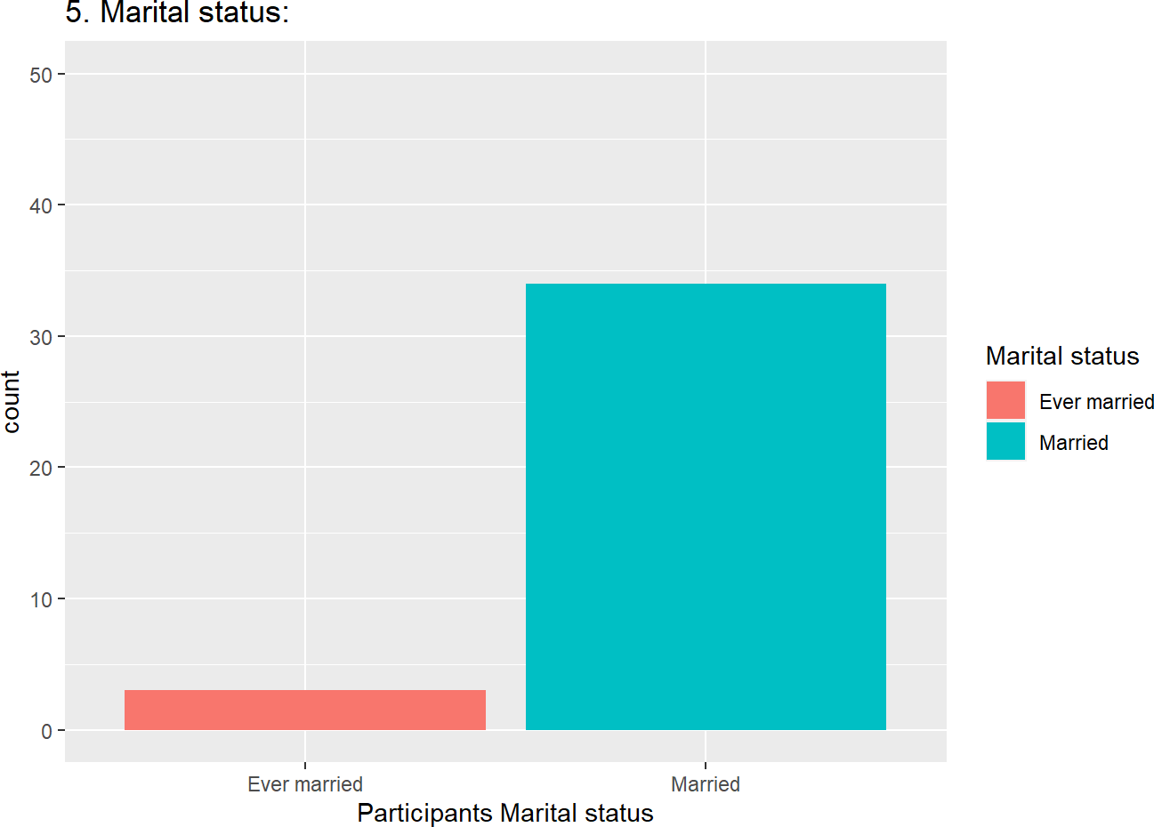

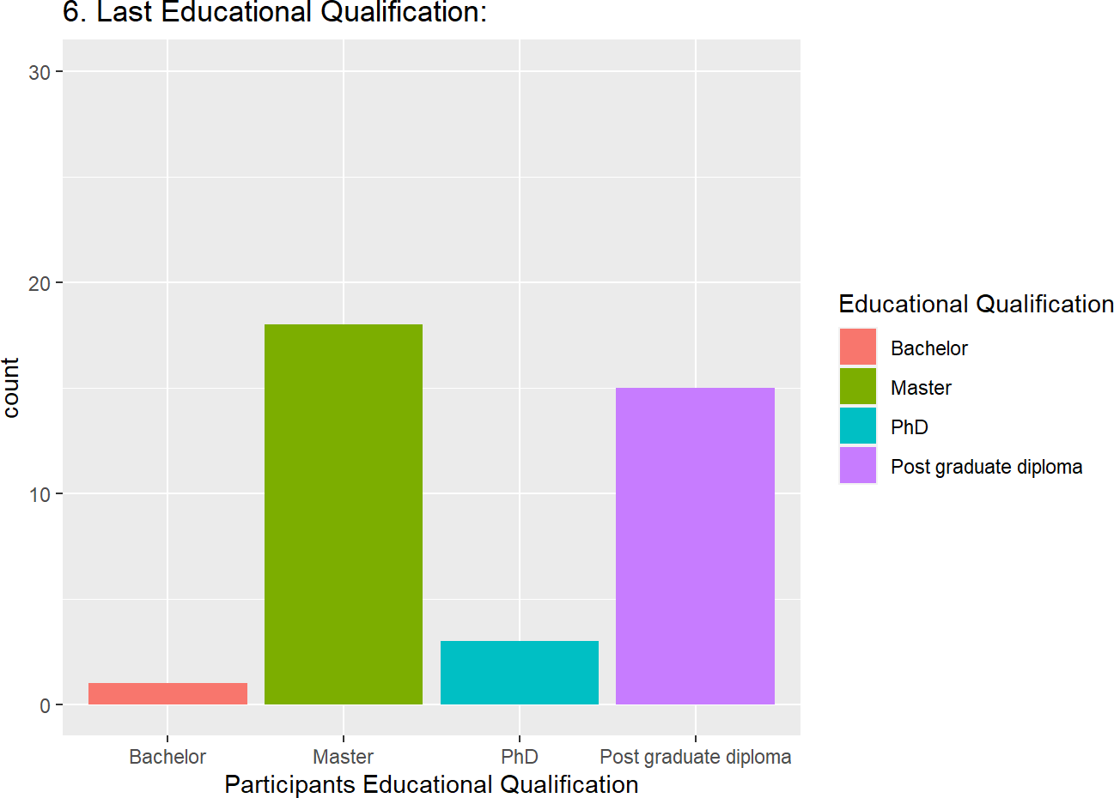

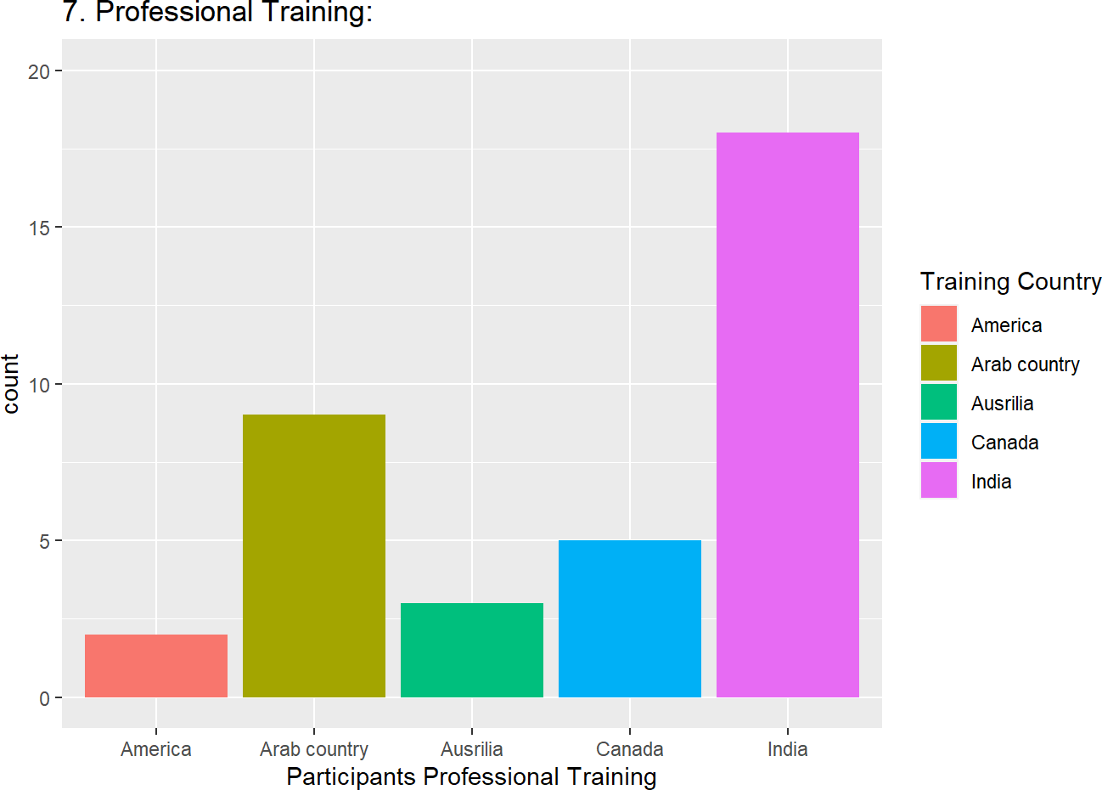

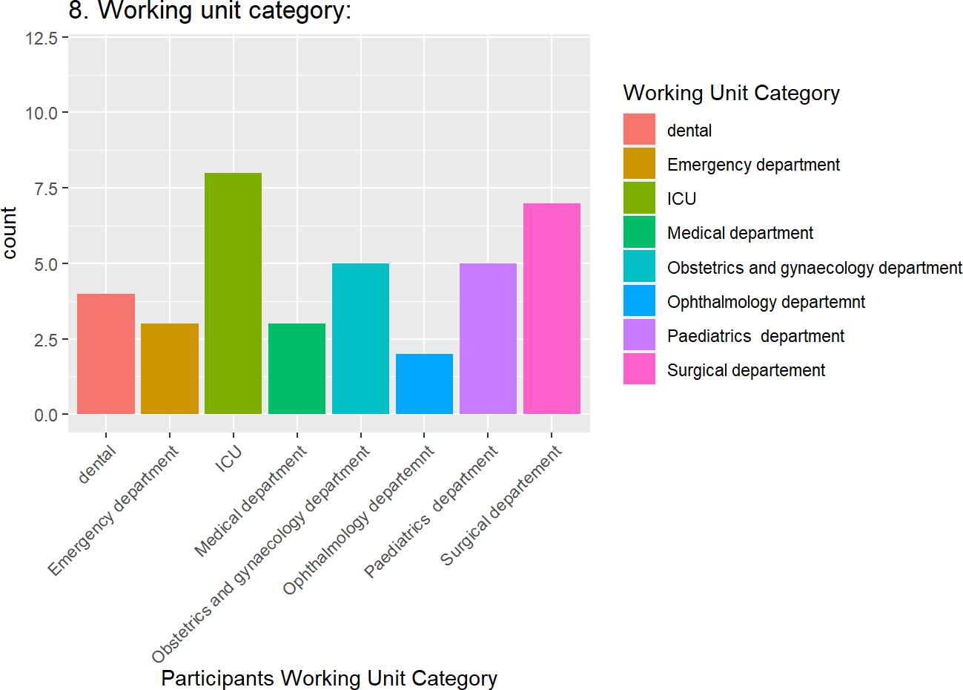

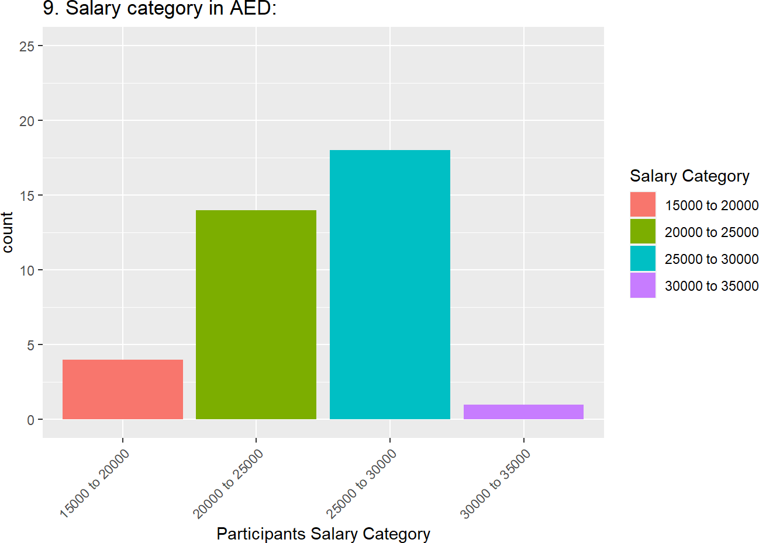

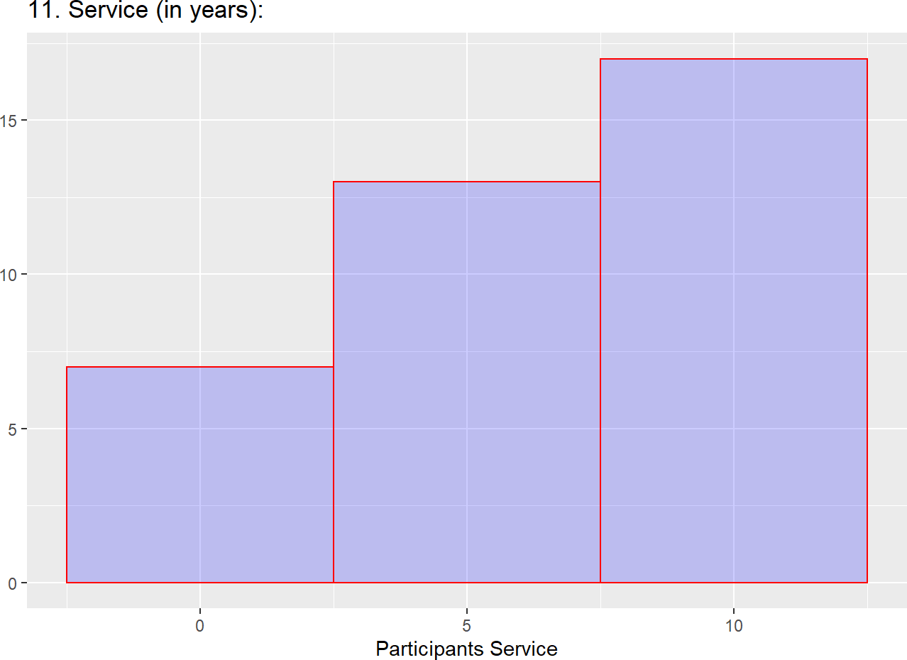

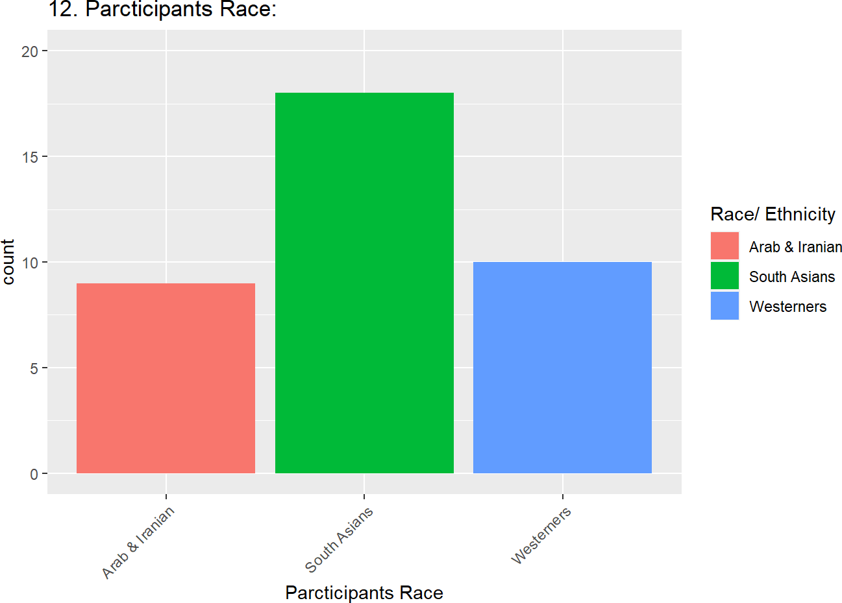

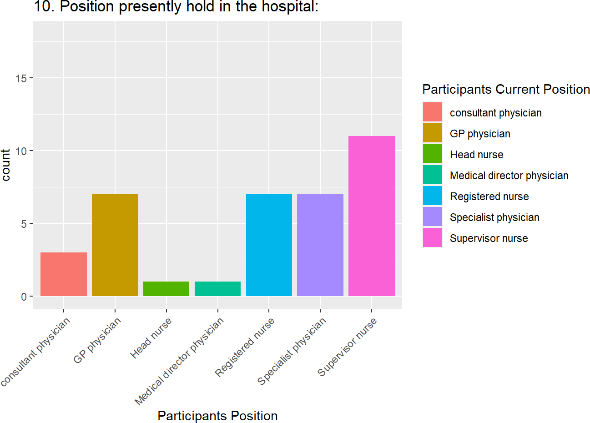

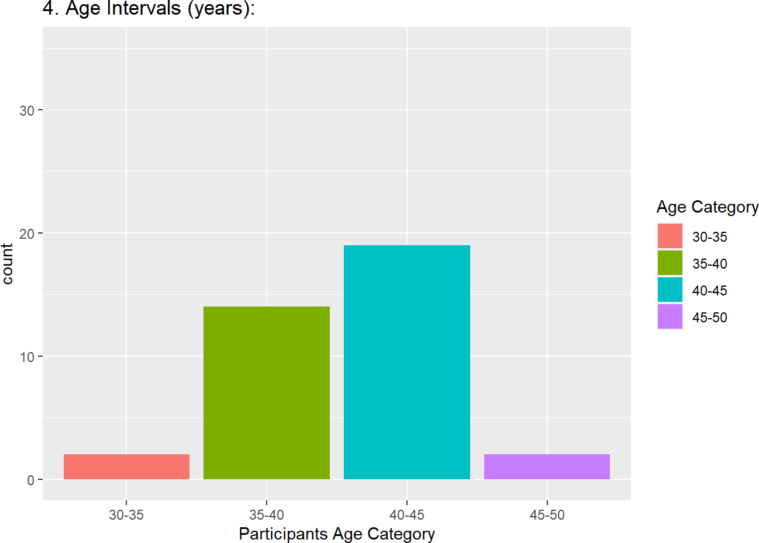

## lower alpha upper 95% confidence boundaries ## 0.26 0.51 0.75

##

|  |  |  |  |  |  |  |  |  |  |  |  |  |  |  |  |  |  |
| --- | --- | --- | --- | --- | --- | --- | --- | --- | --- | --- | --- | --- | --- | --- | --- | --- | --- |
| ## | Reliability if | | an item is | | dropped: | | |  | | | | | | | | | |
| ## |  | raw_alpha | | std.alpha | | | G6(smc) | | average_r | | | S/N | alpha se | | var.r | med.r | |
| ## | angry | 0.51 | | 0.52 | | | 0.64 | | 0.120 | | | 1.09 | 0.12 | | 0.032 | 0.086 | |
| ## | frustrated- | 0.56 | | 0.56 | | | 0.67 | | 0.138 | | | 1.28 | 0.11 | | 0.029 | 0.089 | |
| ## | understood | 0.53 | | 0.55 | | | 0.67 | | 0.130 | | | 1.20 | 0.12 | | 0.036 | 0.100 | |
| ## | respected | 0.44 | | 0.46 | | | 0.62 | | 0.097 | | | 0.86 | 0.14 | | 0.041 | 0.075 | |
| ## | pleased | 0.46 | | 0.49 | | | 0.65 | | 0.106 | | | 0.95 | 0.13 | | 0.042 | 0.077 | |
| ## | satisfied | 0.42 | | 0.44 | | | 0.62 | | 0.090 | | | 0.80 | 0.15 | | 0.040 | 0.083 | |
| ## | equal- | 0.45 | | 0.46 | | | 0.60 | | 0.097 | | | 0.86 | 0.14 | | 0.036 | 0.082 | |
| ## | talking | 0.45 | | 0.47 | | | 0.57 | | 0.101 | | | 0.90 | 0.14 | | 0.031 | 0.082 | |
| ## | correct | 0.42 | | 0.43 | | | 0.59 | | 0.087 | | | 0.76 | 0.14 | | 0.035 | 0.080 | |
| ## |  |  | |  | | |  | |  | | |  |  | |  |  | |
| ## | Item statistics | | |  | | |  | |  | | |  |  | |  |  | |
| ## |  | n | raw.r | std.r | r.cor | | r.drop | | mean | sd | | | | | | | |
| ## | angry | 37 | 0.40 | 0.37 | 0.29 | | 0.127 | | 4.4 | 0.82 | | | | | | | |
| ## | frustrated- | 37 | 0.26 | 0.25 | 0.12 | | -0.011 | | 1.6 | 0.79 | | | | | | | |
| ## | understood | 37 | 0.27 | 0.30 | 0.16 | | 0.044 | | 4.4 | 0.64 | | | | | | | |
| ## | respected | 37 | 0.55 | 0.53 | 0.45 | | 0.309 | | 4.4 | 0.79 | | | | | | | |
| ## | pleased | 37 | 0.46 | 0.46 | 0.35 | | 0.260 | | 4.5 | 0.65 | | | | | | | |
| ## | satisfied | 37 | 0.57 | 0.57 | 0.50 | | 0.376 | | 4.5 | 0.69 | | | | | | | |
| ## | equal- | 37 | 0.50 | 0.52 | 0.47 | | 0.302 | | 1.6 | 0.64 | | | | | | | |
| ## | talking | 37 | 0.50 | 0.50 | 0.48 | | 0.284 | | 4.5 | 0.69 | | | | | | | |
| ## | correct | 37 | 0.57 | 0.60 | 0.56 | | 0.384 | | 4.5 | 0.65 | | | | | | | |
| ## |  |  |  |  |  | |  | |  |  | | | | | | | |
| ## Non missing response frequency for each item | | | | | | | | | | | | | | | | | |
| ## |  | 1 | 2 | 3 | 4 | 5 | | miss | | | | | | | | | |
| ## | angry | 0.00 | 0.03 | 0.14 | 0.30 | 0.54 | | 0 | | | | | | | | | |
| ## | frustrated | 0.03 | 0.00 | 0.03 | 0.49 | 0.46 | | 0 | | | | | | | | | |
| ## | understood | 0.00 | 0.00 | 0.08 | 0.43 | 0.49 | | 0 | | | | | | | | | |
| ## | respected | 0.00 | 0.03 | 0.11 | 0.32 | 0.54 | | 0 | | | | | | | | | |
| ## | pleased | 0.00 | 0.00 | 0.08 | 0.32 | 0.59 | | 0 | | | | | | | | | |
| ## | satisfied | 0.00 | 0.00 | 0.11 | 0.32 | 0.57 | | 0 | | | | | | | | | |
| ## | equal | 0.00 | 0.00 | 0.08 | 0.43 | 0.49 | | 0 | | | | | | | | | |
| ## | talking | 0.00 | 0.00 | 0.11 | 0.30 | 0.59 | | 0 | | | | | | | | | |
| ## | correct | 0.00 | 0.00 | 0.08 | 0.32 | 0.59 | | 0 | | | | | | | | | |
| Characteristic | | | | | | | | | | | | Nurse**, N = 181** | | | Physician**, N = 191** | | | p-value**2** | |
| 1. Feeling not angry after nurse and physician interaction? | | | | | | | | | | | |  | | |  | | | >0.9 | |
| Always | | | | | | | | | | | | 10 (56%) | | | 10 (53%) | | |  | |
| Rarely | | | | | | | | | | | | 0 (0%) | | | 1 (5.3%) | | |  | |
| Sometimes | | | | | | | | | | | | 3 (17%) | | | 2 (11%) | | |  | |
| Usually | | | | | | | | | | | | 5 (28%) | | | 6 (32%) | | |  | |
| 2. Feeling not frustrated after nurse and physician interaction? | | | | | | | | | | | |  | | |  | | | 0.2 | |
| Always | | | | | | | | | | | | 6 (33%) | | | 11 (58%) | | |  | |
| Never | | | | | | | | | | | | 0 (0%) | | | 1 (5.3%) | | |  | |
| Sometimes | | | | | | | | | | | | 1 (5.6%) | | | 0 (0%) | | |  | |
| Usually | | | | | | | | | | | | 11 (61%) | | | 7 (37%) | | |  | |
| 3. Feeling understood after nurse and physician interaction? | | | | | | | | | | | |  | | |  | | | 0.060 | |
| Always | | | | | | | | | | | | 10 (56%) | | | 8 (42%) | | |  | |
| Sometimes | | | | | | | | | | | | 3 (17%) | | | 0 (0%) | | |  | |
| Usually | | | | | | | | | | | | 5 (28%) | | | 11 (58%) | | |  | |
| 4. Feeling respected after nurse physician interaction? | | | | | | | | | | | |  | | |  | | | 0.13 | |
| Always | | | | | | | | | | | | 8 (44%) | | | 12 (63%) | | |  | |
| Rarely | | | | | | | | | | | | 0 (0%) | | | 1 (5.3%) | | |  | |
| Sometimes | | | | | | | | | | | | 4 (22%) | | | 0 (0%) | | |  | |
| Usually | | | | | | | | | | | | 6 (33%) | | | 6 (32%) | | |  | |
| 5. Feeling pleased after nurse physician interaction? | | | | | | | | | | | |  | | |  | | | 0.9 | |
| Always | | | | | | | | | | | | 10 (56%) | | | 12 (63%) | | |  | |
| Sometimes | | | | | | | | | | | | 2 (11%) | | | 1 (5.3%) | | |  | |

|  |  |  |  |
| --- | --- | --- | --- |
| Characteristic | Nurse**, N = 181** | Physician**, N = 191** | p-value**2** |
| Usually | 6 (33%) | 6 (32%) |  |
| 6. Feeling satisfied after nurse physician interaction? |  |  | 0.12 |
| Always | 9 (50%) | 12 (63%) |  |
| Sometimes | 4 (22%) | 0 (0%) |  |
| Usually | 5 (28%) | 7 (37%) |  |
| 7. Nurses and physicians have equal understanding during interaction? |  |  | 0.060 |
| Always | 10 (56%) | 8 (42%) |  |
| Sometimes | 3 (17%) | 0 (0%) |  |
| Usually | 5 (28%) | 11 (58%) |  |
| 8. Talking between nurse and physician is joyful? |  |  | 0.5 |
| Always | 9 (50%) | 13 (68%) |  |
| Sometimes | 2 (11%) | 2 (11%) |  |
| Usually | 7 (39%) | 4 (21%) |  |
| 9. Are you receiving correct information relevant to give care for the patient? |  |  | 0.2 |
| Always | 10 (56%) | 12 (63%) |  |
| Sometimes | 3 (17%) | 0 (0%) |  |
| Usually | 5 (28%) | 7 (37%) |  |
| *1* n (%)  *2* Fisher's exact test |  |  |  |

**Table 2. Frequency of perceived professional respect and satisfaction items during nurse-physician communication among nurses and physicians (n = 35):**

|  |  |
| --- | --- |
| Respect and Satisfaction on communication subscale items (a = 0.51) | N = 37**1** |
| **1. Feeling not angry after nurse and physician interaction?** |  |
| Always | 20(54%) |
| Rarely | 1(2.7%) |
| Sometimes | 5(14%) |
| Usually | 11(30%) |
| **2. Feeling not frustrated after nurse and physician interaction?** |  |
| Always | 17(46%) |
| Never | 1(2.7%) |
| Sometimes | 1(2.7%) |
| Usually | 18(49%) |
| **3. Feeling understood after nurse and physician interaction?** |  |
| Always | 18(49%) |
| Sometimes | 3(8.1%) |
| Usually | 16(43%) |
| **4. Feeling respected after nurse physician interaction?** |  |
| Always | 20(54%) |
| Rarely | 1(2.7%) |
| Sometimes | 4(11%) |
| Usually | 12(32%) |
| **5. Feeling pleased after nurse physician interaction?** |  |
| Always | 22(59%) |
| Sometimes | 3(8.1%) |

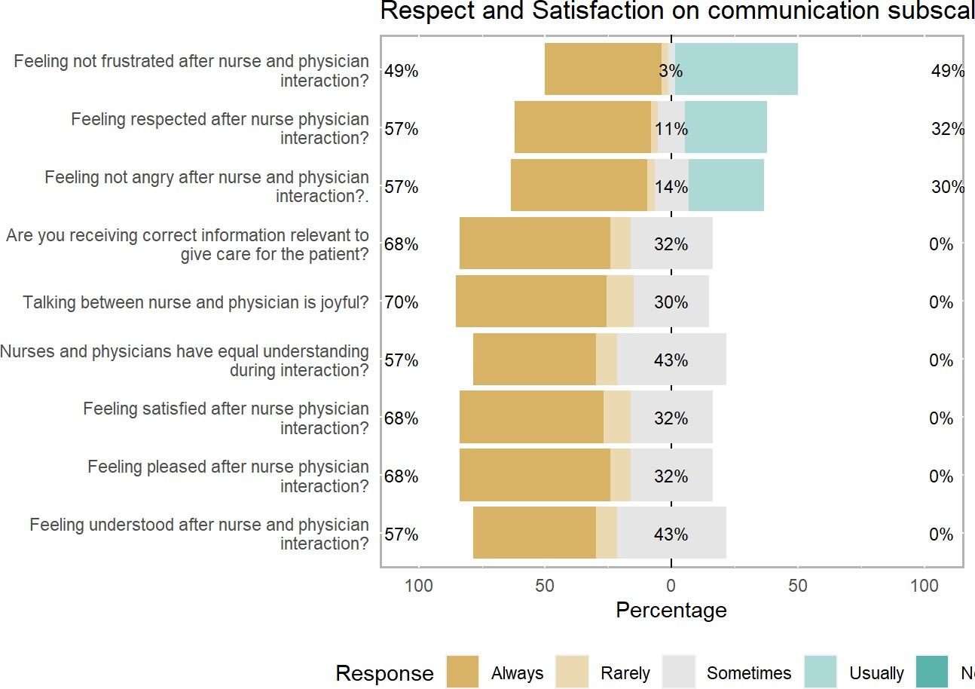

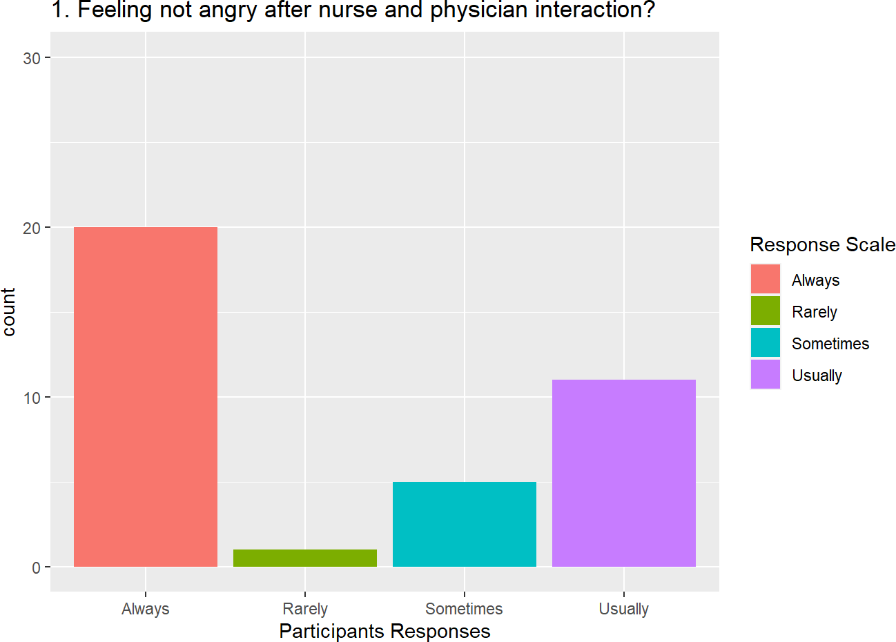

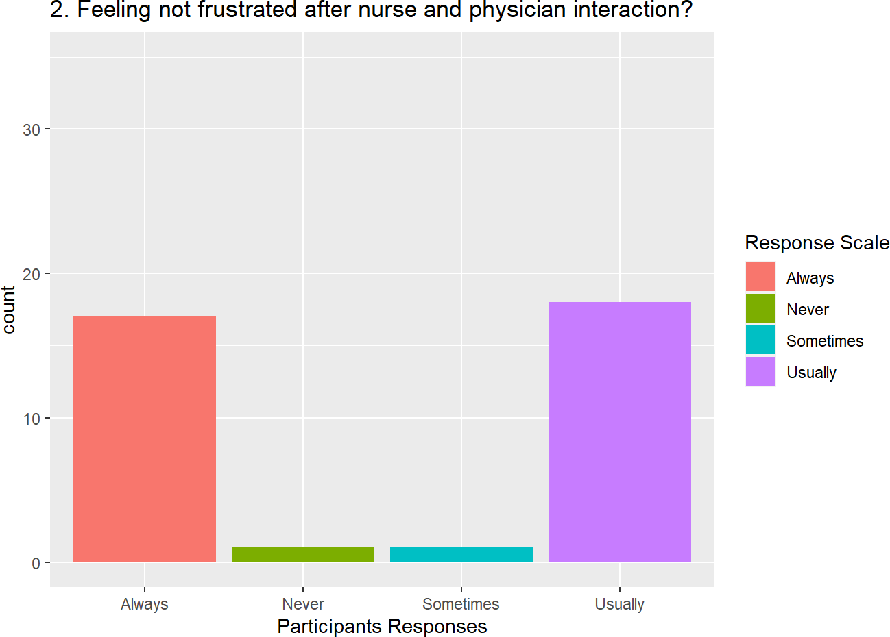

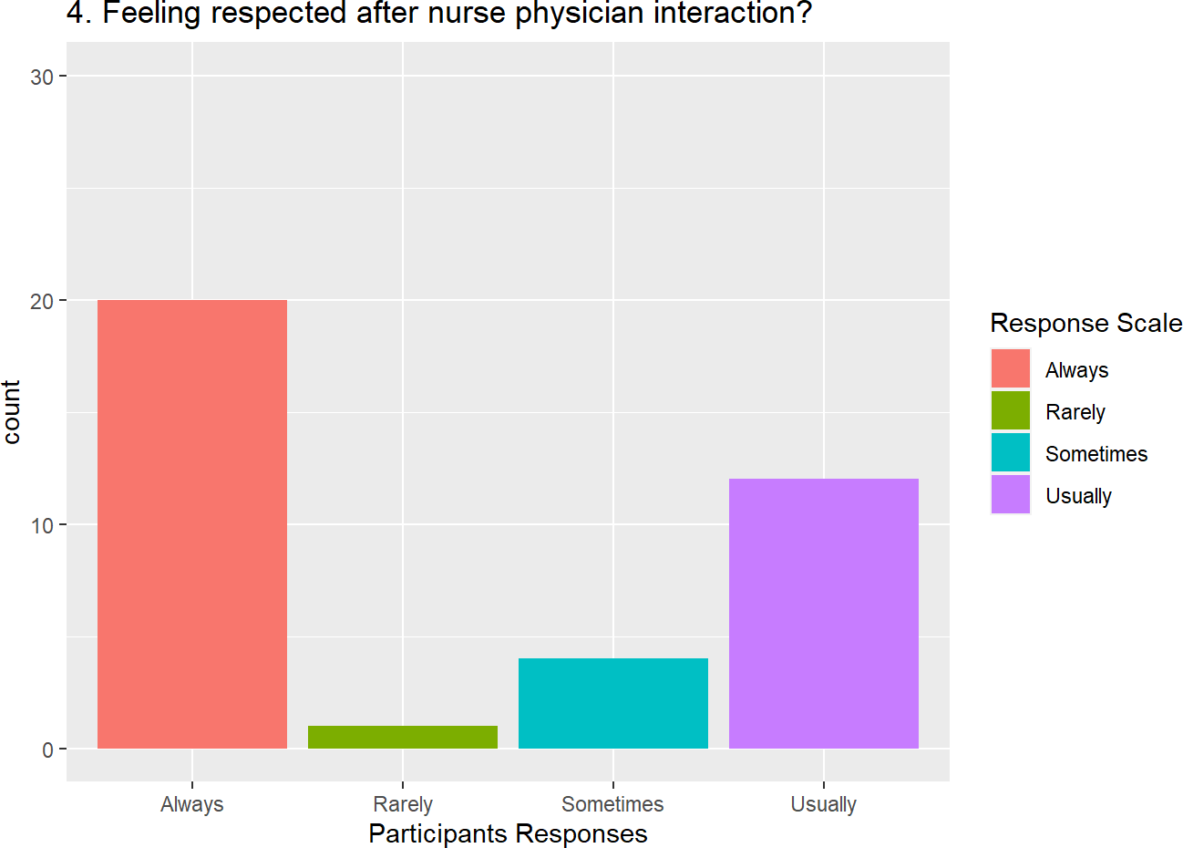

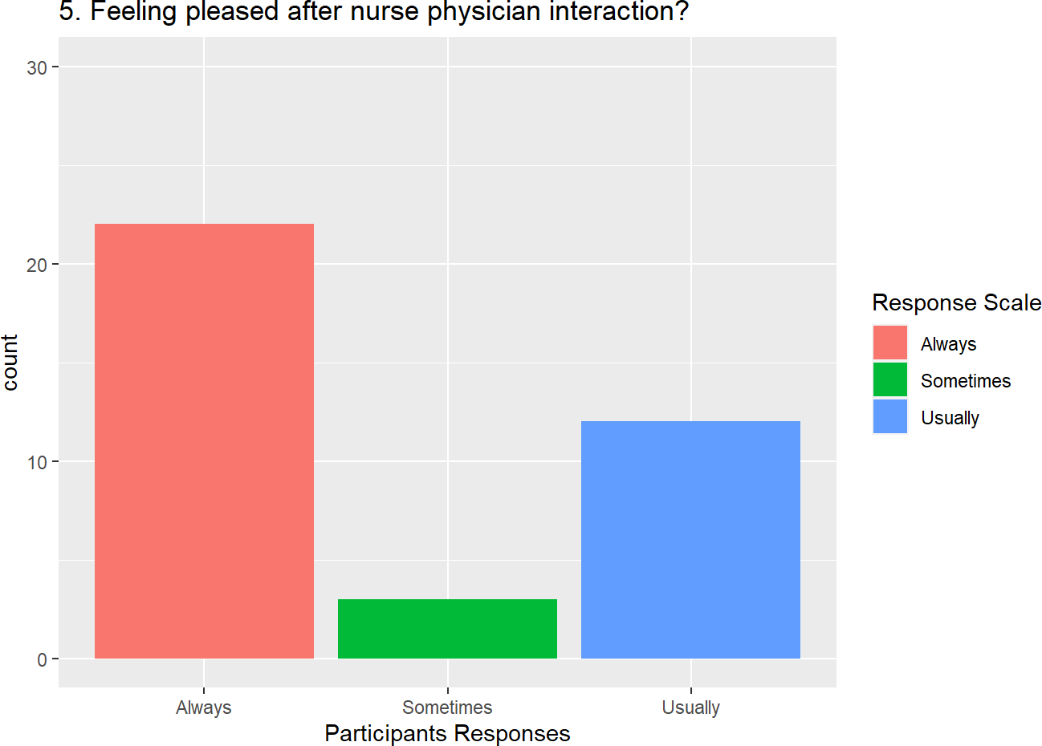

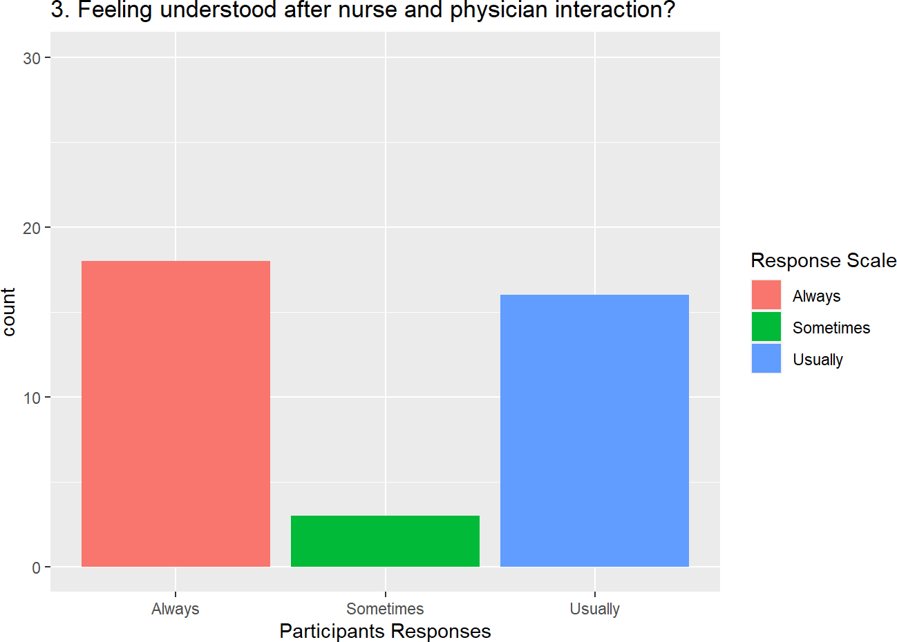

|  |  |
| --- | --- |
| Respect and Satisfaction on communication subscale items (a = 0.51) | N = 37**1** |
| Usually | 12(32%) |
| **6. Feeling satisfied after nurse physician interaction?** |  |
| Always | 21(57%) |
| Sometimes | 4(11%) |
| Usually | 12(32%) |
| **7. Nurses and physicians have equal understanding during interaction?** |  |
| Always | 18(49%) |
| Sometimes | 3(8.1%) |
| Usually | 16(43%) |
| **8. Talking between nurse and physician is joyful?** |  |
| Always | 22(59%) |
| Sometimes | 4(11%) |
| Usually | 11(30%) |
| **9. Are you receiving correct information relevant to give care for the patient?** |  |
| Always | 22(59%) |
| Sometimes | 3(8.1%) |
| Usually | 12(32%) |
| *1* Frequency (%) |  |

## lower alpha upper 95% confidence boundaries ## 0.08 0.38 0.68

##

|  |  |  |  |  |  |  |  |  |  |  |  |  |  |
| --- | --- | --- | --- | --- | --- | --- | --- | --- | --- | --- | --- | --- | --- |
| ## | Reliability if | | an item is | | dropped: | | |  | | | | | |
| ## |  | raw_alpha | | std.alpha | | | G6(smc) | average_r | | S/N | alpha se | var.r | med.r |
| ## | change_ttt- | 0.39 | | 0.41 | | | 0.49 | 0.079 | | 0.69 | 0.15 | 0.024 | 0.0640 |
| ## | pat_saftey | 0.34 | | 0.35 | | | 0.42 | 0.063 | | 0.54 | 0.16 | 0.020 | 0.0213 |
| ## | pat_care | 0.42 | | 0.42 | | | 0.54 | 0.084 | | 0.74 | 0.15 | 0.027 | 0.0640 |
| ## | schedule- | 0.33 | | 0.35 | | | 0.47 | 0.064 | | 0.55 | 0.17 | 0.025 | 0.0294 |
| ## | exch_info | 0.27 | | 0.30 | | | 0.41 | 0.050 | | 0.42 | 0.18 | 0.023 | -0.0032 |
| ## | tired | 0.38 | | 0.40 | | | 0.51 | 0.078 | | 0.68 | 0.15 | 0.024 | 0.0294 |
| ## | help- | 0.28 | | 0.27 | | | 0.36 | 0.045 | | 0.37 | 0.18 | 0.020 | 0.0066 |
| ## | listen | 0.36 | | 0.39 | | | 0.48 | 0.074 | | 0.64 | 0.16 | 0.019 | 0.0461 |
| ## | corr_info | 0.37 | | 0.40 | | | 0.50 | 0.076 | | 0.66 | 0.16 | 0.024 | 0.0381 |
| ## |  |  | |  | | |  |  | |  |  |  |  |
| ## | Item statistics | | |  | | |  |  | |  |  |  |  |
| ## |  | n | raw.r | std.r | r.cor | | r.drop | mean | sd | | | | |
| ## | change_ttt- | 37 | 0.32 | 0.33 | 0.186 | | 0.061 | 2.4 | 0.60 | | | | |
| ## | pat_saftey | 37 | 0.41 | 0.45 | 0.409 | | 0.179 | 4.5 | 0.56 | | | | |
| ## | pat_care | 37 | 0.36 | 0.29 | 0.057 | | 0.030 | 4.4 | 0.75 | | | | |
| ## | schedule- | 37 | 0.48 | 0.44 | 0.308 | | 0.184 | 2.5 | 0.73 | | | | |
| ## | exch_info | 37 | 0.56 | 0.55 | 0.504 | | 0.314 | 4.3 | 0.66 | | | | |
| ## | tired | 37 | 0.33 | 0.34 | 0.159 | | 0.074 | 4.5 | 0.61 | | | | |
| ## | help- | 37 | 0.54 | 0.59 | 0.609 | | 0.351 | 2.5 | 0.51 | | | | |
| ## | listen | 37 | 0.36 | 0.37 | 0.255 | | 0.119 | 4.5 | 0.56 | | | | |
| ## | corr_info | 37 | 0.35 | 0.35 | 0.185 | | 0.105 | 4.7 | 0.57 | | | | |
| ## |  |  |  |  |  | |  |  |  | | | | |
| ## | Non missing | response | | frequency for each | | | | item |  |  |  |  |  |
| ## |  | 2 | 3 | 4 | 5 | miss | | | | | | | |
| ## | change_ttt | 0.00 | 0.05 | 0.30 | 0.65 | 0 | | | | | | | |
| ## | pat_saftey | 0.00 | 0.03 | 0.43 | 0.54 | 0 | | | | | | | |
| ## | pat_care | 0.00 | 0.16 | 0.32 | 0.51 | 0 | | | | | | | |
| ## | schedule | 0.03 | 0.05 | 0.30 | 0.62 | 0 | | | | | | | |
| ## | exch_info | 0.00 | 0.11 | 0.49 | 0.41 | 0 | | | | | | | |
| ## | tired | 0.00 | 0.05 | 0.35 | 0.59 | 0 | | | | | | | |
| ## | help | 0.00 | 0.00 | 0.46 | 0.54 | 0 | | | | | | | |
| ## | listen | 0.00 | 0.03 | 0.49 | 0.49 | 0 | | | | | | | |
| ## | corr_info | 0.00 | 0.05 | 0.19 | 0.76 | 0 | | | | | | | |

|  |  |  |  |
| --- | --- | --- | --- |
| Characteristic | Nurse**, N = 181** | Physician**, N = 191** | p-value**2** |
| **1. In the event of a change in treatment plan, the nurse and the physicians have a mutual understanding?** |  |  | 0.6 |
| Always | 10 (56%) | 14 (74%) |  |
| Sometimes | 1 (5.6%) | 1 (5.3%) |  |
| Usually | 7 (39%) | 4 (21%) |  |
| **2. The nurse and physicians discuss mechanism to maintain patient safety** |  |  | 0.9 |
| Always | 9 (50%) | 11 (58%) |  |
| Sometimes | 1 (5.6%) | 0 (0%) |  |
| Usually | 8 (44%) | 8 (42%) |  |
| **3. The nurse & the physicians have the same understanding on patient's care** |  |  | 0.015 |
| Always | 11 (61%) | 8 (42%) |  |
| Sometimes | 5 (28%) | 1 (5.3%) |  |
| Usually | 2 (11%) | 10 (53%) |  |
| **4. The nurse & the physicians take into account each other's schedule when making plans to treat a patient together** |  |  | >0.9 |
| Always | 11 (61%) | 12 (63%) |  |
| Rarely | 1 (5.6%) | 0 (0%) |  |
| Sometimes | 1 (5.6%) | 1 (5.3%) |  |
| Usually | 5 (28%) | 6 (32%) |  |
| **5. The nurse & the physicians can openly exchange information or opinion about matters related to work** |  |  | 0.8 |
| Always | 6 (33%) | 9 (47%) |  |
| Sometimes | 2 (11%) | 2 (11%) |  |
| Usually | 10 (56%) | 8 (42%) |  |

|  |  |  |  |
| --- | --- | --- | --- |
| Characteristic | Nurse**, N = 181** | Physician**, N = 191** | p-value**2** |
| **6. The nurse and the physicians show concern for each other when they are very tired** |  |  | 0.5 |
| Always | 10 (56%) | 12 (63%) |  |
| Sometimes | 2 (11%) | 0 (0%) |  |
| Usually | 6 (33%) | 7 (37%) |  |
| **7. The nurse and the physicians help each other** |  |  | >0.9 |
| Always | 10 (56%) | 10 (53%) |  |
| Sometimes | 0 (0%) | 0 (0%) |  |
| Usually | 8 (44%) | 9 (47%) |  |
| **8. Physicians and nurse listen to each other** |  |  | 0.9 |
| Always | 8 (44%) | 10 (53%) |  |
| Sometimes | 1 (5.6%) | 0 (0%) |  |
| Usually | 9 (50%) | 9 (47%) |  |
| **9. Receiving correct information or advice** |  |  | 0.2 |
| Always | 14 (78%) | 14 (74%) |  |
| Sometimes | 2 (11%) | 0 (0%) |  |
| Usually | 2 (11%) | 5 (26%) |  |
| *1* n (%)  *2* Fisher's exact test |  |  |  |

**Table 3. Frequency of perceived Openness and Sharing of information items during nurse**

**physician communication among nurses and physicians (n = 35):**

|  |  |
| --- | --- |
| Openness & Sharing of information subscale item scpre (a = 0.38) | N = 37**1** |
| **1. In the event of a change in treatment plan, the nurse and the physicians have a mutual understanding?** |  |
| Always | 24(65%  ) |
| Sometimes | 2(5.4%) |
| Usually | 11(30%) |
| **2. The nurse and physicians discuss mechanism to maintain patient safety** |  |
| Always | 20(54%  ) |
| Sometimes | 1(2.7%) |
| Usually | 16(43%) |
| **3. The nurse & the physicians have the same understanding on patient's care** |  |
| Always | 19(51%  ) |
| Sometimes | 6(16%) |
| Usually | 12(32%) |
| **4. The nurse & the physicians take into account each other's schedule when making plans to treat a patient together** | |
| Always | 23(62%  ) |
| Rarely | 1(2.7%) |
| Sometimes | 2(5.4%) |
| Usually | 11(30%) |
| **5. The nurse & the physicians can openly exchange information or opinion about matters related to work** |  |
| Always | 15(41%  ) |
| Sometimes | 4(11%) |

|  |  |
| --- | --- |
| Openness & Sharing of information subscale item scpre (a = 0.38) | N = 37**1** |
| Usually | 18(49%) |
| **6. The nurse and the physicians show concern for each other when they are very tired** | |
| Always | 22(59%  ) |
| Sometimes | 2(5.4%) |
| Usually | 13(35%) |
| **7. The nurse and the physicians help each other** |  |
| Always | 20(54%  ) |
| Sometimes | 0(0%) |
| Usually | 17(46%) |
| **8. Physicians and nurse listen to each other** |  |
| Always | 18(49%  ) |
| Sometimes | 1(2.7%) |
| Usually | 18(49%) |
| **9. Receiving correct information or advice** |  |
| Always | 28(76%  ) |
| Sometimes | 2(5.4%) |
| Usually | 7(19%) |
| *1* Frequency (%) |  |

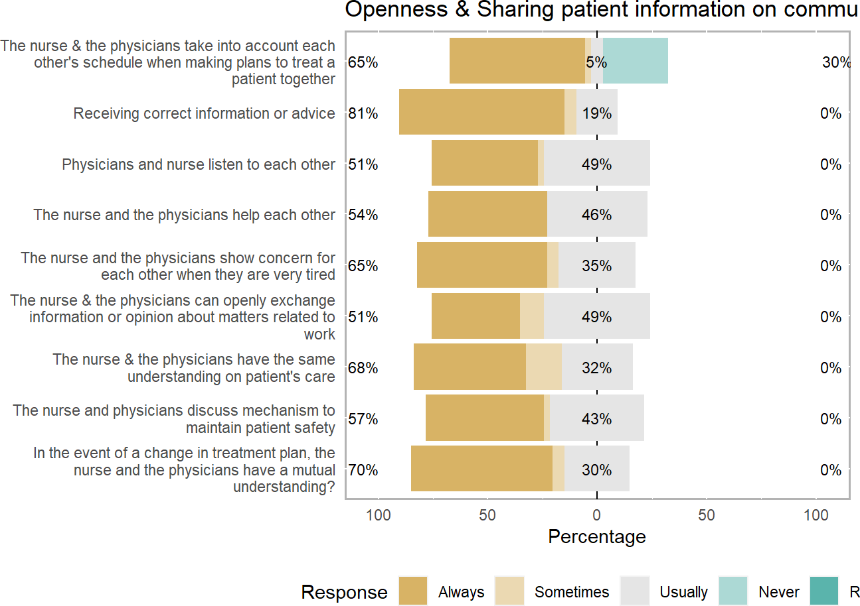

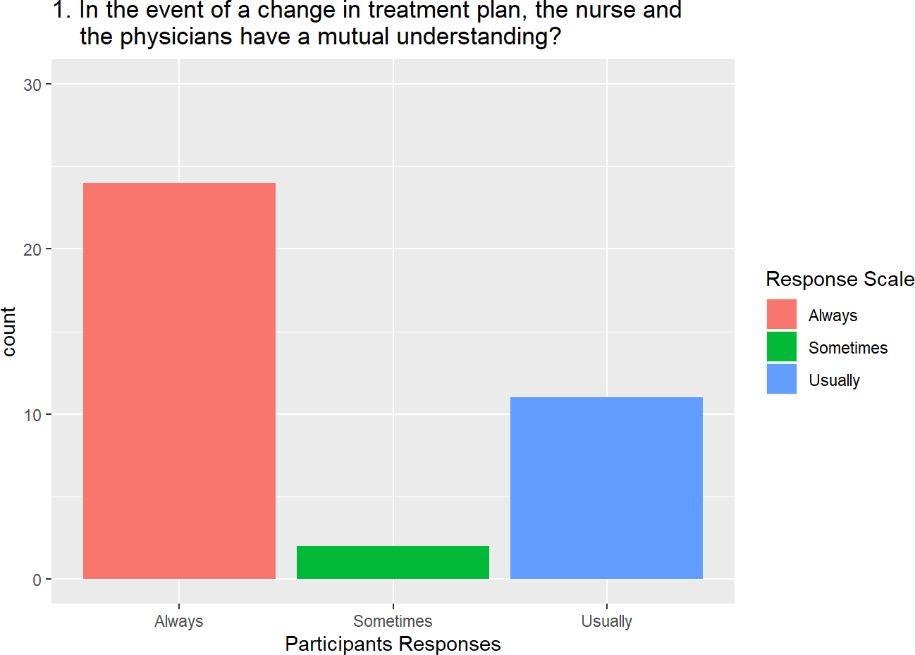

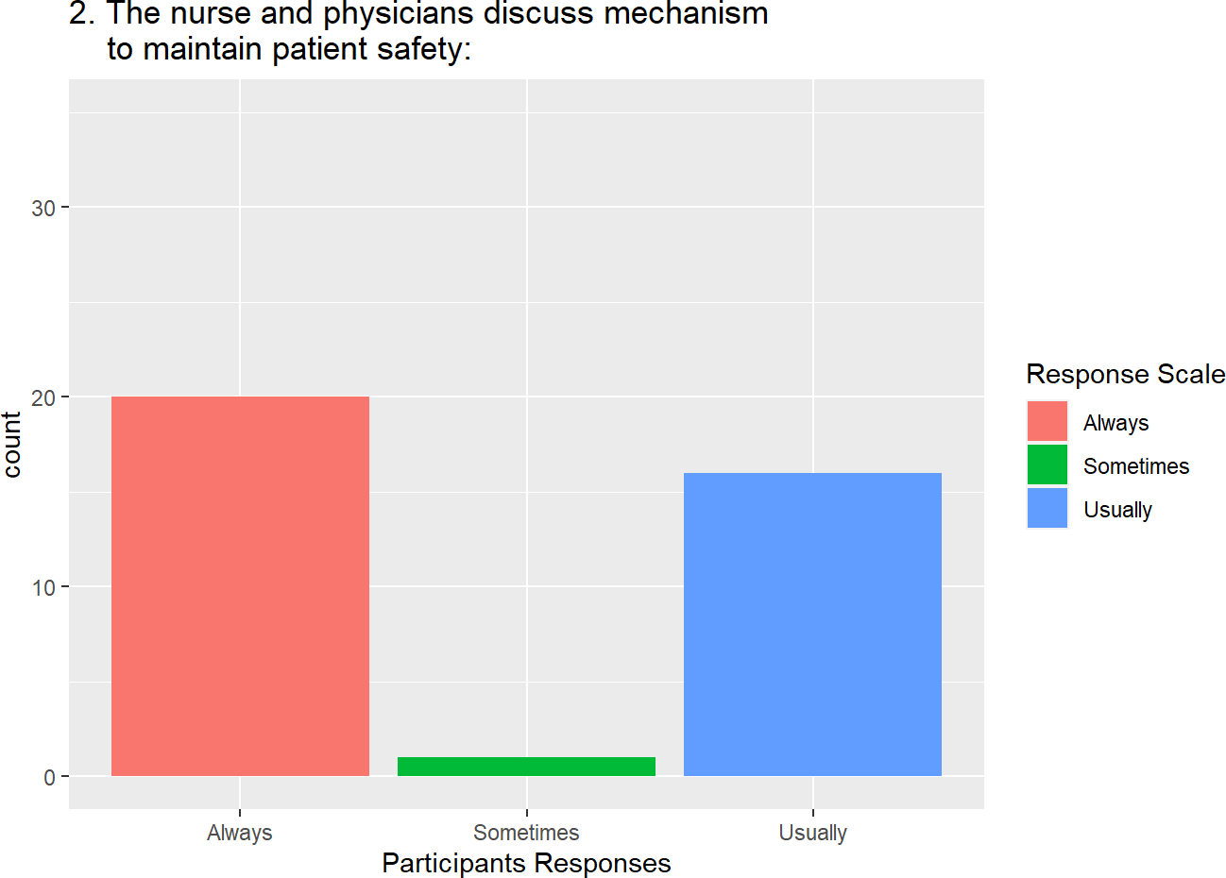

## **level of nurse-physician communication in patient care:**

The factor analysis of perceived level of nurse-physician communication measured by the two communication sub-scale showed the total variance explained 67% for perceived professional respect and satisfaction and 33% for perceived openness and sharing of patients information during nurse-physician communication (Table 4).

As shown in figures below, the perceived professional respect and satisfaction during nurse-physician communication had mean and maximum scale percentage mean score of 37.43±2.4 (Figure 1) and 83.18±5.3% (Figure 2) respectively. The results in the perceived openness and sharing of information during nurse-physician communication showed mean and maximum scale percentage mean score of 37.73±1.6 (Figure 3) and 83.84±3.7% (Figure 4) respectively.

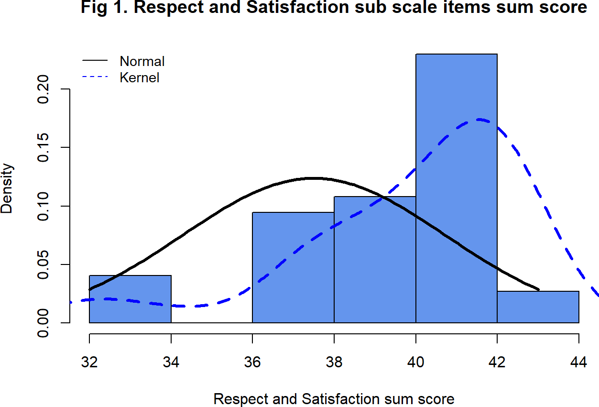

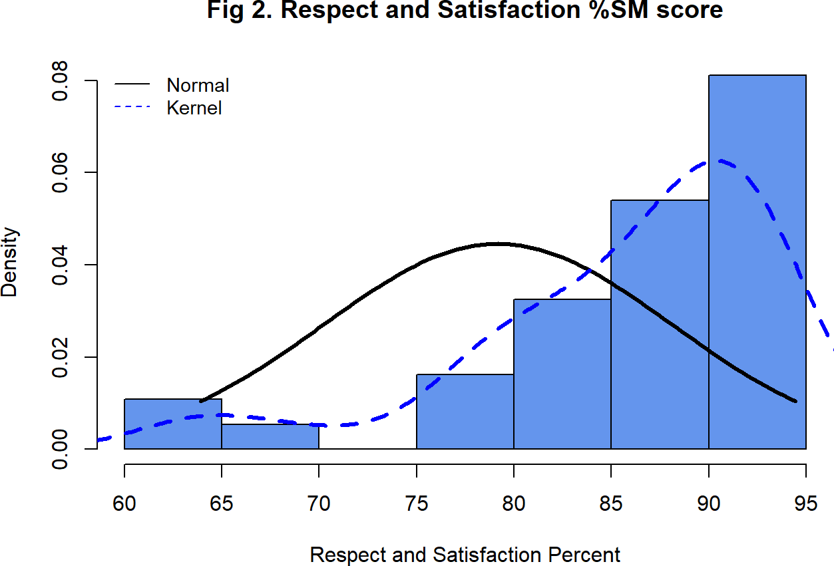

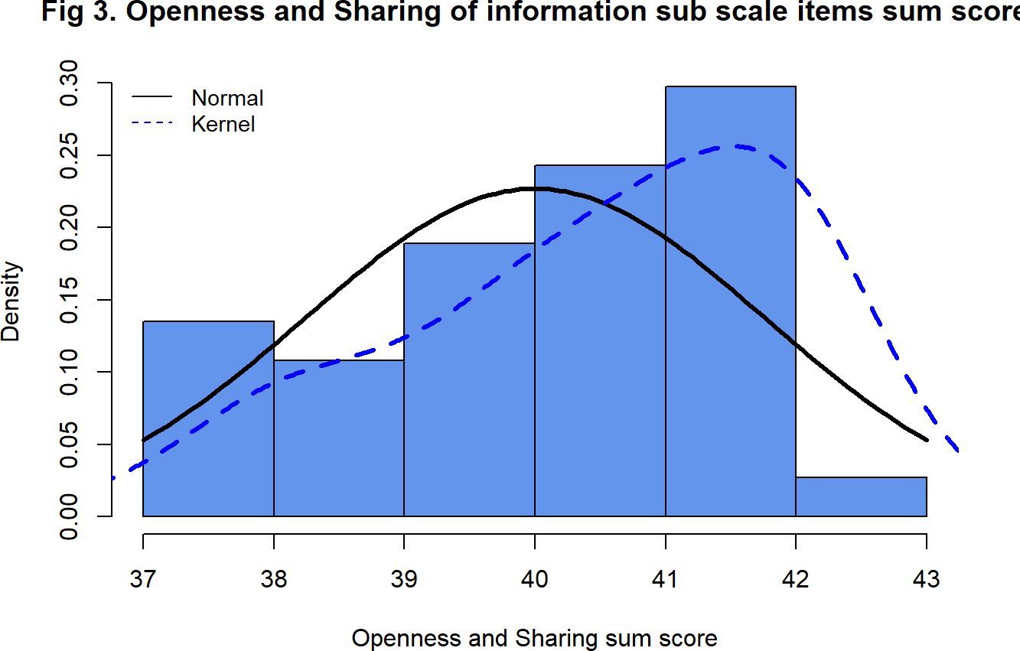

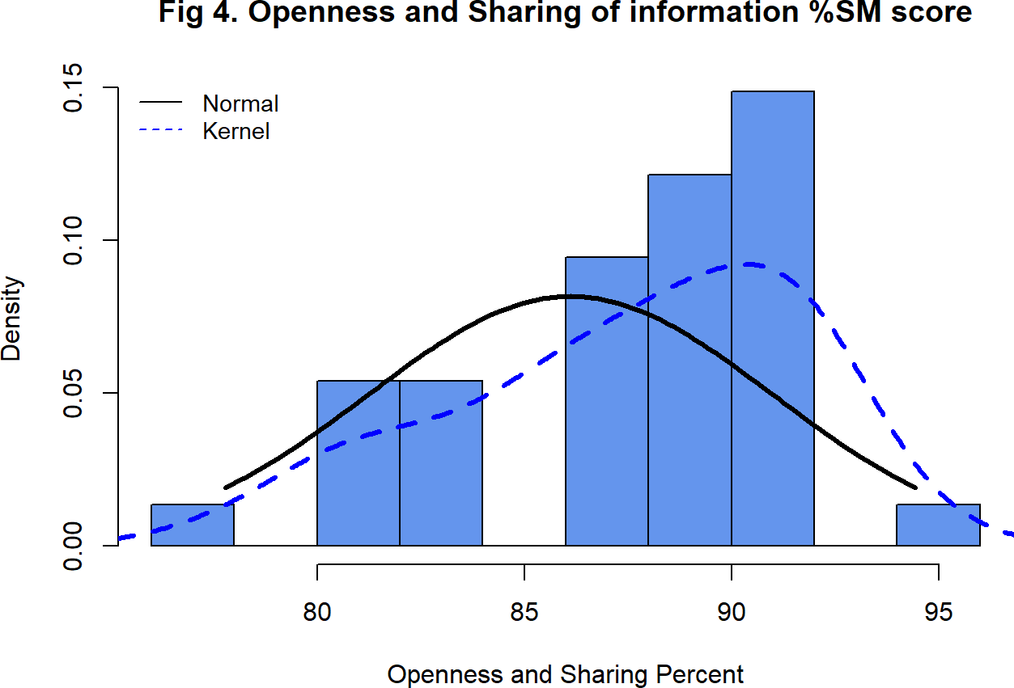

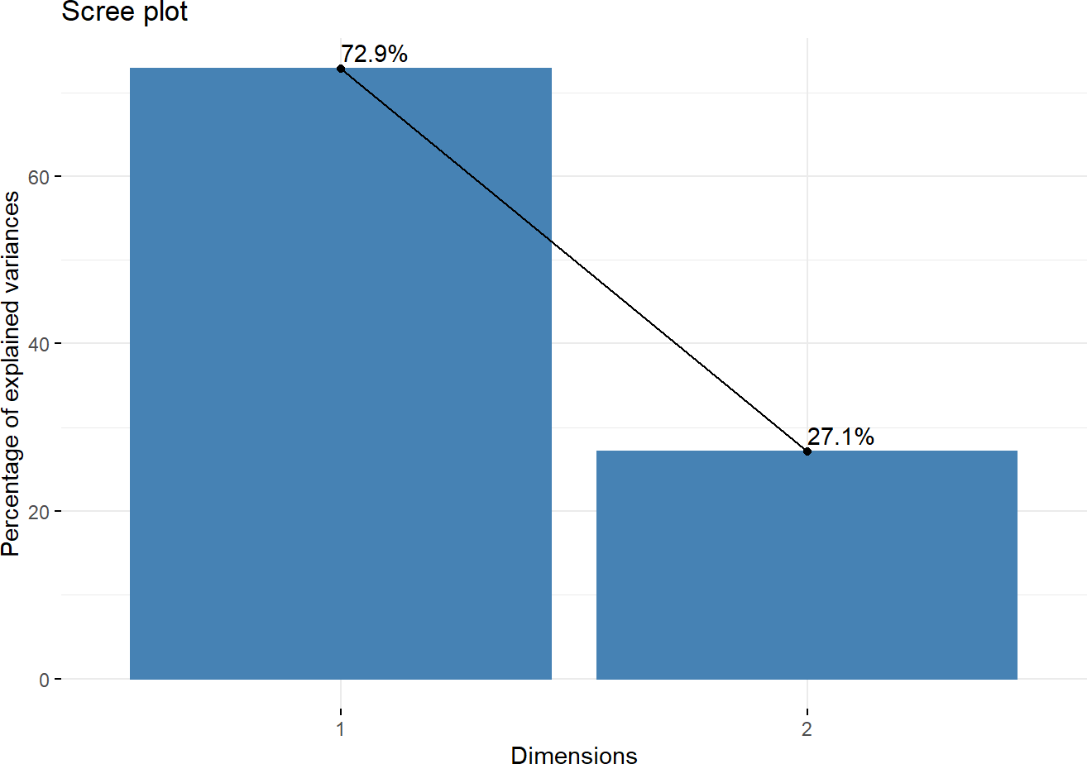

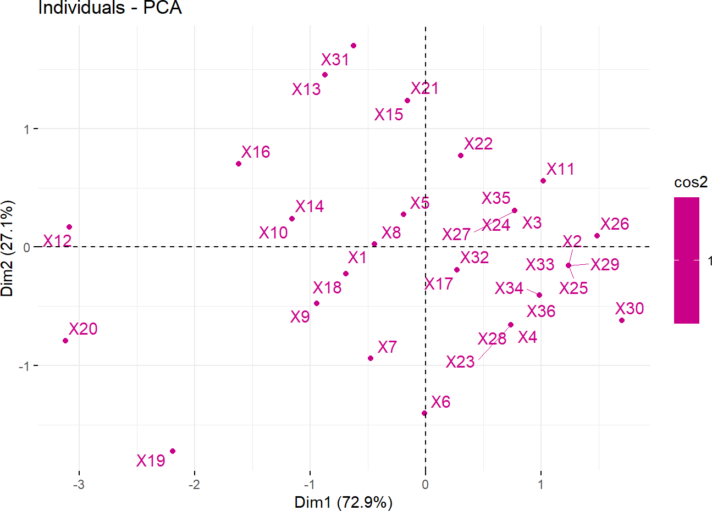

**Table 4. Eigen values and the percentage of variance associated with each two component of communication sub-scale among nurses and physicians (n = 37)**

|  |  |  |  |
| --- | --- | --- | --- |
|  | **eigenvalue** | **variance.percent** | **cumulative.variance.percent** |
| Dim.1 | 1.457355 | 72.86775 | 72.86775 |
| Dim.2 | 0.542645 | 27.13225 | 100.00000 |

**Table 5. Independent sample t-test showing perceived nurse-physician communication as measured by respect and satisfaction in patients care among nurses and physician (n = 35)**

|  |  |  |  |  |  |  |
| --- | --- | --- | --- | --- | --- | --- |
| **label** | **Total N** | **levels** | **unit** | **value** | **Total** | **p** |
| 1.  Professional | 37 | Nurse | Mean (sd) | 39.2  (2.3) | 18  (48.6) | 0.140 |

|  |  |  |  |  |  |  |
| --- | --- | --- | --- | --- | --- | --- |
| **label** | **Total N** | **levels** | **unit** | **value** | **Total** | **p** |
| category |  |  |  |  |  |  |
|  |  | Physician | Mean (sd) | 40.5  (3.1) | 19  (51.4) |  |
| 2. Working hospital | 37 | district/ non- teaching hospital | Mean (sd) | 39.7  (2.7) | 22  (59.5) | 0.727 |
|  |  | Teaching/referral  hospital | Mean (sd) | 40.1  (3.0) | 15  (40.5) |  |
| 3.  Parcticipants Gender | 37 | Female | Mean (sd) | 39.8  (2.7) | 28  (75.7) | 0.785 |
|  |  | Male | Mean (sd) | 40.1  (3.1) | 9  (24.3) |  |

**Table 6. Independent sample t-test showing perceived nurse-physician communication as measured by openness and sharing of information among nurses and physician (n = 35)**

|  |  |  |  |  |  |  |
| --- | --- | --- | --- | --- | --- | --- |
| **label** | **Total N** | **levels** | **unit** | **value** | **Total** | **p** |
| 1.  Professional | 37 | Nurse | Mean | 40.0 | 18 | 0.041 |

|  |  |  |  |  |  |  |
| --- | --- | --- | --- | --- | --- | --- |
| **label** | **Total N** | **levels** | **unit** | **value** | **Total** | **p** |
| category |  |  | (sd) | (1.5) | (48.6) |  |
|  |  | Physician | Mean (sd) | 41.0  (1.4) | 19  (51.4) |  |
| 2. Working hospital | 37 | district/ non- teaching hospital | Mean (sd) | 40.2  (1.6) | 22  (59.5) | 0.147 |
|  |  | Teaching/referral  hospital | Mean (sd) | 40.9  (1.3) | 15  (40.5) |  |
| 3.  Parcticipants Gender | 37 | Female | Mean (sd) | 40.2  (1.6) | 28  (75.7) | 0.008 |
|  |  | Male | Mean (sd) | 41.3  (0.7) | 9  (24.3) |  |

1. **Results of ANOVA analysis:**

The ANOVA results showed that there was no significance mean difference seen among work experience groups and educational qualification in both perceived nurse-physician communication sub-scales and openness and sharing information among participants’.

**Table 7a. Multiple Comparison ANOVA table of educational qualification and perceived nurse- physician communication as measured by two component scale among nurses and physician (n = 35)**

|  |  |  |  |  |  |  |
| --- | --- | --- | --- | --- | --- | --- |
| **label** | **Total N** | **levels** | **unit** | **value** | **Total** | **p** |
| Education Qualification Category | 37 | Master-Nurse | Mean (sd) | 38.4  (2.2) | 10  (28.6) | 0.423 |
|  | Master-Physician | | Mean (sd) | 40.4  (3.5) | 8  (22.9) |  |

|  |  |  |  |  |  |  |
| --- | --- | --- | --- | --- | --- | --- |
| **label** | **Total N** | **levels** | **unit** | **value** | **Total** | **p** |
|  |  | PhD-Nurse | Mean (sd) | 41.5  (2.1) | 2  (5.7) |  |
|  | Post graduate diploma-Nurse | | Mean (sd) | 39.2  (2.2) | 5  (14.3) |  |
|  | Post graduate  diploma- Physician | | Mean (sd) | 40.4  (3.1) | 10  (28.6) |  |

**Table 7b. Multiple Comparison ANOVA table of educational qualification and perceived nurse- physician communication as measured by two component scale among nurses and physician (n = 35)**

|  |  |  |  |  |  |  |
| --- | --- | --- | --- | --- | --- | --- |
| **label** | **Total N** | **levels** | **unit** | **value** | **Total** | **p** |
| Education Qualification Category | 37 | Master-Nurse | Mean (sd) | 39.9  (1.4) | 10  (28.6) | 0.108 |
|  | Master-Physician | | Mean (sd) | 41.5  (0.9) | 8  (22.9) |  |
|  |  | PhD-Nurse | Mean (sd) | 41.0  (0.0) | 2  (5.7) |  |
|  |  | Post graduate diploma-Nurse | Mean (sd) | 39.4  (1.5) | 5  (14.3) |  |
|  |  | Post graduate  diploma- Physician | Mean (sd) | 40.5  (1.6) | 10  (28.6) |  |

1. **Predictors of Perceived Nurse-Physician Communication in Patient Care:**

In the nurse-physician communication factor description, the top six factors described strongly agreed by nurses and physicians were malfunctioning of equipment in units (88.5%), gender difference (61.9%), differential treatment of nurses or physician in the hospital (33.2%), abuse (30.5%), negligence of duty

(29.4%), and disruptive behavior (28.2%).

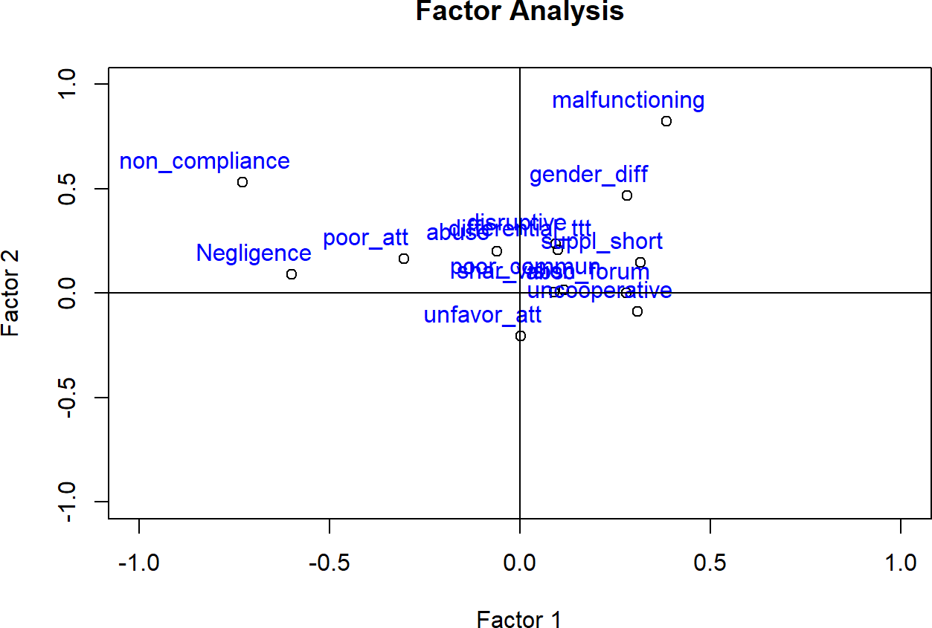

**Work attitude related personal individual Factors:**

Perceived nurse-physician work attitude factor sub scale generated through PCA and measured with six items: non-compliance with advice, negligence of duty, abuse(verbal, physical and sexual), poor attitude to work, uncooperativeness at work, and gender difference. All of these factors measured with agreement Likert Scale and has minimum of 5 and maximum of 25. The higher the score indicates the more to be nurse-physician work attitude factor.

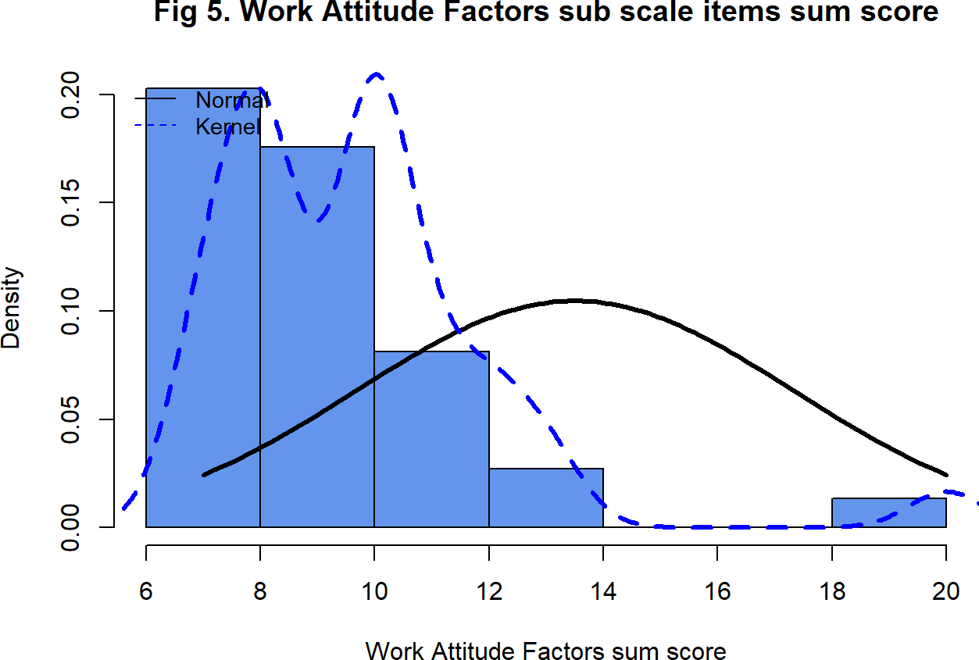

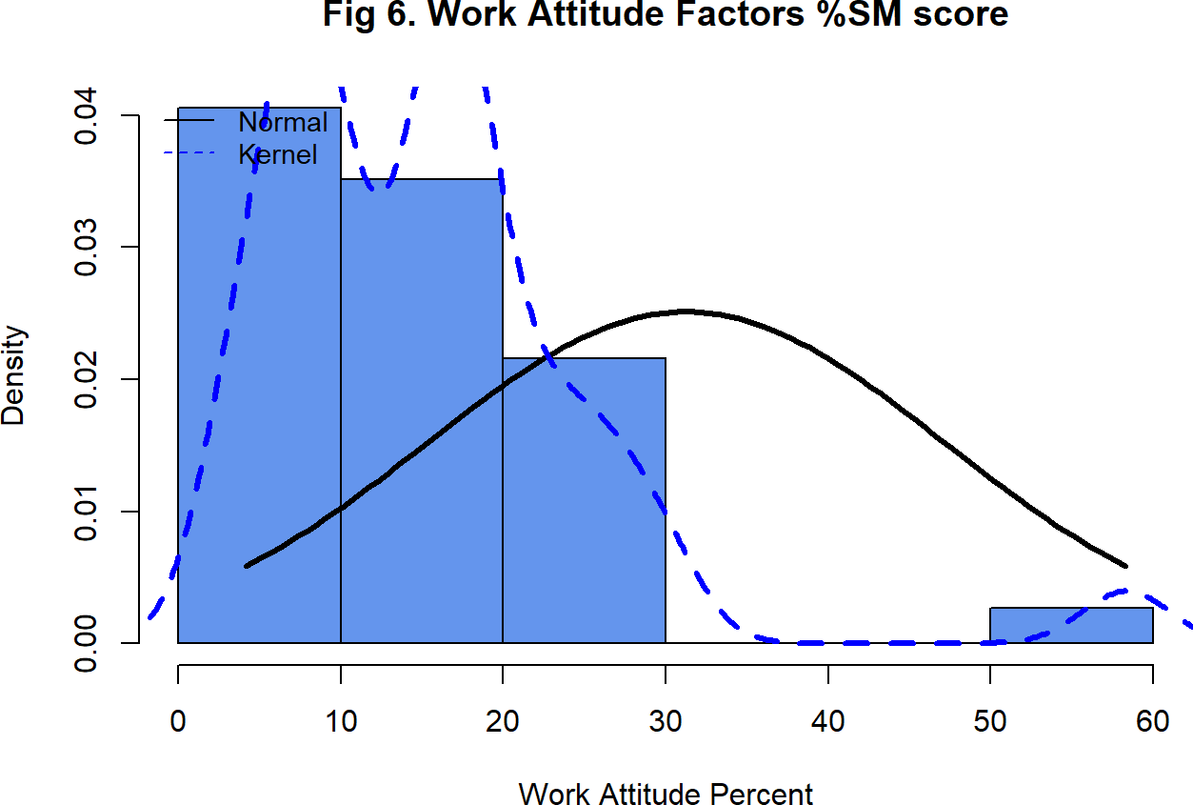

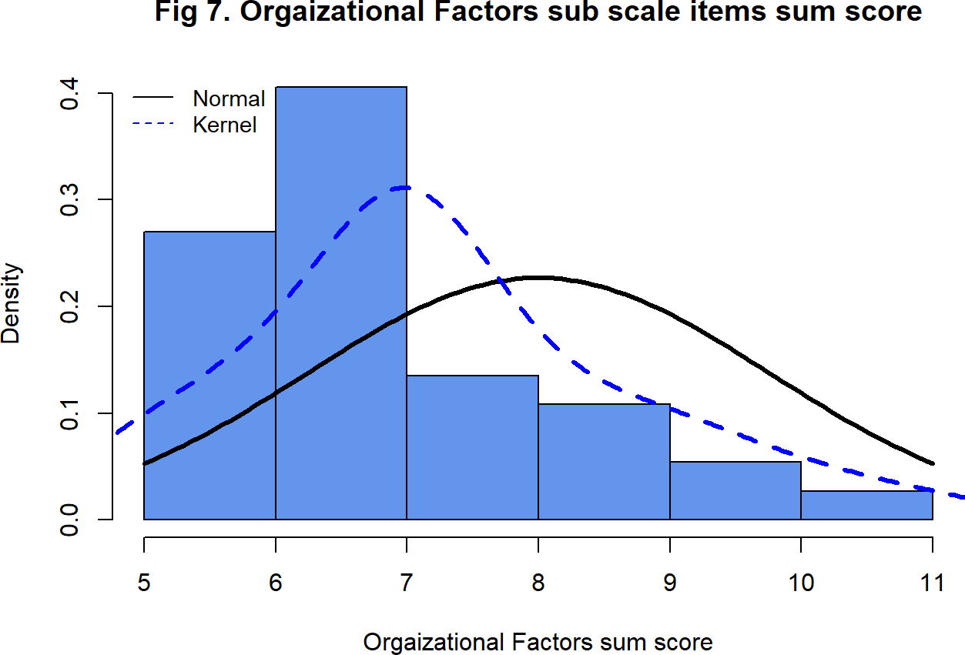

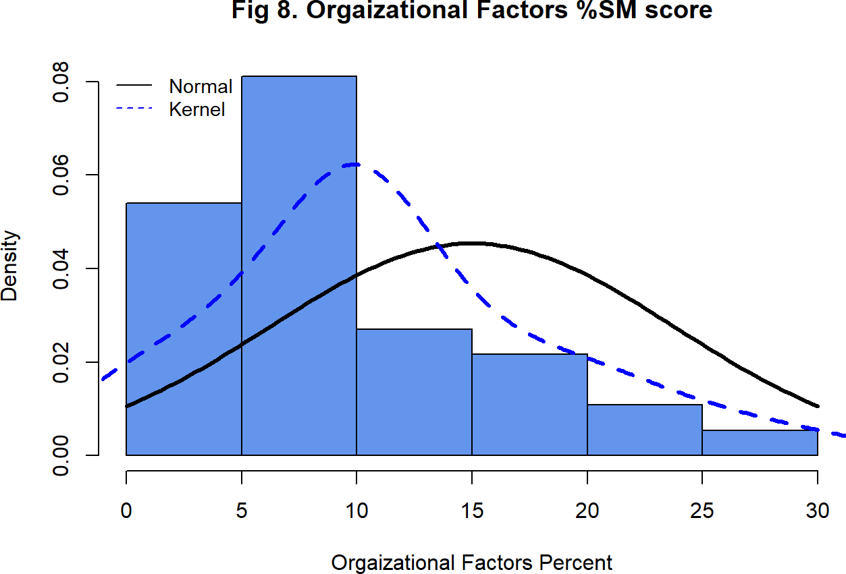

**Personal Behavior related Individual Factors**

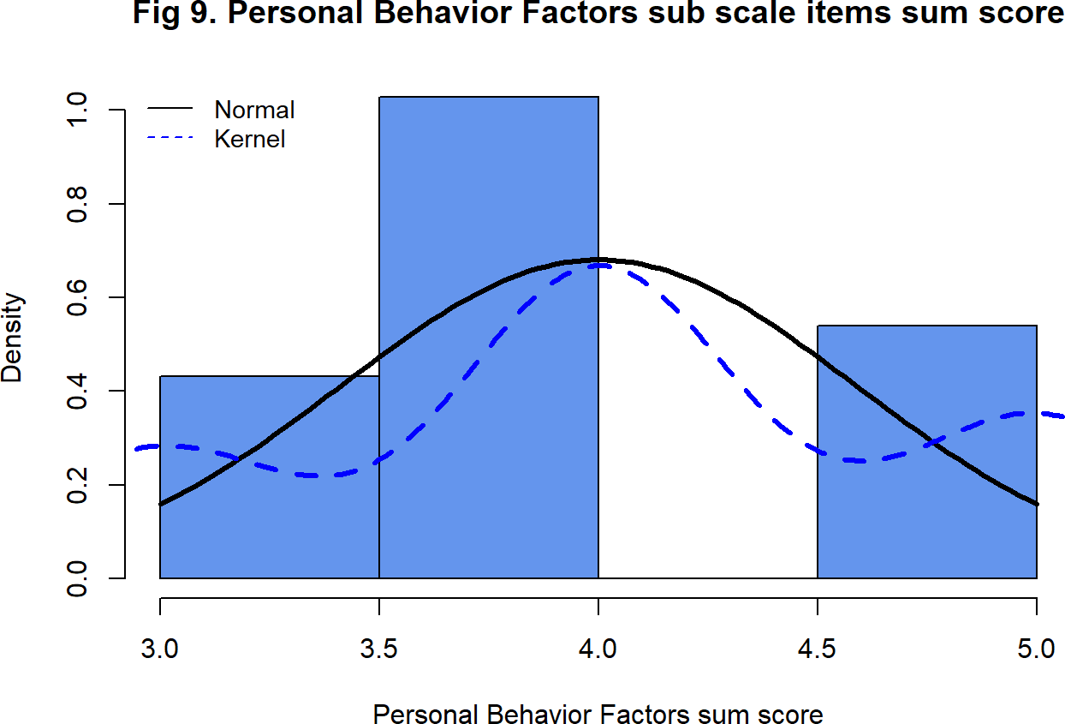

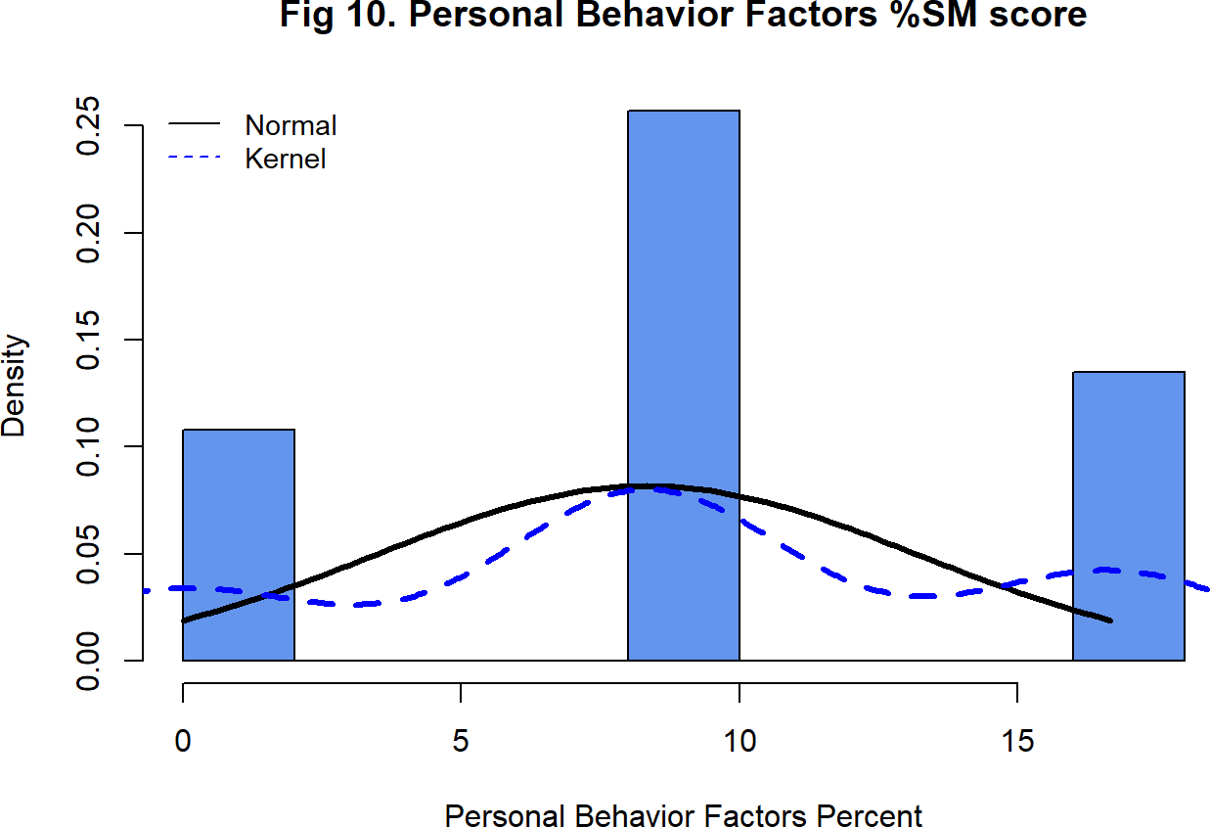

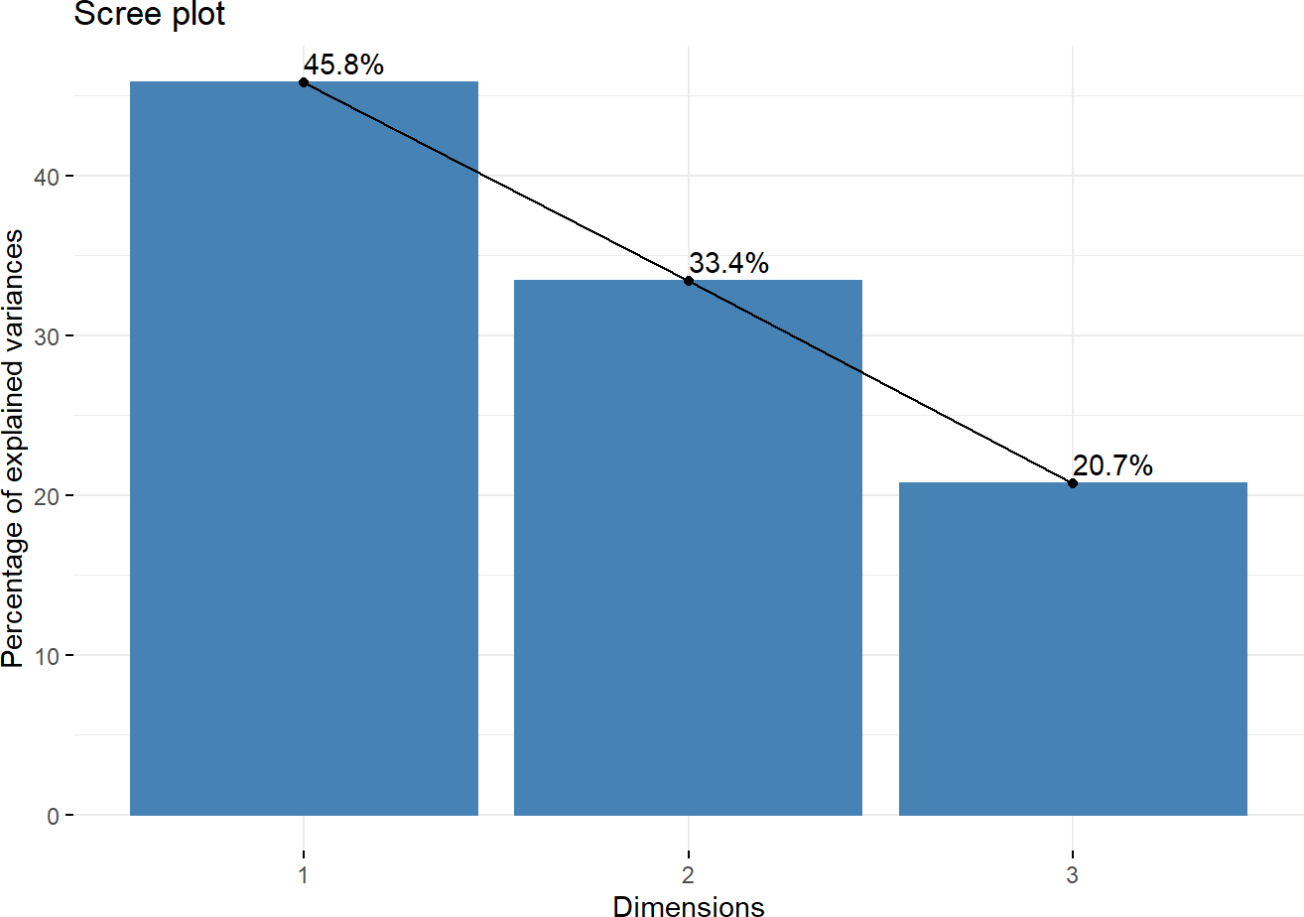

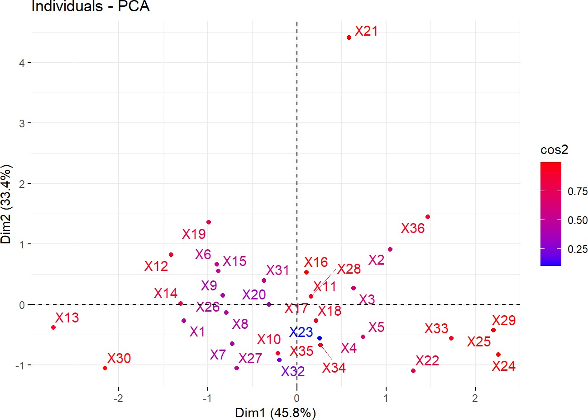

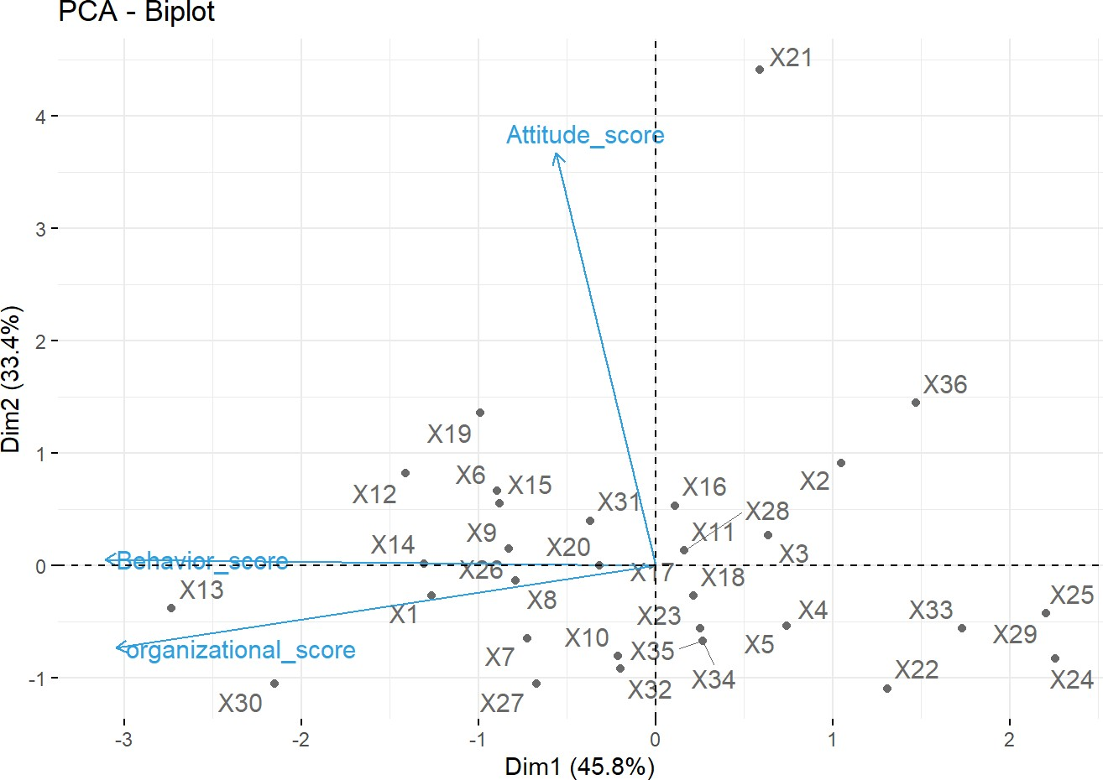

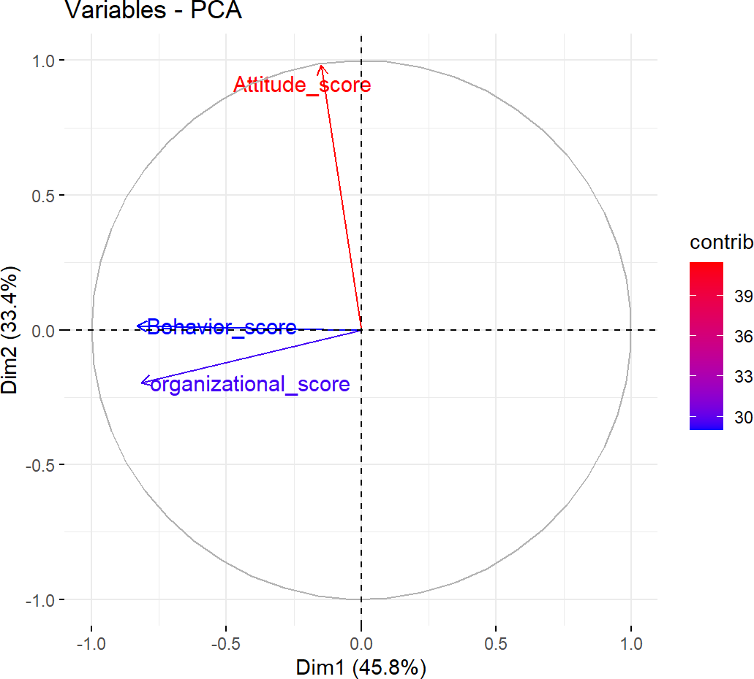

**Table 8. Eigen values and the percentage of variance associated in the three nurse-physician communication factors among nurses and physicians (n = 37)**

|  |  |  |  |
| --- | --- | --- | --- |
|  | **eigenvalue** | **variance.percent** | **cumulative.variance.percent** |
| Dim.1 | 1.3753423 | 45.84474 | 45.84474 |
| Dim.2 | 1.0023031 | 33.41010 | 79.25484 |
| Dim.3 | 0.6223547 | 20.74516 | 100.00000 |

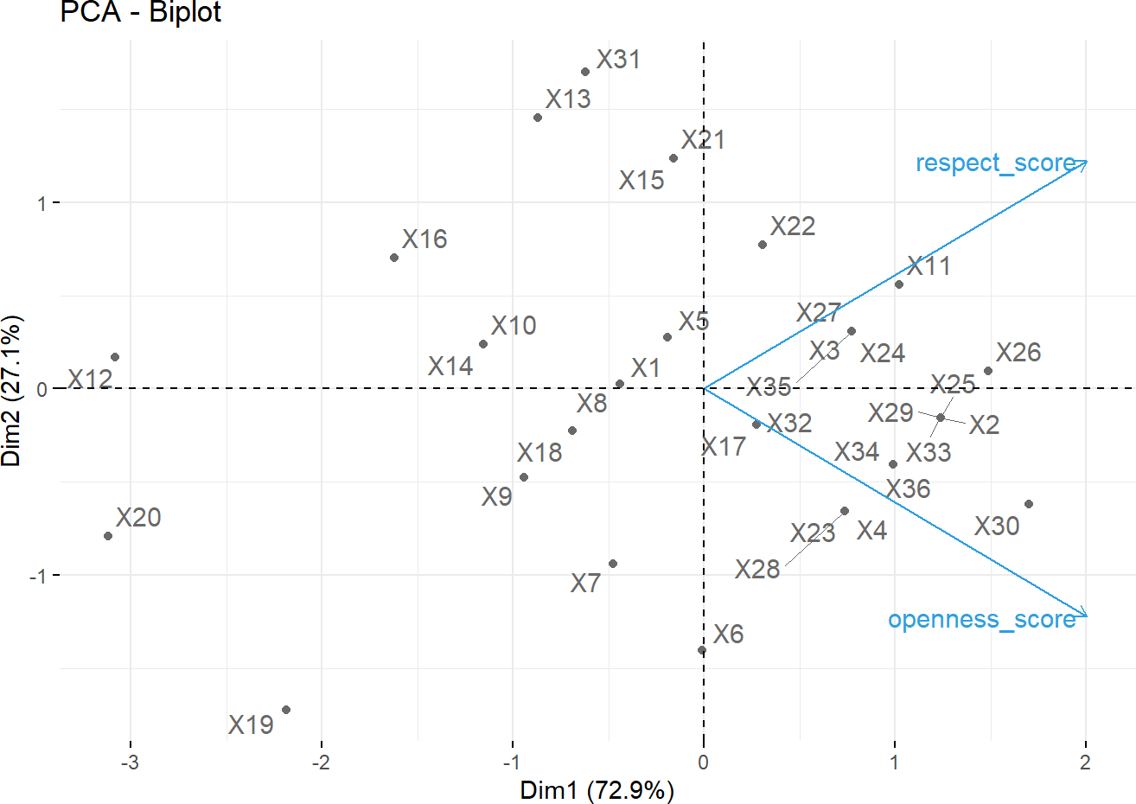

**Table 9. Mean and %SM Score for factors related to perceived level of nurses-physician communication in patient care among nurses and physicians (n = 37)**

|  |  |
| --- | --- |
| Predictots sub-scale or latent scale | N = 37**1** |
|  |  |
| Work Attitude score related individual factors | 9.68 (2.45) |
| Work Attitude %SM related individual factors | 15 (10) |
| Organizational score related individual factors | 7.24 (1.44) |
| Organizational %SM related individual factors | 11 (7) |
| Personal Behavior score related individual factors | 4.05 (0.70) |
| Personal Behavior %SM related individual factors | 8.8 (5.9) |
| *1* Mean (SD) |  |

1. **Results of linear regression analysis predicting respect & satisfaction:**

Linear regression was built in both bi-variable and multiple variable linear regressions in order to find the significant predictors for the two nurses-physician communication sub-scales. Predictor of perceived respect and satisfaction during nurse-physician communication in the bi-variable and multiple linear regression analysis.

**12. Bivariate & Multivariate Linear Regression Predicting perceived Respect and Satisfaction during nurse-physician communication in patients care among nurses and physicians (n = 37):\*\***

Univariate LR Multivariate LR

|  |  |  |  |  |  |  |  |  |
| --- | --- | --- | --- | --- | --- | --- | --- | --- |
| Predictor Variables | Beta | SE**1** | 95% CI**1** | p-value | Beta | SE**1** | 95% CI**1** | p-value |
| **2. Working hospital**  district/ non-teaching hospital | 0.00 | Ref. | Ref. |  | 0.00 | Ref. | Ref. |  |
| Teaching/referral hospital | 0.34 | 0.949 | -1.6, 2.3 | 0.7 | -0.81 | 2.32 | -5.9, 4.2 | 0.7 |
| **1. Professional category**  Nurse | 0.00 | Ref. | Ref. |  | 0.00 | Ref. | Ref. |  |
| Physician | 1.4 | 0.905 | -0.48,  3.2 | 0.14 | -1.4 | 3.91 | -9.9, 7.2 | 0.7 |
| **3. Parcticipants Gender**  Female | 0.00 | Ref. | Ref. |  | 0.00 | Ref. | Ref. |  |
| Male | 0.33 | 1.09 | -1.9, 2.5 | 0.8 | -0.51 | 1.92 | -4.7, 3.7 | 0.8 |
| **4. Age Intervals (years)**  30-35 | 0.00 | Ref. | Ref. |  | 0.00 | Ref. | Ref. |  |
| 35-40 | -3.0 | 2.15 | -7.4, 1.4 | 0.2 | -1.6 | 4.18 | -11, 7.5 | 0.7 |
| 40-45 | -2.7 | 2.11 | -7.0, 1.6 | 0.2 | -1.6 | 3.85 | -10, 6.8 | 0.7 |
| 45-50 | -2.5 | 2.84 | -8.3, 3.3 | 0.4 | -3.9 | 5.45 | -16, 8.0 | 0.5 |

**Table 12. Bivariate & Multivariate Linear Regression Predicting perceived Reect and Satisfaction during nurse-physician communication in patients care among nurses and physicians (n = 37):\*\***

Univariate LR Multivariate LR

|  |  |  |  |  |  |  |  |  |
| --- | --- | --- | --- | --- | --- | --- | --- | --- |
| Predictor Variables  **5. Marital status** | Beta | SE**1** | 95% CI**1** | p-value | Beta | SE**1** | 95% CI**1** | p-value |
| Ever married | 0.00 | Ref. | Ref. |  | 0.00 | Ref. | Ref. |  |
| Married | -2.3 | 1.66 | -5.7, 1.1 | 0.2 | -6.9 | 4.45 | -17, 2.8 | 0.15 |
| **service** | -0.17 | 0.137 | -0.45,  0.11 | 0.2 | -0.33 | 0.366 | -1.1,  0.47 | 0.4 |
| **6. Last Educational Qualification** |  |  |  |  |  |  |  |  |
| Bachelor | 0.00 | Ref. | Ref. |  | 0.00 | Ref. | Ref. |  |
| Master | -2.7 | 2.87 | -8.6, 3.1 | 0.3 | -5.0 | 4.20 | -14, 4.1 | 0.3 |
| PhD | 0.00 | 3.23 | -6.6, 6.6 | >0.9 | -1.5 | 4.50 | -11, 8.3 | 0.7 |
| Post graduate diploma | -2.0 | 2.89 | -7.9, 3.9 | 0.5 | -2.9 | 3.80 | -11, 5.4 | 0.5 |
| **8. Working unit category** |  |  |  |  |  |  |  |  |
| dental | 0.00 | Ref. | Ref. |  | 0.00 | Ref. | Ref. |  |

Emergency department

|  |  |  |  |  |  |  |  |
| --- | --- | --- | --- | --- | --- | --- | --- |
| 0.33 | 2.16 | -4.1, 4.7 | 0.9 | -2.7 | 3.35 | -10.0, | 0.4 |
|  |  |  |  |  |  | 4.6 |  |
| -2.0 | 1.73 | -5.5, 1.5 | 0.3 | -1.3 | 3.39 | -8.7, 6.1 | 0.7 |
| 1.0 | 2.16 | -3.4, 5.4 | 0.6 | 1.3 | 3.75 | -6.8, 9.5 | 0.7 |
| 0.20 | 1.89 | -3.7, 4.1 | >0.9 | -0.46 | 2.47 | -5.8, 4.9 | 0.9 |
| 2.0 | 2.44 | -3.0, 7.0 | 0.4 | 2.0 | 4.35 | -7.5, 12 | 0.7 |
| -0.80 | 1.89 | -4.7, 3.1 | 0.7 | -2.1 | 2.87 | -8.3, 4.2 | 0.5 |
| 0.86 | 1.77 | -2.8, 4.5 | 0.6 | -0.20 | 2.18 | -4.9, 4.5 | >0.9 |

ICU

Medical department

Obstetrics and gynaecology department

Ophthalmology departemnt Paediatrics department Surgical departement

**9. Salary category in AED**

**Table 12. Bivariate & Multivariate Linear Regression Predicting perceived Respect and Satisfaction during nurse-physician communication in patients care among nurses and physicians (n = 37):\*\***

Univariate LR Multivariate LR

|  |  |  |  |  |  |  |  |  |
| --- | --- | --- | --- | --- | --- | --- | --- | --- |
| Predictor Variables | Beta | SE**1** | 95% CI**1** | p-value | Beta | SE**1** | 95% CI**1** | p-value |
| 15000 to 20000 | 0.00 | Ref. | Ref. |  | 0.00 | Ref. | Ref. |  |
| 20000 to 25000 | -0.36 | 1.54 | -3.5, 2.8 | 0.8 | -6.0 | 4.57 | -16, 4.0 | 0.2 |
| 25000 to 30000 | 0.33 | 1.50 | -2.7, 3.4 | 0.8 | -3.4 | 3.29 | -11, 3.8 | 0.3 |
| 30000 to 35000 | -6.0 | 3.04 | -12, 0.18 | 0.056 | -6.0 | 5.84 | -19, 6.7 | 0.3 |

0.3 -0.62 0.465 -1.6,

|  |  |  |  |  |
| --- | --- | --- | --- | --- |
|  | | | 0.39 |  |
| **0.017** | -0.04 | 1.19 | -2.6, 2.6 | >0.9 |
| 0.2 | 0.14 | 0.725 | -1.4, 1.7 | 0.9 |

|  |  |  |  |
| --- | --- | --- | --- |
| **Work Attitude score related**  **individual factors** | -0.21 | 0.190 | -0.60,  0.17 |
| **Personal Behavior score** | -1.5 | 0.618 | -2.8, - |

0.2

**individual factors** 0.24

|  |  |  |  |
| --- | --- | --- | --- |
| **related individual factors** |  |  | 0.29 |
| **Organizational score related** | -0.41 | 0.321 | -1.1, |

*1* SE = Standard Error, CI = Confidence Interval

1. **Results of linear regression analysis predicting respect & satisfaction:**

### Table 13. Bivariate & Multivariate Linear Regression Predicting perceived Openness and Sharing of Patient information during nurse-physician communication in patients care among nurses and physicians (n = 37):**

Predictor Variables

Univariate LR Multivariate LR

Beta SE**1** 95% CI**1** p-value Beta SE**1** 95% CI**1** p-value

### 2. Working hospital

district/ non-teaching hospital 0.00 Ref. Ref. 0.00 Ref. Ref.

Teaching/referral hospital 0.71 0.496 -0.30,

1.7

0.2 -0.10 0.856 -2.0, 1.8 >0.9

### 1. Professional category

Nurse 0.00 Ref. Ref. 0.00 Ref. Ref.

Physician 1.0 0.472 0.04, 2.0 **0.041** -0.50 1.44 -3.6, 2.6 0.7

### 3. Parcticipants Gender

Female 0.00 Ref. Ref. 0.00 Ref. Ref.

Male 1.1 0.554 -0.04,

|  |  |  |  |  |  |  |
| --- | --- | --- | --- | --- | --- | --- |
|  | | | 2.2 |  | | |
| **4. Age Intervals (years)**  30-35 | 0.00 | Ref. | Ref. |  | 0.00 | Ref. |
| 35-40 | 0.43 | 1.18 | -2.0, 2.8 | 0.7 | 2.7 | 1.54 |
| 40-45 | 0.63 | 1.16 | -1.7, 3.0 | 0.6 | 2.9 | 1.42 |
| 45-50 | 0.50 | 1.56 | -2.7, 3.7 | 0.8 | 1.4 | 2.01 |
| **5. Marital status** |  |  |  |  |  |  |

0.059 1.1 0.708 -0.47,

2.6

0.2

Ref.

-0.70,

6.0

-0.15,

6.0

0.11

0.060

-3.0, 5.7 0.5

### Table 13. Bivariate & Multivariate Linear Regression Predicting perceived Openness and Sharing of Patient information during nurse-physician communication in patients care among nurses and physicians (n = 37):**

Predictor Variables

Univariate LR Multivariate LR

Beta SE**1** 95% CI**1** p-value Beta SE**1** 95% CI**1** p-value

Ever married 0.00 Ref. Ref. 0.00 Ref. Ref.

Married -0.17 0.917 -2.0, 1.7 0.9 -0.29 1.64 -3.9, 3.3 0.9

**service** -0.06 0.074 -0.21,

|  |  |  |  |  |  |  |
| --- | --- | --- | --- | --- | --- | --- |
| **6. Last Educational Qualification** |  |  | 0.09 |  |  |  |
| Bachelor | 0.00 | Ref. | Ref. |  | 0.00 | Ref. |
| Master | -1.4 | 1.55 | -4.5, 1.8 | 0.4 | -3.3 | 1.55 |
| PhD | -0.67 | 1.74 | -4.2, 2.9 | 0.7 | -0.72 | 1.66 |
| Post graduate diploma | -1.9 | 1.55 | -5.0, 1.3 | 0.2 | -3.3 | 1.40 |
| **8. Working unit category** |  |  |  |  |  |  |
| dental | 0.00 | Ref. | Ref. |  | 0.00 | Ref. |
| Emergency department | 0.08 | 1.08 | -2.1, 2.3 | >0.9 | 0.33 | 1.24 |

0.4 -0.06 0.135 -0.36,

0.23

0.6

Ref.

-6.7,

0.10

0.056

-4.3, 2.9 0.7

-6.4, -

0.27

Ref.

### 0.035

-2.4, 3.0 0.8

|  |  |  |  |  |  |  |  |  |
| --- | --- | --- | --- | --- | --- | --- | --- | --- |
| ICU | -1.0 | 0.865 | -2.8, | 0.3 | -0.58 | 1.25 | -3.3, 2.1 | 0.7 |
|  |  |  | 0.77 |  |  |  |  |  |
| Medical department | 0.42 | 1.08 | -1.8, 2.6 | 0.7 | 1.6 | 1.38 | -1.4, 4.7 | 0.3 |
| Obstetrics and gynaecology department | 0.15 | 0.947 | -1.8, 2.1 | 0.9 | -1.1 | 0.912 | -3.1,  0.92 | 0.3 |
| Ophthalmology departemnt | 1.3 | 1.22 | -1.3, 3.8 | 0.3 | 1.9 | 1.61 | -1.6, 5.4 | 0.3 |
| Paediatrics department | 1.0 | 0.947 | -1.0, 2.9 | 0.3 | 0.13 | 1.06 | -2.2, 2.4 | >0.9 |

Surgical departement 1.2 0.885 -0.63,

3.0

0.2 0.22 0.804 -1.5, 2.0 0.8

### 9. Salary category in AED

**Table 13. Bivariate & Multivariate Linear Regression Predicting perceived Openness and Sharing of Patient information during nurse-physician communication in patients care among nurses and physicians (n = 37):\*\***

|  |  |  |  |  |
| --- | --- | --- | --- | --- |
| Predictor Variables |  | Univariate LR |  | Multivariate LR |
| 15000 to 20000 | Beta  0.00 | SE**1** 95% CI**1** p-value  Ref. Ref. | Beta  0.00 | SE**1** 95% CI**1** p-value  Ref. Ref. |
| 20000 to 25000 | -1.2 | 0.763 -2.8, 0.11 | -2.6 | 1.69 -6.3, 1.1 0.15 |
| 25000 to 30000 | -0.31 | 0.743 -1.8, 1.2 0.7 | -1.5 | 1.22 -4.1, 1.2 0.2 |
| 30000 to 35000 | -4.3 | 1.50 -7.3, -1.2 **0.008** | -3.5 | 2.15 -8.2, 1.2 0.13 |

0.30

### Work Attitude score related individual factors

**Personal Behavior score related individual factors**

### Organizational score related individual factors

-0.40,

0.00

|  |  |
| --- | --- |
| -0.20 | 0.098 |
| -0.84 | 0.331 |
| -0.22 | 0.172 |

-1.5, -

0.17

-0.57,

0.13

-0.70,

0.05

|  |  |  |
| --- | --- | --- |
| 0.051 | -0.32 | 0.172 |
| **0.016** | 0.10 | 0.439 |
| 0.2 | -0.18 | 0.267 |

-0.86,

1.1

-0.76,

0.41

0.084

0.8