Abu Dhabi University

ITE408: Information Security
Fall 2026-27

Lab 2 Report
Secret-Key Encryption, Frequency Analysis,
Encryption Modes and Error Propagation

Student Name | Mezrait Menber
Student ID | 1093911
Course | ITE408 – Information Security
Section | [Section]
Instructor | [Instructor Name]
Submission Date | 18 October 2026
Video Demonstration | [Paste OneDrive video link here]

Table of Contents
1. Introduction and Lab Setup
2. Task 1 – Encryption using Substitution Cipher
3. Task 2 – Frequency Analysis
4. Task 3 – Encryption using Different Ciphers and Modes
5. Task 4 – Encryption Mode (ECB vs. CBC)
6. Task 5 – Error Propagation – Corrupted Cipher Text
7. Video Demonstration
8. Conclusion
9. References

1. Introduction
The aim of this lab is to get hands-on experience with secret-key (symmetric) encryption and some of its weaknesses. In the first two tasks I worked with the monoalphabetic substitution cipher: first I encrypted my own article, and then I broke a given ciphertext using frequency analysis. In the last three tasks I used OpenSSL to encrypt files with modern block ciphers (AES and Blowfish), compared the ECB and CBC modes by encrypting a picture, and studied how a single corrupted bit affects the decrypted data in the ECB, CBC, CFB and OFB modes.

Lab setup
All the tasks were done on Ubuntu 24.04 (running in WSL on Windows 11) with OpenSSL 3.0.13. I downloaded and unzipped the Files folder from Blackboard, which contains freq.py, ciphertext.txt and pic_original.bmp. Before starting, I changed the terminal prompt so that the date, the time and my student ID appear in every screenshot:
PS1="\d \@ [1093911]"
The same key (00112233445566778899aabbccddeeff) and IV (0102030405060708090a0b0c0d0e0f10) were used in Tasks 3, 4 and 5 so the results can be repeated.

2. Task 1 – Encryption using Substitution Cipher
In this task I encrypted my own short English article with a monoalphabetic substitution cipher. In this kind of cipher every plaintext letter is always replaced by the same ciphertext letter, so the key is just a permutation of the 26 letters of the alphabet.

Step 1 – Generating the encryption key
I created a small Python script called keygen.py. It uses random.sample() to shuffle the string "abcdefghijklmnopqrstuvwxyz" and prints the shuffled alphabet, which is used as the substitution table (key).
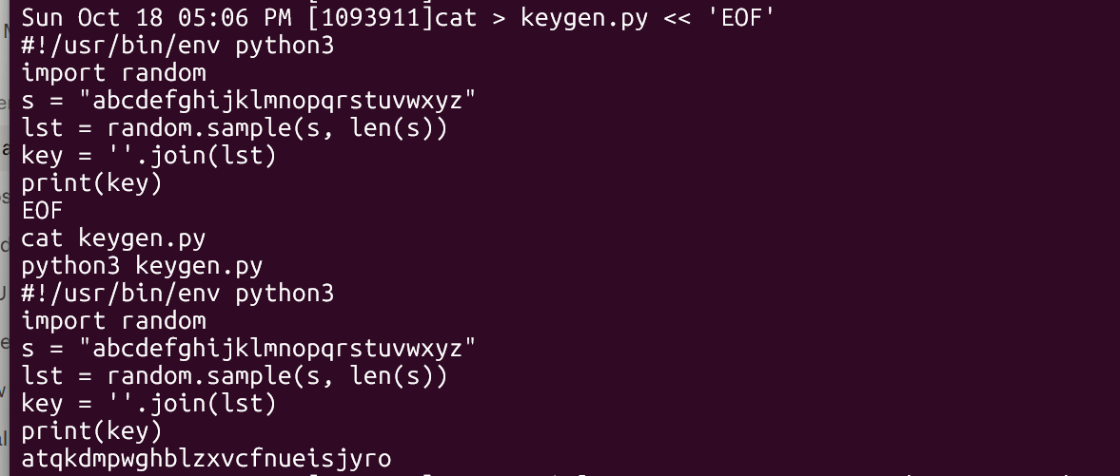
Figure 1: keygen.py and the generated key
The key generated was:
Plain: abcdefghijklmnopqrstuvwxyz
Key: atqkdmpwghblzxvcfnueisjyro
This means a→a, b→t, c→q, d→k, e→d and so on. I checked that the key contains all 26 letters with no repetition, otherwise two plaintext letters would map to the same ciphertext letter and decryption would not be possible. One thing I noticed is that the letter "a" maps to itself. This is allowed in a random permutation, and it shows that a random key can leave some letters unchanged, which gives a small hint to an attacker.

Step 2 – Preparing the article
I took a paragraph about symmetric and asymmetric cryptosystems from the Wikipedia article "Cryptography" [1] and saved it in article.txt.
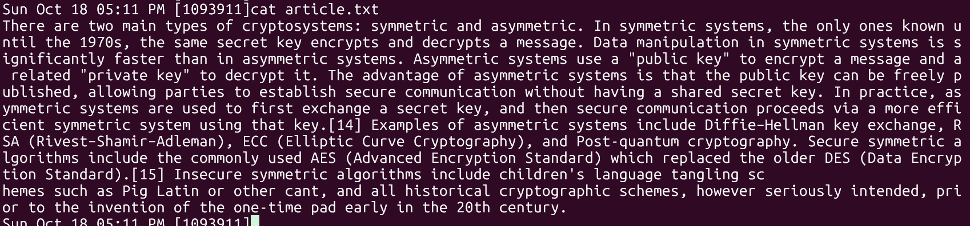
Figure 2: The original article saved in article.txt
Then I simplified the text with two tr commands:
tr '[:upper:]' '[:lower:]' < article.txt > lowercase.txt
tr -cd '[a-z][\n][:space:]' < lowercase.txt > plaintext.txt
The first command converts all capital letters to small letters. The second command uses -c (complement) and -d (delete) so it deletes every character that is NOT a lowercase letter, a newline or a space. So all punctuation and numbers are removed but the spaces stay, which keeps the word boundaries.
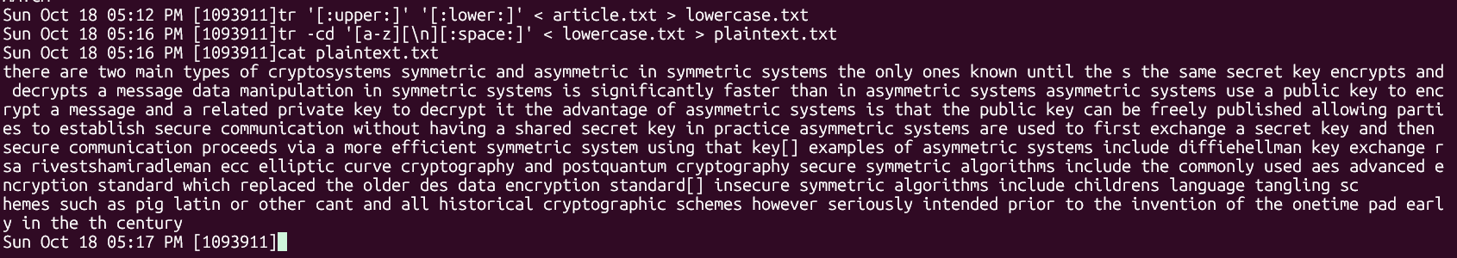
Figure 3: Preprocessing commands and plaintext.txt

Step 3 – Encryption with tr
To encrypt I used tr again, mapping the normal alphabet to my key:
tr 'abcdefghijklmnopqrstuvwxyz' 'atqkdmpwghblzxvcfnueisjyro' < plaintext.txt > my_ciphertext.txt
Only letters are changed, spaces and newlines stay the same. I saved the output as my_ciphertext.txt so I would not overwrite the ciphertext.txt that is given for Task 2.
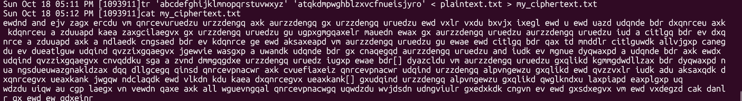
Figure 4: The ciphertext I created (my_ciphertext.txt)
For example the first words "there are two main types" became "ewdnd and ejv zagx ercdu". In "there" → "ewdnd" the letter e appears twice and both times it became d, so repeated letters in the plaintext stay repeated in the ciphertext at the same positions. This is exactly the weakness that frequency analysis uses in Task 2.

Verification – Decryption
To make sure the encryption was correct I decrypted the file by swapping the two sets in tr (key → alphabet) and compared the result with plaintext.txt using diff. diff printed nothing and the echo printed MATCH, so the decrypted file is identical to the plaintext.
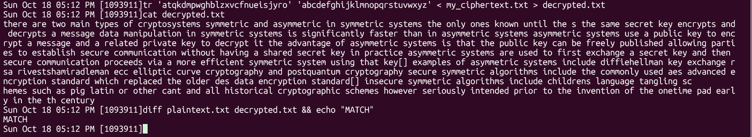
Figure 5: Decryption and verification with diff

Observations
- The numbers like "1970s" and "20th" lost their digits, so "1970s" became just "s" and "20th" became "th". This is expected because the command deletes digits.
- The citation brackets "[14]" and "[15]" became "[]" instead of being removed completely. The reason is that inside the tr set '[a-z][\n][:space:]' the square brackets are treated as normal characters and not as part of a range, so "[" and "]" are also kept. A cleaner command would be tr -cd 'a-z\n[:space:]'. It does not affect the encryption since tr only changes letters, but the brackets give a small extra hint to an attacker.
- Since spaces are kept, the attacker can see the word lengths. For example one-letter words can only be "a" or "i", and three-letter words are often "the" or "and". In real use of a monoalphabetic cipher the spaces would be removed.

3. Task 2 – Frequency Analysis
In this task I was given ciphertext.txt, which was encrypted with a monoalphabetic substitution cipher using a key I do not know. The goal was to recover the original English text using frequency analysis. The idea is simple: a monoalphabetic cipher changes the letters but it does not change how often each letter appears. So the most common letter in the ciphertext is probably the most common letter in English (E), the most common three-letter group is probably THE, and so on [2][3][4].
To keep track of my progress I wrote the plaintext letters in CAPITALS and left the unknown ciphertext letters in small letters, as the lab suggested. Every stage starts again from the original ciphertext.txt and the tr command gets longer as I learn more letters.

Stage 0 – Running freq.py
First I ran the provided freq.py program. It prints the top 20 single letters (1-grams), bigrams (2-grams) and trigrams (3-grams) in the ciphertext. It ignores groups that contain spaces.
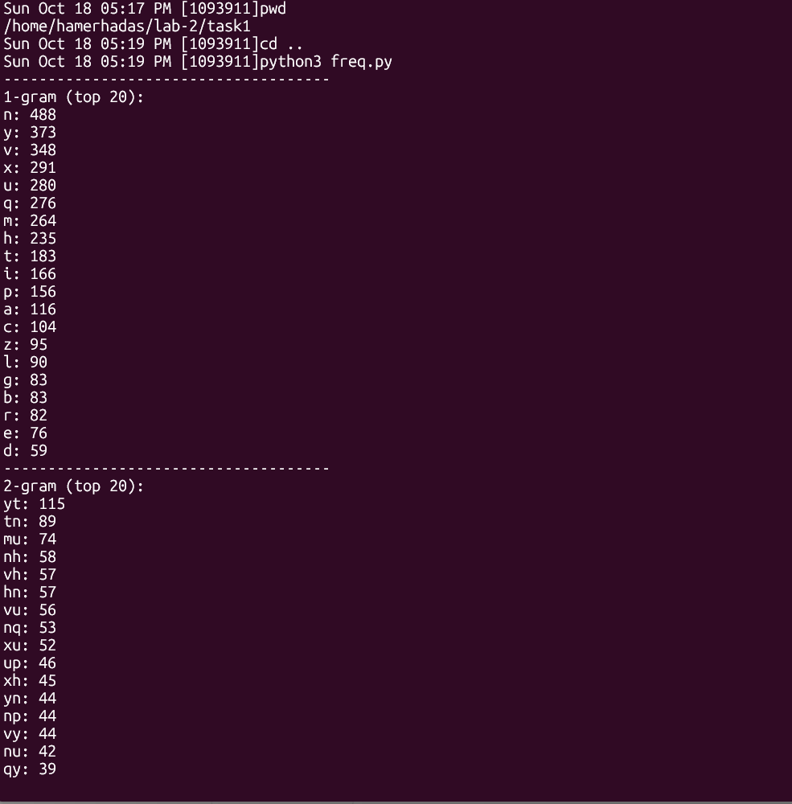
Figure 6: freq.py output – single letter and bigram frequencies
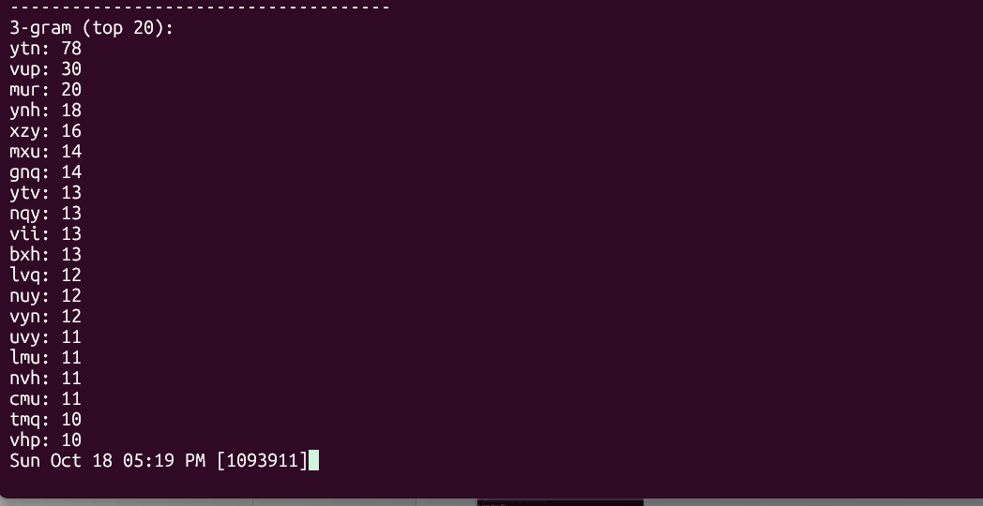
Figure 7: freq.py output – trigram frequencies
The most important results were:
Rank | 1-gram | 2-gram | 3-gram
1 | n (488) | yt (115) | ytn (78)
2 | y (373) | tn (89) | vup (30)
3 | v (348) | mu (74) | mur (20)
4 | x (291) | nh (58) | ynh (18)
5 | u (280) | vh (57) | xzy (16)
Table 1: Most frequent n-grams in ciphertext.txt
In typical English text the most common letters are E, T, A, O, I, N, the most common bigrams are TH, HE, IN, ER, AN and the most common trigrams are THE, AND, ING [2][3][4]. The ciphertext statistics fit this pattern very well.

Stage 1 – ytn → THE
The trigram ytn appears 78 times, far more than any other trigram (the second one only appears 30 times). In English THE is by far the most common trigram, so I guessed y→T, t→H, n→E. This guess is also supported by the other statistics: n is the most common single letter (E is the most common in English), y is the second most common (T is second in English), and yt and tn are the two most common bigrams, which match TH and HE.
tr 'ytn' 'THE' < ciphertext.txt > out.txt && head -5 out.txt
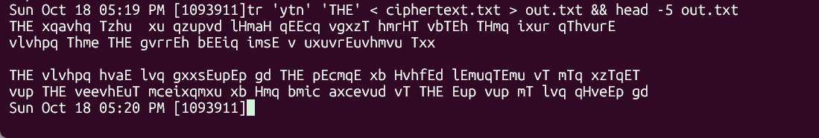
Figure 8: Stage 1 – after replacing ytn with THE
After this step, THE appears in many places in the text, which shows the guess is correct.

Stage 2 – vup → AND and mur → ING
The second and third most common trigrams are vup (30) and mur (20). The next most common English trigrams are AND and ING. I chose vup→AND because v is the third most common letter (A is third in English) and vup often appears as a separate word between other words. mur→ING because mur appears at the end of words, which is where ING usually is in English. This gives v→A, u→N, p→D, m→I, r→G.
tr 'ytnvupmr' 'THEANDIG' < ciphertext.txt > out.txt && head -5 out.txt
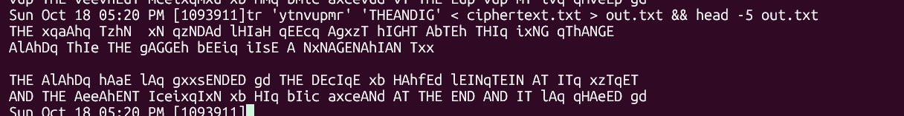
Figure 9: Stage 2 – after adding AND and ING
Now real words started to appear, for example "THE END AND IT" and "NxNAGENAhIAN".

Stage 3 – guessing from partly decrypted words
From this point I mostly used word patterns instead of the frequency table:
- "xN" is a two-letter word ending in N, so it is most likely ON → x→O. This also matches x being the 4th most common letter (O is 4th in English).
- "qzNDAd" looks like SUNDAY → q→S, z→U, d→Y.
- "hIGHT" could be RIGHT, LIGHT, MIGHT or FIGHT. I chose R because h is very common (235) and the bigrams nh (58) and hn (57) would then be ER and RE, which are among the most common English bigrams → h→R.
tr 'ytnvupmrxqhzd' 'THEANDIGOSRUY' < ciphertext.txt > out.txt && head -8 out.txt
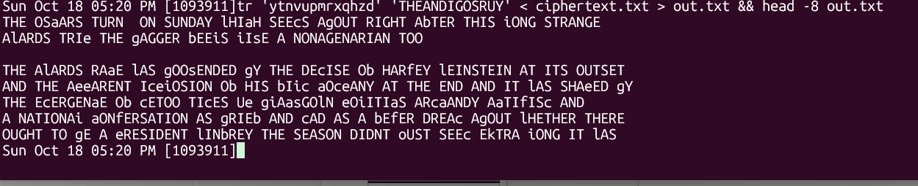
Figure 10: Stage 3 – after adding O, S, R, U, Y
The first line now reads "THE OSaARS TURN ON SUNDAY lHIaH SEEcS AgOUT RIGHT AbTER THIS iONG STRANGE". It is clear that this is an article about the Oscars.

Stage 4 – more letters from the context
- "OSaARS" → OSCARS, so a→C
- "lHIaH" → WHICH, so l→W
- "AgOUT" → ABOUT, so g→B
- "AbTER" → AFTER, so b→F
- "iONG" → LONG, so i→L
- "iIsE" → LIKE, so s→K
- "TRIe" → TRIP, so e→P
tr 'ytnvupmrxqhzdalgbise' 'THEANDIGOSRUYCWBFLKP' < ciphertext.txt > out.txt && head -8 out.txt
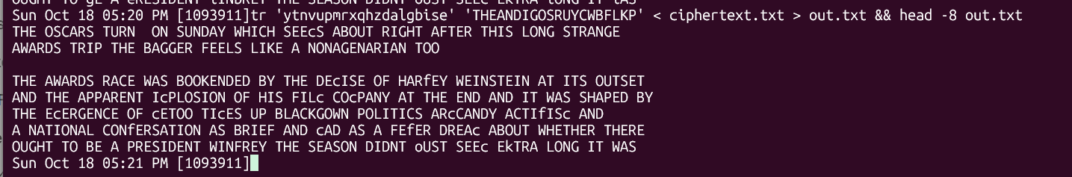
Figure 11: Stage 4 – after adding C, W, B, F, L, K, P

Stage 5 – the remaining letters and the full key
Only a few small letters were left in the text and they were easy to guess from the words they are in:
- "DEcISE" → DEMISE, so c→M
- "HARfEY" → HARVEY (Harvey Weinstein), so f→V
- "EjUALLY" → EQUALLY, so j→Q
- "EkTRA" → EXTRA, so k→X
- "oUST" → JUST, so o→J
- "PRIwE" → PRIZE, so w→Z
These letters (Q, X, J, Z) are the least common letters in English, and that is why they were the last ones to be found: they appear only a few times, so the frequency table gives almost no information about them and they can only be found from the context of the words.
The final key is:
Ciphertext | a | b | c | d | e | f | g | h | i | j | k | l | m
Plaintext | C | F | M | Y | P | V | B | R | L | Q | X | W | I
Ciphertext | n | o | p | q | r | s | t | u | v | w | x | y | z
Plaintext | E | J | D | S | G | K | H | N | A | Z | O | T | U
Table 2: Recovered substitution key (ciphertext → plaintext)
tr 'abcdefghijklmnopqrstuvwxyz' 'CFMYPVBRLQXWIEJDSGKHNAZOTU' < ciphertext.txt > plaintext.txt && cat plaintext.txt
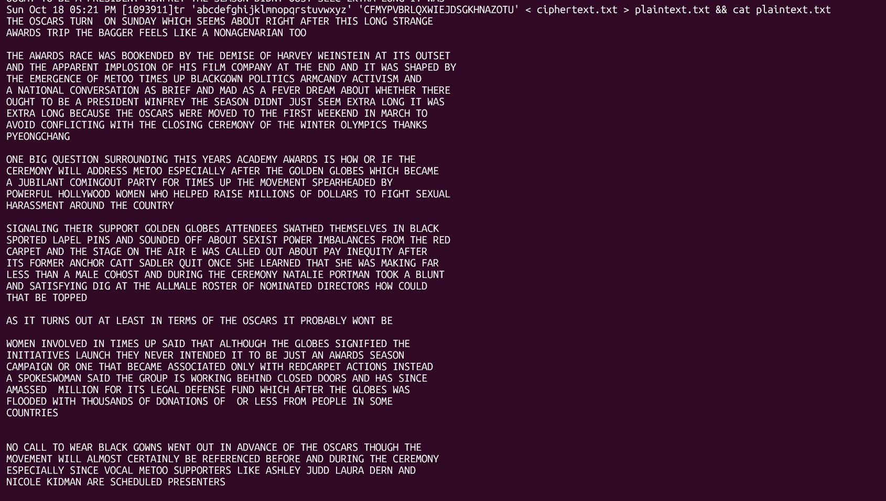
Figure 12: Stage 5 – the fully decrypted article
The decrypted text is a news article about the Oscars and the #MeToo / Times Up movement: "THE OSCARS TURN ON SUNDAY WHICH SEEMS ABOUT RIGHT AFTER THIS LONG STRANGE AWARDS TRIP …". The whole text reads as correct English, so the key is correct.

Observations and analysis
- Frequency analysis worked very well because the text is long (4759 characters). In a short text like my one-paragraph article from Task 1 the statistics would be less reliable and it would take more guessing.
- The trigram ytn (78) was much more useful than the single letter frequencies. For example the single letters x (291), u (280) and q (276) have very close counts, so I could not be sure which one is O, N or S only from the letter count. But one trigram that stands out so clearly gives three letters at once.
- Keeping the spaces made the attack much easier. Short words like "xN" (ON) and "vup" (AND) give strong hints. If the spaces were removed it would still be possible but harder.
- In some places there are double spaces, for example "AMASSED MILLION" and "DONATIONS OF OR LESS". This is because the numbers (like dollar amounts) were deleted from the original article before encryption, the same way digits were removed in Task 1.
- My conclusion is that a monoalphabetic substitution cipher is not secure, even though the key space is very big (26! ≈ 4 × 10^26 keys, so brute force is not practical). The problem is that it keeps the statistical structure of the language, so an attacker does not need to try all the keys. I only needed the frequency table and some guessing to recover the full message in a few steps.

4. Task 3 – Encryption using Different Ciphers and Modes
In this task I used the openssl enc command to encrypt and decrypt a file with three different ciphers: AES-128 in CBC mode, AES-128 in CFB mode and Blowfish in CBC mode [5]. The general form of the command is:
openssl enc -ciphertype -e -in plain.txt -out cipher.bin -K <key in hex> -iv <iv in hex>
The options I used are:
- -e / -d: encrypt or decrypt
- -in / -out: input and output file
- -K: the key given directly in hexadecimal
- -iv: the initialisation vector in hexadecimal
Because I give the key and IV directly with -K and -iv, openssl does not use a password or a salt, so I can decrypt with exactly the same values later.

Setup
I created a folder task3 and a small plaintext file plain.txt containing one sentence. The file is 63 bytes long (62 characters + the newline added by echo).
Figure 13: Creating the plaintext file
For all three ciphers I used the same 128-bit key 00112233445566778899aabbccddeeff. For AES the IV is 16 bytes (0102030405060708090a0b0c0d0e0f10) because the AES block size is 128 bits. For Blowfish the IV is only 8 bytes (0102030405060708) because Blowfish has a 64-bit block size.

Cipher 1 – AES-128-CBC
AES (Advanced Encryption Standard) is a block cipher with a 128-bit block and here a 128-bit key. In CBC (Cipher Block Chaining) mode each plaintext block is XORed with the previous ciphertext block before it is encrypted, and the first block is XORed with the IV. Because of this, the same plaintext block gives a different ciphertext block depending on what came before it.
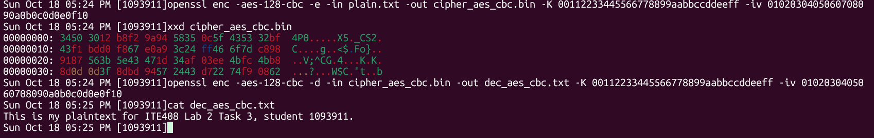
Figure 14: AES-128-CBC encryption, ciphertext in hex (xxd) and decryption
The xxd output shows that the ciphertext is random-looking bytes with no readable text. The decrypted file dec_aes_cbc.txt is exactly the same as the original sentence. The ciphertext is 64 bytes (4 lines of 16 bytes in xxd), which is 1 byte more than the plaintext. The reason is that CBC can only encrypt full blocks, so openssl adds PKCS#7 padding to fill the last block: 63 bytes → 4 × 16 = 64 bytes. The padding is removed automatically when decrypting.

Cipher 2 – AES-128-CFB
This uses the same AES algorithm but in CFB (Cipher Feedback) mode. In CFB the block cipher is used to produce a key stream: the IV (and after that the previous ciphertext block) is encrypted and the result is XORed with the plaintext. So AES works like a stream cipher here, and only the encryption function of AES is used for both encryption and decryption.
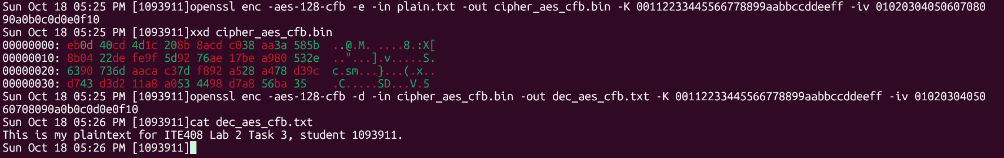
Figure 15: AES-128-CFB encryption, ciphertext in hex (xxd) and decryption
Even though the key, IV and plaintext are the same as in Cipher 1, the ciphertext is completely different, because the mode is different. Decryption gives back the original sentence. The important difference is the size: the last xxd line has only 15 bytes, so the ciphertext is 63 bytes, exactly the same as the plaintext. CFB does not need padding because the plaintext is just XORed with the key stream, so the last block can be cut to any length.

Cipher 3 – Blowfish-CBC
Blowfish is an older block cipher designed by Bruce Schneier in 1993. It has a 64-bit block and a variable key length (32 to 448 bits).
When I first ran the command, it failed with the error "Error setting cipher BF-CBC … unsupported".
Figure 16: Blowfish error in OpenSSL 3
The reason is that my system uses OpenSSL 3.0.13. In OpenSSL 3, older or weaker algorithms such as Blowfish, DES, RC4 and CAST were moved to the "legacy provider", which is not loaded by default [6]. To use it, I added -provider legacy -provider default to the command (the default provider is still needed for the other functions).
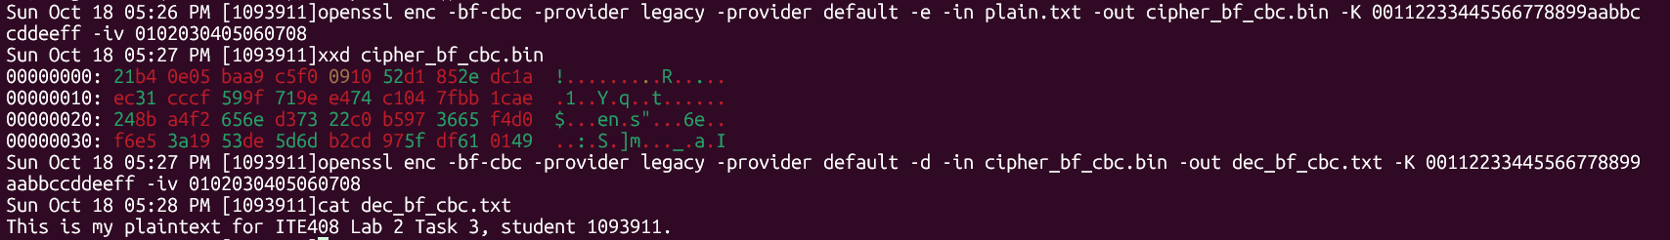
Figure 17: Blowfish-CBC encryption with the legacy provider, ciphertext and decryption
With the legacy provider, encryption and decryption worked and the decrypted file matches the original. The ciphertext is also 64 bytes: 63 bytes padded up to 8 × 8 = 64 bytes, because the Blowfish block is 8 bytes.

Comparing the file sizes
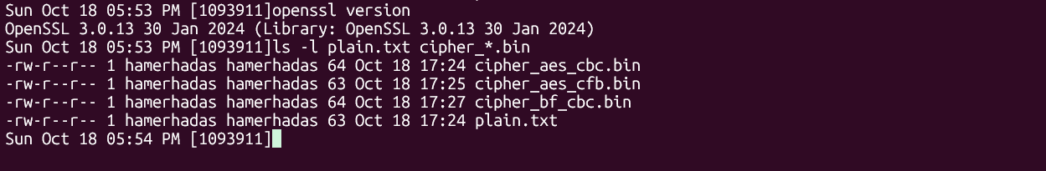
Figure 18: OpenSSL version and file sizes
File | Size (bytes) | Reason
plain.txt | 63 | original text
cipher_aes_cbc.bin | 64 | padded to a multiple of 16 (AES block)
cipher_aes_cfb.bin | 63 | CFB is a stream mode, no padding
cipher_bf_cbc.bin | 64 | padded to a multiple of 8 (Blowfish block)
Table 3: File sizes of the plaintext and the three ciphertexts
Here both CBC files happen to be 64 bytes, but for a different reason. For example, if the plaintext was 65 bytes, AES-CBC would give 80 bytes (5 blocks of 16) and Blowfish-CBC would give 72 bytes (9 blocks of 8), while CFB would stay 65 bytes.

Observations
- The same plaintext and key give totally different ciphertexts with different algorithms and modes, so to decrypt we need to know the algorithm, the mode, the key and the IV.
- Block modes like CBC need padding, so the ciphertext can be bigger than the plaintext. Stream-like modes like CFB keep the same size.
- The fact that OpenSSL 3 disables Blowfish by default shows that it is not recommended anymore. Its 64-bit block is small: after encrypting a lot of data with the same key (around 32 GB) blocks start to repeat, which is the idea behind the Sweet32 attack [7]. For new systems AES is the better choice.
- In this lab I used a fixed key and IV so I could repeat the experiment. In real use the IV should be random and never reused with the same key.

5. Task 4 – Encryption Mode (ECB vs. CBC)
In this task I encrypted the picture pic_original.bmp with AES-128 in two modes, ECB (Electronic Code Book) and CBC (Cipher Block Chaining), and then viewed the encrypted files as pictures to see how much information each mode leaks.

Encrypting the picture
I used the same key as in Task 3. ECB does not use an IV, so the -iv option is only given for CBC.
openssl enc -aes-128-ecb -e -in pic_original.bmp -out pic_ecb.bin -K 00112233445566778899aabbccddeeff
openssl enc -aes-128-cbc -e -in pic_original.bmp -out pic_cbc.bin -K 00112233445566778899aabbccddeeff -iv 0102030405060708090a0b0c0d0e0f10
Figure 19: Encrypting the picture with AES-128-ECB and AES-128-CBC

Step 1 – Fixing the BMP header
A .bmp file starts with a 54-byte header that holds information like the file type, width, height and colour depth. The eog properties panel shows that the picture is 460 × 134 pixels, and for a normal 24-bit BMP like this one the pixel data starts right after the 54-byte header. After encryption the header is also encrypted, so an image viewer cannot open the file. To be able to view it, I took the first 54 bytes from the original picture and the rest of the data (from byte 55 to the end) from the encrypted file, and joined them together:
head -c 54 pic_original.bmp > header
tail -c +55 pic_ecb.bin > body_ecb
tail -c +55 pic_cbc.bin > body_cbc
cat header body_ecb > new_ecb.bmp
cat header body_cbc > new_cbc.bmp
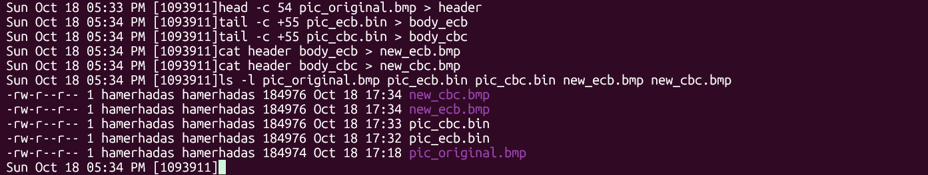
Figure 20: Replacing the header and checking the file sizes
The original file is 184,974 bytes and the encrypted files are 184,976 bytes. The 2 extra bytes are the PKCS#7 padding, because 184,974 is not a multiple of 16 and the next multiple of 16 is 184,976 (16 × 11,561). The new .bmp files are also 184,976 bytes (54 bytes header + 184,922 bytes of encrypted data). The image viewer just ignores the 2 extra bytes at the end because the header says how big the image is.

Step 2 – Displaying the pictures
I installed eog (Eye of GNOME) and opened the original and both encrypted pictures.
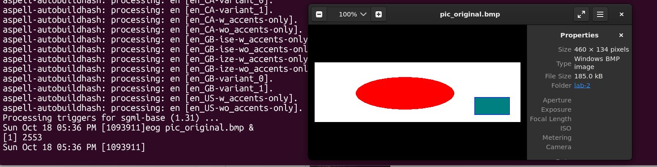
Figure 21: The original picture
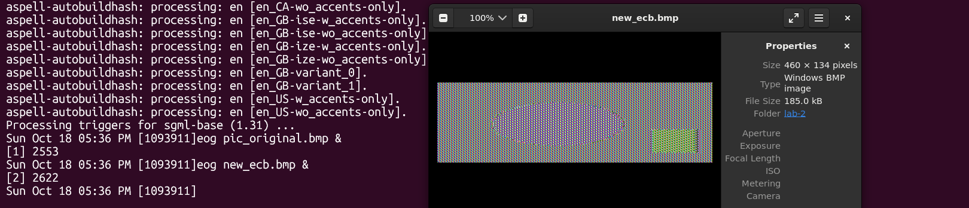
Figure 22: The picture encrypted with ECB mode
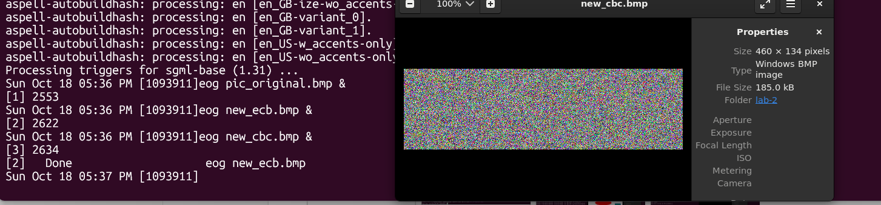
Figure 23: The picture encrypted with CBC mode

Step 3 – Observations
Original: a white background with a red ellipse in the middle and a teal rectangle with a blue border at the bottom right.
ECB: the colours are changed to a repeating striped pattern, but the shape of the picture is still completely visible. I can clearly see the ellipse, its exact size and position, and the rectangle at the bottom right. Someone without the key can still tell what the picture shows, so ECB fails to hide the information in this picture.
The reason is how ECB works. The data is split into 16-byte blocks and every block is encrypted separately with the same key:
C_i = E_K(P_i)
So two identical plaintext blocks always give two identical ciphertext blocks. In this picture large areas have the same colour (the white background is all FF FF FF bytes, the ellipse is all red pixels), so many 16-byte blocks are the same and they all become the same ciphertext block. The colours change, but the areas with the same colour stay as areas with the same pattern, and the edges between them stay where they were. The stripes in the background come from the fact that one row of the image is 460 × 3 = 1380 bytes, which is not a multiple of 16, so the blocks do not line up exactly with the rows and the same few ciphertext blocks repeat with a shift from row to row.
CBC: the picture looks like random coloured noise. There is no ellipse, no rectangle and no pattern at all. I cannot get any useful information about the original picture from it, only its size, which comes from the header I copied.
In CBC each plaintext block is XORed with the previous ciphertext block before encryption, and the first block is XORed with the IV:
C_i = E_K(P_i ⊕ C_(i-1)), C_0 = IV
So even if two plaintext blocks are the same (like two white blocks), the blocks before them are different, so the input to AES is different and the output is different. Every ciphertext block depends on all the previous blocks, so the repeated patterns of the picture are completely hidden.

Conclusion
This experiment shows that the encryption algorithm alone is not enough, the mode is also very important. Both pictures were encrypted with the same AES-128 cipher and the same key, but ECB leaked the structure of the image while CBC hid it. In my opinion ECB should not be used to encrypt data that is longer than one block, especially data with a lot of repetition such as images, documents with fixed formats, or database records. The same problem is shown in the well-known "ECB penguin" example on Wikipedia [8]. For real use a mode with an IV (like CBC or CTR) or an authenticated mode like GCM should be used instead.
One thing I also noticed is that the header must still be readable to view the picture. In my case I copied it from the original, but in a real attack the attacker could guess it easily, since BMP headers are standard and only the width and height change.

6. Task 5 – Error Propagation – Corrupted Cipher Text
In this task I checked what happens when one bit of the ciphertext gets corrupted and the file is then decrypted with the correct key and IV. I tested AES-128 in four modes: ECB, CBC, CFB and OFB.

My predictions (before doing the task)
I made these predictions from the decryption formula of each mode [8][9].
The 55th byte is byte number 54 when counting from 0 (offset 0x36). With 16-byte AES blocks, bytes 1–16 are block 1, 17–32 block 2, 33–48 block 3 and 49–64 block 4, so the 55th byte is the 7th byte of block 4.
Mode | Prediction | Reason
ECB | Only block 4 (16 bytes) is destroyed, everything else is recovered | Each block is decrypted on its own, P_i = D_K(C_i). A changed C_4 gives a completely different P_4 (avalanche effect of AES), but no other block uses C_4.
CBC | Block 4 is destroyed, block 5 has 1 wrong bit at the same position (byte 71), the rest is recovered | P_i = D_K(C_i) ⊕ C_(i-1). C_4 is used twice: in D_K(C_4) for block 4 (whole block destroyed) and in the XOR for block 5 (only the same one bit flips).
CFB | Byte 55 has 1 wrong bit, block 5 is destroyed, the rest is recovered | P_i = C_i ⊕ E_K(C_(i-1)). In block 4 the ciphertext is only XORed, so just one bit flips. But C_4 is also the input to AES for the next block, so the key stream for block 5 is completely wrong.
OFB | Only 1 bit in byte 55 is wrong, everything else is recovered | The key stream O_i = E_K(O_(i-1)) depends only on the key and IV, not on the ciphertext. So the error stays in the one bit where it happened.
Table 4: Predicted effect of a one-bit error in each mode
So my expectation was that in all four modes almost all the file can be recovered and the damage is local, but the amount of damage is different: OFB < ECB < CBC ≈ CFB.

Step 1 – Creating the file
I created a text file with 70 lines like "Block 001 text." where each line is exactly 16 bytes (15 characters + newline). This way every line is exactly one AES block, so it is easy to see which block is damaged after decryption. The file is 1120 bytes, which is more than the required 1000 bytes.
for i in $(seq 1 70); do printf "Block %03d text.\n" $i; done > plain.txt
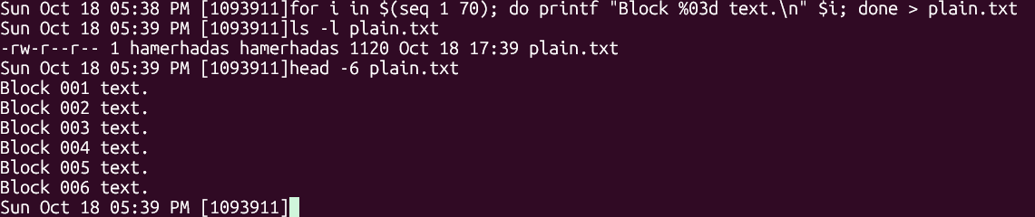
Figure 24: Creating the 1120-byte plaintext file

Step 2 – Encrypting with AES-128 in four modes
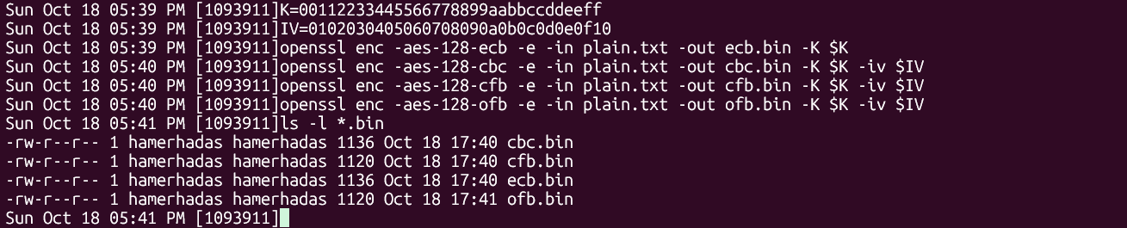
Figure 25: Encryption in ECB, CBC, CFB and OFB modes
The ECB and CBC files are 1136 bytes and the CFB and OFB files are 1120 bytes. Since 1120 is already a multiple of 16, PKCS#7 adds a full extra block of padding (16 bytes) in ECB and CBC. CFB and OFB do not use padding, like I saw in Task 3.

Step 3 – Corrupting one bit of the 55th byte
The lab says to use the bless hex editor, but bless could not be installed on my Ubuntu 24.04 system ("Unable to locate package bless"). Bless was written in Mono and it is not in the newer Ubuntu repositories anymore.
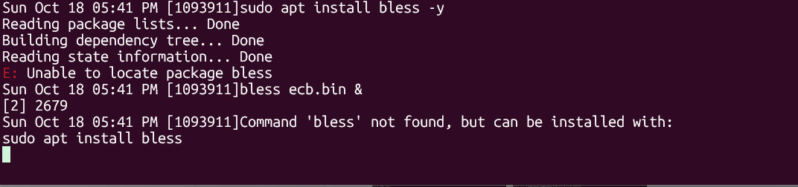
Figure 26: bless is not available
Instead, I installed GHex, which is another graphical hex editor, and opened ecb.bin. In GHex I could see that the 55th byte (offset 0x36, row 00000030, 7th column) has the value B7.
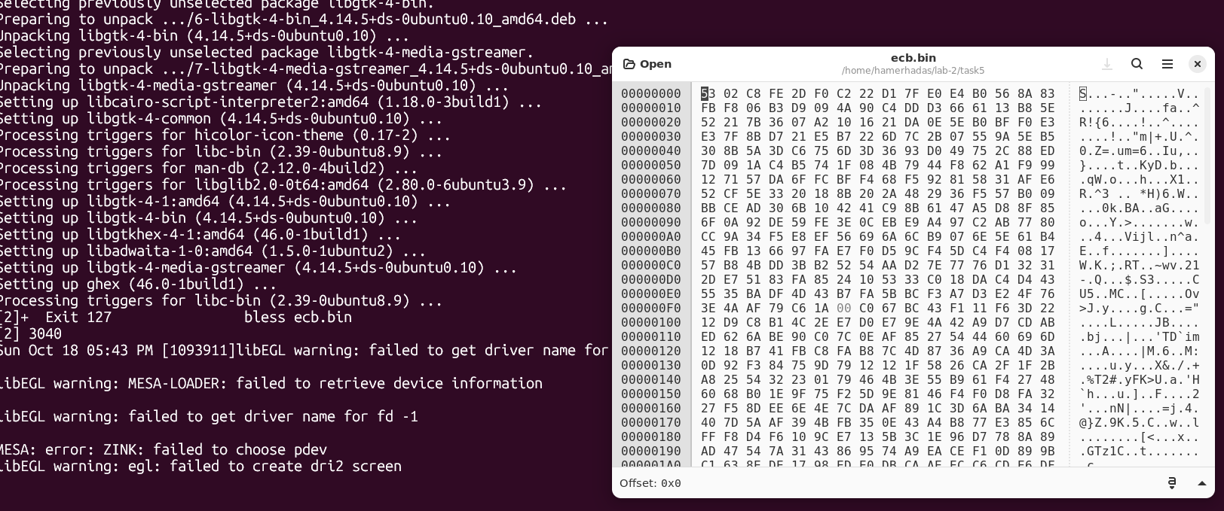
Figure 27: ecb.bin in GHex, the byte at offset 0x36 is B7
When I tried to edit and save the file in GHex, the change was not written to the file (I checked with xxd and the byte was still b7). The first decryption of all four files gave 0 different bytes, which confirmed that the files were not changed yet. Because of this I flipped the bit with a short Python command instead. It reads the file, XORs byte 54 with 1 (this flips only the lowest bit), and writes it back. It does exactly the same thing as changing B7 to B6 in a hex editor.
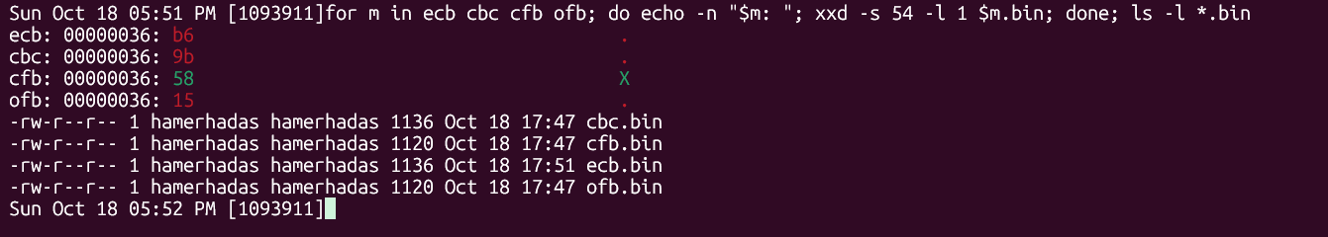
Figure 28: Checking the corrupted byte (offset 0x36) and the file sizes of all four files
File | Byte 55 before | Byte 55 after
ecb.bin | B7 | B6
cbc.bin | 9A | 9B
cfb.bin | 59 | 58
ofb.bin | 14 | 15
Table 5: Byte 55 before and after the bit flip
I checked with xxd that only the expected byte changed and with ls -l that the file sizes did not change.

Step 4 – Decrypting the corrupted files
I decrypted each file with the correct key and IV, and used cmp -l to count how many bytes are different from the original plain.txt. I also printed the first lines with cat -v so the non-printable characters can be seen.
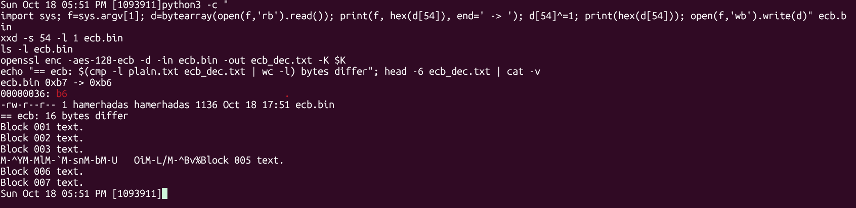
Figure 29: ECB – bit flip and decryption result
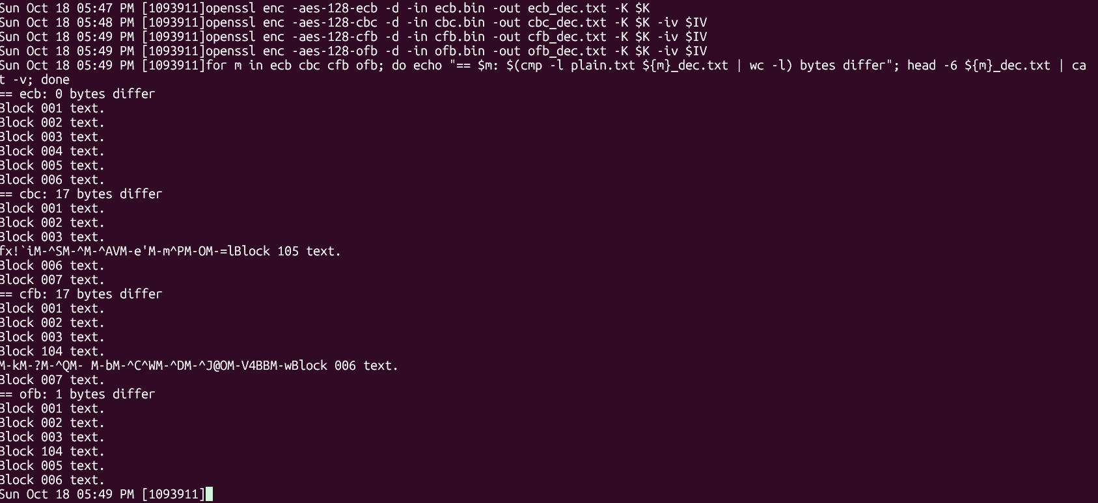
Figure 30: CBC, CFB and OFB decryption results

Results
Mode | Bytes different | What I saw
ECB | 16 | Line 4 is completely garbage, all other lines are correct
CBC | 17 | Line 4 is completely garbage, line 5 shows "Block 105" instead of "Block 005", the rest is correct
CFB | 17 | Line 4 shows "Block 104" instead of "Block 004", line 5 is completely garbage, the rest is correct
OFB | 1 | Only line 4 shows "Block 104" instead of "Block 004", everything else is correct
Table 6: Measured effect of the one-bit error
All my predictions were correct.
- ECB: the whole 4th block (bytes 49–64) was destroyed and nothing else. Because AES has the avalanche effect, flipping 1 input bit to the decryption changes about half of the output bits, so the whole block becomes random.
- CBC: the 4th block was destroyed for the same reason as ECB. In the 5th block only one character changed, "0" → "1" in "Block 005". This is byte 71, which is exactly 16 bytes after byte 55, and "0" (0x30) → "1" (0x31) is exactly the lowest bit, the same bit I flipped in the ciphertext. This is because C_4 is XORed directly with D_K(C_5). From block 6 the decryption is correct again because C_5 is not damaged. 16 + 1 = 17 bytes.
- CFB: it is the opposite order of CBC. In block 4 only one bit flipped ("Block 004" → "Block 104", byte 55, again "0" → "1"), because in CFB the ciphertext is just XORed with the key stream. Then block 5 is completely garbage, because the damaged C_4 was the input to AES to make the key stream for block 5. After that it recovers. 1 + 16 = 17 bytes.
- OFB: only one bit in byte 55 was wrong. The key stream does not depend on the ciphertext at all, so a bit error in the ciphertext only gives the same bit error in the plaintext.

Analysis
Even though CBC and CFB both lose 17 bytes, the pattern is different: CBC destroys the corrupted block and flips one bit in the next, CFB flips one bit in the corrupted block and destroys the next one. The error does not spread further in any of the modes. CBC and CFB are "self-synchronising": after one extra block they recover by themselves.
OFB has the best error propagation, only 1 bit, so it is good for noisy channels such as radio or satellite links. But this also means something negative: an attacker can flip a chosen bit in the ciphertext and the same bit flips in the plaintext without destroying anything else (bit-flipping attack). For example in my file the attacker changed "004" to "104" and the text still looks valid. The same is true for the corrupted block in CFB and for the next block in CBC. This shows that encryption alone does not protect the integrity of the data, and a MAC or an authenticated mode like AES-GCM should be used to detect such changes.

7. Video Demonstration
The video demonstration of Task 2 and Task 4 with voice narration is available on OneDrive at the following link:
[Paste OneDrive video link here]

8. Conclusion
This lab showed me several important points about secret-key encryption:
- A monoalphabetic substitution cipher has a huge key space (26!), but it is still easy to break because it keeps the letter frequencies of the language. In Task 2 I recovered the whole article with only the frequency table and some guessing about common words.
- Modern ciphers like AES are strong, but the way they are used (the mode) matters just as much. In Task 4 the same AES key in ECB mode still showed the shapes of the picture, while CBC mode hid them completely.
- Older ciphers like Blowfish are now disabled by default in OpenSSL 3, which shows how recommendations change over time.
- Different modes react differently to errors. OFB only loses one bit, ECB loses one block, CBC and CFB lose one block plus one bit. Because a bit flip can pass through to the plaintext without being noticed, encryption alone does not give integrity, and a MAC or an authenticated mode such as AES-GCM is needed in practice.
Some problems I had during the lab were that the bless hex editor is not available on Ubuntu 24.04 and that my edits in GHex were not saved, so I used a short Python command to flip the bit. I also found that the tr command given in Task 1 does not remove square brackets. Solving these problems helped me understand the commands better than just running them.

9. References
[1] Wikipedia, "Cryptography," Wikipedia, The Free Encyclopedia. [Online]. Available: https://en.wikipedia.org/wiki/Cryptography. [Accessed: Oct. 18, 2026].
[2] Wikipedia, "Frequency analysis." [Online]. Available: https://en.wikipedia.org/wiki/Frequency_analysis. [Accessed: Oct. 18, 2026].
[3] Wikipedia, "Bigram." [Online]. Available: https://en.wikipedia.org/wiki/Bigram. [Accessed: Oct. 18, 2026].
[4] Wikipedia, "Trigram." [Online]. Available: https://en.wikipedia.org/wiki/Trigram. [Accessed: Oct. 18, 2026].
[5] OpenSSL Project, "openssl-enc – symmetric cipher routines," OpenSSL 3.0 manual. [Online]. Available: https://docs.openssl.org/3.0/man1/openssl-enc/. [Accessed: Oct. 18, 2026].
[6] OpenSSL Project, "OSSL_PROVIDER-legacy – OpenSSL legacy provider," OpenSSL 3.0 manual. [Online]. Available: https://docs.openssl.org/3.0/man7/OSSL_PROVIDER-legacy/. [Accessed: Oct. 18, 2026].
[7] K. Bhargavan and G. Leurent, "On the Practical (In-)Security of 64-bit Block Ciphers: Collision Attacks on HTTP over TLS and OpenVPN," in Proc. ACM CCS, 2016.
[8] Wikipedia, "Block cipher mode of operation." [Online]. Available: https://en.wikipedia.org/wiki/Block_cipher_mode_of_operation. [Accessed: Oct. 18, 2026].
[9] W. Stallings, Cryptography and Network Security: Principles and Practice, 8th ed. Pearson, 2020.

