KHAIZURAN RAFIE ATHMARRULLAH  Full-Stack Software Engineer  Bandung, West Java, Indonesia | +62 851-4119-7534 | mithomizuno@gmail.com  linkedin.com/in/khaizuran-athmarrullah | github.com/Mezuran | mezuran.github.io | 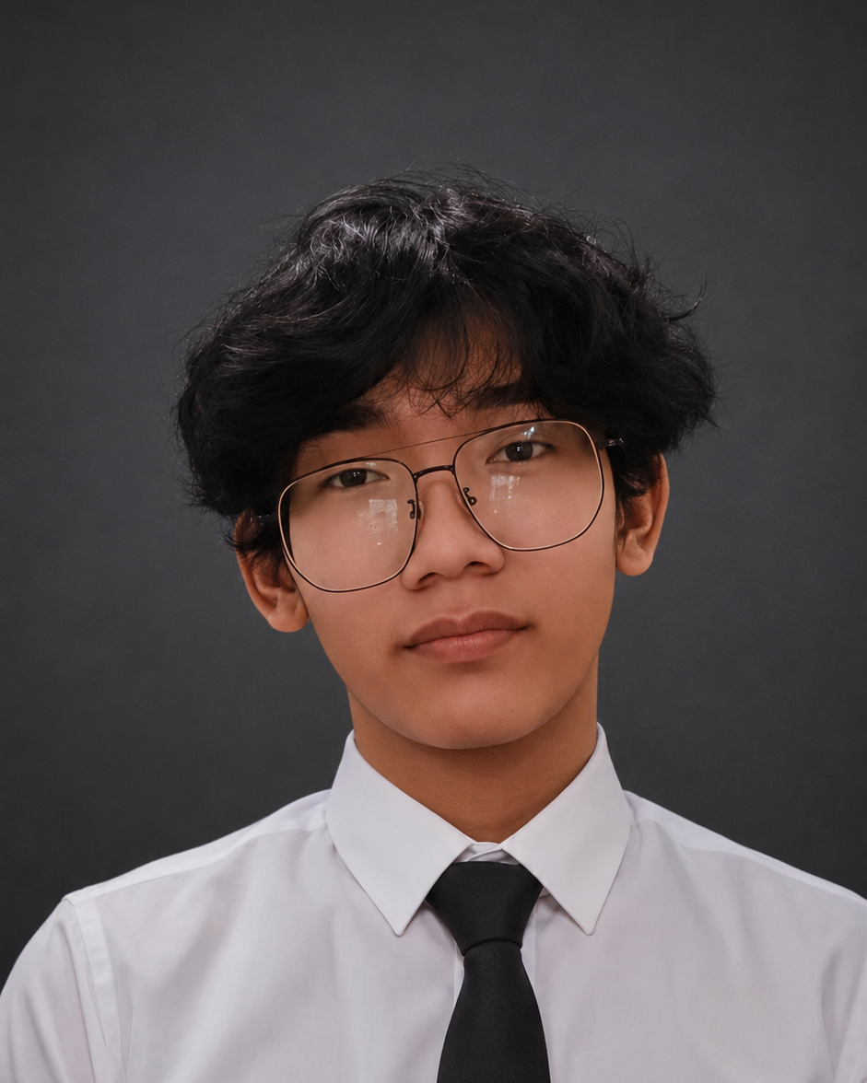

PROFILE
Self-taught full-stack developer with 5 years of hands-on, practice-driven learning across the web, game, and mobile stacks — from front-end frameworks and authentication to server deployment and DevOps. Comfortable working independently, picking up new tools quickly, and delivering working software end to end.

EXPERIENCE
DevOps Engineer (Internship)
Ministry of Public Works and Public Housing (PUPR) | Central Jakarta, Indonesia • Late Aug – Early Dec 2024
- Deployed a production website using the NGINX web server.
- Migrated a large volume of data from Excel spreadsheets into a relational DBMS.
- Secured server access using SSH and a private VPN (Twingate).
- Mirrored a GitHub repository to the production server for streamlined deployment.

PROJECTS
GOR Hames — Badminton court booking & management system with real-time scheduling and reservations, used by venues nationwide across Indonesia. Code | Live
React, TypeScript, Supabase, Vite
Kas Kelas — Class treasury management app for a single class, tracking income, expenses, and balances. Live
TypeScript, Vercel

SKILLS
Languages: TypeScript, JavaScript, PHP, Python, Java, Rust, C#, Lua
Frameworks & Runtimes: React, SolidJS, Next.js, Astro, Laravel, Node.js, Express, React Native, Tauri, Flutter
Databases & Backend Services: MySQL, MongoDB, PostgreSQL, SurrealDB, GraphQL, Supabase, Firebase, Redis
Auth & State Management: Supabase Auth, OAuth (Discord, Google, GitHub), Redux
DevOps & Infra: Docker, Kubernetes, NGINX, SSH/VPN (Twingate), Linux, Windows, macOS
CI/CD: GitHub Actions (automated PR checks & testing, deployment to Netlify)
Game & Mobile Development: Unity (C#), Roblox Studio (Lua), Minecraft Plugin Development (PHP/Java), Flutter (Android)
Spoken Languages: Indonesian (Native), English (Conversational)

EDUCATION
Universitas Komputer Indonesia (UNIKOM)
Bachelor of Engineering, Informatics — 2024–2028 (in progress)
SMK Yapin 02 Setu
Vocational High School — Computer & Network Engineering (TKJ) — 2021–2024
SMP Yapin 02 Setu
Junior High School — 2018–2021
SD Teratai Putih Global School
Elementary School — 2014–2017

CERTIFICATIONS
- CCNA: Introduction to Networks

