# **Why using c ?**

There are many reasons why C programming is used in embedded systems. Here are a few of the most important reasons:

* Performance: C is a compiled language, which means that the code is converted to machine code before it is executed. This makes C code very efficient, which is important for embedded systems that have limited resources.
* Portability: C is a portable language, which means that the same code can be compiled and run on different platforms. This is important for embedded systems that need to be able to work in a variety of environments.
* Control: C gives the programmer a high degree of control over the hardware. This is important for embedded systems that need to be able to interact with the hardware in a precise way.
* Simplicity: C is a relatively simple language to learn and use. This is important for embedded systems that need to be developed and maintained by a team of engineers with different levels of experience.

# Difference between MPU and MCU ?

The main difference between an MPU and an MCU is that an MPU has a memory protection unit (MPU), while an MCU does not. An MPU is a hardware device that controls access to memory, which helps to prevent unauthorized access to data. This makes MPUs more secure than MCUs, and they are often used in applications where security is important, such as in financial systems and medical devices.

Here is a table that summarizes the key differences between MPUs and MCUs:

|  |  |  |
| --- | --- | --- |
| Feature | MPU | MCU |
| Memory protection unit | Yes | No |
| Cost | More expensive | Less expensive |
| Complexity | More complex | Less complex |
| Power consumption | Higher | Lower |
| Applications | Security-critical applications,  high-performance applications | General-purpose applications, low-power applications |

Here are some examples of applications where MPUs are used:

* Point-of-sale systems
* ATMs
* Medical devices
* Networking equipment
* Industrial control systems

Here are some examples of applications where MCUs are used:

* Remote controls
* Toys
* Home appliances
* Consumer electronics
* Automotive systems

Ultimately, the best choice for a particular application will depend on the specific requirements of that application. If security is a top priority, then an MPU is the best choice. If cost or power consumption are more important, then an MCU may be a better option.

**What is difference between ECU , SOC ,SOB ?**

ECU, SOC, and SOB are all acronyms that stand for different things in the world of electronics.

ECU stands for Electronic Control Unit. It is a computer that is used to control various systems in a vehicle, such as the engine, transmission, and brakes. ECUs are typically made up of a microprocessor, memory, and input/output (I/O) devices.

SOC stands for System on a Chip. It is a single integrated circuit (IC) that contains all of the components of a computer system, including the microprocessor, memory, and I/O devices. SOCs are typically used in embedded systems, such as smartphones, tablets, and wearable devices.

SOB stands for System on a Board. It is a complete electronic system that is built on a single printed circuit board (PCB). SOBs are typically used in industrial and commercial applications, such as networking equipment and medical devices.

The main difference between ECUs, SOCs, and SOBs is the size and complexity of the systems they control. ECUs are typically used to control relatively small and simple systems, such as the engine in a car. SOCs are used to control more complex systems, such as the computer in a smartphone. SOBs are used to control the most complex systems, such as the networking equipment in a data center.

|  |  |  |  |
| --- | --- | --- | --- |
| Feature | ECU | SOC | SOB |
| Size | Small | Medium | Large |
| Complexity | Simple | Complex | Very complex |
| Cost | Low | Medium | High |
| Applications | Automotive, industrial | Consumer electronics, networking | Medical devices, data centers |

Ultimately, the best choice for a particular application will depend on the specific requirements of that application. If a small and simple system is needed, then an ECU may be the best choice. If a more complex system is needed, then a SOC may be a better option. If a very complex system is needed, then a SOB may be the best choice.

# **Difference between GPCs and Embedded system ?**

A general-purpose computer (GPC) is a computer that can be used for a variety of tasks, such as word processing, web browsing, and gaming. Embedded systems are computer systems that are designed to perform a specific task or set of tasks. They are typically used in devices that are not intended to be general-purpose computers, such as cars, appliances, and medical devices.

|  |  |  |
| --- | --- | --- |
| Feature | GPC | Embedded System |
| Purpose | Can be used for a variety of tasks | Designed to perform a specific task or set of tasks |
| Features | More powerful and versatile | Less powerful and specialized |
| Cost | More expensive | Less expensive |
| Applications | General-purpose computing | Cars, appliances, medical devices |

Here is a table that summarizes the key differences between GPCs and embedded systems:

Ultimately, the best choice for a particular application will depend on the specific requirements of that application. If a system is needed that can be used for a variety of tasks, then a GPC may be the best choice. If a system is needed that is designed to perform a specific task or set of tasks, then an embedded system may be a better option.

Here are some examples of GPCs:

* Laptops
* Desktop computers
* Smartphones
* Tablets

Here are some examples of embedded systems:

* Car engines
* Traffic lights
* Digital cameras
* Medical devices

Here are some of the benefits of using a GPC:

* Versatility: GPCs can be used for a variety of tasks, which makes them a good choice for businesses and individuals who need a computer that can do a lot of different things.
* Power: GPCs are typically more powerful than embedded systems, which makes them a good choice for tasks that require a lot of processing power, such as gaming and video editing.
* Versatile software: There is a wide variety of software available for GPCs, which makes them a good choice for businesses and individuals who need a computer that can run a variety of applications.

Here are some of the benefits of using an embedded system:

* Cost: Embedded systems are typically less expensive than GPCs, which makes them a good choice for businesses and individuals who are on a budget.
* Size and weight: Embedded systems are typically smaller and lighter than GPCs, which makes them a good choice for applications where size and weight are important, such as in cars and appliances.
* Reliability: Embedded systems are typically more reliable than GPCs, which makes them a good choice for applications where reliability is important, such as in medical devices.

ــــــــــــــــــــــــــــــــــــــــــــــــــــــــــــــــــــــــــــــــــــــــــــــــــــــــــــــــــــــــــــــــــــــــــــــــــــــــــــــــــــــــــــــــــ

## **Difference between interpreter and Compiler?**

A compiler and an interpreter are both computer programs that convert high-level programming languages into machine code. However, they do so in different ways.

A compiler reads the entire source code of a program and converts it into machine code all at once. This means that the entire program must be compiled before it can be run. Compilers are typically used for programming languages that require high performance, such as C and C++.

An interpreter, on the other hand, reads and executes the source code of a program one line at a time. This means that the program can be run as soon as the interpreter starts, but it will be slower than if it were compiled. Interpreters are typically used for programming languages that are designed for ease of development, such as Python and JavaScript.

Here is a table that summarizes the key differences between compilers and interpreters:

## 

Compilers

Pros:

* + Faster execution speed .
  + More efficient use of memory .
  + Can be used for programming languages that require high performance .

Cons:

* + Requires the entire source code to be compiled before it can be run .
  + Can be more difficult to debug .

Interpreters

Pros:

* + Can be used to run programs as soon as the interpreter starts .
  + Easier to debug .

Cons:

* + Slower execution speed .
  + Less efficient use of memory .
  + Can only be used for programming languages that are designed for interpretation .

# **Why we are using hexadecimal in c programming ?**

* It is shorter and easier to read than binary. A hexadecimal number can be represented with only two digits, while a binary number requires eight digits. This makes it easier to read and write hexadecimal numbers, especially when dealing with large numbers.
* It is a more compact way to represent memory addresses. Memory addresses are typically represented in hexadecimal because it is a more compact way to represent the binary values that make up the address. This can be useful when debugging or when working with large amounts of data.
* It is a standard way to represent colors. Colors are typically represented in hexadecimal because it is a standard way to represent the RGB values that make up the color. This can be useful when working with graphics or when displaying colors on a screen.

**( session 4 task ) Some Methods for swapping two numbers**

1-Using a temporary variable

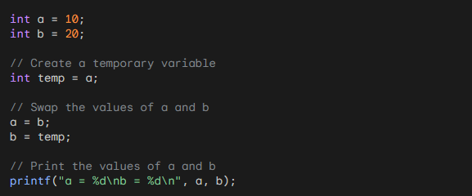

2-Using the addition and subtraction operators:

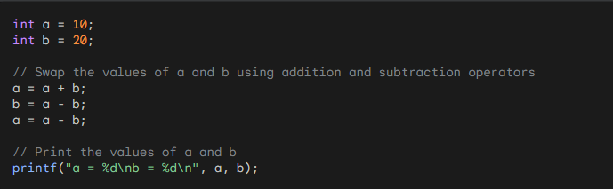

3-Swapping using bitwise XOR operator

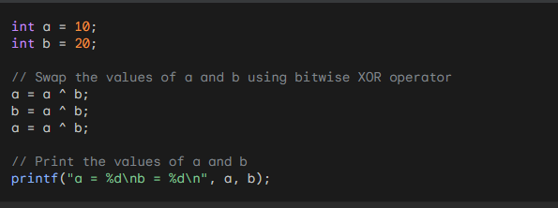

4-Using the addition and subtraction operators:

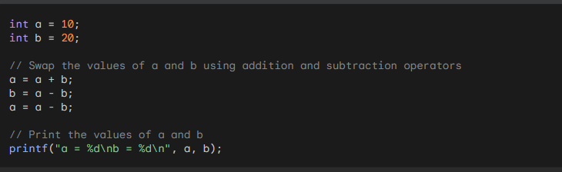

5-Using the multiplication and division operators:

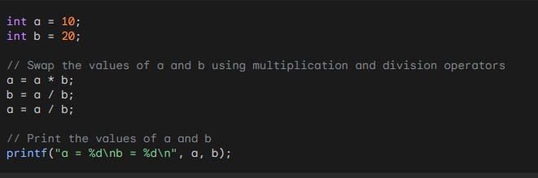

**1-How free function know that size of memory for freeing?**

The `free()` function in C does not require explicit knowledge of the size of the memory block being freed. When you allocate memory dynamically using functions like `malloc()`, `calloc()`, or `realloc()`, the memory management system internally keeps track of the size of the allocated memory blocks.

When you call `free(pointer)` to deallocate memory, the memory management system uses the information it stored to determine the size of the memory block associated with the provided pointer. It then releases that entire block, making it available for reuse.

This mechanism is possible because when you allocate memory dynamically, the memory management system usually adds some additional bookkeeping information to the allocated memory block. This information includes the size of the block, which is used later by `free()` to release the memory properly.

Here's a simplified representation of how the memory management system might manage a dynamically allocated memory block:

+----------------+

| Size of Block |

+----------------+

| Allocated |

| Data |

| (User Data) |

+----------------+

When you call `free(pointer)`, the memory management system uses the `pointer` to locate the size of the block (which it had stored earlier) and then releases the entire block, including both the user data and the bookkeeping information.

This internal management of memory by the memory management system makes the process of freeing memory efficient and allows you to deallocate dynamically allocated memory without having to explicitly provide the size. However, you must ensure that you provide a valid pointer to `free()` (a pointer that was returned by `malloc()`, `calloc()`, or `realloc()`) to avoid undefined behavior.

**What is differance between malloc ,ralloc and calloc?**

The functions `malloc()`, `realloc()`, and `calloc()` are used for dynamic memory allocation in C programming. However, there is no function called `ralloc()` in standard C. Instead, you might be referring to `realloc()`, which is a different function. Let's explore the differences between `malloc()`, `realloc()`, and `calloc()`:

1.malloc():

- `malloc` stands for "memory allocation."

- It is used to allocate a block of memory of a specified size from the heap (the region of memory used for dynamic memory allocation).

- The allocated memory block contains garbage values, and it does not initialize the memory to zero.

- The syntax of `malloc` is as follows:

```c

void* malloc(size_t size);

```

- `size`: The number of bytes you want to allocate.

- Example:

```c

int* dynamicArray;

dynamicArray = (int*)malloc(5 * sizeof(int));

```

2. realloc():

- `realloc` stands for "reallocate memory."

- It is used to resize the previously allocated memory block.

- `realloc` can be used to increase or decrease the size of the memory block.

- If the resizing operation can be performed in place, the existing memory block is returned with its content preserved. If not, a new block is allocated, and the data from the old block is copied to the new block.

- The syntax of `realloc` is as follows:

```c

void* realloc(void* ptr, size_t size);

```

- `ptr`: A pointer to the previously allocated memory block.

- `size`: The new size in bytes that you want to resize the memory block to.

- Example:

```c

// Assuming dynamicArray is a valid pointer to an allocated memory block

dynamicArray = (int*)realloc(dynamicArray, 10 * sizeof(int));

```

3. calloc():

- `calloc` stands for "contiguous allocation."

- It is used to allocate memory for an array of elements, initializing all the allocated bytes to zero.

- The syntax of `calloc` is as follows:

```c

void* calloc(size_t num_elements, size_t element_size);

```

- `num_elements`: The number of elements you want to allocate space for.

- `element_size`: The size (in bytes) of each element.

- Example:

```c

int* dynamicArray;

dynamicArray = (int*)calloc(5, sizeof(int));

```

In summary, `malloc()` is used for basic memory allocation, `realloc()` is used for resizing previously allocated memory, and `calloc()` is used for allocating memory for arrays, initializing all elements to zero. It's important to note that when using these functions, you should always check if the returned pointer is not NULL to ensure successful memory allocation. Also, remember to free dynamically allocated memory using `free()` when it is no longer needed to avoid memory leaks.