INSTRUCTIONS FOR TYPESETTING the accepted MANUSCRIPTS
USING MSWORD
FIRST AUTHOR
University Department, University Name, Address,
City, State ZIP/Zone, Country
firstauthor_id@domain_name
http://<webaddress>
SECOND AUTHOR
Group, Laboratory, Address,
City, State ZIP/Zone, Country
secondauthor_id@domain_name
http://<webaddress>
THIRD AUTHOR
Group, Laboratory, Address,
City, State ZIP/Zone, Country
secondauthor_id@domain_name
http://<webaddress>
Received (Day Month Year)
Revised (Day Month Year)
Accepted (Day Month Year)
Abstract

Purpose-
Design/Methodology/Approach-
Findings-
Research limitations/implications (if applicable)-
Practical implications (if applicable)-
Originality/value-
Keywords Keyword1; keyword2; keyword3; keyword4; keyword5; keyword6.
Paper type In addition, you should categorize your paper under one of these classifications:
General review Research paper Technical paper Conceptual paper Viewpoint

The Main Text
Authors are encouraged to have their contribution checked for grammar. Abbreviations are allowed but should be spelt out in full when first used. Integers ten and below are to be spelt out. Italicize foreign language phrases (e.g. Latin, French).
The text is to be typeset in 10 pt roman, single spaced with baselineskip of 13 pt. Text area is 5 inches in width and the height is 8 inches (including running head). Final pagination and insertion of running titles will be done by the publisher. Upon acceptance, authors are required to submit their data source file including postscript files for figures. Figures and tables are best included at the end of a file.

Major Headings
Major headings should be typeset in boldface with the first letter of important words capitalized. There should usually be no more than three heading levels.

Sub-headings
Sub-headings should be typeset in boldface italic and capitalize the first letter of the first word only. Section number to be in boldface roman.

3.1.1. Sub-subheadings
Typeset sub-subheadings in medium face italic and capitalize the first letter of the first word only. Section numbers to be in roman.

Numbering and spacing
For clarity during the typesetting process, sections, sub-sections and sub-subsections should be numbered in Arabic. Use double spacing before all section headings, and single spacing after section headings. Flush left all paragraphs that follow after section headings.

Lists of items
List may be presented with each item marked by bullets and numbers.

Bulleted items
- item one
- item two
- item three.

Numbered items
- item one
- item two
- item three.
The order of subdivisions of items in bullet and numbered lists may be presented as follows:

Bulleted items
- First item in the first level
- Second item in the first level
- First item in the second level
- Second item in the second level
- First item in the third level
- Second item in the third level
- Third item in the second level
- Fourth item in the second level
- Third item in the first level
- Fourth item in the first level

Numbered items
- First item in the first level
- Second item in the first level
- First item in the second level
- Second item in the second level
    - First item in the third level
    - Second item in the third level
- Third item in the second level
- Fourth item in the second level
(3) Third item in the first level
(4) Fourth item in the first level

Equations
Where possible, equations should be supplied using Mathtype 4. Displayed equations should be numbered consecutively, with the number set flush right and enclosed in parentheses. The equation numbers should be consecutive within the contribution
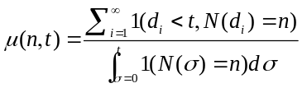. (1)
Equations should be referred to, e.g. “Equation (1)”. In multiple-line equations, the number should be given on the last line.
Displayed equations are to be centered on the page width. Standard English letters like x are to appear as x (italicized) in the text if they are used as mathematical symbols. Punctuation marks are used at the end of equations as if they appeared directly in the text.

Theorem Environments
Theorem 4.1. Theorems, lemmas, etc. are set on a separate paragraph, with extra 1 line space above and below. They are to be numbered consecutively within the contribution.

Lemma 4.2. Theorems, lemmas, etc. are set on a separate paragraph, with extra 1 line space above and below. They are to be numbered consecutively within the contribution.

Proof. Proofs should end with □

Illustrations and Photographs
Figures are to be supplied at the end of the article. An indication of where the figure should go should be made on a line after the paragraph in which they are first mentioned, in bold font, e.g. ‘Figure 1 here’. Please send one set of originals with copies. If the author requires the publisher to reduce the figures, ensure that the figures (including letterings and numbers) are large enough to be clearly seen after reduction. Photos are acceptable.
Figures are to be sequentially numbered in Arabic numerals. The caption must be placed below the figure. Typeset in 8 pt Times Roman with baselineskip of 10 pt. Long captions are to be justified by the “page-width”'. Use double spacing between a caption and the text that follows immediately, e.g. Fig. 1.
Previously published material must be accompanied by written permission from the author and publisher.

Tables

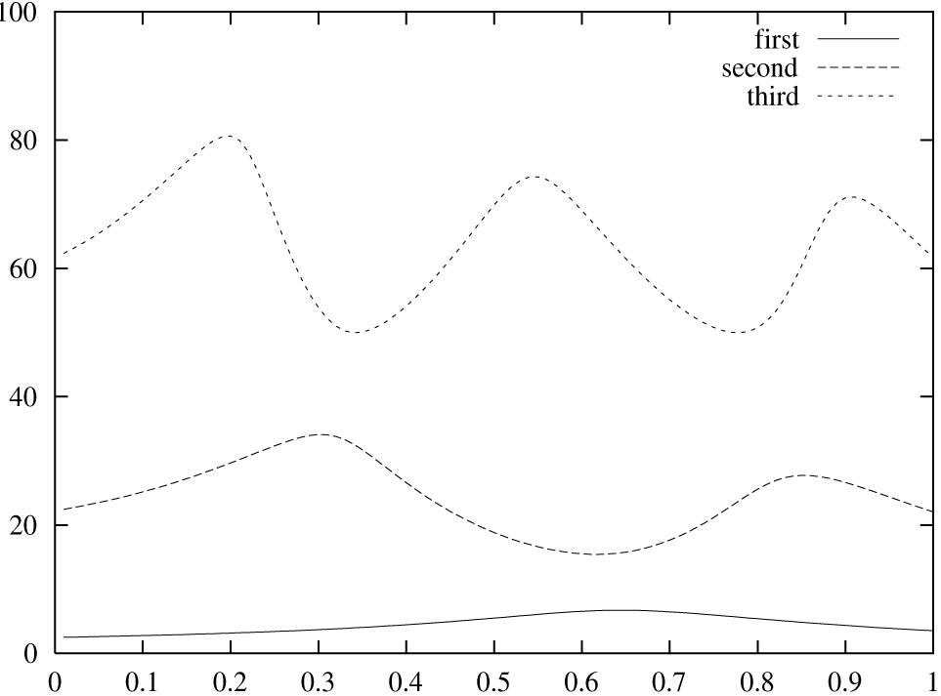
Fig. 1. This is the caption for the figure.
The position of tables should be inserted in the text as close to the point of reference as possible. All actual tables should be placed at the end of the article for typesetting purposes.
Table I. The planning and control components.
Schedule | Capacity | Level
Business plan | Financial planning | Planning
Production planning | Resource requirement plan (RRP)
Master production schedule (MPS) | Rough cut capacity plan (RCCP)
Material requirement plan | Capacity requirement plan (CRP)
Final assembly schedule | Capacity control
Stock picking schedule | Inventory control
Order priorities | Factory order control | Execution
Scheduling | Machine (work-centre) control
Operation sequencing | Tool control
 | Preventive maintenance
Tables should be numbered sequentially in the text in Roman numerals. Captions are to be centralized above the tables. Typeset tables and captions in 8 pt Times Roman with baselineskip of 10 pt. Long captions are to be justified by the “table-width”.
If tables need to extend over to a second page, the continuation of the table should be preceded by a caption, e.g., “Table 1 (Continued)”. Notes to tables are placed below the final row of the table and should be flushleft. Footnotes in tables should be indicated by superscript lowercase letters and placed beneath the table.

Footnotes
Footnotes should be numbered sequentially in superscript Arabic numbers.a

Acknowledgments
This section should come before the References. Funding information may also be included here. Please keep as brief as possible.
- Appendix
Appendices should be used only when absolutely necessary. They should come after the References. If there is more than one appendix, number them alphabetically. Number displayed equations occurring in the Appendix in this way, e.g. (A.1), (A.2), etc.
(A.1)

References
The references section should be labeled “References” and should appear at the end of the paper before any appendices. Authors should follow a consistent format for the reference entries. For journal names, use the standard abbreviations. An sample format is given in the following page:

Citations in Text
Since the references are unnumbered, citations to them in the text must identify them by authors’ names and year of publication. References should be cited in text in parentheses by giving the last name of the author and the date of publication, e.g. (Duan, 2006). A comma should be present before the date. For papers by two authors, the last names are joined by “and” e.g. (Duan and Wang, 2006). Papers by three and more authors should be cited by giving the last name of the first author followed by et al. and the date (note that et al. is in italics and that a period follows the abbreviation al.).
References are given in brackets unless the author’s name is part of the sentence, e.g. “the a-model (Duan et al., 2006)” but “according to Gupta et al. (2006).” If a citation cites two or more papers, they should be separated by a semicolon: (Dorigo and Maniezzo,1996; Duan 2006). If two or more papers by the same author(s) are cited together, the author(s) should be listed once, with the dates of the papers separated by a comma: (Duan and Wang, 2005, 2006). Papers by the same author(s) published in the same year should be distinguished by appending a, b, c, etc., to the date: e.g. (Duan and Wang, 2005a, b).

Reference List
Reference entries should be ordered alphabetically, starting with the last name of the first author, followed by the first author’s initial(s), and so on for each additional author. Multiple entries for one author or one group of authors should be ordered chronologically, and multiple entries for the same year (including references with three authors that may be cited in the text as “et al.”) should be distinguished by appending sequential lowercase letters to the year; e.g. Duan and Wang (2005a); Duan and Wang (2006b).

References
Harrow, R. (2005), No Place to Hide, Simon & Schuster, New York, NY.
Calabrese, F.A. (2005), "The early pathways: theory to practice – a continuum", in Stankosky, M. (Ed.), Creating the Discipline of Knowledge Management, Elsevier, New York, NY, pp. 15-20.
Capizzi, M.T. and Ferguson, R. (2005), "Loyalty trends for the twenty-first century", Journal of Consumer Marketing, Vol. 22 No. 2, pp. 72-80.
Jakkilinki, R., Georgievski, M. and Sharda, N. (2007), "Connecting destinations with an ontology-based e-tourism planner", in Information and communication technologies in tourism 2007 proceedings of the international conference in Ljubljana, Slovenia, 2007, Springer-Verlag, Vienna, pp. 12-32.
Moizer, P. (2003), "How published academic research can inform policy decisions: the case of mandatory rotation of audit appointments", working paper, Leeds University Business School, University of Leeds, Leeds, 28 March.

a Footnotes should be typeset in 8 pt Times Roman at end of the article.

