
FAST National University of Computer and Emerging Sciences
Department of Computer Science

Deep Learning Programming (DLP)
Assignment 1
Neural Networks from Scratch, Training Dynamics, and Optimization Study on Fashion-MNIST
Submitted By
Student 1 | M Fahad | 23F-0696
Student 2 | Muneeb Akbar | 23F-0608

Submitted To: Ms. Aqsa Younas
Section: BCS-7A

GitHub Repository

Summary
This assignment implements and studies fully connected neural networks on the Fashion-MNIST dataset across seven parts: manual backpropagation, activation function comparison, loss function comparison, optimizer comparison, deliberate overfitting, regularization study, and hyperparameter tuning with k-fold cross-validation. The key outcomes are summarized below.
Final Test Score
Test Accuracy: 88.36% | Macro Precision: 88.81% | Macro Recall: 88.36% | Macro F1: 88.44%
This represents a +0.17 percentage-point improvement over the Part 2 ReLU baseline (88.19%).
Configuration That Produced It
Hyperparameter | Selected Value
Architecture | 784 → 256 (hidden, ReLU) → 10 (softmax), single hidden layer
Learning rate | 0.0005
Hidden width | 256
Dropout rate | 0.2
Optimizer | Adam
Selection method | Random search (12 configurations), 5-fold cross-validation
Mean CV accuracy | 88.26% (± 0.46%)
Final training set | Full 48,000-sample training split
The Single Change That Helped Most
Switching the optimizer from plain SGD to Adam (Part 4) produced the largest single gain observed in the whole study. With a tuned learning rate, plain SGD reached only 82.22% validation accuracy after 10 epochs and had not crossed 85%, whereas Adam crossed 85% accuracy by epoch 2 and finished with the best validation performance among all four optimizers. This single change adopting Adam had a far bigger effect on model quality and training speed than any of the regularization techniques (Part 6) or the later hyperparameter search (Part 7), both of which only produced small, incremental gains once Adam was already in use.

Part 0 Environment Setting
The Fashion-MNIST dataset (60,000 training images, 10,000 test images, 28×28 grayscale, 10 classes) was loaded, pixel values were normalized to the range [0, 1], the training data was split into training and validation subsets, and the class distribution was verified to be balanced across all 10 categories.

Part 1 Backpropagation from Scratch
Architecture
- Input: 784 features → Hidden layer: 64 neurons (ReLU) → Output: 10 neurons (Softmax)
- Loss: Categorical Cross-Entropy
- Training samples: 5,000 | Epochs: 20 | Learning rate: 0.1
Gradient Verification (NumPy vs. PyTorch Autograd)
Weight Matrix | Maximum Absolute Difference
W1 | 1.45e-09
W2 | 1.04e-08

The differences are negligible and attributable to floating-point precision, confirming the manual backpropagation implementation is correct. Training loss decreased from approximately 2.30 to 2.19 over 20 epochs, showing the manually implemented network successfully learned.
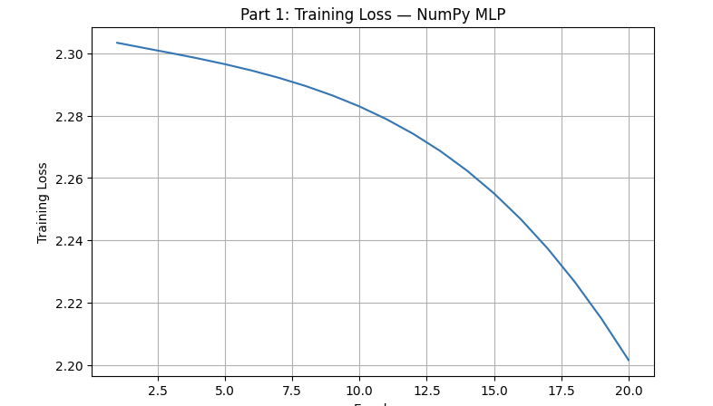

Part 2 Baseline Model & Activation Study
Four activation functions were compared on an identical 784-128-64-10 MLP, optimizer, learning rate, batch size, and epoch count.
Activation | Final Validation Loss | Validation Accuracy
Sigmoid | 0.3336 | 87.95%
Tanh | 0.3263 | 87.95%
ReLU | 0.3253 | 88.19%
Leaky ReLU | 0.3263 | 87.88%

ReLU achieved the highest validation accuracy. Sigmoid showed signs of vanishing gradients due to saturation near 0/1, and a measurable fraction of ReLU units were found to be "dead" (outputting zero for every validation sample), quantifying the dead-ReLU phenomenon empirically.
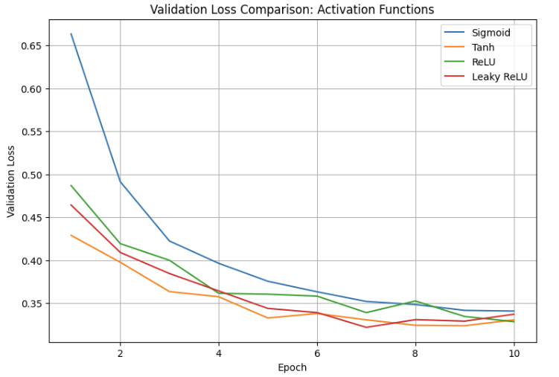

Part 3 Loss Functions
Classification: Cross-Entropy vs. MSE
Loss Function | Final Training Loss | Test Accuracy
Cross-Entropy | 0.2824 | 88.29%
MSE | 0.0154 | 88.15%
Regression (California Housing)
Metric | Test Result
MSE | 0.3190
RMSE | 0.5648
MAE | 0.3951

Cross-entropy directly measures the gap between predicted and true class probability distributions, giving more useful gradients for classification than MSE, which is better suited to continuous regression targets.

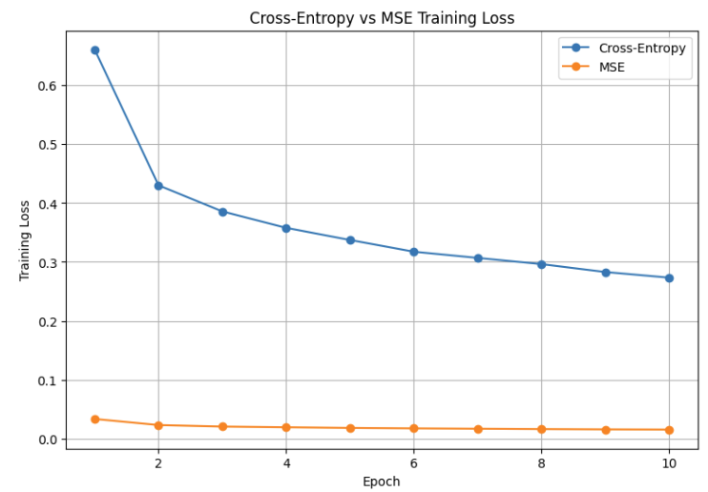

Part 4 Optimizer Comparison
Four optimizers were compared on an identical 784-128-64-10 ReLU MLP, each first at a shared learning rate (0.001) and then with a tuned per-optimizer learning rate, of 10 epochs.
Optimizer | Tuned LR | Epoch to reach 85% Val. Acc. | Final Val. Accuracy | Final Val. Loss
SGD | 0.01 | Not reached in 10 epochs | 82.22% | 0.5057
SGD + Momentum | 0.01 | 6 | 87.42% | 0.3489
RMSProp | 0.001 | 3 | 87.64% | 0.3327
Adam | 0.001 | 2 | 88.44% | 0.3195

Optimizer choice and learning rate strongly affect both convergence speed and final validation performance. Adam reached the 85% accuracy mark fastest (by epoch 2) and produced the best final validation accuracy, making it the best optimizer in this experiment.

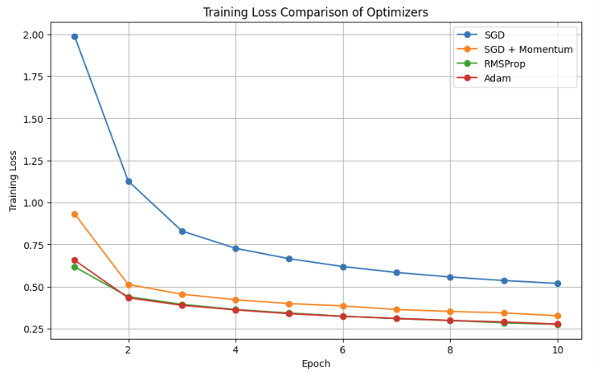

Part 5 Forcing Overfitting
Metric | Value
Training samples | 2,000
Final training accuracy | 99.20%
Final validation accuracy | 82.73%
Generalisation gap | 16.47 pp
Loss curves first separate | Epoch 4
A deliberately over-capacity four-layer, 512-unit network was trained on only 2,000 samples. Training and validation loss track together early on, then diverge sharply at epoch 4 a classic high-variance signature as the network memorizes training-specific noise rather than generalisable patterns.

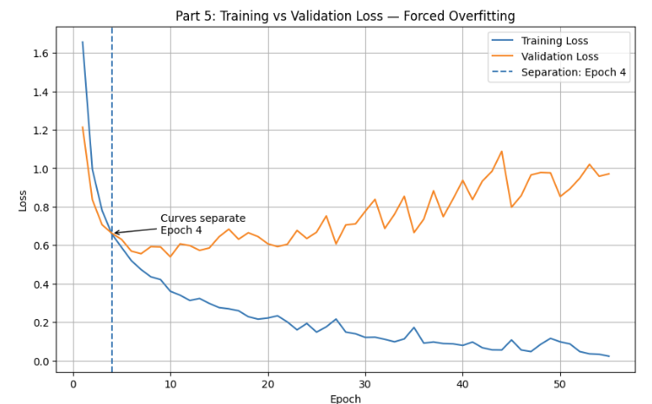

Part 6 Regularisation Study
Gap Reduction vs. Training-Accuracy Cost (relative to baseline)
Method | Setting | Gap Reduction (pp) | Training Acc. Loss (pp)
Early stopping | patience = 5, epoch = 15 | 7.53 | 9.00
Dropout | 0.6 | 6.03 | 5.95
More training data | 20,000 samples | 5.08 | 0.73
More training data | 10,000 samples | 4.74 | 3.19
Data augmentation | Flip + rotation 10° | 3.26 | 3.85
Dropout | 0.4 | 2.72 | 1.95
Dropout | 0.2 | 0.72 | 0.80
L1 penalty | 0.00001 | 0.29 | 0.00
L2 weight decay | 0.00001 | 0.27 | 0.00
L2 weight decay | 0.0001 | 0.02 | 0.00
Batch normalisation | — | -0.15 | 0.00
L2 weight decay | 0.001 | -0.18 | 0.00

Early stopping gave the largest gap reduction but at the highest training-accuracy cost, meaning it closes the gap partly by cutting training short. Training on 20,000 samples achieved nearly as large a gap reduction (5.08 pp) at a much lower cost (0.73 pp), making it the best trade-off overall since it addresses the root cause of overfitting insufficient data for the model's capacity rather than penalizing the model after the fact. Weak L1/L2 settings and batch normalization barely moved the gap, and the strongest L2 setting even made it slightly worse.
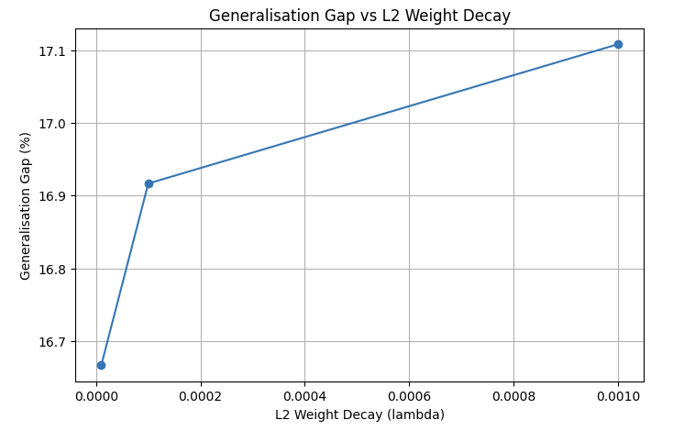

Part 7 Hyperparameter Tuning with k-Fold Cross-Validation
Search Space
Hyperparameter | Values Searched
Learning rate | 0.0001, 0.0005, 0.001, 0.005
Hidden width | 256, 512, 768
Dropout rate | 0.2, 0.4, 0.6
Top 5 Configurations (12 random configs, 5-fold CV)
Rank | Learning Rate | Hidden Width | Dropout | Mean CV Acc. | Std
1 | 0.0005 | 256 | 0.2 | 88.26% | 0.46%
2 | 0.0005 | 512 | 0.2 | 87.82% | 0.73%
3 | 0.0005 | 256 | 0.4 | 87.68% | 0.46%
4 | 0.0001 | 512 | 0.6 | 87.66% | 0.40%
5 | 0.0010 | 768 | 0.4 | 87.17% | 0.18%
Final Test Results (Selected Configuration, Retrained on Full 48,000-sample Training Set)
Metric | Value
Accuracy | 88.36%
Macro precision | 88.81%
Macro recall | 88.36%
Macro F1 | 88.44%
Improvement over Part 2 baseline | +0.17 pp

The 5-fold cross-validated random search selected learning rate = 0.0005, hidden width = 256, dropout = 0.2, with mean CV accuracy 88.26% (± 0.46%). Notably, the smallest hidden width tested outperformed larger 512- and 768-unit configurations, suggesting a smaller, better-regularised network generalised more reliably. Retrained on the full training set, this configuration reached 88.36% test accuracy, a modest +0.17 pp improvement over the Part 2 ReLU baseline, suggesting the search budget was already close to this architecture family's performance ceiling on Fashion-MNIST.

