**MACHINE LEARNING**

**ASSIGNMENT: 01**

**FA21-BSE-024**

**Fahad Ajmal**

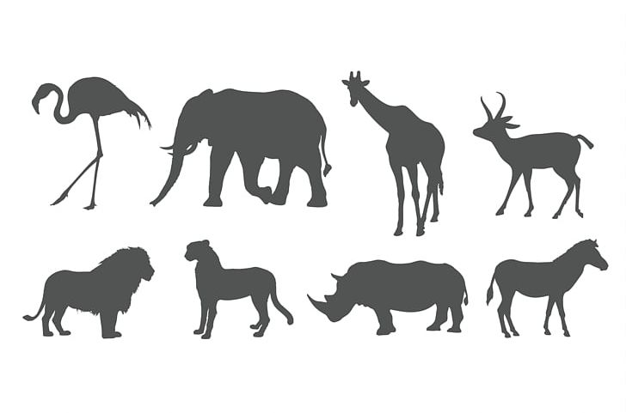

**Number of Legs: Four**

**Diet: Herbivore**

**Instance Space**

|  |  |  |
| --- | --- | --- |
| Number of Legs | Diet | Mammal? |
| Four | Herbivore | - |
| Four | Omnivore | - |
| Four | Carnivore | - |
| Two | Herbivore | - |
| Two | Omnivore | - |
| Two | Carnivore | - |

Size of instance space = |X| = 3*2

**Concept Space**

|  |  |  |
| --- | --- | --- |
| Number of Legs | Diet | Mammal? |
| Four | Herbivore | 1 |
| Four | Omnivore | 0 |
| Four | Carnivore | 0 |
| Two | Herbivore | 0 |
| Two | Omnivore | 0 |
| Two | Carnivore | 0 |

|  |  |  |
| --- | --- | --- |
| 1 | 0 | 0 |
| 0 | 0 | 0 |

C1 = < Number of Legs = Four AND Diet = Herbivore >

|  |  |  |
| --- | --- | --- |
| Number of Legs | Diet | Mammal? |
| Four | Herbivore | 0 |
| Four | Omnivore | 1 |
| Four | Carnivore | 0 |
| Two | Herbivore | 0 |
| Two | Omnivore | 0 |
| Two | Carnivore | 0 |

|  |  |  |
| --- | --- | --- |
| 0 | 1 | 0 |
| 0 | 0 | 0 |

C2 = < Number of Legs = Four AND Diet = Omnivore >

|  |  |  |
| --- | --- | --- |
| Number of Legs | Diet | Mammal? |
| Four | Herbivore | 0 |
| Four | Omnivore | 0 |
| Four | Carnivore | 1 |
| Two | Herbivore | 0 |
| Two | Omnivore | 0 |
| Two | Carnivore | 0 |

|  |  |  |
| --- | --- | --- |
| 0 | 0 | 1 |
| 0 | 0 | 0 |

C3 = < Number of Legs = Four AND Diet = Carnivore >

|  |  |  |
| --- | --- | --- |
| Number of Legs | Diet | Mammal? |
| Four | Herbivore | 0 |
| Four | Omnivore | 0 |
| Four | Carnivore | 0 |
| Two | Herbivore | 1 |
| Two | Omnivore | 0 |
| Two | Carnivore | 0 |

|  |  |  |
| --- | --- | --- |
| 0 | 0 | 0 |
| 1 | 0 | 0 |

C4 = < Number of Legs = Two AND Diet = Herbivore >

|  |  |  |
| --- | --- | --- |
| Number of Legs | Diet | Mammal? |
| Four | Herbivore | 0 |
| Four | Omnivore | 0 |
| Four | Carnivore | 0 |
| Two | Herbivore | 0 |
| Two | Omnivore | 1 |
| Two | Carnivore | 0 |

|  |  |  |
| --- | --- | --- |
| 0 | 0 | 0 |
| 0 | 1 | 0 |

C5 = < Number of Legs = Two AND Diet = Omnivore >

|  |  |  |
| --- | --- | --- |
| Number of Legs | Diet | Mammal? |
| Four | Herbivore | 0 |
| Four | Omnivore | 0 |
| Four | Carnivore | 0 |
| Two | Herbivore | 0 |
| Two | Omnivore | 0 |
| Two | Carnivore | 1 |

|  |  |  |
| --- | --- | --- |
| 0 | 0 | 0 |
| 0 | 0 | 1 |

C6 = < coloration = bright AND beak shape = pointed OR coloration = dull AND beak shape = hooked OR coloration = speckled AND beak shape = curved >

|  |  |  |
| --- | --- | --- |
| **C1**= 1 | **C2**= 0 | **C3**= 0 |
| **C4**= 0 | **C5**= 0 | **C6**= 0 |

C1

|  |  |  |
| --- | --- | --- |
| 0 | 1 | 0 |
| 0 | 0 | 0 |

C2

C3

|  |  |  |
| --- | --- | --- |
| 0 | 0 | 1 |
| 0 | 0 | 0 |

|  |  |  |
| --- | --- | --- |
| 0 | 0 | 0 |
| 1 | 0 | 0 |

C4

C5

|  |  |  |
| --- | --- | --- |
| 0 | 0 | 0 |
| 0 | 1 | 0 |

|  |  |  |
| --- | --- | --- |
| 0 | 0 | 0 |
| 0 | 0 | 1 |

C6

.

.

.

|  |  |  |
| --- | --- | --- |
| 1 | 1 | 1 |
| 1 | 0 | 1 |

C63

|  |  |  |
| --- | --- | --- |
| 1 | 1 | 1 |
| 1 | 1 | 1 |

C64