**Task 1: Global App Theme Switcher**

1. **Task-Description**  
   In this task, I developed a global theme switcher for a React application, enabling users to toggle between light and dark themes. The objective was to enhance user experience by providing a personalized interface while ensuring that the selected theme persists across page reloads.
2. **Screenshot of Output**

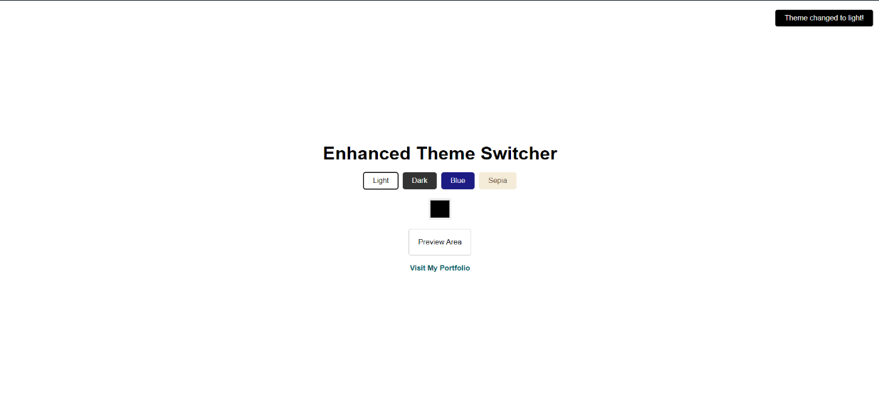

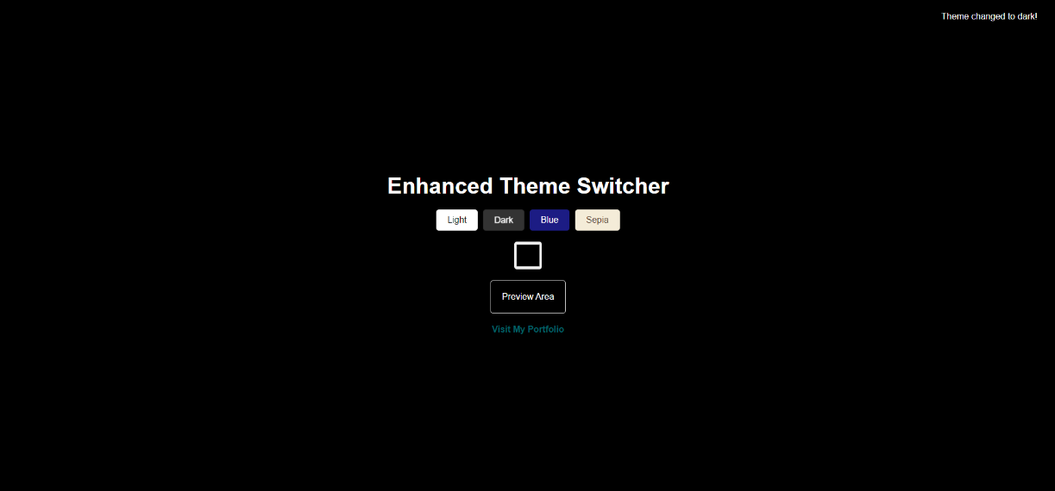

1. **Widget/Algorithm Used**
   * **React Context API**: This was utilized to create a global context for theme management. By wrapping the application in a ThemeProvider, I ensured that any component within the tree could access and modify the current theme.
   * **Local Storage**: The selected theme is stored in the browser’s local storage. Upon loading the application, I check the local storage for the user's previous selection and set the theme accordingly.
   * **CSS Variables**: CSS variables were implemented to dynamically change styles based on the selected theme. This allows for smooth transitions and easy management of theme-related styles.
2. **Implementation Steps**
   * Created a ThemeContext.js file to define the context and provider.
   * Implemented functions to toggle the theme and to save/retrieve the theme from local storage.
   * Designed a simple UI with a toggle switch that allows users to switch between light and dark themes.