**Task 2: Shared Component for Form Inputs**

1. **Task-Description**  
   The goal of this task was to develop a shared input component that could be reused across multiple forms. This component supports various types of inputs, including text fields, text areas, checkboxes, and radio buttons, improving the consistency and maintainability of the codebase.
2. **Screenshot of Output**

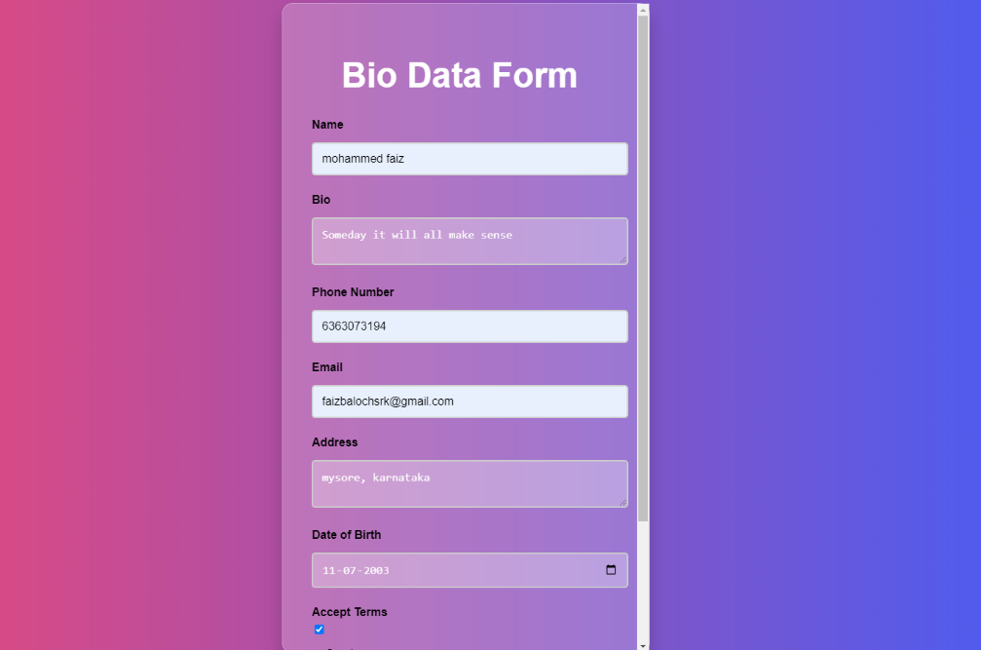

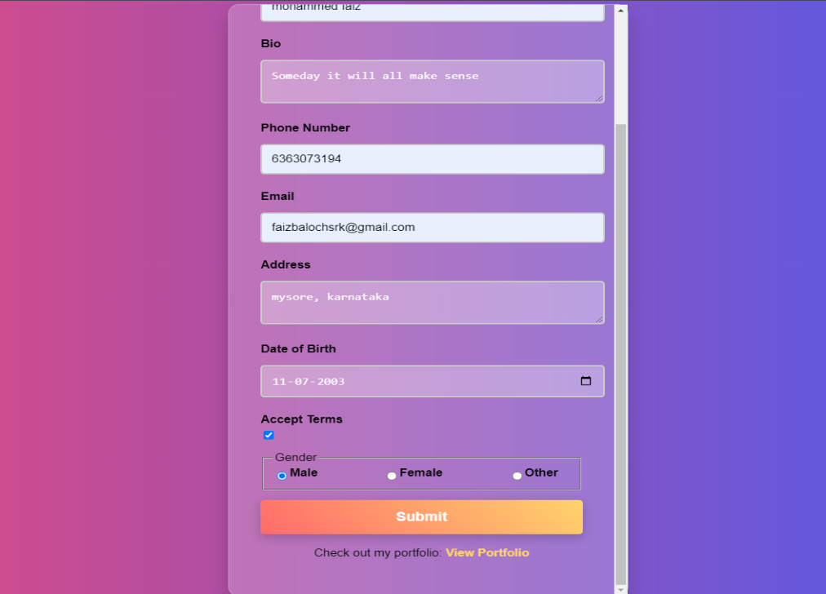

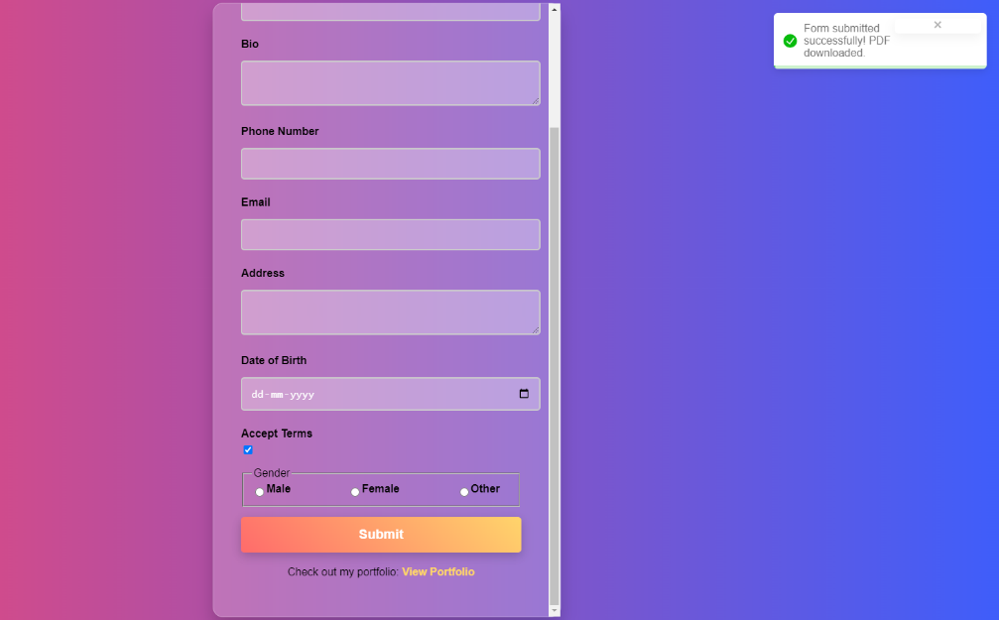

1. **Widget/Algorithm Used**
   * **React Functional Components**: I created a functional component called InputField that accepts props to define the type of input, placeholder text, and any validation rules.
   * **CSS Flexbox**: Flexbox was used for styling the component layout, ensuring responsiveness and alignment across different screen sizes.
   * **Prop Validation**: Implemented PropTypes to ensure the component receives the correct data types, enhancing robustness.
2. **Implementation Steps**
   * Defined the InputField component with conditional rendering based on the type prop.
   * Created a centralized stylesheet to handle all the input field styling.
   * Integrated the InputField component into various forms across the application to ensure consistency.