**Task 3: Multi-Step Form with Submission and Toast Notification**

1. **Task-Description**  
   This task involved creating a multi-step form that guides users through a series of input steps. Upon completion, the form displays a summary of the submitted data, resets the form, and triggers a toast notification to inform users of successful submission.
2. **Screenshot of Output**

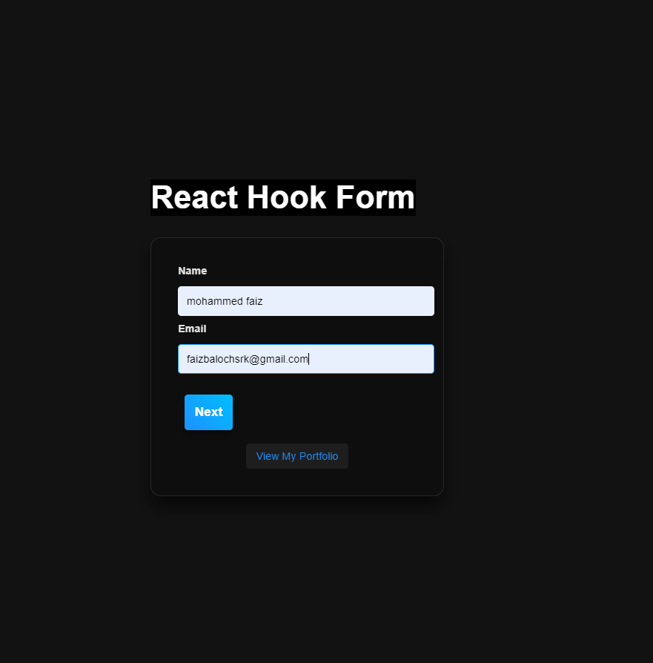

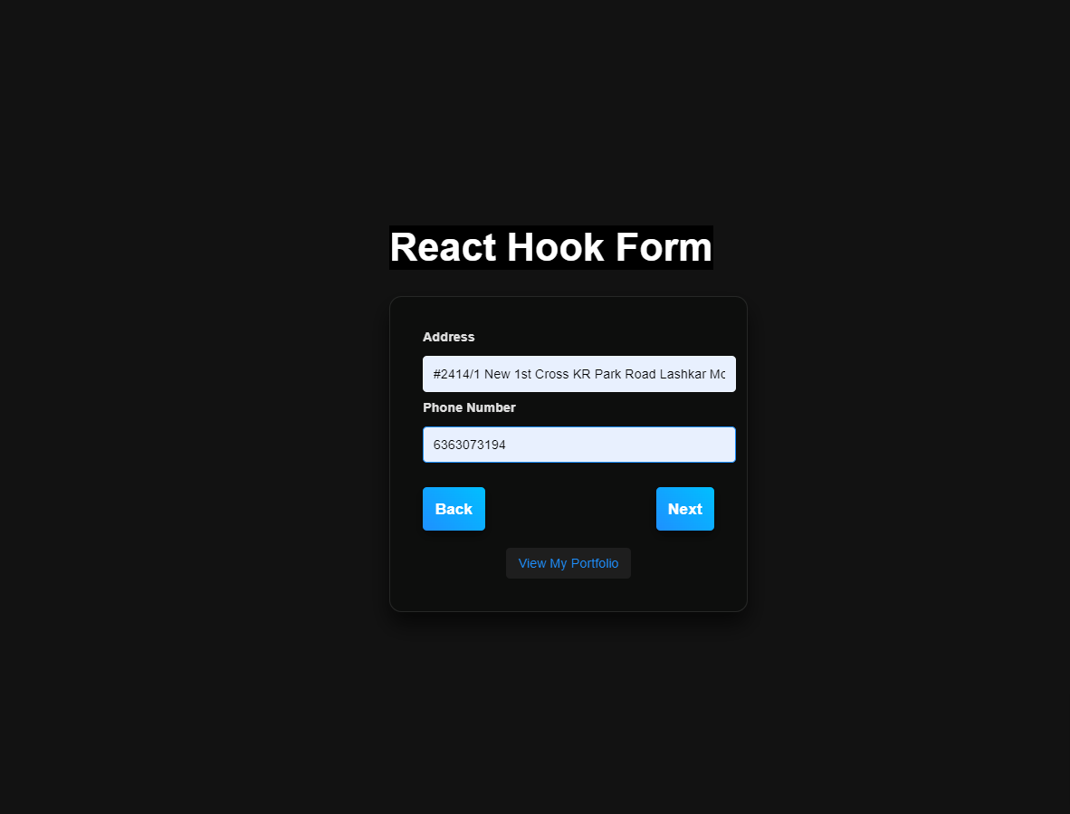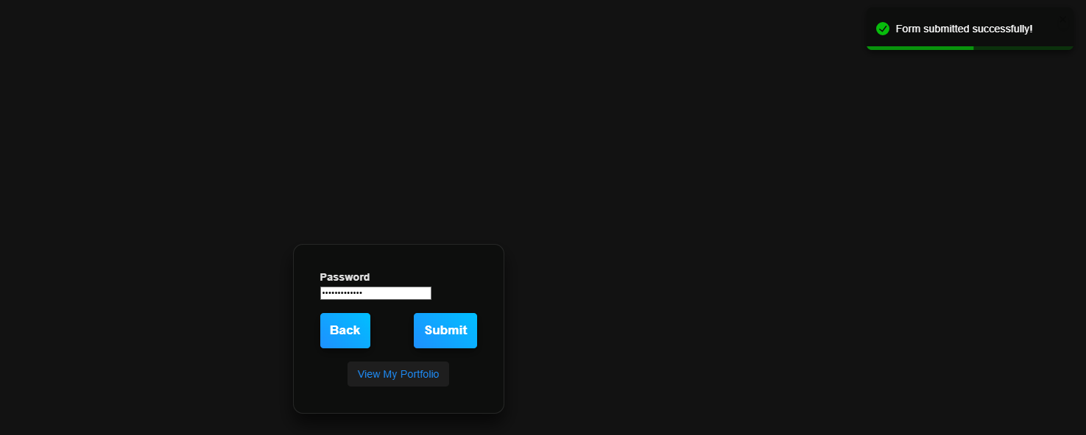

1. **Widget/Algorithm Used**
   * **React Hook Form**: Utilized for managing form states, handling validation, and simplifying the submission process across multiple steps. This library offers a more efficient way to manage form data and reduces the amount of boilerplate code.
   * **React Toastify**: Integrated to provide users with visual feedback through toast notifications upon successful form submission.
   * **useState & useEffect**: These hooks were used for managing local state between different form steps and for side effects like resetting the form.
2. **Implementation Steps**
   * Created a main MultiStepForm component that manages the current step and handles navigation.
   * Implemented individual components for each step of the form.
   * Configured validation rules using React Hook Form and displayed error messages accordingly.
   * Integrated React Toastify to show success messages, enhancing user feedback.