**Task 4: Formik-Job Application Form**

1. **Task-Description**  
   This task focused on developing a comprehensive job application form, allowing users to enter personal information, work experience, and submit their applications. The form includes features to save drafts, enabling users to complete their applications over multiple sessions.
2. **Screenshot of Output**

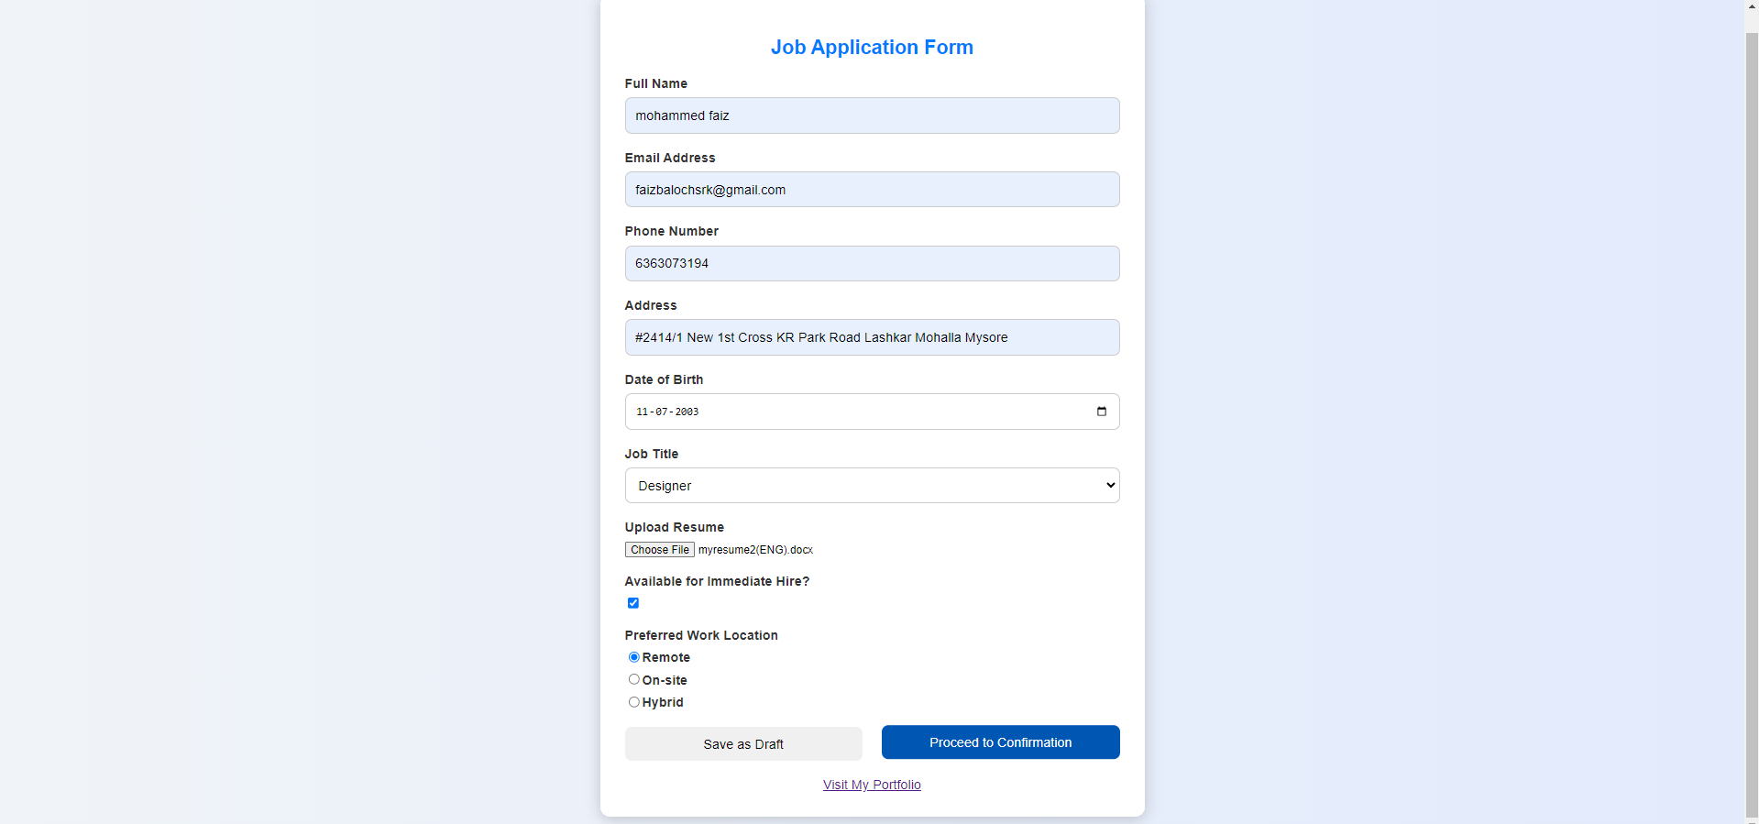

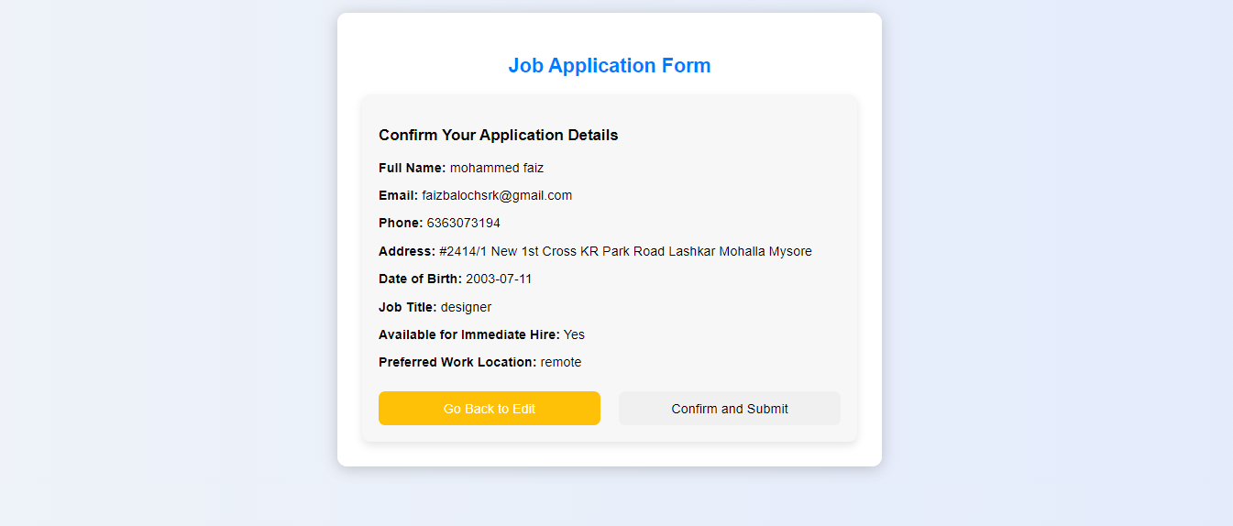

1. **Widget/Algorithm Used**
   * **Formik**: Used for managing form state and validation, providing a straightforward way to handle complex forms with multiple input types.
   * **jsPDF**: Implemented to enable users to download a PDF version of their application form, which can serve as a backup or for offline use.
   * **Local Storage**: Utilized for temporarily saving the draft state of the application, allowing users to resume filling out the form later without losing their progress.
2. **Implementation Steps**
   * Designed the form layout, including input fields for personal information, education, and work experience.
   * Integrated Formik for form handling and validation.
   * Added functionality to save the current form state in local storage.
   * Created a download button that triggers jsPDF to generate a PDF document of the form data.