**Task 5: Expense Sharing App**

1. **Task-Description**  
   This task included the development of an expense-sharing application, focusing on features like user authentication, group creation, expense logging, and bill splitting. Users can create groups, add transactions, and track expenses shared with friends or family.
2. **Screenshot of Output**

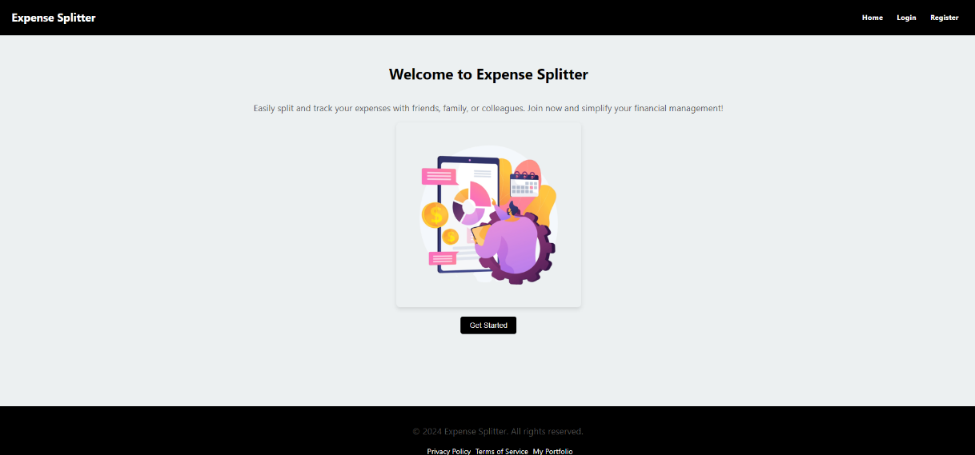

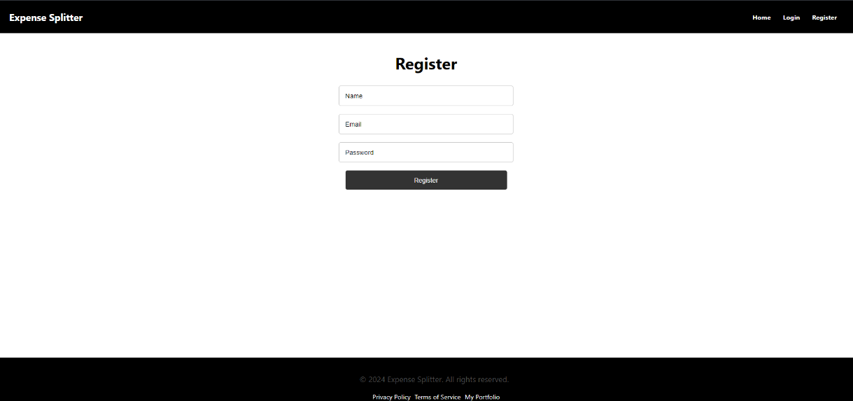

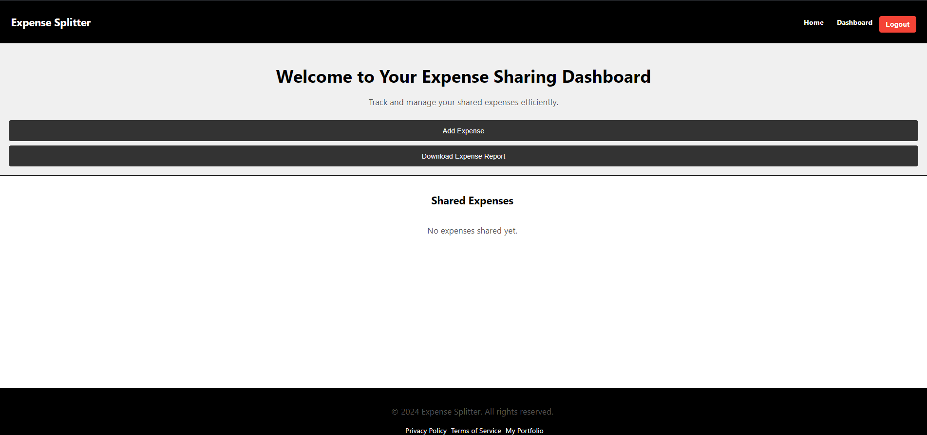

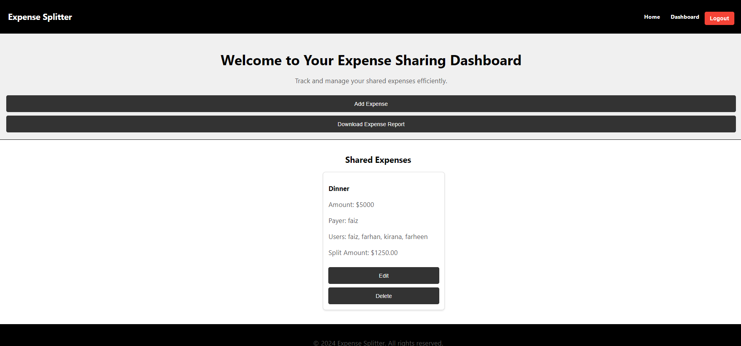

1. **Widget/Algorithm Used**
   * **React Router**: Implemented for navigation between different components/pages, ensuring a smooth user experience.
   * **React State Management**: Managed user-specific data such as groups and transactions, allowing real-time updates to the UI.
   * **Axios**: Used for making API calls to a backend service to handle data persistence.
2. **Implementation Steps**
   * Set up the routing structure for the app, defining routes for login, group pages, and expense logs.
   * Developed the UI components for creating groups and adding expenses, ensuring user-friendly interactions.
   * Integrated state management to keep track of the logged-in user’s data and render it dynamically on the dashboard