1. Make deployment called iti

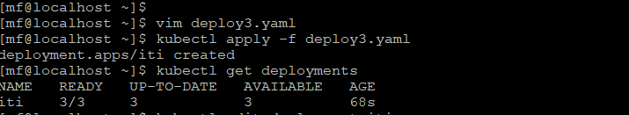

1. 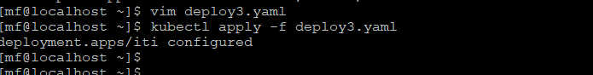Edit in deployment and add port

1. 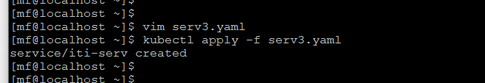 create new service
2. Expose vi Nodeport

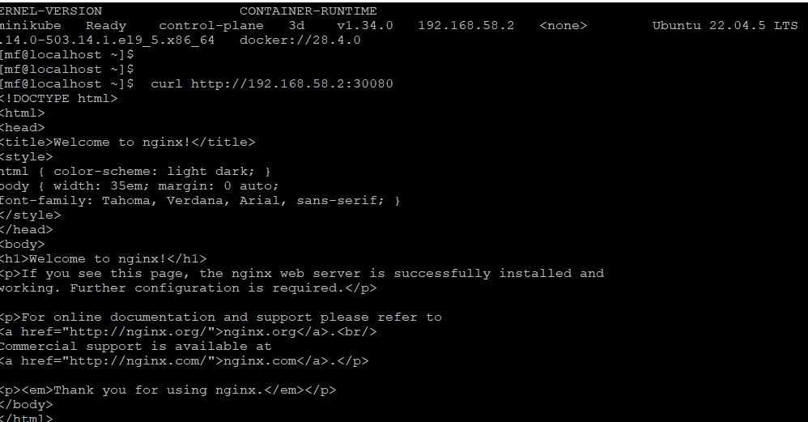

1. Expose from inside cluster