**Section 1**

This can be achieved by running below command on OpenSSL command prompt

* openssl s_client -connect ultimateqa.com:443 | openssl x509 -noout –dates

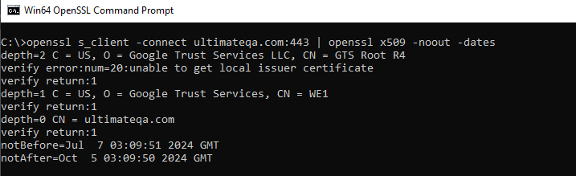

* This can be automated by creating a PowerShell script that will always check notAfter date against the current date and should fail if notAfter date is less than current date.

**Section 2 – Follow up questions**

1. First by ensuring that there is no redundancy in the code and by applying the testing technique to ensure test coverage.
2. Pipeline Setup

a) Import the test repo into Azure DevOps

b) Edit Pipeline, under projects specify the path of the tests you want to run on pipeline

c) Using Triggers you can specify when you would these tests to run.

1. To do perform test on a web based application
2. You would need to gather performance metrics (response time etc)
3. Create test scenarios that you use for load ranges that you would the application against
4. Monitor the performance of the applications on various loads
5. Security Testing
6. Penetration testing - to check application weaknesses
7. Authentication – to ensure that only allowed users can login and access application features.
8. Data Protection – to ensure that sensitive data like credit details is maybe encrypted.
9. You can build exception and error handling by using the try-catch block then ensure that every error is mapped to an error code which would describe in your apidocs in case of an API code.