WEBSITE PROJECT
Website Page Guide & Feature Overview
Audit, Accounting, Taxation & Business Advisory Website
Prepared for: [CLIENT COMPANY NAME]
Date: 29 September 2026
Version: 1.0 — for client review

Overview
The website has 26 pages: 19 main pages and 7 resource articles. Please review each page in this document, mark its status in the review tracker, and write any changes in the "Changes requested" column of that page's table.
Page group | Pages | Included
Home | 1 | Home page
Company | 3 | About Us, Contact Us, Book a Consultation
Services | 9 | Services overview and 8 detailed service pages
Industries | 1 | Industries we serve
Resources | 8 | Resources (blog) and 7 articles
Quote & help | 2 | Instant Quote, FAQs
Legal | 2 | Privacy Policy, Terms & Conditions
Total | 26

Site map
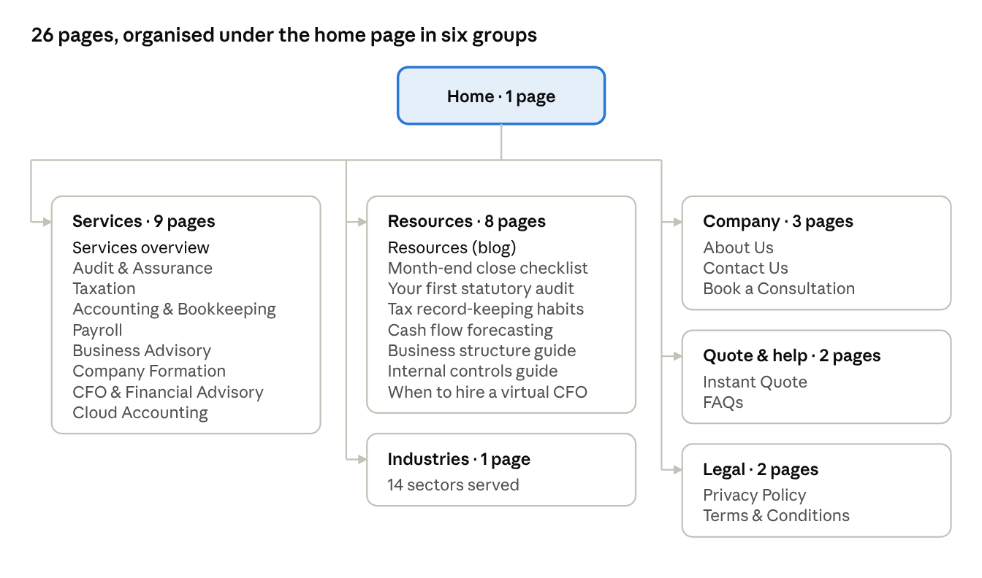
Every page is reachable from the main menu or footer; the eight service pages share one layout, and so do the seven articles.

Page review tracker
Tick one status for each page as you review it. Web addresses follow your domain name (for example, yourdomain.com/about).
# | Page | Web address | Status | Notes
1 | Home | / | ☐ Approved ☐ Changes
2 | About Us | /about | ☐ Approved ☐ Changes
3 | Services overview | /services | ☐ Approved ☐ Changes
4 | Audit & Assurance | /services/audit-assurance | ☐ Approved ☐ Changes
5 | Taxation | /services/taxation | ☐ Approved ☐ Changes
6 | Accounting & Bookkeeping | /services/accounting-bookkeeping | ☐ Approved ☐ Changes
7 | Payroll | /services/payroll | ☐ Approved ☐ Changes
8 | Business Advisory | /services/business-advisory | ☐ Approved ☐ Changes
9 | Company Formation | /services/company-formation | ☐ Approved ☐ Changes
10 | CFO & Financial Advisory | /services/cfo-services | ☐ Approved ☐ Changes
11 | Cloud Accounting | /services/cloud-accounting | ☐ Approved ☐ Changes
12 | Industries | /industries | ☐ Approved ☐ Changes
13 | Resources (blog) | /resources | ☐ Approved ☐ Changes
14 | FAQs | /faqs | ☐ Approved ☐ Changes
15 | Instant Quote | /quote | ☐ Approved ☐ Changes
16 | Contact Us | /contact | ☐ Approved ☐ Changes
17 | Book a Consultation | /book-consultation | ☐ Approved ☐ Changes
18 | Privacy Policy | /privacy-policy | ☐ Approved ☐ Changes
19 | Terms & Conditions | /terms-and-conditions | ☐ Approved ☐ Changes
20–26 | Resource articles (7) | /resources/… | ☐ Approved ☐ Changes

1. Home page
The home page has 12 sections, from the headline down to a callback form.
# | Section | What it shows | Changes requested
1.1 | Hero | Headline "Audit, Tax & Accounting Expertise That Moves Your Business Forward", short intro, three buttons (Get a Free Quote, Book a Consultation, WhatsApp Us), four trust points, office photo with 3D icons
1.2 | Our services | Eight service cards, each with a 3D icon, summary, key services and a link to its page
1.3 | About teaser | Team photo, short introduction, four key strengths, links to About and Book a Consultation
1.4 | Key figures | Four counters: years of experience, clients served, professionals, industries (shown as [XX] until you supply the numbers)
1.5 | Why choose us | Eight advantage cards, e.g. Transparent Pricing, Confidential Service, Timely Delivery
1.6 | How we work | Four steps: Initial Consultation, Requirement Assessment, Professional Execution, Ongoing Support
1.7 | Industries we serve | Eight industry cards and a link to the full Industries page
1.8 | Instant quote banner | Invitation to get a quote, with Quote and WhatsApp buttons
1.9 | Client testimonials | Slider of client reviews (three samples, clearly labelled, to be replaced with real reviews)
1.10 | Insights & guides | The three latest articles from the Resources section
1.11 | FAQs | Six common questions with expandable answers
1.12 | Closing call to action | Quote, Consultation and WhatsApp buttons, plus a "Request a callback" form

2. About Us
The About page has 9 sections introducing the firm, its values and its team.
# | Section | What it shows | Changes requested
2.1 | Page header | Title "Professional expertise, personal service" with a short introduction
2.2 | Company introduction | Your firm's story, location and services, next to an office photo (introduction text to be supplied by you)
2.3 | Mission & vision | Two statements: our mission and our vision
2.4 | Our values | Four values: Integrity, Confidentiality, Partnership, Excellence
2.5 | Professional approach | Four stages: Understand, Plan, Deliver, Advise, plus the key figures counters
2.6 | Leadership & team | Four team profile cards: photo, name, position, qualification, specialisation, short bio, LinkedIn (sample profiles until real details are supplied)
2.7 | Why clients choose us | The eight advantage cards and a link to Services
2.8 | Client testimonials | The review slider
2.9 | Closing call to action | "Let's talk about your business" with the callback form

3. Services overview
The Services page presents all eight services in 5 sections.
# | Section | What it shows | Changes requested
3.1 | Page header | Title, short introduction and a Get a Free Quote button
3.2 | Explore our services | The eight service cards with 3D icons
3.3 | Service index | A complete list of every sub-service under each of the eight services, each linked
3.4 | How we work | The four-step process
3.5 | Closing call to action | Quote, Consultation and WhatsApp buttons with the callback form

4. Service pages (8 pages)
Each of the eight services has its own detailed page, all built on one shared layout. Note changes to a specific service in the first table, and changes to the layout of every service page in the second.
# | Service page | Services included on the page | Changes requested
4.1 | Audit & Assurance | Statutory Audit, Internal Audit, External Audit, Financial Statement Audit, Compliance Review, Internal Controls Review, Risk Assessment
4.2 | Taxation | Corporate Tax, Personal Tax, VAT / Sales Tax, Tax Registration, Tax Return Preparation, Tax Planning, Tax Compliance, Tax Advisory
4.3 | Accounting & Bookkeeping | Bookkeeping, Annual Accounts, Management Accounts, Financial Statements, Bank Reconciliation, Accounts Payable, Accounts Receivable
4.4 | Payroll | Payroll Processing, Payslips, Employee Records, Payroll Reporting, Compliance Support
4.5 | Business Advisory | Business Planning, Budgeting, Forecasting, Financial Analysis, Business Growth Advisory, Cash Flow Management
4.6 | Company Formation | Business Registration, Company Formation, Tax Registration, Compliance Setup, Startup Advisory
4.7 | CFO & Financial Advisory | Virtual CFO, Financial Strategy, Management Reporting, KPI Analysis, Cash Flow Forecasting, Financial Planning
4.8 | Cloud Accounting | Accounting System Setup, Data Migration, Accounting Automation, Software Integration, Digital Bookkeeping

Sections on every service page
# | Section | What it shows | Changes requested
A | Page header | Service headline, introduction, 3D icon, Get a Free Quote and Book a Consultation buttons
B | Overview | Why the service matters (three paragraphs), a photo and an "Ideal for" list
C | What's included | A card for each service listed above, with a short description
D | Benefits & deliverables | Three benefits and the typical deliverables, with Quote and WhatsApp buttons
E | Our process | The four-step process
F | FAQs | Two or three questions specific to the service
G | Related services | Three services often combined with this one
H | Closing call to action | Buttons and a callback form with this service pre-selected

5. Industries
The Industries page covers 14 sectors in 4 sections.
# | Section | What it shows | Changes requested
5.1 | Page header | Title "Specialist support for your sector" with an introduction
5.2 | Industries we serve | 14 cards with icons: Startups, SMEs, Corporations, E-commerce, Construction, Real Estate, Healthcare, Retail, Hospitality, Professional Services, Technology, Manufacturing, Freelancers, Nonprofit Organizations
5.3 | Our approach | How the firm adapts its work to each sector, with a photo and a consultation button
5.4 | Services for every sector | The eight service cards, then the closing call to action

6. Resources and articles (8 pages)
The Resources page lists all articles; seven general-guidance articles are published, one or more in each of the seven categories. New articles can be added at any time.
# | Section | What it shows | Changes requested
6.1 | Page header | Title "Insights, guides & updates"
6.2 | Featured article | The highlighted article, shown large
6.3 | Browse all articles | Category filters (Accounting, Audit, Tax, Business, Compliance, Finance, Startup Guides) and a search box
6.4 | Closing call to action | Invitation to get advice specific to the business

The seven articles
# | Article | Category | Changes requested
6.5 | A Practical Month-End Close Checklist for Small Businesses (featured) | Accounting
6.6 | Preparing for Your First Statutory Audit: What to Expect | Audit
6.7 | Seven Record-Keeping Habits That Make Tax Season Easier | Tax
6.8 | Cash Flow Forecasting: A Practical Guide for Business Owners | Finance
6.9 | Choosing a Business Structure: Questions to Ask Before You Register | Startup Guides
6.10 | Internal Controls for Growing Teams: A Starter Framework | Compliance
6.11 | When Does a Business Need a Virtual CFO? | Business
Every article page shows breadcrumbs, author and date, reading time, a cover photo, an "In this article" contents list, share buttons (LinkedIn, X, Facebook, WhatsApp, copy link), a quote invitation mid-article, a general-information disclaimer and three related articles.

7. FAQs
The FAQs page answers 12 questions, with a "Still have questions?" panel offering Contact and WhatsApp.
# | Question | Changes requested
7.1 | What accounting services do you provide?
7.2 | What is included in your audit services?
7.3 | Do you work with small businesses?
7.4 | Can you manage monthly bookkeeping?
7.5 | Do you provide tax advisory services?
7.6 | Can you help with company formation?
7.7 | Do you offer payroll services?
7.8 | How do I request a quotation?
7.9 | Can I book an online consultation?
7.10 | What documents are needed to get started?
7.11 | How is client information protected?
7.12 | Can I switch from my existing accountant?

8. Instant Quote
The Instant Quote page is the main lead-generation page: a four-step form that sends the request by WhatsApp or online.
# | Section | What it shows | Changes requested
8.1 | Page header | Title "Get your instant quote" with an introduction
8.2 | Step 1: Your details | Full name, business name, email, phone, country, city
8.3 | Step 2: Your business | Business type, industry, annual turnover range, number of employees, existing accountant (yes / no)
8.4 | Step 3: Services required | Tick boxes: Audit, Taxation, Bookkeeping, Annual Accounts, Payroll, VAT / Sales Tax, Company Formation, Business Advisory, CFO Services, Cloud Accounting, Other
8.5 | Step 4: Contact preferences | Preferred contact method and time, message / requirements
8.6 | Consent & privacy | Privacy consent tick box and a note not to send sensitive financial data
8.7 | Send buttons | "Send Quote Request via WhatsApp" and "Submit Quote Request"
8.8 | How it works panel | Explains the WhatsApp and online options, response time and the no-obligation quote
How the WhatsApp quote works: the form checks every required field, then opens WhatsApp with a neatly formatted message containing all the details, addressed to your WhatsApp number. The visitor reviews it and presses Send themselves; nothing is sent automatically. The online Submit button delivers the same details to your email or office system.

9. Contact Us
The Contact page has 5 sections, with every contact method on one screen.
# | Section | What it shows | Changes requested
9.1 | Page header | Title "Let's talk about your business"
9.2 | Contact details | Five cards: office address, phone, WhatsApp, email, business hours (tap to call, message or email)
9.3 | Contact form | Name, email, phone, company, subject, service, message, preferred contact method, privacy consent
9.4 | Office map | Google Map of the office (a placeholder panel until the address is supplied)
9.5 | Consultation panel | Book a Consultation and WhatsApp Us buttons

10. Book a Consultation
The booking page lets visitors request a meeting at a time that suits them, in 3 sections.
# | Section | What it shows | Changes requested
10.1 | Page header | Title "Book a consultation" with an introduction
10.2 | Booking form | Name, company, email, phone, service, consultation type (Phone, Video Meeting, Office Meeting), preferred date (past dates blocked), preferred time, message, privacy consent
10.3 | Consultation options | Short descriptions of the three meeting types
Time slots offered: 09:00, 10:00, 11:00, 12:00, 14:00, 15:00, 16:00 and 17:00. Change them to match your office hours if needed.

11. Legal pages and elements on every page
The two legal pages are ready-made templates that your legal adviser should review; the header, footer and WhatsApp button appear on every page.
# | Page or element | What it shows | Changes requested
11.1 | Privacy Policy | Ten sections: who we are, information collected, how it is used, WhatsApp, sharing, security, retention, your rights, cookies, changes
11.2 | Terms & Conditions | Ten sections: about us, website information, quotations and engagements, use of the site, intellectual property, third-party links, liability, privacy, governing law, contact
11.3 | Header | Logo, menu (Home, About, Services drop-down, Industries, Resources, Contact), Get a Quote button, top bar with phone, email and hours; a slide-down menu on phones
11.4 | Footer | Company, Services, Resources and Contact columns, social media links, copyright line
11.5 | Floating WhatsApp button | Green button in the bottom corner of every page with a ready-made greeting message
11.6 | Page not found | A friendly error page with links back to the home page and services

Website features
The website includes 24 features across six areas, all built in and tested on desktop and mobile.
Area | Feature | What it does for your business
Lead generation | Instant Quote with WhatsApp | Turns a completed quote form into a ready-to-send WhatsApp message to your number
Lead generation | Floating WhatsApp button | Lets visitors start a WhatsApp chat from any page
Lead generation | Four enquiry forms | Quote, contact, consultation booking and callback request, each with a confirmation message
Lead generation | Calls to action throughout | Quote, consultation and WhatsApp buttons on every page, with a callback form at the end
Trust | Professional 3D service icons | A consistent, premium icon set for every service and section
Trust | Key figures counters | Animated figures for experience, clients, team and industries, shown only once you supply real numbers
Trust | Testimonials slider | Client reviews with star ratings (samples are clearly marked until replaced)
Trust | Team profiles | Photo, qualification, specialisation, bio and LinkedIn for each team member
Content | Resource centre | Articles with category filters, search, sharing buttons and related articles
Content | FAQs | Expandable questions and answers, easy to edit
Content | Industries section | 14 sectors your firm supports
Search engines (SEO) | Unique page titles and descriptions | Each page is described clearly for Google and other search engines
Search engines (SEO) | Rich search information | Tells search engines about your firm, services, FAQs and articles
Search engines (SEO) | Sitemap and breadcrumbs | Helps search engines find every page and shows visitors where they are
Search engines (SEO) | Social sharing previews | A branded preview image and text when a page is shared on social media or WhatsApp
Search engines (SEO) | Local landing pages (ready) | "Accountants in [City]" pages can be added when you have unique local content
Security & privacy | Form protection | Spam blocking, limits on repeated submissions and checks on every field
Security & privacy | Privacy consent | Every form asks for consent and never requests bank details or tax numbers
Security & privacy | Secure connection settings | Industry-standard protections against common website attacks
Experience | Mobile-first design | Works on phones, tablets, laptops and desktops
Experience | Smooth, subtle animations | Sections fade and slide in gently; motion is reduced for visitors who prefer it
Experience | Fast loading | Optimised images and lightweight graphics
Experience | Accessibility | Keyboard navigation, screen-reader support and strong colour contrast
Easy updates | Central settings | Company name, contact details, services, team and reviews are changed in one place

Information needed from you before launch
The website currently shows placeholders such as [COMPANY NAME] and [PHONE]. Please supply the items below so they can be replaced.
☐ Company name, tagline and logo file
☐ Phone number, WhatsApp number (with country code) and email address
☐ Office address, city, country and business hours
☐ Google Maps location of the office
☐ Social media links (LinkedIn, Facebook, X, Instagram)
☐ Company introduction for the About page
☐ Key figures: years of experience, clients served, team size, industries served
☐ Team details: photo, name, position, qualification, specialisation, short bio and LinkedIn for each member
☐ Client testimonials, with each client's permission to publish
☐ Professional memberships, registrations and regulatory body (only those the firm holds)
☐ Website domain name
☐ Email address that should receive form submissions
☐ Legal details for the Privacy Policy and Terms (registered name, registration number, jurisdiction)
☐ Your own team and office photos (optional; professional stock photos are in place)

Client approval
Once all pages are marked Approved, or the requested changes have been made, please sign below to approve the website for launch.
Name
Position
Signature
Date

