Mobile Money Investigations with PostgreSQL and Neo4j
Advanced Big Data Analytics – Project 2 · Group 17 · AUCA
Member | Student ID
Fulgence Muhirwa | [ID]
Uwineza Deborah | [ID]
Babatunde Oyedele | [ID]
GitHub: [URL] · Submitted [date] · Models: relational (PostgreSQL 16) and property graph (Neo4j Community [version]).
How to finish this draft. Everything about query answers below is final – the dataset is fixed and the answers are identical on every machine. Values in [YOUR …] brackets are machine-specific (times, sizes, load test): replace them with the numbers your runs print. The figures in italics labelled “reference run” are from our own PostgreSQL run on a 2-vCPU / 8 GB Linux machine and are only there so you can see the expected order of magnitude. Insert each 📸 screenshot where marked; reuse earlier screenshots instead of repeating them.

1 Capture the data

1.1 Workspace
Item | Value
OS / CPU / RAM | [YOUR – results/environment.json]
Python / psycopg / neo4j driver / numpy | [YOUR]
PostgreSQL version, settings | [YOUR] shared_buffers, effective_cache_size, work_mem, maintenance_work_mem; TimeZone = Africa/Kigali
Neo4j version / edition, memory | [YOUR] heap initial/max, page cache
📸 1.1 – step01 output: both connections, TimeZone, memory settings.

1.2 capture.py
step02_capture.py previews ten records per stream with itertools.islice, then streams each generator straight into csv.DictWriter (no stream is held in memory), counting consumed and written rows and logging every million transfers. Because transfers are not time-sorted, the earliest/latest occurred_at are tracked as running min/max.
Stream | Rows written | Expected | Seconds | CSV GB
customers | 228,000 | 228,000 | [YOUR] | 0.004
accounts | 248,000 | 248,000 | [YOUR] | 0.005
devices | 228,600 | 228,600 | [YOUR] | 0.004
account_devices | 285,600 | 285,600 | [YOUR] | 0.006
transfers | 20,003,300 | 20,003,300 | [YOUR] (reference run 75.7 s) | 0.780
Total | 20,993,500 | 20,993,500 | [YOUR] (77.5 s) | 0.799
Transfer audit: count 20,003,300 · earliest 1,788,235,200 (2026-09-01 06:00:00 CAT) · latest 1,790,798,399 (2026-09-30 21:59:59 CAT) · sum 231,482,327,870 RWF.
📸 1.2a preview · 📸 1.2b five-stream totals and audit.

2 PostgreSQL

2.1 Schema
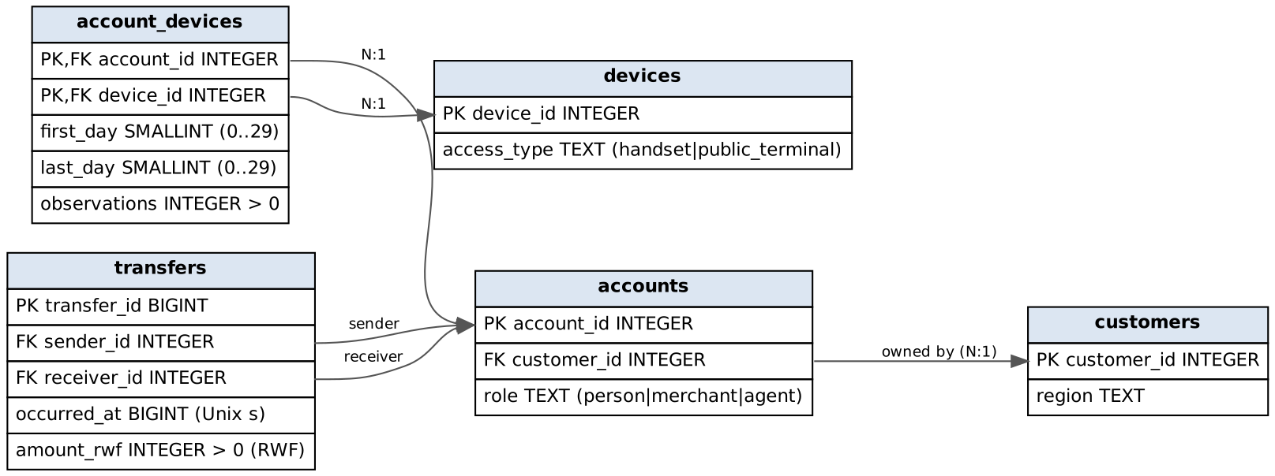
PostgreSQL schema
Table | Field | Meaning and unit
customers | customer_id, region | customer key; one of five provinces/Kigali
accounts | account_id, customer_id, role | wallet key; owning customer (FK); person / merchant / agent
devices | device_id, access_type | device key; handset or public_terminal
account_devices | account_id, device_id | an observed (wallet, device) pair – composite PK, both FKs
 | first_day, last_day | inclusive day numbers 0–29 (0 = 1 Sep 2026 CAT)
 | observations | number of sightings in that interval (> 0)
transfers | transfer_id | event key (BIGINT)
 | sender_id, receiver_id | paying and receiving wallets (two FKs to accounts)
 | occurred_at | Unix seconds (BIGINT); shown in Africa/Kigali
 | amount_rwf | whole Rwandan francs (> 0)
All 17 columns are NOT NULL. Constraints: 5 primary keys, 5 foreign keys, amount_rwf > 0, observations > 0, 0 <= first_day <= last_day <= 29, plus role/access_type value checks. 📸 2.1 – \d+ accounts, \d+ account_devices, \d+ transfers.

2.2 Load and checks
Phase | Seconds
\copy load of five files | [YOUR] (reference 15 s; transfers 14.1 s)
PK/FK/CHECK + indexes + VACUUM ANALYZE | [YOUR] (reference 58 s)
Row counts and the transfer audit match capture.py exactly; roles are 240,000 person, 6,000 merchant, 2,000 agent; every constraint is convalidated = true.
Size (1 GB = 10⁹ B) | Data | Indexes | Total
transfers | [YOUR] (1.206) | [YOUR] (2.434) | [YOUR] (3.639)
all tables | [YOUR] (1.250) | [YOUR] (2.468) | [YOUR] (3.718)
The two covering indexes on transfers are each larger than the table data – the price of index-only scans in both transfer directions. 📸 2.2a load timings · 📸 2.2b step04 checks, constraints, indexes, sizes.

3 Neo4j

3.1 Graph mapping
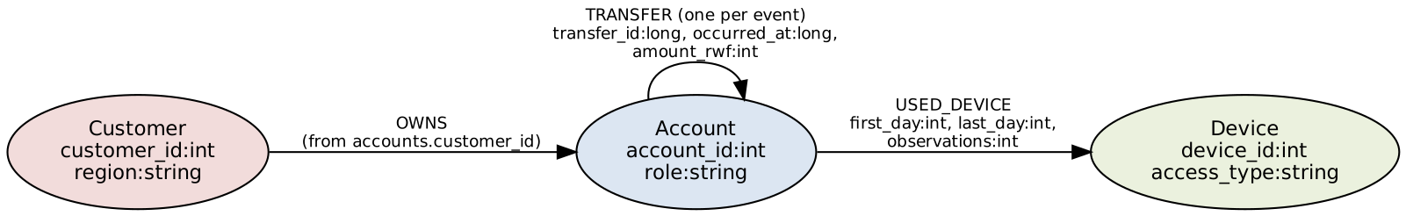
Graph schema
Source field | Graph
customers.customer_id, region | (:Customer {customer_id:int, region})
accounts.account_id, role | (:Account {account_id:int, role})
accounts.customer_id | (:Customer)-[:OWNS]->(:Account) (derived owns.csv)
devices.device_id, access_type | (:Device {device_id:int, access_type})
account_devices.account_id / device_id | start / end of [:USED_DEVICE]
account_devices.first_day, last_day, observations | properties of USED_DEVICE
transfers.sender_id / receiver_id | start / end of [:TRANSFER]
transfers.transfer_id, occurred_at, amount_rwf | properties of one TRANSFER per row (repeated payments kept)

3.2 Import
Typed headers (temporary copies; source CSVs unchanged, verified by MD5): customer_id:ID(Customer),region:string · account_id:ID(Account),:IGNORE,role:string · device_id:ID(Device),access_type:string · owns.csv :START_ID(Customer),:END_ID(Account) · used_device.csv :START_ID(Account),:END_ID(Device),first_day:int,last_day:int,observations:int · transfers.csv transfer_id:long,:START_ID(Account),:END_ID(Account),occurred_at:long,amount_rwf:int.
neo4j-admin database import full neo4j --overwrite-destination=true --id-type=integer
--nodes=Customer=customers.csv --nodes=Account=accounts.csv --nodes=Device=devices.csv
--relationships=OWNS=owns.csv --relationships=USED_DEVICE=used_device.csv
--relationships=TRANSFER=transfers.csv
Item | Value
Import seconds | [YOUR]
Constraint + index setup (until ONLINE) | [YOUR]
Store GB / transaction-log GB | [YOUR] / [YOUR]
Checks: Customer 228,000 · Account 248,000 · Device 228,600 · OWNS 248,000 · USED_DEVICE 285,600 · TRANSFER 20,003,300 · 704,600 nodes · 20,536,900 relationships · roles as in SQL · 0 accounts without exactly one owner · distinct transfer_id = 20,003,300 · audit totals equal. 📸 3.2a import · 📸 3.2b constraints/indexes · 📸 3.2c checks · 📸 cleanup.

3.3 One account in both models
Account 998 (person) → owner Customer 998 (Kigali) → Device 998 (handset, days 0–29, 39 observations) → first outgoing transfer 113540 to merchant 240004 on 2026-09-01 08:43:29 CAT, 2,100 RWF. Same record from JOIN accounts/customers/account_devices/devices/transfers and from MATCH (c)-[:OWNS]->(a)-[:USED_DEVICE]->(d), (a)-[:TRANSFER]->(r). 📸 3.3.
Foreign keys become relationships. accounts.customer_id becomes an OWNS relationship; the account_devices row (a junction table) becomes a USED_DEVICE relationship carrying its three columns; the two transfer FKs become the start and end nodes of a TRANSFER. A join that SQL resolves at query time through an index is stored in the graph as a direct pointer. If repeated payments were collapsed into one edge per sender–receiver pair, each event’s transfer_id, exact occurred_at and amount_rwf would be lost (only a count or sum could remain). Q1, Q2, Q5 and Q6 would become impossible: we could no longer test the hour window, strict time order, the 600-second gap, the 1,800-second span or the 90–105 % amount rule.

4 Routine business questions
Hour window: 09:45:00 ≤ t < 10:45:00 CAT, converted to epoch seconds in Python (mm_common.hour_bounds). All queries are in queries.py.

4.1 Q1 Account activity
Set | Account | Date | Transfers | Total RWF
A | 998 | 6 Sep | 1 | 200,000
B | 147228 | 13 Sep | 1 | 1,050,000
C | 206978 | 8 Sep | 1 | 300,000
D | 237998 | 6 Sep | 1 | 45,000
E | 144228 | 13 Sep | 1 | 40,000
F | 203978 | 8 Sep | 1 | 30,000
PostgreSQL and Neo4j agree for all six. Outgoing value is not a balance: it ignores money received, opening balance, cash-in/cash-out at agents, fees and reversals – the dataset is explicitly not a ledger. 📸 4.1.

4.2 Q2 Daily activity
30 rows; sums reconcile to 20,003,300 transfers and 231,482,327,870 RWF. 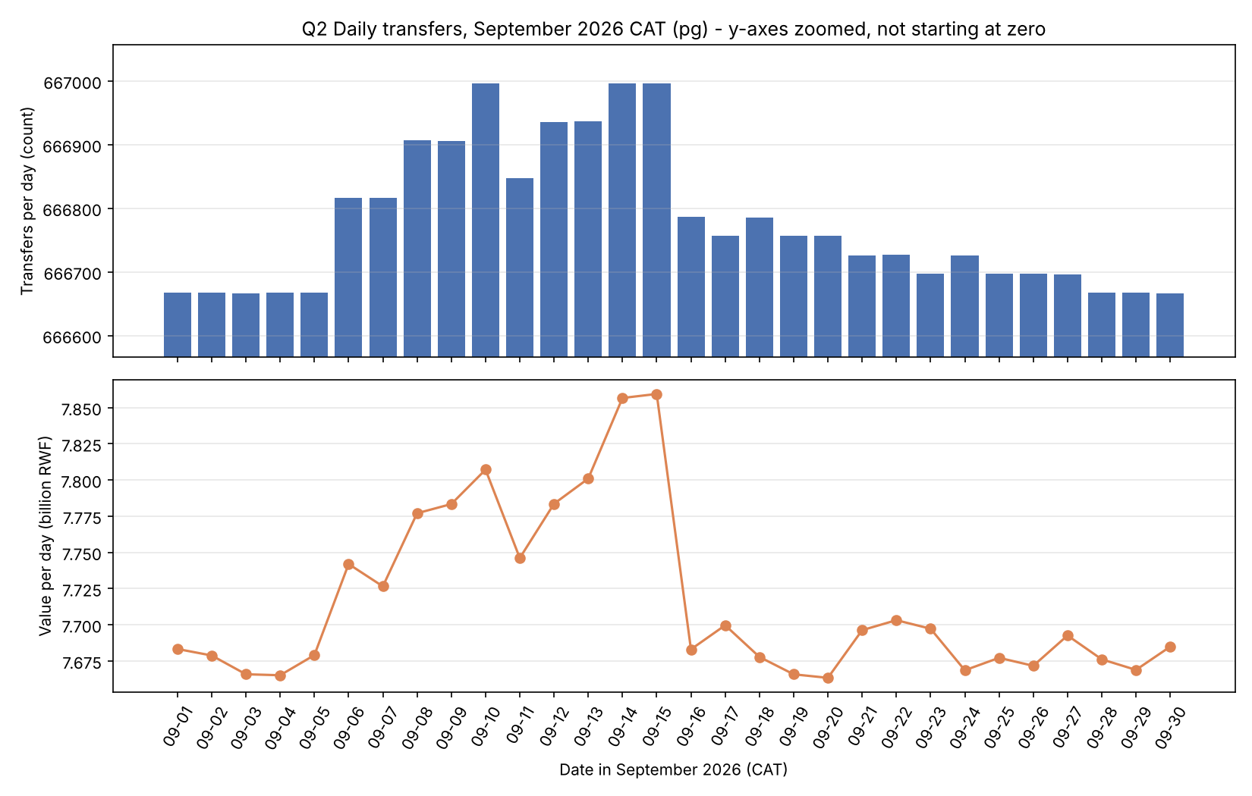
Pattern. Volume is almost perfectly flat (666,666–666,667 transfers per day from 1–5 Sep and 28–30 Sep), but 6–15 Sep carry an extra 150–330 transfers and up to ≈190 million RWF per day (e.g. 14 Sep: 666,997 transfers, 7.857 bn RWF vs ≈7.67 bn on quiet days), and 16–27 Sep a smaller 30–120. The extra events are the scenario payments: large, fast person-to-person hops (200,000–1,150,000 RWF, the chains found in Q5/Q6) on 6–15 Sep, and small hops repeated every second day afterwards – visible in value far more than in count. All activity falls between 06:00 and 22:00 CAT. Value is not revenue: the provider earns fees and commissions, which are not in the data; P2P, merchant and agent flows carry different (or zero) fees, and the same money may be counted several times as it moves wallet to wallet. 📸 4.2.

4.3 Q3 Shared devices
Set | Rows | Devices shared
A 998 | 4 | handset 998 with own second wallet 220998; handset 228001 with 8917, 16836, 24755
B 147228 | 9 | household handset 147226 (4 accounts); handset 228018 with 155147, 163066, 170985, 178904, 186823
C 206978 | 9 | household handset 206976 (4; one overlap only days 11–29); handset 228043 with 5 accounts incl. 6573
D 237998 | 4 | own second wallet 17998 on handset 17998; handset 228301 with 5917, 13836, 21755
E 144228 | 9 | household 144226 (4); handset 228318 with 5 accounts incl. 183823
F 203978 | 9 | household 203976 (4); handset 228343 with 5 accounts incl. 3573
Legitimate sharing. B’s handset 147226 is used by wallets of five neighbouring customers – a family sharing one phone; account 206976 appears only from day 11 because that customer replaced their phone. A customer’s second wallet naturally appears on their own handset. Public terminals at agents are shared by many unrelated customers by design. Overlap ≠ simultaneous use. An interval only says the device was seen with each account at some time between first and last day: [2,7] and [5,11] overlap on [5,7], but one account could have used it on day 5 morning and the other on day 7 evening. The data has no session times. 📸 4.3.

5 Connected accounts

5.1 Q4 Ownership and device network
Distinct other accounts reached through OWNS/USED_DEVICE in either direction:
Set | ≤4 | ≤6 | ≤8 | ≤10 | Predicted 8 / 10 (from 4→6 growth)
A | 10 | 43 | 175 | 187 | 185 / 795
B | 46 | 178 | 188 | 228 | 689 / 2,665
C | 146 | 483 | 832 | 1,433 | 1,598 / 5,286
D | 10 | 44 | 180 | 192 | 194 / 852
E | 47 | 183 | 193 | 230 | 713 / 2,774
F | 147 | 488 | 837 | 1,426 | 1,620 / 5,378
Region breakdowns for all 24 cases are in results/examples_pg.txt; all 24 match in Neo4j. 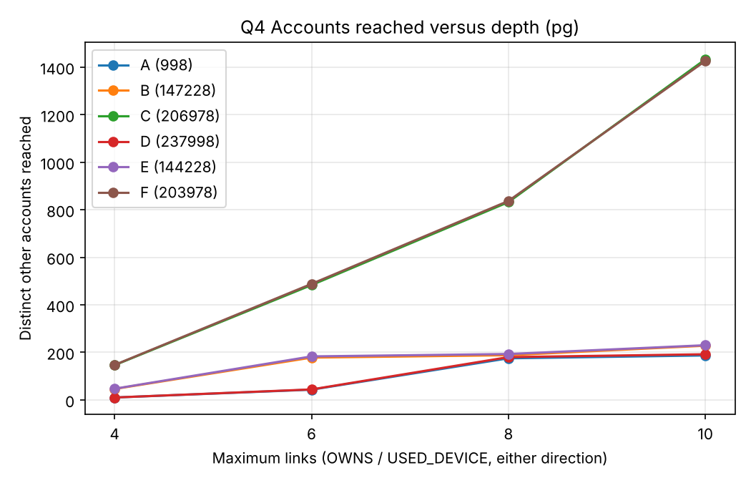
Supporting path: Account 998 –USED_DEVICE– Device 228001 –USED_DEVICE– Account 24755 (2 links). Prediction vs result. Constant geometric growth over-predicted depth 10 by 3–12×: the network is made of small household/scenario clusters, and growth stalls once a cluster is exhausted, then jumps only when a path reaches a widely shared device. C and F reach four public terminals from depth 3 (each used by dozens of unrelated wallets), so they keep growing to ≈1,430 accounts; A, B, D and E never reach a terminal and level off near 190–230. Weak associations: each extra pair of links crosses another device or customer, so at depth 8–10 an account is “connected” only through a chain like my household phone → a neighbour’s second wallet → an agent’s public terminal → a stranger. Such reach reflects shared infrastructure, not a relationship; counts grow while the evidential value per account falls. 📸 5.1.

5.2 Q5 Rapid onward payments
Set | Chains | Transfer IDs → final receiver
A | 1 | 20000001, 20000002, 20000003 → 24755
B | 1 | 20000092, 20000093, 20000094 → 170985
C | 1 | 20000229, 20000230, 20000231 → 230735
D, E, F | 0 | –
Example (A, 6 Sep 2026): 998 → 8917 at 10:00:00, 200,000 RWF; 8917 → 16836 at 10:00:40, 196,000 RWF (98 %); 16836 → 24755 at 10:01:20, 192,080 RWF (98 %). 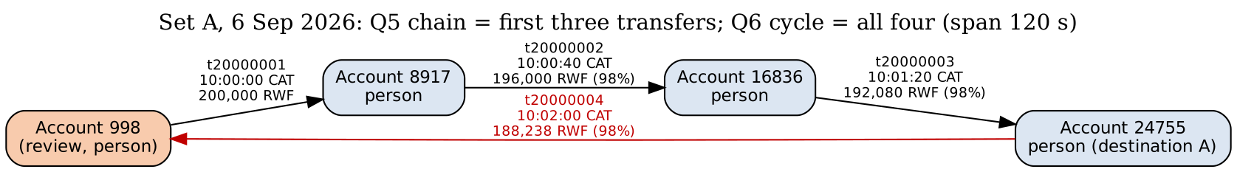 Not proof that the same funds moved: wallets hold pooled balances; 8917 may already have had 196,000 RWF and paid a debt that was coincidentally due. Timing and amount similarity are consistent with pass-through but do not trace money. 📸 5.2.

5.3 Q6 Circular payments
Set | Cycles | Sequence (length)
A | 1 | 20000001 → 20000002 → 20000003 → 20000004 (4) – returns to 998 at 10:02:00, 188,238 RWF, span 120 s
C | 1 | 20000229 … 20000234 (6), span 200 s
B, D, E, F | 0 | –
Further evidence to request: KYC of the accounts (are 8917, 16836, 24755 related people?), the device used to initiate each payment and its location, balances before/after, the source of 998’s 200,000 RWF and what 998 did next, fees charged, earlier months (one-off or recurring), and any customer explanation (e.g. a rotating savings group, ikimina). 📸 5.3.

5.4 Q7 Shortest transfer connection (person accounts only)
Set | Review → destination | Bound 4 | Bound 6 | Verified path (bound 6)
A | 998 → 24755 | 3 | 3 | 998→8917→16836→24755
B | 147228 → 186823 | no route | 5 | via background P2P transfers
C | 206978 → 6573 | no route | 5 | 206978→214897→222816→230735→238654→6573
D | 237998 → 21755 | 3 | 3 | 237998→5917→13836→21755
E | 144228 → 183823 | no route | 5 | 144228→152147→…→183823
F | 203978 → 3573 | no route | 5 | 203978→211897→…→3573
All paths verified for transfer IDs, direction, person roles, event existence and length (both engines; paths may differ when several shortest routes exist). No route within 4 ≠ no connection: B, C, E, F all connect at 5; the bound, the person-only filter and the one-month window all hide longer or non-person routes (e.g. through an agent). A route is not a flow of funds: Q7 ignores time order and amounts – the teaching example’s upper route runs backwards in time, so money could not have travelled along it. 📸 5.4.

6 Correctness and performance

6.1 Comparison program
run_pg() / run_neo() return every row; rows are normalised (ints, tuples, ISO dates) and sorted before exact comparison. Result: 61 / 61 cases match (Q1 6, Q2 1, Q3 6, Q4 24, Q5 6, Q6 6, Q7 12 lengths) and all 8 non-empty Q7 supporting paths are valid in both engines. Mismatches resolved: [YOUR – e.g. none / describe]. Independent plain-Python check from the CSVs (step09b): the four set-A overlaps, the A chain and the A cycle equal both databases. 📸 6.1a table · 📸 6.1b independent check.

6.2 Timings (3 warm-ups, 5 measured runs, one engine at a time)
Case | PG median ms | PG min–max | Neo4j median ms | Neo4j min–max | PG/Neo4j
Q1 B / E | [YOUR] (0.3 / 0.2) |  | [YOUR]
Q2 month | [YOUR] (3,504) | (3,236–3,892) | [YOUR]
Q3 B / E | [YOUR] (1.1 / 0.4) |  | [YOUR]
Q4 B d4/6/8/10 | [YOUR] (1.7/1.9/3.7/5.8) |  | [YOUR]
Q4 E d4/6/8/10 | [YOUR] (0.9/1.9/3.9/10.5) |  | [YOUR]
Q5 B / E | [YOUR] (1.6 / 0.4) |  | [YOUR]
Q6 B / E | [YOUR] (0.9 / 0.3) |  | [YOUR]
Q7 B b4 / b6 (SQL v1) | [YOUR] (278 / 23,699) |  | [YOUR]
Q7 E b4 / b6 (SQL v1) | [YOUR] (254 / 23,384) |  | [YOUR]
Errors/timeouts: [YOUR]. Raw runs: results/bench_*.csv.
One processing difference (plans). PostgreSQL Q4 (B, depth 10) inlines the edges CTE and probes the accounts/account_devices B-tree indexes once per frontier node (≈14,000 buffer hits, 8 ms). Neo4j’s PROFILE for the same query shows [YOUR – expect a VarLengthExpand(Pruning)/BFS operator that follows stored relationship pointers from the anchor node, with db hits proportional to the neighbourhood]. Q2 is the opposite case: PostgreSQL does one sequential scan + hash aggregate (143,420 pages read), while Neo4j must visit all 20 M relationships and build a datetime per relationship [YOUR PROFILE numbers]. 📸 6.2.

6.3 SQL improvement for Q7
Wasted work in v1 (EXPLAIN ANALYZE, B bound 6, reference run): the recursive walk produced 427,955 (account, depth) rows, made 187,957 index scans of transfers_sender_time_idx returning 14.6 M transfer rows, then 14.6 M accounts look-ups – 60 M buffer hits, 28.7 s – to find a destination 5 steps away. It cannot stop early and re-expands accounts already reached at a smaller depth.
Prediction: searching 3 levels forward from the review account and 3 backward from the destination (Q7_SQL_V2, meet in the middle) should touch about 16³ ≈ 4,000 states per side and be two to three orders of magnitude faster with identical lengths.
Result: all 12 lengths unchanged, all paths valid. Plan after: 2,216 forward rows, ≈112 k buffer hits, 49 ms.
Case | v1 median ms | v2 median ms | Speed-up
B bound 4 | [YOUR] (278.0) | [YOUR] (6.5) | (43×)
B bound 6 | [YOUR] (23,699) | [YOUR] (41.0) | (578×)
E bound 4 | [YOUR] (253.8) | [YOUR] (5.8) | (44×)
E bound 6 | [YOUR] (23,384) | [YOUR] (61.1) | (383×)
Version 2 is selected for Section 7 and the final comparison. The gain is algorithmic (bidirectional search), not a property of the relational model – the same trick is what makes native shortest-path search fast. 📸 6.3.

7 Concurrent requests

7.1 Load test
16 combinations (engine × workload × clients), median of 3 repetitions:
Engine | Workload | Clients | Throughput req/s | Median ms | p95 ms | Errors | Timeouts
PostgreSQL | Q4 d10 | 1 / 4 / 8 / 16 | [YOUR] (66 / 125 / 118 / 119) | (7 / 17 / 37 / 70) | (44 / 89 / 183 / 364) | (0) | (0)
PostgreSQL | Q7 b6 (v2) | 1 / 4 / 8 / 16 | [YOUR] (20 / 40 / 36 / 35) | (44 / 92 / 212 / 431) | (73 / 148 / 313 / 613) | (0) | (0)
Neo4j | Q4 d10 | 1 / 4 / 8 / 16 | [YOUR]
Neo4j | Q7 b6 | 1 / 4 / 8 / 16 | [YOUR]
📸 7.1a active clients / Task Manager · 📸 7.1b summary.

7.2 Scaling
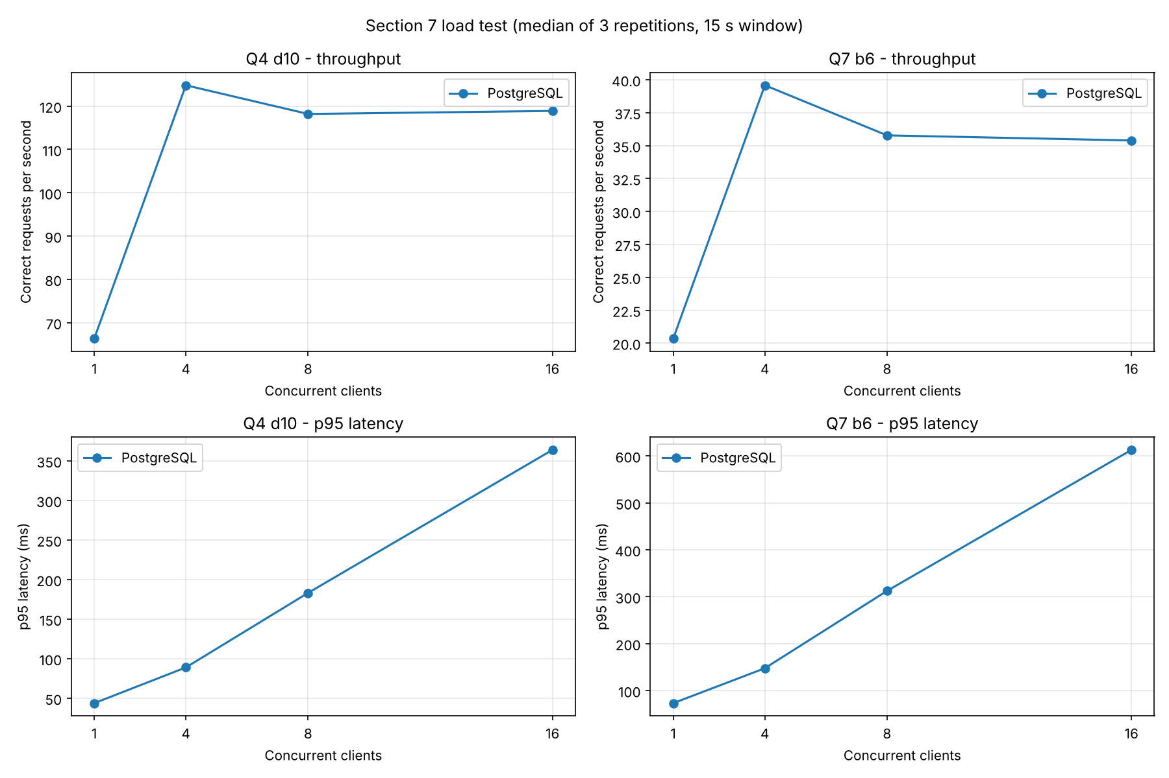 Reference-run plot (PostgreSQL only) – replace with your results/plots/load_scaling.png, which shows both engines. [YOUR analysis – template:] From 1 to 16 clients PostgreSQL Q4 throughput rose from [x] to [y] req/s and flattened beyond [n] clients, where CPU reached ≈100 % on [cores] cores (reference run, 2 vCPU, PostgreSQL: Q4 d10 66 → 125 → 118 → 119 req/s and Q7 b6 20 → 40 → 36 → 35 req/s for 1 → 4 → 8 → 16 clients; CPU ≈50 % with one client – one busy core – and 94–100 % from four clients; Q4 p95 grew 44 → 89 → 183 → 364 ms). After saturation extra clients only queue: throughput stays flat while median and p95 latency grow roughly in proportion to the client count. Throughput is work completed by the system per second; latency is what one analyst waits – the system can be “faster” overall while each analyst waits longer. With the improved SQL, [state whether Neo4j’s Q7 advantage survives]. Limit claims to this laptop, this data size and these two workloads.

8 Decisions

8.1 Investigation priorities
Pair | Q3 devices | Q4 reach d4→d10 | Q5 chains | Q6 cycles | Q7 len | Review first
A 998 / D 237998 | both share a scenario handset with 3 others incl. their destination | 10→187 / 10→192 | 1 / 0 | 1 / 0 | 3 / 3 | A
B 147228 / E 144228 | both: household phone + scenario handset with 5 others incl. destination | 46→228 / 47→230 | 1 / 0 | 0 / 0 | 5 / 5 | B
C 206978 / F 203978 | both: household phone (replacement) + scenario handset with 5 others | 146→1,433 / 147→1,426 | 1 / 0 | 1 / 0 | 5 / 5 | C
Pair A vs D in detail. Device and network evidence is identical in shape: 998 shares handset 228001 with 8917, 16836 and 24755 for all 30 days, and 237998 shares handset 228301 with 5917, 13836 and 21755; both reach about 190 accounts by depth 10 and both connect to their destination in 3 transfers. What separates them is transfer behaviour. On 6 Sep 998 sent 200,000 RWF at 10:00:00; within 40-second steps 196,000, 192,080 and 188,238 RWF moved 8917 → 16836 → 24755 → 998, each 98 % of the previous, returning to 998 120 s after it left (Q5 and Q6 both fire). D’s group pays 45,000 RWF hops two days apart with no reduction, so neither rule fires. A is reviewed first. 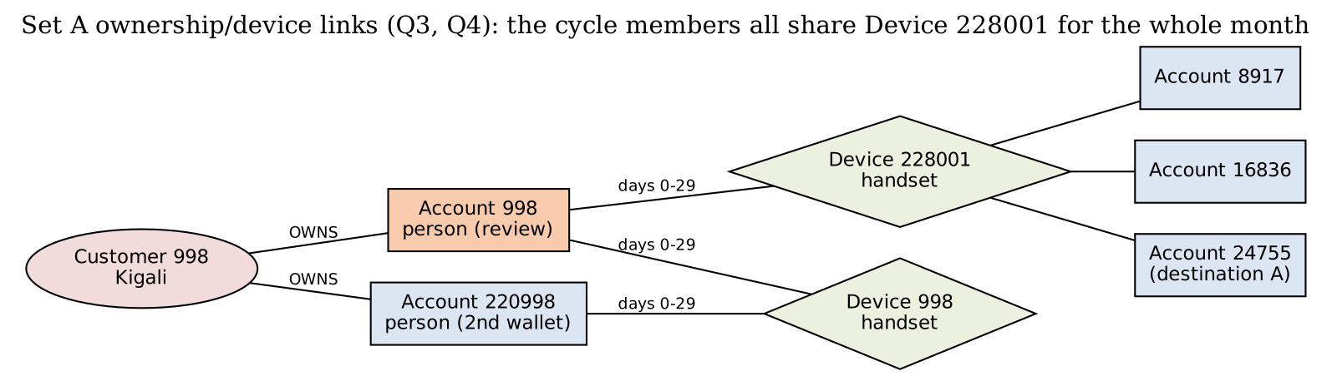
Ordinary explanation. Four people who share one phone could be a household or a savings group (ikimina) passing a contribution round the circle; a 2 % reduction per hop could be fees or a small deduction. Missing evidence: who owns the shared handset, which device initiated each transfer, balances, KYC links between the four customers, and whether the pattern repeats. If KYC shows one family and the cycle recurs monthly with a fee schedule matching 2 %, priority would drop; if the four are unrelated and 998 immediately cashed out at an agent, it would rise. We do not declare fraud from these records.

8.2 Recommendation (≤ 500 words)
[Draft – edit with your measured numbers.] Reporting → PostgreSQL. Q1–Q2 are filters and aggregates over one large event table. With a covering B-tree, Q1 is sub-millisecond; Q2 is a single sequential scan and hash aggregate (≈3.5 s) versus [YOUR Neo4j Q2]. Load was [15] s + [58] s for indexes against [YOUR] s for the Neo4j import; storage [3.7] GB vs [YOUR] GB. Investigation → Neo4j for exploration, PostgreSQL acceptable for fixed rules. Q4–Q7 are traversals. The Cypher is shorter and closer to the analyst’s question – Q6 is one bounded path pattern against a 20-line recursive CTE, and Q7 is a single SHORTEST 1 with the person filter inside the pattern. [YOUR Neo4j Q4/Q7 timings.] Evidence against our preference: once the SQL was improved (bidirectional search) PostgreSQL answered Q7 bound 6 in ≈41–61 ms, and Q3/Q5/Q6 – anchored, time-bounded joins – were already ≈1 ms in SQL. Concurrency: [YOUR comparison of throughput at 16 clients]. Model vs implementation. Graph modelling benefits: relationships are stored, so neighbourhood expansion needs no join planning and variable-length patterns are declarative. Implementation/ algorithm effects: v1 SQL was slow because of breadth-first re-expansion, not because of tables; Neo4j’s shortest path is fast mainly because it runs a bidirectional BFS. Our SQL v2 shows the gap is largely algorithmic. Freshness. If operational data are copied into a graph, target ≤ 15 minutes lag (micro-batch CDC from PostgreSQL). Stale data would miss a cycle that completes in two minutes (case A) until the next batch, and a case could be closed on incomplete evidence. Limits: (1) one laptop, one month (20 M transfers), cold/warm cache effects and a single run series; (2) only seven question shapes – results may differ for global graph algorithms (community detection, PageRank) or for write-heavy workloads.

8.3 Individual judgement (each member, 150–200 words, own text)
Suggested non-overlapping findings – each member writes their own note: * Fulgence Muhirwa – Q7 SQL v1 vs v2 (≈500× faster). Check that could overturn it: rerun with a destination 6 steps away and with cold caches; if v2’s advantage vanishes, the gain was cache. * Uwineza Deborah – Q4 growth stalls between depths 8 and 10 for A/B/D/E. Check: count how many depth-10 accounts are reached only through public terminals; if most are, the stall is a property of terminal placement, not of household structure. * Babatunde Oyedele – Load test saturation point. Check: repeat with the database on a machine with more cores; if throughput keeps rising, the limit was hardware, not the engine.
Contributions: [who did what]. External/LLM assistance: Claude (Anthropic) was used to draft code and text; every query result was checked by running both engines, the 61-case comparison and the independent CSV check, and [describe your own review].

9 Reproducibility
Code, raw results and plans: [GitHub URL] and the ZIP. README lists commands in execution order; secrets are placeholders. step00_verify_generator.py confirms the generator is unchanged. 📸 9.2a final 61-case rerun · 📸 9.2b services stopped.

