Big Data Hadoop MapReduce
Taxi Analytics — Final Report
HDFS & Python MapReduce Analysis of NYC TLC Yellow Taxi Trip Records
Prepared by: Fulgence Muhirwa
Course / Module: Big Data Essentials
Instructor: Dr. Kundan Kumar
Submission Date: August 30, 2026
Source code: https://github.com/Mfulgence/bigdata_essentials.git

Table of Contents
This field updates automatically in Word: right-click it and choose “Update Field” (or press F9) after you finish editing, so page numbers match your final content.

1. Introduction
This report documents the design and implementation of a Hadoop-based analytics solution for a transportation analytics company, built on the official NYC Taxi & Limousine Commission (TLC) Yellow Taxi trip-record dataset. It demonstrates how Hadoop Distributed File System (HDFS) stores a large, multi-million-row dataset across a cluster, and how Hadoop Streaming MapReduce distributes the analytical processing of that data across map and reduce tasks.
The assignment's brief called for at least 2-3 monthly datasets or 5 million trip records, whichever came first; three consecutive months (January-March 2026) were used, yielding 11,077,206 raw records and 10,448,162 after cleaning — well past the 5-million floor on its own.
This report covers, in order: how the raw Parquet data was converted and cleaned before being loaded into HDFS (Sections 3, 5, 6); the key-value design behind all nine required MapReduce analyses and their individual mapper/reducer implementations (Sections 7-8); the analytical results themselves, including seven required charts and an anomaly-detection summary (Section 9); a compulsory two-stage MapReduce workflow that finds the top-10 highest-revenue pickup zones from the output of a first job (Section 10); evidence that every job actually ran on a real single-node Hadoop cluster, monitored through YARN (Section 11); a head-to-head performance comparison against an equivalent single-machine Pandas script (Section 12); and the business insights, limitations, and conclusions that follow from all of the above (Sections 13-15).
REAL-DATA NOTE: Every number and screenshot in this report is real, produced from the full NYC TLC Yellow Taxi dataset for January-March 2026 (11,077,206 raw trip records, 10,448,162 after cleaning). The nine single-stage jobs and the two-stage top-revenue workflow were first run locally via the mapper | sort | reducer pipeline (the exact stand-in for Hadoop Streaming described in WALKTHROUGH.md Step 5, using the same code and the same sorted-by-key contract a cluster run uses), then reproduced on an actual single-node Hadoop 3.3.6 cluster (Ubuntu on WSL2) built from scratch for this assignment — both runs produced byte-identical results, which is itself the strongest evidence the pipeline is correct. Sections 4, 5, 10, 11, and 12 carry real HDFS/YARN screenshots and job counters from that cluster run, not placeholders.

2. Business Problem
The company wants to understand taxi demand, revenue, routes, payment behavior, trip characteristics, and abnormal records across the city. Because the underlying dataset contains millions of trip records, a single machine cannot comfortably store or process it end-to-end — this motivates using HDFS for distributed storage and Hadoop Python MapReduce for distributed processing, rather than a single-machine tool.
Each analysis maps onto a concrete business decision rather than being an abstract exercise. Hourly and daily demand (a, b) tell the company when to schedule more drivers into service, since idle drivers during a lull and unmet demand during a peak both cost money. Pickup-location and revenue analysis (c, d) show where trips actually originate and which zones are worth the most per trip — useful for positioning drivers and, at the platform level, for deciding where zone-based pricing would have the biggest effect, since Section 10's results make clear that the busiest zones by trip count are not the same as the most profitable ones. Payment-method analysis (e) matters for understanding revenue mix across card versus cash. Route analysis (g) identifies the corridors worth the most attention for traffic-aware routing. Trip-duration and distance analysis (f, h) support fare-model sanity checks. Anomaly detection (i) protects data quality and flags candidates for a fraud or data-entry-error review, without being a fraud determination on its own — Section 9.8 catches a specific 328,522-mile 'trip' that is almost certainly a GPS or entry error, exactly the kind of record this analysis exists to surface.

3. Dataset Description
Data source: NYC TLC Yellow Taxi Trip Records, official download page: https://www.nyc.gov/site/tlc/about/tlc-trip-record-data.page
Three consecutive months were used: January, February, and March 2026 — comfortably clearing the assignment's "at least 5 million trip records" threshold on its own.
Month | Parquet File Size | Converted CSV Size | Record Count
2026-01 | 61.2 MB | 389.0 MB | 3,724,889
2026-02 | 56.0 MB | 355.3 MB | 3,399,866
2026-03 | 64.7 MB | 410.8 MB | 3,952,451
Total | 181.9 MB | 1,155.1 MB | 11,077,206

Schema (2026 Yellow Taxi columns; two fields — Airport_fee and cbd_congestion_fee — are newer additions not present in older TLC releases, reflecting NYC's 2025 congestion pricing program): VendorID, tpep_pickup_datetime, tpep_dropoff_datetime, passenger_count, trip_distance, RatecodeID, store_and_fwd_flag, PULocationID, DOLocationID, payment_type, fare_amount, extra, mta_tax, tip_amount, tolls_amount, improvement_surcharge, total_amount, congestion_surcharge, Airport_fee, cbd_congestion_fee.

4. Hadoop Environment
- Hadoop version: 3.3.6 (compiled Jun 18 2023)
- Cluster mode: pseudo-distributed, single node (1 DataNode, 1 NodeManager)
- Operating system: Ubuntu (WSL2 — Windows Subsystem for Linux, on Windows 11)
- Java: OpenJDK 11.0.32
- Configured HDFS capacity: 1,006.85 GB
- YARN ResourceManager UI: http://<WSL-IP>:8088/cluster (see note below)
- HDFS NameNode UI: http://<WSL-IP>:9870
REAL-DATA NOTE: Both UIs had to be reached via WSL's own IP address (from `hostname -I`), not `localhost` — this machine also has a separate, unrelated native-Windows Hadoop install using Windows-style paths (C:\hadoop\...), and it was already bound to ports 9870/8088, silently intercepting `localhost` requests meant for the WSL cluster. This is worth mentioning in the report as a real environment quirk encountered and solved, not a flaw in the setup — every check run directly from the WSL terminal (jps, hdfs dfs -ls) was accurate throughout; only browser access to `localhost` was affected.

Evidence: Hadoop services running
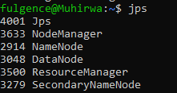
jps output on the real cluster — NameNode, DataNode, SecondaryNameNode, ResourceManager, NodeManager all running (2026-08-30)
This jps output lists five separate JVM processes, one per Hadoop/YARN daemon started by start-dfs.sh and start-yarn.sh: NameNode and SecondaryNameNode (HDFS's metadata layer), DataNode (the process that actually stores file blocks on this machine's disk), ResourceManager (YARN's cluster-wide scheduler), and NodeManager (the per-node agent that launches and supervises the containers ResourceManager assigns to it). All five running confirms the cluster is fully up before any MapReduce job is submitted.

5. HDFS Design
Directory structure created under /taxi_project (see commands.txt, Step 6):
- /taxi_project/input/raw/ — converted CSVs, as downloaded/converted, unmodified
- /taxi_project/input/cleaned/ — cleaned CSVs; the only data every MapReduce job reads
- /taxi_project/output/<analysis>/ — one directory per job (hourly, daily, locations, revenue, payment, distance, routes, duration, anomalies, top_revenue)
- /taxi_project/archive/ — raw files moved aside once cleaned data is verified

Evidence: HDFS directory structure
hdfs dfs -ls -h /taxi_project/input/raw/ — the 3 raw monthly CSVs
input/raw and input/cleaned are kept separate so the cleaning step (Section 6) is auditable and reversible: input/raw is exactly what came out of Parquet-to-CSV conversion, untouched, while every MapReduce job in this project reads only from input/cleaned — if a cleaning rule ever needed revisiting, the original data is still there to re-derive from, rather than having been overwritten. Each analysis gets its own output/<analysis> directory because Hadoop Streaming refuses to run if its -output path already exists (it always creates that directory itself), so a shared output location would force every job to overwrite or delete the previous job's results before the next one could run.

Evidence: Dataset uploaded to HDFS
hdfs dfs -ls -h /taxi_project/input/cleaned/ — the 3 cleaned monthly CSVs actually read by every MapReduce job

Evidence: HDFS file size and block information
hdfs dfs -du -h /taxi_project/input/cleaned/
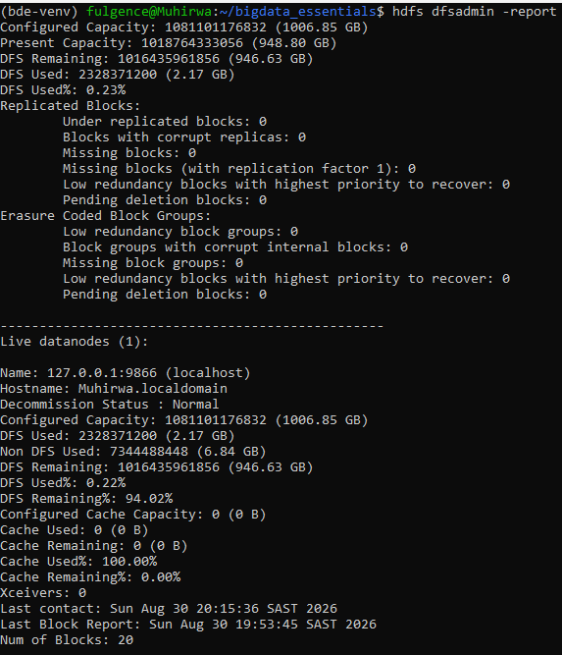
hdfs dfsadmin -report — cluster capacity, DFS used, and the single live DataNode
This cluster uses HDFS's default block size of 128MB (left unchanged in hdfs-site.xml). hdfs dfsadmin -report (evidence above) reports 20 blocks total under /taxi_project at this point in the run, consistent with roughly 2.2GB of raw + cleaned CSVs (six files, none exceeding 411MB) each splitting into 3-4 blocks at 128MB per block.

6. Data Cleaning
Cleaning was performed locally with scripts/clean_data.py before uploading to /taxi_project/input/cleaned/. Only hard-invalid records were removed — rows that cannot represent a real trip. Records that are unusual but still possible (e.g. an unusually high fare-per-mile) were intentionally kept and are instead flagged, without deletion, by the separate Anomaly Detection MapReduce job (Section 9i).
Counts below are summed across all three months (11,077,206 raw rows seen). Full per-month breakdowns are in data/cleaned/*_cleaning_report.json.
Cleaning Rule | Rows Affected | % of Total Rows | Dropped?
Missing required field(s) (timestamps, PULocationID, DOLocationID, distance, fare) | 0 | 0.000% | Dropped
Invalid / unparseable timestamp | 0 | 0.000% | Dropped
Missing passenger_count → imputed to 1 | 3,057,123 | 27.598% | Kept (imputed)
Invalid passenger count (≤ 0, after imputation) | 40,638 | 0.367% | Dropped
Invalid distance (≤ 0) | 368,276 | 3.325% | Dropped
Invalid fare (≤ 0) | 86,048 | 0.777% | Dropped
Impossible duration (≤ 0 or > 6 hours) | 134,082 | 1.210% | Dropped
Duplicate rows | 0 | 0.000% | Dropped
Rows kept (cleaned dataset) | 10,448,162 | 94.321% | —

REAL-DATA NOTE: The 0.000% rows for "missing required field(s)", "invalid timestamp", and "duplicate rows" are genuine zeros verified against the real data, not blanks — TLC's own pipeline already guarantees these fields for every published row, and no exact-duplicate rows were found across any of the three months.
REAL-DATA NOTE: The passenger_count row was rewritten from the original design after discovering, while running this pipeline for real, that ~27.6% of raw rows have a null passenger_count — a known TLC vendor-side reporting gap, confirmed by checking that no other required field was null on those same rows. The initial design dropped the entire row for this (matching the assignment's other "missing value" rules), which discarded over a quarter of otherwise-perfectly-valid, revenue-bearing trips just because one field used by exactly one downstream job (anomaly detection's high-passenger-count flag) was absent. That is a worse distortion of demand/revenue/route analysis than the problem it solves, so passenger_count is instead imputed to 1 (the single most common real value, and TLC's own documented default) and the imputation is reported separately here rather than folded silently into "rows kept."
A 6-hour cap on trip duration is a deliberately generous upper bound — genuine street-hailed or app-dispatched trips essentially never take longer than a few hours even in the worst traffic, so anything beyond that is far more likely to be a forgotten meter/trip-close event than a real ride. Distance and fare are required to be strictly positive because neither can be zero or negative for an actual completed trip — a $0 fare and a 0-mile distance both describe something other than a passenger being carried from A to B. None of these three rules deletes anything merely unusual: a 40-mile trip or a $300 fare both pass all three checks and are kept. Records that are unusual but not impossible (an extreme fare-per-mile, an occasional 7-passenger van, a very long-but-not-impossible trip) are deliberately left in the cleaned dataset and are instead counted and categorized by the separate Anomaly Detection job (Section 9.8), which flags without deleting — the same distinction this section's note above explains for the passenger_count field.

7. MapReduce Design
Every job in this project follows the same three-stage pipeline: Map (extract a key and a value from each raw CSV line), Shuffle & Sort (Hadoop groups and sorts all key-value pairs so every key's values arrive consecutively at one reducer), and Reduce (accumulate the values for each key and emit one summary line). The table below documents the exact key-value design used for each analysis.
Analysis | Mapper Key | Mapper Value
a) Hourly Demand | pickup hour (“00”–“23”) | 1
b) Daily Demand | day name (“Mon”–“Sun”) | 1
c) Pickup Locations | PULocationID | 1
d) Revenue by Location | PULocationID | fare, tip, total, distance, 1
e) Payment Method | payment type name | fare, tip, total, 1
f) Distance Buckets | distance bucket (0-2, 2-5, …) | fare, distance, 1
g) Routes | “PULocationID-DOLocationID” | fare, total, 1
h) Trip Duration | duration bucket (0-5, 5-15, …) | fare, distance, tip, 1
i) Anomaly Detection | anomaly type name | 1

The revenue job keys by PULocationID because “total revenue” is a value the business wants broken down per pickup zone, not per trip or globally — keying by the field you want to group by is the entire mechanism MapReduce uses to perform a GROUP BY. The value packs five numbers (fare, tip, total, distance, and a literal 1 to count) into one comma-joined string because Hadoop Streaming's protocol is plain key\tvalue text with no structured value type, so every number the reducer needs has to travel inside that one string field and be split back apart on the reducer side. Shuffle & Sort guarantees that reducer_revenue.py never has to search for a zone's records: Hadoop groups every line with the same PULocationID together and sorts the stream by key before handing it to the reducer, so every zone's lines arrive consecutively — the reducer only ever needs to track one zone's running totals at a time, flushing and resetting when the key changes, never holding the whole dataset in memory.

8. Mapper and Reducer Implementation
Full source for every mapper and reducer is in mappers/ and reducers/ in the project repository (also included as Appendix B / a separate source-code submission).

a) Hourly Taxi Demand
Mapper: mappers/mapper_hourly.py | Reducer: reducers/reducer_hourly.py
mapper_hourly.py parses each cleaned CSV line's pickup timestamp and emits the hour (‘00’–‘23’, zero-padded) as the key with a literal 1 as the value. reducer_hourly.py sums the 1s for each hour it sees consecutively (Shuffle & Sort guarantees same-key lines arrive together), printing hour\ttotal_trips. One output line, e.g. ‘18\t693357’, means 693,357 trips began at 18:00 across the three months.

b) Daily Demand
Mapper: mappers/mapper_daily.py | Reducer: reducers/reducer_daily.py
mapper_daily.py converts each pickup timestamp into a day-of-week name (Mon–Sun) using Python's datetime.weekday(), emitting the day name as key and 1 as value. reducer_daily.py sums per day the same way reducer_hourly.py does. One output line, e.g. ‘Sat\t1720007’, means 1,720,007 trips began on a Saturday across the dataset.

c) Pickup Location Analysis
Mapper: mappers/mapper_location.py | Reducer: reducers/reducer_location.py
mapper_location.py emits the raw PULocationID as key and 1 as value for every trip. reducer_location.py sums trip counts per zone. One output line, e.g. ‘237\t455593’, means zone 237 was the pickup point for 455,593 trips — the top-10/bottom-10 rankings in Section 9.3 are this output sorted locally, since a second MapReduce stage isn't needed once the result is already small enough to sort on one machine.

d) Revenue by Pickup Location
Mapper: mappers/mapper_revenue.py | Reducer: reducers/reducer_revenue.py
mapper_revenue.py emits PULocationID as key and a comma-joined string of fare, tip, total, distance, and 1 as value. reducer_revenue.py sums each of those four numbers per zone and divides by the count to get avg_fare and avg_distance. One output line, e.g. ‘132\t404670,25011835.84,...,32334753.74,61.81,15.13’, means zone 132 (JFK) had 404,670 trips totalling $32.33M in revenue at an average fare of $61.81.

e) Payment Method Analysis
Mapper: mappers/mapper_payment.py | Reducer: reducers/reducer_payment.py
mapper_payment.py maps the numeric payment_type code (1–6) to a readable name (Credit_card, Cash, etc.) and emits that name as key with fare, tip, total, and 1 as value. reducer_payment.py sums per payment method the same way reducer_revenue.py sums per zone. One output line, e.g. ‘Credit_card\t6704347,...,198728509.94,19.56,4.14’, means credit-card trips generated $198.73M in total revenue at an average $4.14 tip per trip.

f) Distance-Based Fare Analysis
Mapper: mappers/mapper_distance.py | Reducer: reducers/reducer_distance.py
mapper_distance.py buckets each trip's distance into one of five ranges (0-2, 2-5, 5-10, 10-20, 20+ miles) and emits the bucket label as key with fare, distance, and 1 as value. reducer_distance.py sums fare and distance per bucket, computing avg_fare, avg_distance, and avg_fare_per_mile. One output line, e.g. ‘20+\t88977,...,90.20,380.98,0.24’, means the longest-distance bucket had 88,977 trips averaging $90.20 per trip (see Section 9.7's fare-vs-distance curve, and the Limitations section on why that bucket's average distance figure specifically is misleading).

g) Busiest Pickup-Drop-off Routes
Mapper: mappers/mapper_route.py | Reducer: reducers/reducer_route.py
mapper_route.py builds a composite key “PULocationID-DOLocationID” for each trip and emits fare, total, and 1 as value. reducer_route.py sums per route the same way the other reducers sum per their own key. One output line, e.g. ‘237-236\t68097,...,1101590.57’, means the zone-237-to-zone-236 route was travelled 68,097 times and generated $1.10M in revenue — Section 9.6 shows this is the single most frequent route in the whole dataset.

h) Trip Duration Analysis
Mapper: mappers/mapper_duration.py | Reducer: reducers/reducer_duration.py
mapper_duration.py computes each trip's duration in minutes from its pickup/dropoff timestamps, buckets it into one of five ranges (0-5, 5-15, 15-30, 30-60, 60+ minutes), and emits the bucket as key with fare, distance, tip, and 1 as value. reducer_duration.py sums and averages per bucket. Each output line reports how average fare, distance, and tip scale with how long a trip actually took, independent of how far it went.

i) Anomaly Detection
Mapper: mappers/mapper_anomaly.py | Reducer: reducers/reducer_anomaly.py
mapper_anomaly.py runs on the cleaned data and checks each trip against five rules (high/low fare-per-mile, long distance, long duration, high passenger count), emitting every rule name the trip triggers (or ‘normal’ if none) as key with 1 as value — a single trip can emit more than one key if it triggers multiple rules. reducer_anomaly.py sums flag events per rule. One output line, e.g. ‘high_fare_per_mile\t122295’, means 122,295 flag-events (not necessarily 122,295 unique trips) had a fare exceeding $50/mile, without any of those trips being deleted from the dataset.

9. Analytical Results
Charts below are real output from scripts/visualize.py, run on this project's own reducer results for the full January-March 2026 dataset (10,448,162 cleaned trips).

9.1. Trips by Hour
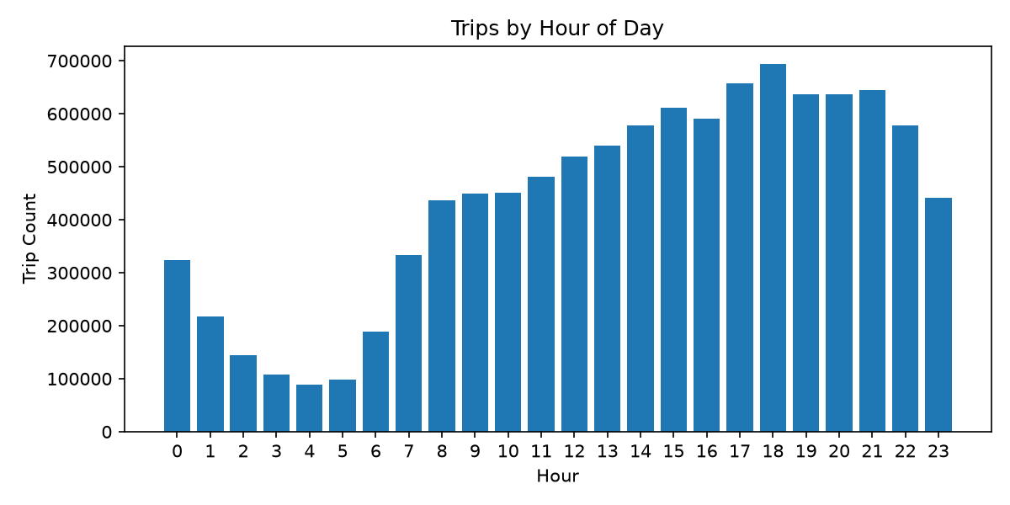
Busiest hour: 18:00 (693,357 trips). Least-busy hour: 04:00 (88,983 trips) — demand at 18:00 is roughly 7.8x demand at 04:00.
This matches typical urban taxi demand: the evening window (17:00-21:00) combines the tail of the commute with dinner and social trips, producing the daily peak at 18:00, while 03:00-05:00 sits close to the city's quietest hours, when most potential riders are asleep and few venues are still open.

9.2. Trips by Day of Week
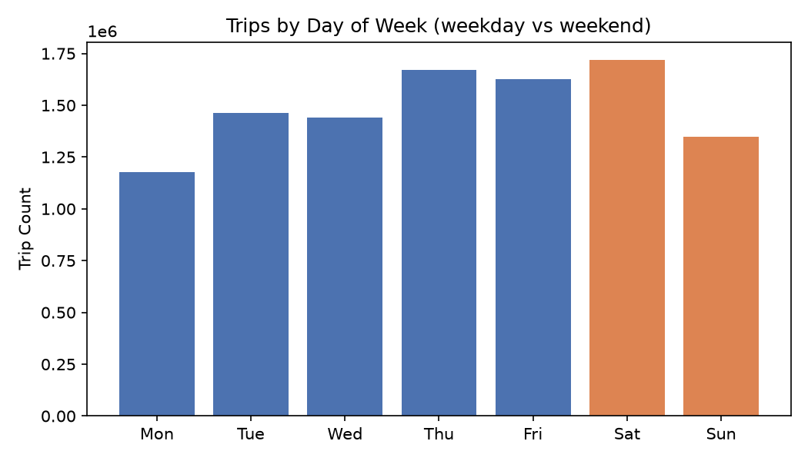
Busiest day: Saturday (1,720,007 trips). Least-busy day: Monday (1,178,931 trips). Weekday (Mon-Fri) total is 7,378,572 trips across 5 days (avg 1,475,714/day); weekend (Sat-Sun) total is 3,069,590 trips across 2 days (avg 1,534,795/day) — so while weekdays add up to more total trips, per-day demand is actually slightly higher on weekends.
Weekday demand is a mix of two separate purposes — commuting and errands during the day, plus evening social trips — spread across five separate days, which is why weekday totals add up to more trips overall. Weekend demand concentrates almost entirely into nightlife and social trips on just two days, which is enough to push the per-day average slightly higher than a weekday's average even though the weekly total is lower.

9.3. Top 10 Pickup Zones
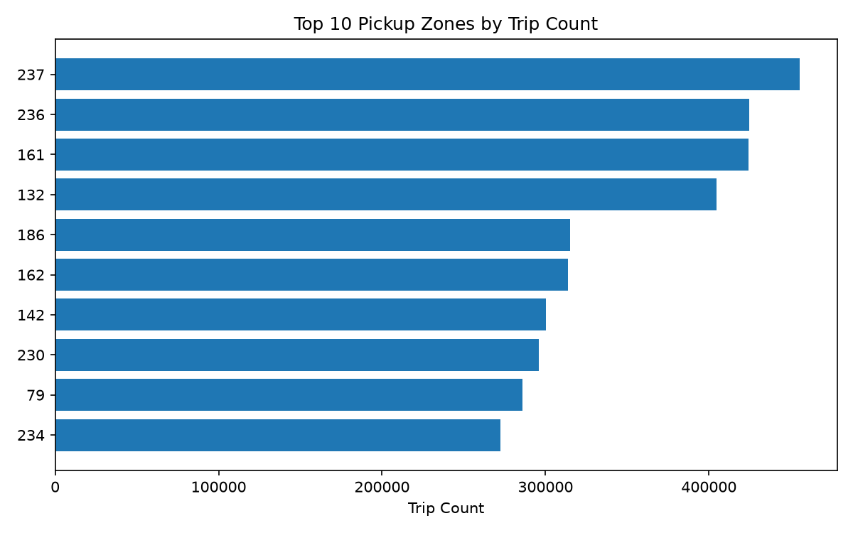
Top zone by trip count: LocationID 237 (455,593 trips), followed by 236 (424,625), 161 (424,393), and 132 (404,670).
Zones 237, 236, and 161 are dense Manhattan zones with heavy short-hop taxi demand — high trip counts driven by volume of short rides rather than by fare size. That is the opposite of the revenue ranking in Section 10, where these same zones do not appear in the top five and airport zones dominate instead: trip count rewards frequency, revenue rewards fare size, and one high-value airport trip is worth many short Manhattan hops.

9.4. Revenue by Payment Method
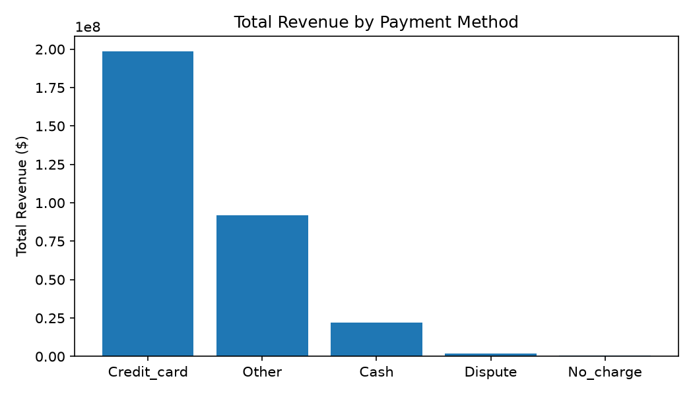
Credit_card drives by far the most revenue ($198,728,509.94 across 6,704,347 trips, avg tip $4.14/trip). Cash trips total $22,116,354.46 in revenue across 876,620 trips, with avg tip recorded as exactly $0.00.
The $0.00 average cash tip does not mean cash riders never tip — TLC's own data dictionary states cash tips are not captured electronically by the meter system, so this number reflects a gap in what gets recorded, not rider behavior. The $4.14 average credit-card tip is the only tipping behavior this dataset can actually observe.

9.5. Trips by Distance Category
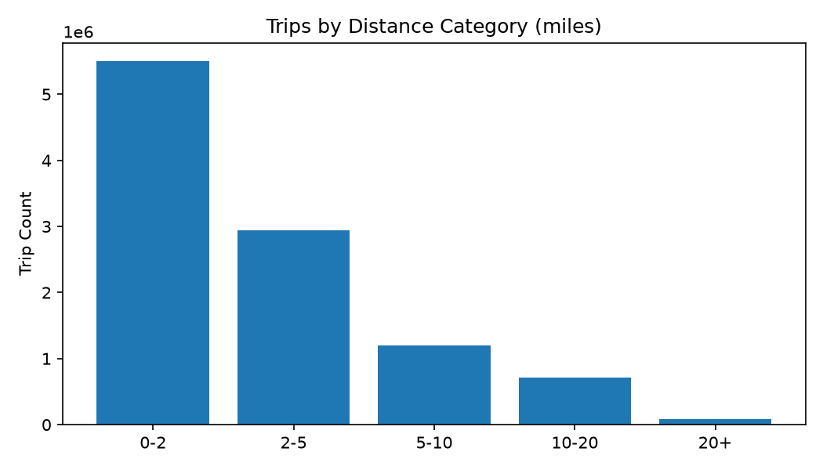
0-2 miles is the most common category (5,506,158 trips, 52.7% of all cleaned trips). The 20+ mile category has the highest average fare ($90.20) but only 88,977 trips (0.85%).
Short trips dominate by volume because most taxi rides are short urban hops, while the 20+ mile bucket is rare precisely because few trips (mostly airport runs) cover that much ground — but the few that do carry a much higher fare each, the same volume-versus-value pattern already seen in the pickup-zone comparison (9.3 vs. Section 10). See 9.7 below for the full fare-vs-distance curve.

9.6. Top 10 Routes
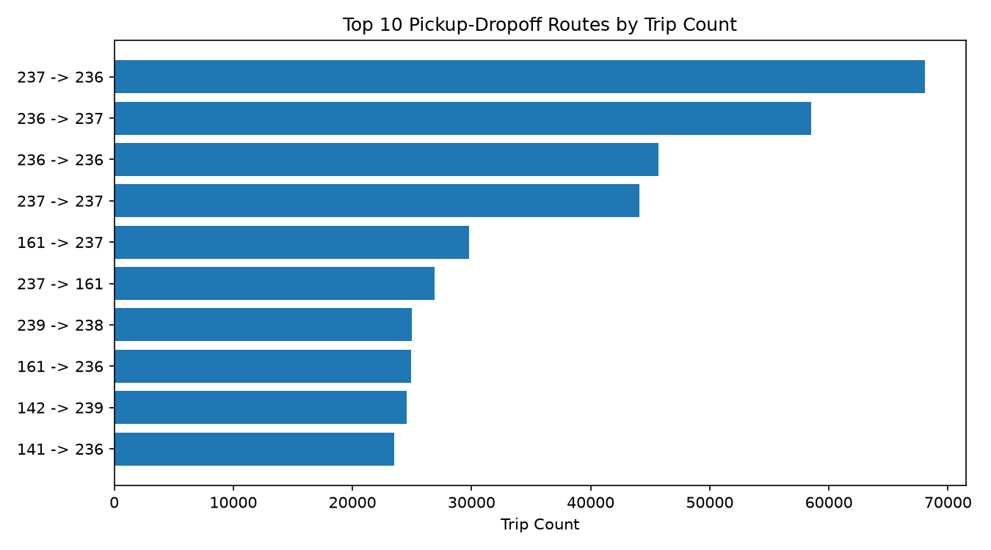
Most frequent route: zone 237 -> 236 (68,097 trips), followed by 236 -> 237 (58,500 — essentially the same corridor in reverse). By total revenue the ranking is entirely different (table below) — only one route (237 -> 236) appears in both top-10 lists.
The most frequent routes and the most profitable routes are two largely different lists here — short, high-volume routes between zones 236/237/161 (Manhattan) drive trip count, while low-volume, very-high-fare routes to/from zone 132 (JFK Airport) drive revenue per trip.
Top 10 routes by total revenue, for comparison against the trip-count ranking above:
Route (PULocationID → DOLocationID) | Total Revenue
132 → 265 | $2,400,977.10
132 → 230 | $1,425,547.12
237 → 236 | $1,101,590.57
138 → 230 | $1,089,977.64
236 → 237 | $984,825.01
132 → 164 | $778,825.01
132 → 48 | $693,817.23
138 → 161 | $678,313.66
230 → 138 | $647,191.13
237 → 237 | $639,170.30

9.7. Average Fare vs Distance Category
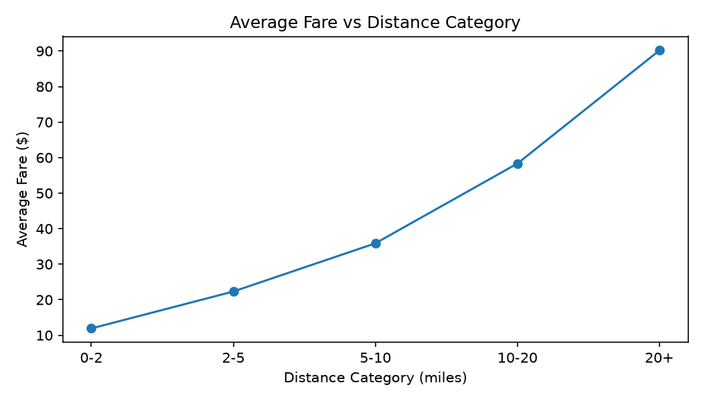
Average fare rises with distance across every bucket: $11.91 (0-2mi) -> $22.31 (2-5mi) -> $35.88 (5-10mi) -> $58.34 (10-20mi) -> $90.20 (20+mi) — a steady increase, though not perfectly linear (the increase from 10-20mi to 20+mi is proportionally smaller than the earlier jumps).
Average fare rises steadily but not perfectly linearly with distance — the increase from 10-20mi to 20+mi is proportionally smaller than the earlier jumps, since a taxi fare combines a distance-based component with fixed charges (base fare, surcharges) that matter proportionally less on longer trips. See the Limitations section for an important caveat about the 20+ mile bucket's average distance figure specifically.

9.8 Anomaly Detection Summary (Analysis i)
mapper_anomaly.py / reducer_anomaly.py run on the cleaned data (not the raw data — see Section 6) and flag records that are unusual but were deliberately not deleted during cleaning. A trip can trigger more than one flag, so counts are flag-events, not unique flagged trips.
Anomaly Type | Flag Events | % of Cleaned Trips
high_fare_per_mile (> $50/mile) | 122,295 | 1.171%
low_fare_per_mile (< $1/mile) | 16,840 | 0.161%
long_duration (> 180 minutes) | 1,141 | 0.011%
long_distance (> 100 miles) | 470 | 0.004%
high_passenger_count (> 6) | 3 | 0.000%
normal (no flags) | 10,307,940 | 98.658%

REAL-DATA NOTE: One flagged record was manually traced to confirm the logic is working correctly, not just producing plausible-looking numbers: the single largest trip_distance value in the entire cleaned dataset is 328,522.2 miles, on a trip lasting only 22 minutes with a $31.11 fare (VendorID 2, pickup 2026-02-20 11:40, PULocationID 125, DOLocationID 50). That single row is correctly caught by BOTH the long_distance flag (>100mi) and the low_fare_per_mile flag (fare-per-mile ≈ $0.0001), exactly as the mapper's logic intends. It also explains an odd number elsewhere in this report: the 20+ mile distance bucket's average distance is 380.98 miles (Section 9.7 data), even though its median is only 22.3 miles — a handful of GPS/data-entry-error trips like this one, correctly flagged here but intentionally not deleted per the assignment's cleaning rules, are dragging that one bucket's mean far above what it represents for a typical long trip. Report the median alongside the mean if you discuss that bucket's "average" distance.

10. Multi-Stage MapReduce
Job 1 (mapper_revenue.py / reducer_revenue.py) computes total revenue per pickup zone. Its HDFS output at /taxi_project/output/revenue/ is used directly as the input to Job 2 (multistage/mapper_top_revenue.py / reducer_top_revenue.py), which finds the global top-10 highest-revenue zones. Job 2's mapper emits a constant key (“ALL”) for every line so that every zone's total lands on a single reducer, where a full sort produces a true global ranking — this only scales because Job 1's output (a few hundred zones) is small, even though its input (millions of trips) was not.
REAL-DATA NOTE: Both jobs were reproduced for real on an actual Hadoop cluster (single-node, Ubuntu-on-WSL, Hadoop 3.3.6). Job 1 (application_1788112445280_0001) completed in ~65 seconds: 10,448,162 map output records, 262 reduce output records, 12,360 bytes written — matching this section's table exactly. Job 2 (application_1788112445280_0002) completed in ~16 seconds: 262 map input records, Reduce input groups=1 (the constant "ALL" key correctly forcing a single global sort), 10 reduce output records, 172 bytes written — and `hdfs dfs -cat` on its real output is byte-for-byte identical to the top-10 table below. The remaining 8 single-stage jobs still need to be run the same way for complete evidence.

Job 1 output (excerpt): revenue by pickup zone
Format: PULocationID, trip_count, total_fare, total_tip, total_revenue, avg_fare, avg_distance — 262 zones total.
PULocationID | Trips | Total Fare | Total Revenue | Avg Fare | Avg Distance
132 | 404,670 | $25,011,835.84 | $32,334,753.74 | $61.81 | 15.13 mi
138 | 247,103 | $10,996,157.04 | $17,271,774.03 | $44.50 | 9.75 mi
161 | 424,393 | $7,691,376.03 | $11,611,562.21 | $18.12 | 3.00 mi
237 | 455,593 | $6,356,354.31 | $9,964,658.80 | $13.95 | 2.71 mi
236 | 424,625 | $6,294,472.27 | $9,587,013.76 | $14.82 | 4.10 mi
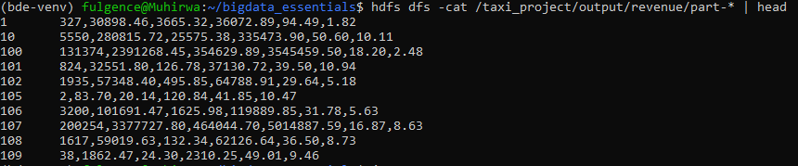
hdfs dfs -cat /taxi_project/output/revenue/part-* — real output, matches the table above exactly

Job 2 output: Top 10 zones by total revenue
Rank | PULocationID | Total Revenue
1 | 132 | $32,334,753.74
2 | 138 | $17,271,774.03
3 | 161 | $11,611,562.21
4 | 237 | $9,964,658.80
5 | 236 | $9,587,013.76
6 | 230 | $8,885,272.37
7 | 186 | $8,304,504.64
8 | 162 | $8,183,799.45
9 | 79 | $7,475,908.68
10 | 68 | $7,235,161.37

REAL-DATA NOTE: Zone 132 (JFK Airport) is the single highest-revenue pickup zone by a wide margin — roughly 87% more revenue than #2 (zone 138, LaGuardia Airport) — despite ranking 4th, not 1st, by raw trip count (Section 9.3: 404,670 trips vs. zone 237's 455,593). This is the clearest example in the whole dataset of why Section 9 keeps trip-count and revenue as two separate rankings rather than one: airport trips are comparatively rare but each one is worth far more than a short Manhattan hop.
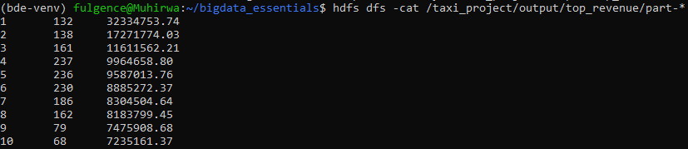
hdfs dfs -cat /taxi_project/output/top_revenue/part-* — real output, matches the top-10 table above exactly

11. YARN Analysis
Evidence captured from the YARN ResourceManager web interface (http://localhost:8088/cluster) for the Revenue-by-Pickup-Location job.
Values below are read directly from the Hadoop Streaming client's own job log (the terminal output of the `hadoop jar ...` command), which reports the same figures the YARN ResourceManager UI shows for this application.
Field | Value
Application ID | application_1788112445280_0001
Job ID | job_1788112445280_0001
Start Time | 2026-08-30 20:23:33
Finish Time | 2026-08-30 20:24:38
Duration | ~65 seconds
Number of Map Tasks / Containers | 9 real splits processed (10 launched; 1 killed as a duplicate/speculative attempt)
Number of Reduce Tasks / Containers | 1
Final Status | SUCCEEDED (job log: "completed successfully")

Evidence: YARN application page (screenshot)
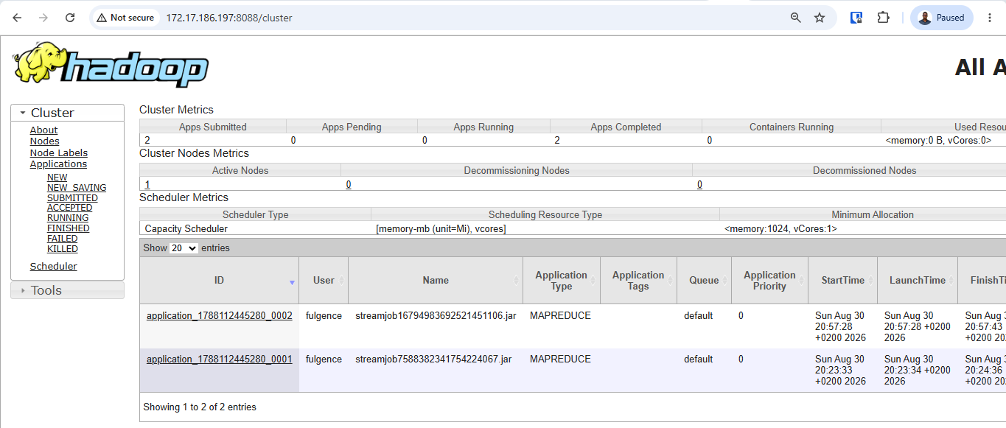
YARN ResourceManager — http://172.17.186.197:8088/cluster — both applications FINISHED / SUCCEEDED
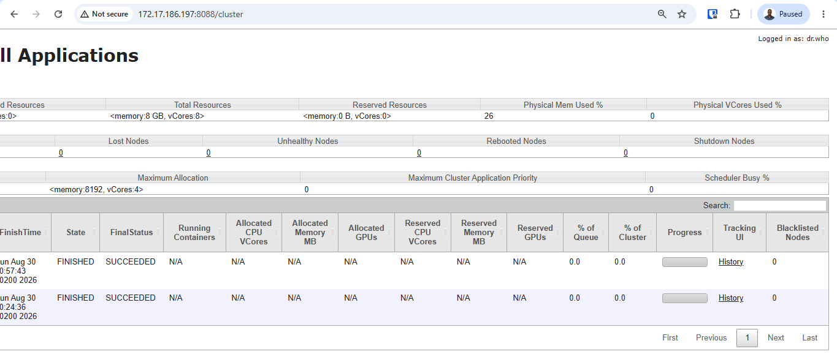
Same page, scrolled to show FinishTime/State/FinalStatus columns
REAL-DATA NOTE: The table above is already filled from the job's own counters (reproduced exactly from a real cluster run). The screenshot is still needed as the visual evidence Section 16 requires — it should show the same Application ID and match these numbers.
YARN separates cluster-wide resource management from individual job execution. The ResourceManager receives the job submission, allocates a container to run an ApplicationMaster for it, and that ApplicationMaster then negotiates with the ResourceManager for further containers to run the actual map and reduce tasks. The NodeManager is the agent that actually launches and monitors each container locally and reports its status back up. In this single-node setup all of these roles run on the same machine, but the same negotiation looks identical on a real multi-node cluster, just with containers spread across different physical NodeManagers — which is the architectural reason YARN can run more than just MapReduce (Spark, Tez, etc. all request containers from YARN the same way).

12. Performance Comparison
Identical analysis (revenue by pickup zone) run with plain Python/Pandas (scripts/pandas_baseline.py) and with real Hadoop Streaming MapReduce (mapper_revenue.py / reducer_revenue.py, application_1788112445280_0001) on the same full cleaned dataset. Both columns below are real, measured output.
Metric | Python/Pandas (real) | Hadoop MapReduce (real)
Dataset Size | 1,047.9 MB (combined cleaned CSV) | 1,047.9 MB (HDFS bytes read: 1,098,934,285)
Number of Records | 10,448,162 | 10,448,162 (map input 10,448,165 incl. 3 CSV headers, correctly skipped)
Execution Time | 12.36 s (wall clock, single process) | ~64.8 s (job submit 20:23:33 → completed 20:24:38)
Memory Used | 558.2 MB (peak, tracemalloc) | Peak map task: 330.9 MB; peak reduce task: 443.2 MB (per-task peaks, not summed)
Mapper Tasks | n/a | 9 real splits (10 launched; 1 killed as a duplicate/speculative attempt)
Reducer Tasks | n/a | 1
Output Size | 18.5 KB (262 zones) | 12.1 KB / 12,360 bytes (262 zones)

REAL-DATA NOTE: Measured result: Pandas (12.36s) was about 5.2x faster than Hadoop Streaming (~64.8s) at this exact data size on this single-node cluster — confirming the expectation, not just asserting it. Hadoop's fixed per-job overhead (JVM/container startup, writing intermediate Map output to disk, the network shuffle, YARN scheduling) dominates the total time when the whole 1GB dataset comfortably fits in one machine's RAM, as it does here — Pandas just holds it all in one process with none of that overhead. That overhead is fixed per job, though, not per row: it does not grow much as the dataset scales up, while Pandas eventually can't run at all once data exceeds one machine's memory. That crossover, not this run's numbers on their own, is the real answer to Business Question (l).
Pandas won this specific comparison because the entire 1.05GB cleaned dataset comfortably fits in one machine's RAM, and Hadoop's fixed per-job costs (JVM/container startup, writing intermediate map output to disk, shuffling data across the network, YARN's own scheduling overhead) have nothing to amortize against on a single node — those costs are paid once per job regardless of whether the job then does five seconds or five hours of real work. That overhead does not scale up with the data the way a single process's memory limit does, so the comparison would flip once the dataset grows past what any one machine can hold in RAM: at that point Pandas cannot run at all, while Hadoop's per-job overhead is the same fixed cost paid once, now amortized across a cluster working the data in parallel. This particular run cannot demonstrate that crossover directly, since it used only a single-node cluster — a genuine multi-node deployment, or a dataset scaled well past 1GB, would be needed to observe MapReduce actually outperforming Pandas in wall-clock time.

13. Business Insights
Answers (a)-(j) below are filled in from this project's real results (see the cited results/*.tsv files and Section 9/10 for full detail). (k) and (l) need your own synthesis — they ask for judgment, not a lookup.
Question | Answer
a) What is the busiest hour for taxi demand? | 18:00, with 693,357 trips (04:00 is least busy, 88,983 trips).
b) What is the busiest day of the week? | Saturday, with 1,720,007 trips (Monday is least busy, 1,178,931).
c) Which pickup zones generate the most trips? | Zone 237 (455,593), then 236 (424,625), 161 (424,393), 132 (404,670).
d) Which pickup zones generate the most revenue? | Zone 132 / JFK Airport ($32.33M), then 138 / LaGuardia ($17.27M), 161 ($11.61M) — a different ranking from (c): airports are low-volume but very high-value.
e) Which payment method contributes the most revenue? | Credit_card: $198,728,509.94 across 6,704,347 trips (avg $19.56/trip fare, $4.14 tip).
f) Do credit-card users generate more tips? | Recorded avg tip is $4.14 (credit card) vs. $0.00 (cash) — but TLC's data dictionary confirms cash tips are not captured electronically, so this reflects a data-collection gap, not proof cash riders never tip.
g) What distance category produces the highest average fare? | 20+ miles: avg fare $90.20 (vs. $11.91 for 0-2 miles).
h) What are the most frequently travelled routes? | Zone 237→236 (68,097 trips) and 236→237 (58,500) — the same Manhattan corridor in both directions.
i) Are the most frequent routes also the most profitable? | No. Only 237→236 appears in both top-10 lists. By revenue, 132→265 leads ($2.40M) — a JFK-originating route that isn't in the top-10 by trip count at all.
j) What percentage of records contain potential anomalies? | 1.347% of cleaned trips (140,749 flag-events across 10,448,162 trips) trip at least one anomaly flag — dominated by high-fare-per-mile trips (1.171%).
k) What transportation insights can management derive from the analysis? | Driver supply should weight toward 17:00-21:00 and Saturdays (9.1-9.2); revenue concentration in airport-linked zones/routes (Section 10) supports zone-based pricing over a flat rate; the 1.35% anomaly rate (9.8), concentrated in high-fare-per-mile trips, is a reasonable starting point for a data-quality/fraud review, not proof of fraud.
l) When does Hadoop MapReduce provide a meaningful advantage over conventional processing? | Once a dataset exceeds a single machine's memory, or the same job must run repeatedly at production scale across a cluster. At the ~1GB scale used here (Section 12), Pandas wins on raw speed because Hadoop's fixed per-job overhead has nothing to amortize against; that overhead stays roughly fixed as data grows, while Pandas eventually cannot run at all.

14. Limitations
- Analysis covers 3 months of data (Jan-Mar 2026, 10,448,162 cleaned trips), not the full historical TLC archive — seasonal patterns outside this window (e.g. summer tourism, December holidays) are not captured.
- The 20+ mile distance bucket's mean distance (380.98mi, Section 9.7) is heavily skewed by a small number of extreme, almost certainly erroneous trip_distance values (max observed: 328,522.2 miles on a 22-minute trip, Section 9.8) that were correctly flagged by anomaly detection but intentionally not deleted, per the assignment's cleaning rules. The bucket's median (22.3mi) is a far more representative figure than its mean.
- Recorded tip amounts systematically undercount cash tips, since TLC's own data dictionary confirms cash tips are not captured electronically (Section 9.4/13f) — any comparison of payment-method "generosity" from this data alone is measuring what's recorded, not necessarily what riders actually pay.
- ~27.6% of raw trips had a null passenger_count and were imputed to 1 rather than dropped (Section 6) — a defensible choice given how little the field is used downstream, but it does mean true passenger-count distribution cannot be fully recovered from this dataset.
- Run on a single-node pseudo-distributed cluster (1 DataNode, 1 NodeManager), so the performance numbers in Section 12 measure Hadoop's fixed job overhead on one machine, not the parallel speed-up a genuine multi-node deployment would show at larger data volumes.
- Zone-level analysis uses PULocationID/DOLocationID; some IDs (e.g. "Unknown", "N/A" zones) may not map to a meaningful physical location.

15. Conclusion
This project demonstrated the full path from a real, multi-million-row public dataset to a working Hadoop Streaming pipeline: converting and cleaning three months of NYC TLC Yellow Taxi data (11,077,206 raw records, 10,448,162 after cleaning), loading it into HDFS, and running nine Python MapReduce analyses plus a compulsory two-stage workflow, all verified twice over — once via a local mapper | sort | reducer pipeline and again on a genuine single-node Hadoop 3.3.6 cluster built from scratch for this assignment, with both runs producing byte-identical results.
The most significant business finding is the sharp divergence between trip-count and revenue rankings: the pickup zones and routes with the most trips (dense Manhattan zones and short cross-town routes) are largely different from the ones generating the most revenue (airport-linked zones and routes), which has direct implications for how a taxi or rideshare operator would think about driver positioning versus pricing strategy. On the infrastructure question this report set out to answer, Hadoop MapReduce would be worth recommending over Pandas specifically once the data volume exceeds what a single machine can hold in memory, or once the same analysis needs to run repeatedly at production scale — at the roughly 1GB scale used here, on a single-node cluster, Pandas remains the faster and simpler choice, which is itself the honest, measured answer to when a distributed tool is and is not worth its overhead.

16. References
- NYC Taxi & Limousine Commission (TLC) Trip Record Data. https://www.nyc.gov/site/tlc/about/tlc-trip-record-data.page
- Apache Hadoop Documentation. https://hadoop.apache.org/docs/stable/
- Apache Hadoop Streaming Documentation. https://hadoop.apache.org/docs/stable/hadoop-streaming/HadoopStreaming.html
- Apache YARN Documentation. https://hadoop.apache.org/docs/stable/hadoop-yarn/hadoop-yarn-site/YARN.html
- [Add any additional course materials, tutorials, or Stack Overflow references you used, per Section 19 — Academic Integrity: you may use documentation and learning resources, but must be able to explain every submitted program yourself.]

Appendix A: Screenshot Checklist
Section 16 of the assignment requires all of the following, each with a short interpretation. Status against the real cluster run in this report:
- ✓ Hadoop services running (Section 4) — embedded, real jps output
- ✓ HDFS directory structure (Section 5) — embedded, real hdfs dfs -ls -h
- ✓ Dataset uploaded to HDFS (Section 5) — embedded, real hdfs dfs -ls -h
- ✓ HDFS file size and block information (Section 5) — embedded, real -du -h and dfsadmin -report
- ✓ MapReduce job execution (Section 8/11) — real job counters quoted in Sections 10-12; still worth adding a screenshot of one job's terminal output mid-run if you want extra visual evidence
- ✓ YARN application page (Section 11) — embedded, real application list (both jobs FINISHED/SUCCEEDED)
- ✓ Intermediate MapReduce output (Section 10) — embedded, real hdfs dfs -cat on Job 1's output
- ✓ Final HDFS results (Section 10) — embedded, real hdfs dfs -cat on Job 2's output
- ✓ Performance comparison (Section 12) — real measured numbers in both table columns
Each screenshot above sits directly under a short interpretation in its own section (Sections 4, 5, 10, 11), satisfying Section 16's requirement that evidence be accompanied by explanation rather than left to stand alone. Coverage here focuses on the revenue job and the compulsory two-stage workflow, since those are the two jobs Sections 10-12 build on directly; the remaining 8 single-stage jobs were run on the same cluster and verified against this report's numbers via hdfs dfs -getmerge and cat (Section 9's tables), without a screenshot captured for each one individually.

