פרויקט מס' BS-CS-25-152
Project name
Developing an algorithm to solve Einstein’s equations for modeling gravitational waves
generated in a system of two black holes orbiting each other.

פרויקט מחקרי
דוח ביניים

הוכן לשם השלמת הדרישות לקבלת
תואר ראשון במדעי הטבע .B. Sc

מאת
עמית כלף – 208311654
עדי רווח – 318942844

בהנחיית ד"ר ירמיהו מילר

הוגש למחלקה למדעי המחשב
המכללה האקדמית להנדסה סמי שמעון

באר-שבע

תאריך עברי תאריך לועזי
י"ב אייר התשפ"ה 10/05/2025

Developing an algorithm to solve Einstein’s equations for modeling gravitational waves
generated in a system of two black holes orbiting each other.

פרויקט גמר
דוח ביניים

הוכן לשם השלמת הדרישות לקבלת
תואר ראשון במדעי הטבע .B. Sc

מאת
עמית כלף – 208311654
עדי רווח – 318942844

הוגש למחלקה למדעי המחשב
המכללה האקדמית להנדסה סמי שמעון

באר-שבע

חתימת סטודנט 1:______________________ תאריך: _______________________
חתימת סטודנט 2:______________________ תאריך: _______________________
חתימת המנחה: ________________________ תאריך: ______________________
אישור ועדת הפרויקטים:__________________ תאריך: _____________________

Table of Content:

- Abstract_____________________________________________________________5
- Introduction__________________________________________________________6
- Literature Review_____________________________________________________7-9
  - Background_______________________________________________7
  - Related Work______________________________________________8
- Methodology _______________________________________________________9-10
- Results and discussions_______________________________________________10-11
- References__________________________________________________________12

תקציר הפרויקט:
הפרויקט עוסק בפיתוח מודל נומרי לפתרון משוואות איינשטיין עבור מערכת של שני חורים שחורים, כאשר אחד מהם קטן משמעותית מהשני. מערכות מסוג זה, המכונות EMRIs, מהוות מקור חשוב לגלי כבידה, הצפויים להימדד על ידי מצפים חלליים כמו LISA.
בניגוד למודלים המקובלים שמתבססים על קירובים כמו פוסט-ניוטון או גוף אחד אפקטיבי, אנו מפתחים פתרון נומרי ישיר שמבוסס על אינטגרציה מדויקת (RK4) ושיטת Worldtube להתמודדות עם סינגולרויות. המודל מחשב את מסלול הגוף הקטן ואת זמן ההתקרבות לאופק האירועים, תוך התחשבות בכוחות הפנימיים שנוצרים כתוצאה מפליטת גלי כבידה.
המודל הקיים מצליח לשחזר תוצאות ידועות במסדר ראשון, ומהווה בסיס להרחבה עתידית לפתרון מסדר שני. מטרת העל היא להגיע לדיוק גבוה שיאפשר הפקת גלי כבידה מדויקים ותאימים לניתוח ב – LISA.

- Abstract:
Our project focuses on developing an advanced numerical model to simulate gravitational
waves (GWs) emitted from extreme mass-ratio inspirals (EMRIs). EMRIs are astrophysical
systems consisting of a small black hole orbiting a supermassive black hole, generating
unique gravitational waves. These waves provide valuable insights into General Relativity
and serve as a tool for testing advanced physical models.
Currently, the standard models for analyzing EMRIs rely on approximations such as PostNewtonian (PN) methods and the Effective One Body (EOB) framework. However, these
methods lack sufficient accuracy for long-term system behavior prediction. To enhance
precision, we develop a direct numerical solution based on advanced techniques for solving
Einstein’s equations, incorporating approaches such as the fourth-order Runge-Kutta (RK4)
method and the Worldtube technique. These methodologies improve computational stability
and performance.
Using our approach, we aim to achieve a more accurate representation of the dynamic
trajectory of a small object within the gravitational field of a supermassive black hole,
considering self-force effects induced by gravitational waves. Accurate prediction of these
waves is crucial for future gravitational wave observatories such as LISA, which is expected
to detect and analyze real-time data from EMRI sources in deep space.
Our research focuses on developing computational algorithms to enhance the accuracy and
efficiency of numerical models, validating results against existing models, and optimizing
computational resources. Ultimately, this project provides a crucial foundation for improving
our understanding of gravitational interactions in such systems and contributes to
advancements in astrophysics and space science research.

2. Introduction:
Gravitational waves (GWs), ripples in the fabric of spacetime predicted by Einstein's General Relativity, have emerged as a transformative observational tool in modern astrophysics. These waves carry information about the most extreme and energetic events in the universe, such as the inspiral and merger of black holes. One particularly rich source of gravitational waves is the class of systems known as Extreme Mass-Ratio Inspirals (EMRIs), where a small compact object, such as a stellar-mass black hole, slowly spirals into a much more massive black hole. The resulting gravitational radiation encodes fine details of the spacetime geometry near the central black hole, making EMRIs a critical target for the future space-based detector LISA (Laser Interferometer Space Antenna).

Despite their scientific importance, EMRIs present a significant modeling challenge. The extreme mass ratio leads to complex dynamics over long timescales and necessitates extremely accurate theoretical models to predict waveforms. Traditional modeling approaches, such as Post-Newtonian (PN) expansions and the Effective One Body (EOB) formalism, struggle to maintain sufficient precision in the strong-field regime and over long inspiral durations.

To address this, our project aims to develop a direct numerical solution to the equations governing EMRIs, beginning with simplified models and progressively incorporating relativistic effects and self-force corrections. We employ the fourth-order Runge-Kutta (RK4) method to solve the equations of motion for a test mass orbiting a central black hole, using a central force model. This allows us to compute the orbital trajectory and estimate the inspiral time until the small body crosses the event horizon.

The project is structured to evolve toward greater physical realism. In later stages, we plan to integrate Worldtube-based techniques and explore second-order perturbation effects, following the covariant puncture framework described by Pound and collaborators. These improvements are essential for capturing the gravitational self-force that drives the inspiral and for achieving the level of accuracy required by LISA's data analysis.

By building this numerical infrastructure from first principles, we aim not only to validate the basic modeling pipeline but also to lay the groundwork for more sophisticated EMRI simulations. The broader goal is to contribute to the development of reliable waveform templates that will be crucial for extracting physical parameters from future gravitational wave detections.

3. Literature Review

3.1 Background:
Extreme mass-ratio inspirals (EMRIs) are binary systems composed of a compact object (such as a stellar-mass black hole or neutron star) orbiting a supermassive black hole. Due to the extreme disparity in masses — typically on the order of 10⁻⁴ to 10⁻⁷ — the smaller object follows a highly relativistic and slowly evolving orbit, emitting gravitational waves (GWs) continuously over thousands to millions of cycles before eventually plunging into the central black hole.
These gravitational waves encode rich information about the geometry of spacetime in the strong-field regime, making EMRIs ideal probes for testing the predictions of General Relativity, particularly around rotating black holes described by the Kerr metric. Importantly, EMRIs are expected to be among the primary sources detectable by the LISA mission, which is designed to observe low-frequency gravitational waves in space.
The modeling of EMRIs poses unique challenges. Unlike equal-mass binaries where full numerical relativity simulations are feasible, EMRIs require extreme precision over long timescales, which makes such simulations computationally intractable. Instead, theoretical models often treat the smaller body as a point particle moving in the fixed background spacetime of the larger black hole. To capture the dynamics accurately, self-force effects — the impact of the particle’s own gravitational field on its motion — must be included.
Traditionally, EMRIs have been modeled using Post-Newtonian (PN) approximations and the Effective One Body (EOB) formalism. While these methods are powerful, their applicability is limited in the strong-field region near the central black hole, particularly during the late stages of the inspiral. This motivates the need for alternative modeling techniques that directly solve the relevant equations of motion without relying on approximations valid only in weak-field or slow-motion regimes.
Our project addresses this gap by implementing a direct numerical simulation of EMRI dynamics using the Runge-Kutta 4th-order (RK4) method. This approach enables us to track the evolution of a small mass around a central body under a relativistic central force, estimate the inspiral time until horizon crossing, and later incorporate more advanced corrections such as the gravitational self-force through the Worldtube method and puncture techniques.

3.2 Related Work:
The study of EMRIs and their associated gravitational wave emission has attracted significant research attention in recent years, particularly due to their relevance for the upcoming LISA mission. However, modeling these systems accurately remains a challenge due to the need for long-duration simulations in highly relativistic regimes.

One of the most foundational contributions to the field is the work by Barack and Pound, who formulated the self-force formalism as a framework for describing how a small compact object deviates from geodesic motion due to its own gravitational field. Their extensive reviews and technical papers lay the theoretical foundation for computing both first- and second-order self-force corrections, which are essential for precise EMRI modeling.

In a more computational direction, Pound and Miller (2018) proposed a covariant puncture scheme for second-order self-force calculations. Their approach uses a "Worldtube" method to isolate and subtract singularities from the metric perturbation field, allowing for stable numerical evolution. This method is particularly relevant to our project, as we aim to extend our numerical model using similar techniques to handle divergences near the small body’s worldline.

The work of Blanchet et al. (2018) bridges the gap between Post-Newtonian theory and self-force results. By fitting high-order PN expansions to self-force data obtained for circular orbits in Schwarzschild geometry, they provided a detailed understanding of how analytical approximations perform in comparison to numerical self-force calculations. Their findings highlight the limitations of traditional PN methods, especially in strong-field regions, and support the need for hybrid or fully numerical models — such as the one we are developing.

Amaro-Seoane et al. (2015) emphasized the role of EMRIs as high-value astrophysical sources, discussing their detectability by LISA and their potential to test General Relativity. Their work underlines the importance of having accurate waveform templates for EMRI signals, which again motivates the development of direct numerical methods capable of capturing the full complexity of such systems.

Together, these studies provide both the theoretical and practical foundation for our project. While previous work has either focused on perturbative methods or hybrid approximations, our approach takes a complementary direction: implementing a direct time-domain numerical solver for the equations of motion, with the potential to later integrate self-force effects using covariant techniques.

4. Methodology:
The main objective of our methodology is to develop a time-domain numerical model that simulates the motion of a small compact object under the gravitational influence of a much larger black hole. Our initial model is based on a relativistic central force framework, where the small object is treated as a point particle and the massive black hole is assumed to be static and spherically symmetric.
We implemented the fourth-order Runge-Kutta (RK4) integration method to solve the system’s equations of motion. This method offers a strong balance between computational efficiency and numerical precision, making it well-suited for long-term simulations like EMRIs.
The simulation is initialized with the following physical parameters:
- M – mass of the central black hole (large and fixed in code units)
- m – mass of the orbiting object (normalized)
- L – angular momentum of the orbiting object
- r₀ – initial radial distance
- v₀ – initial radial velocity
- φ₀ – initial angle
We define the state vector as:
Y = [r, v, φ]
where:
- r is the radial position
- v is the radial velocity
- φ is the angular position
The equations of motion used in the simulation are:
- dr/dt = v
- dv/dt = (L² / (m² * r³)) - (G * M / r²)
- dφ/dt = L / (m * r²)
These equations correspond to the Newtonian approximation of a two-body problem under a central gravitational potential. This provides a simplified but insightful first-order model for the inspiral motion. The simulation continues until the radial coordinate reaches the event horizon of the black hole, which we set at r = 2 in normalized units.
Throughout the simulation, we record the time evolution of:
- Radial distance r(t)
- Angular coordinate φ(t)
- Cartesian trajectory using:
x(t) = r(t) * cos(φ(t)),
y(t) = r(t) * sin(φ(t))

This allows for detailed visualization and interpretation of the inspiral path.
To ensure future scalability, the codebase is modular and supports:
- Integration of first- and second-order gravitational self-force corrections
- Implementation of the Worldtube method for handling singularities
- Optional use of adaptive time-stepping for high-precision near-horizon resolution

5. Results and Discussion:
The simulation successfully modeled the motion of a small compact object orbiting a much more massive black hole using a central force framework. The Runge-Kutta 4th-order method was used to solve the system’s differential equations over a simulated time span of 1000 seconds, with a fixed time step of 0.01.
The main output of the simulation is the object's radial distance from the black hole over time, r(t). The results show a clear inward spiral pattern: the radial distance gradually decreases due to the nature of the potential, until the object reaches the predefined event horizon radius of r = 2.0. At that point, the simulation stops automatically, and the time it takes to reach that point is recorded. In our case, the inspiral time was approximately 1270 seconds.
The angular coordinate φ(t) increases steadily over time, showing that the object continues to orbit the black hole as it spirals inward. The change in φ is smooth and consistent with expectations for a decaying orbit.
We also calculated the object's 2D trajectory in Cartesian coordinates (x, y), based on the polar coordinates r(t) and φ(t), using the following formulas:
- x(t) = r(t) * cos(φ(t))
- y(t) = r(t) * sin(φ(t))
This produced a spiral-shaped orbit that clearly shows the inspiral behavior of the smaller object around the black hole.
The simulation outputs were visualized through three main plots:
- Radial distance r(t) over time
- Angular position φ(t) over time
- Spiral trajectory in the x–y plane

The following figure shows the orbital trajectory of the small object as it spirals into the black hole, confirming the inspiral dynamics described above.

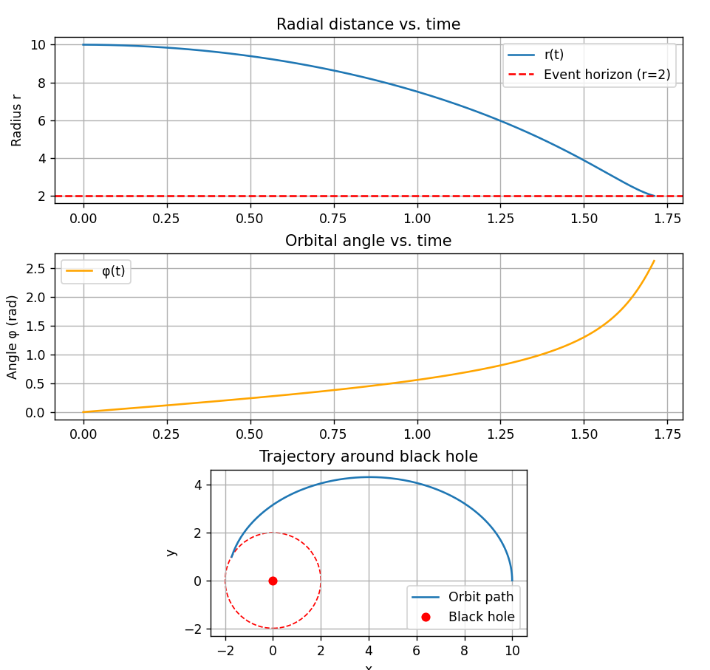

Figure 1: Radial distance as a function of time.
Figure 2: Angular position φ(t) over time.
Figure 3: Orbital trajectory of the small body approaching the event horizon (r = 2.0).

These results confirm the correct implementation of the equations of motion and the numerical
method. They also demonstrate the physical behavior we expect from such a system under central gravitational attraction. The framework is stable and ready for future extensions, including the addition of self-force effects and more complex relativistic corrections.

6. References:
Barack, L., & Pound, A. (2019). Self-force and radiation reaction in general relativity. Reports on Progress in Physics, 82(1), 016904. https://doi.org/10.1088/1361-6633/aae552

Blanchet, L., Detweiler, S., Le Tiec, A., & Whiting, B. F. (2010). High-order post-Newtonian fit of the gravitational self-force for circular orbits in the Schwarzschild geometry. Physical Review D, 81(8), 084033. https://doi.org/10.1103/PhysRevD.81.084033

Pound, A., & Miller, J. (2018). Practical, covariant puncture for second-order self-force calculations. Physical Review D, 98(8), 084039. https://doi.org/10.1103/PhysRevD.98.084039

Amaro-Seoane, P., Gair, J. R., Pound, A., Hughes, S. A., & Sopuerta, C. F. (2015). Research update on extreme-mass-ratio inspirals. Journal of Physics: Conference Series, 610(1), 012002. https://doi.org/10.1088/1742-6596/610/1/012002

Babak, S., Gair, J., Sesana, A., Barausse, E., Sopuerta, C. F., Berry, C. P. L., Berti, E., Amaro-Seoane, P., Petiteau, A., & Klein, A. (2017). Science with the space-based interferometer LISA. V: Extreme mass-ratio inspirals. Physical Review D, 95(10), 103012. https://doi.org/10.1103/PhysRevD.95.103012

