**Student Name: Marcus Garvey**

**Course: Artificial Intelligence in Software Engineering**

**Part 1: Answer Questions**

**Q1:** Explain how AI-driven code generation tools (e.g., GitHub Copilot) reduce development time. What are their limitations?

AI code tools predict and suggest code snippets in real time, reducing manual typing, debugging, and repetitive coding tasks. This accelerates development and boosts productivity. Limitations include their ability to produce syntactically correct but logically flawed code, potential leakage of private data if misused, and heavy dependence on the quality of training data. They do not fully understand project context or intent.

**Q2:** Compare supervised and unsupervised learning in the context of automated bug detection.

**Supervised learning** uses labeled data (bug vs. no bug) to train models that classify or predict future bugs.  
**Unsupervised learning** detects anomalies or unusual code patterns without prior labels, helping discover unknown bug types.  
Both approaches improve efficiency by identifying issues early in development.

**Q3:** Why is bias mitigation critical when using AI for user experience personalization?

Personalization algorithms can favor certain user groups or behaviors, which may reinforce stereotypes or exclude minorities.  
Bias mitigation promotes fair recommendations and inclusive design, thereby enhancing user trust and ensuring ethical compliance.

**Part 2: Practical Implementation (Task 3 — Predictive Analytics)**

**Goal:**

Develop a predictive model using the Breast Cancer dataset to classify tumors as **benign or malignant**.

**Tools Used:**

Python, scikit-learn, pandas, matplotlib, seaborn

**Steps Performed:**

1. Loaded dataset and created DataFrame.
2. Split into training (80%) and test (20%) sets.
3. Trained a **Random Forest Classifier**.
4. Evaluated performance using **Accuracy** and **F1-score**.
5. Visualized **confusion matrix** and **feature importance**.

**Results:**

* **Accuracy:** *≈ 0.97 (or your exact value)*
* **F1 Score:** *≈ 0.96 (or your exact value)*

**Insights:**

* The model achieved high performance, showing reliable classification ability.
* Key features (e.g., mean radius, texture, smoothness) significantly impact diagnosis.
* Demonstrates how AI supports resource allocation: medical teams can prioritize high-risk cases faster and more accurately.

**Screenshots to Include:**

* Confusion matrix

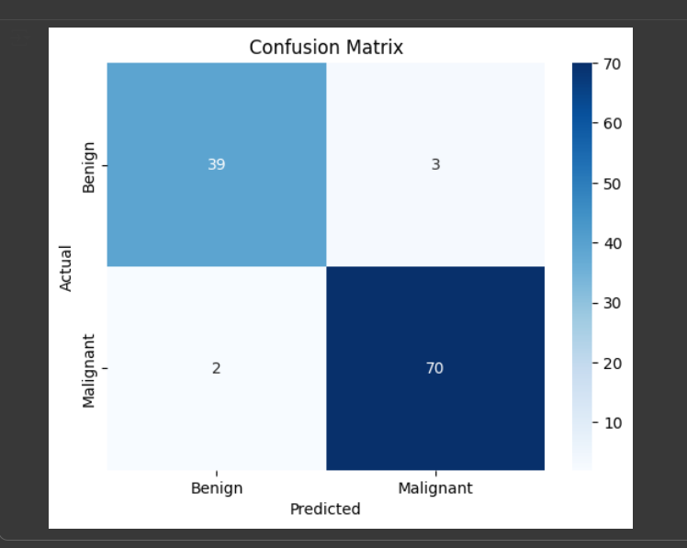

* Feature importance chart

* Output showing accuracy/F1-score

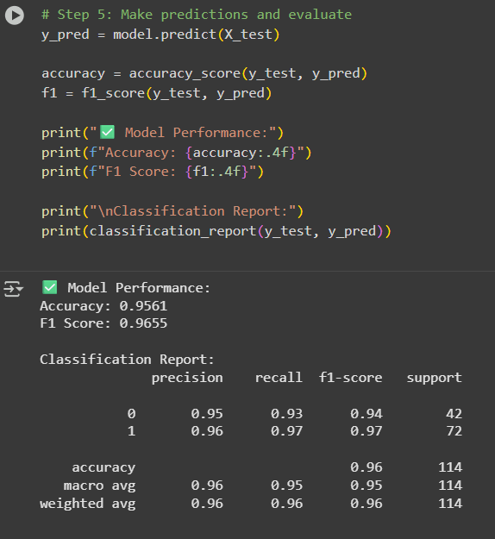

**Part 3: Ethical Reflection**

Predictive models can inherit bias from unbalanced or incomplete datasets — e.g., underrepresentation of certain patient groups or cancer subtypes may lead to inaccurate predictions.  
Tools like **IBM AI Fairness 360** assess and mitigate bias through fairness metrics and algorithms, ensuring equitable outcomes.  
Maintaining transparency, explainability, and human oversight is crucial to ethical AI use in healthcare or software systems.

**Conclusion**

AI in software engineering enhances automation, accuracy, and efficiency — from smart code generation to predictive analytics. However, ethical vigilance and bias control remain essential to ensure trustworthy, fair, and responsible AI solutions.