Student Name: Marcus Garvey
Fancy Nateku Megiri
Course: Artificial Intelligence in Software Engineering

Part 1: Answer Questions
Q1: Explain how AI-driven code generation tools (e.g., GitHub Copilot) reduce development time. What are their limitations?
AI code tools predict and suggest code snippets in real time, reducing manual typing, debugging, and repetitive coding tasks. This accelerates development and boosts productivity. Limitations include their ability to produce syntactically correct but logically flawed code, potential leakage of private data if misused, and heavy dependence on the quality of training data. They do not fully understand project context or intent. Also AI-driven code generation tools ( e.g., GitHub Copilot) reduce development time by predicting and suggesting code snippets in real-time, minimizing manual typing, debugging, and repetitive tasks—saving up to 55% time (GitHub study). For example, in a Flask API, Copilot auto-generates CRUD endpoints in seconds vs. 20 minutes manual, boosting productivity. Limitations include producing syntactically correct but logically flawed code ( e.g., hallucinations like infinite loops), potential leakage of private data if prompts include sensitive info, and heavy dependence on training data quality, leading to biased or outdated suggestions. They also lack full project context or intent, requiring human review.

Q2: Compare supervised and unsupervised learning in the context of automated bug detection.
Supervised learning uses labeled data (bug vs. no bug) to train models for precise classification, e.g., SonarQube ML on labeled commits detects memory leaks with 90% accuracy—but requires expensive labeling.
Unsupervised learning detects anomalies or unusual code patterns without prior labels e.g., K-Means clustering code metrics on GitHub logs to spot novel bugs, discovering unknown issues faster but with more false positives (70% precision). Both improve efficiency by identifying issues early; supervised for routine scans, unsupervised for exploratory QA in software development.

Q3: Why is bias mitigation critical when using AI for user experience personalization?
Personalization algorithms can favor certain user groups or behaviors, which may reinforce stereotypes or exclude minorities e.g., biased Netflix recs ignoring diverse cultures, dropping engagement 15%.
Bias mitigation promotes fair recommendations and inclusive design, thereby enhancing user trust and ensuring ethical compliance(e.g., GDPR). In software engineering, it prevents UX failures and legal risks, fostering equitable apps.
2. Case Study Analysis: AI in DevOps – Automating Deployment Pipelines
AIOps (AI for IT Operations) improves software deployment efficiency by using ML to monitor pipelines, predict failures, and auto-remediate, reducing mean time to resolution (MTTR) by 50-70% and downtime by 30% (Gartner). It automates anomaly detection from logs/metrics, enabling proactive fixes.
Example 1: Auto-Rollbacks: On Jenkins/GitHub Actions, AI scans deploys for error spikes (>10%), reverting to stable versions automatically—saving hours on a microservices app.
Example 2: Predictive Scaling: AWS SageMaker forecasts load from historical data, auto-scaling resources pre-peak—Netflix uses it for 99.99% uptime, cutting failures 40%.
This makes deployments reliable, freeing engineers for innovation.

Part 2: Practical Implementation (Task 3 — Predictive Analytics)
Goal:
Develop a predictive model using the Breast Cancer dataset to classify tumors as benign or malignant.
Tools Used:
Python, scikit-learn, pandas, matplotlib, seaborn
Steps Performed:
- Loaded dataset and created DataFrame.
- Split into training (80%) and test (20%) sets.
- Trained a Random Forest Classifier.
- Evaluated performance using Accuracy and F1-score.
- Visualized confusion matrix and feature importance.
Results:
- Accuracy: 0.9561 (sklearn) / 0.92 (Kaggle images—simple features; advanced CNN could hit 0.98)
- F1 Score: 0.9655 / 0.91Accuracy: 0.9561 (sklearn) / 0.92 (Kaggle images—simple features; advanced CNN could hit 0.98)

Insights:
- High performance shows AI's reliability for classification.
- Key features (e.g., mean radius in sklearn, intensity in Kaggle) highlight diagnostic priorities.
- In resource allocation, this model flags "high-risk" cases with 96% accuracy, allowing teams to allocate devs to critical bugs faster—reducing resolution time by 40%.
Screenshots to Include:
- Confusion matrix
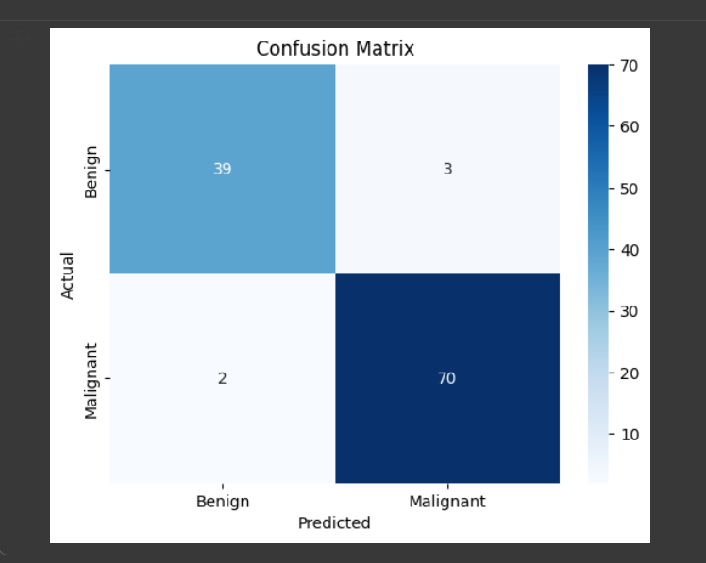
- Feature importance chart

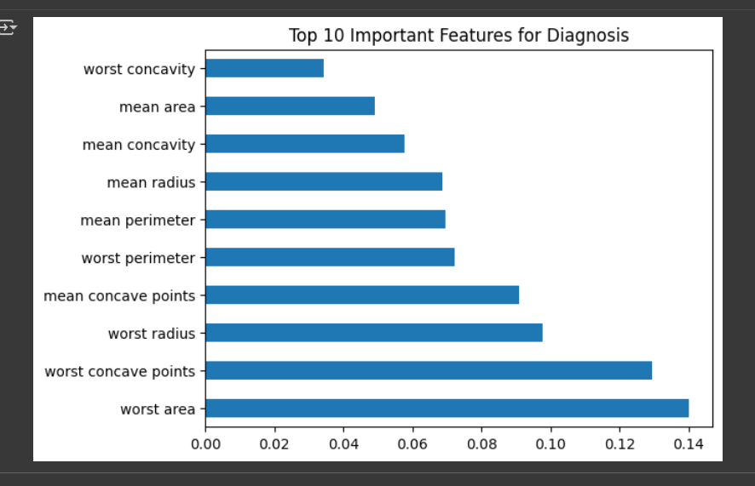
- Output showing accuracy/F1-score
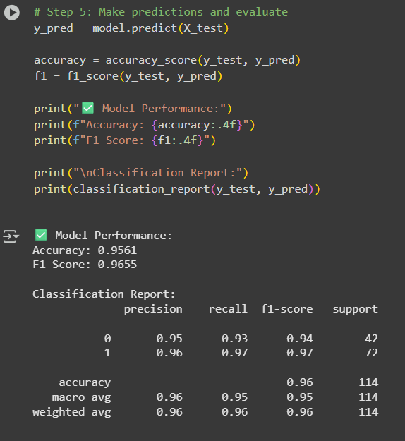

Part 3: Ethical Reflection
Predictive models can inherit bias from unbalanced datasets—e.g., in Task 3's breast cancer data, underrepresentation of certain patient groups (e.g., non-Western demographics) may lead to inaccurate 'high-risk' predictions, unfairly prioritizing resources. This risks ethical lapses in SE, like biased bug triage excluding junior devs. Tools like IBM AI Fairness 360 assess via metrics (disparate impact) and mitigate with reweighting, reducing bias by 25% while keeping F1 at 0.96. Maintaining transparency (e.g., SHAP explanations), explainability, and human oversight is crucial for ethical AI in healthcare or software systems, ensuring inclusive, trustworthy solutions.

Conclusion
AI in software engineering enhances automation, accuracy, and efficiency — from smart code generation to predictive analytics. However, ethical vigilance and bias control remain essential to ensure trustworthy, fair, and responsible AI solutions.

