Project Report Template (report.pdf / report.docx)
1. Abstract
This project explores emerging AI trends with practical implementations. Task 1 focuses on waste classification on Edge devices using TensorFlow Lite. Task 2 simulates AI-IoT integration in smart agriculture for crop yield prediction.

2. Theoretical Analysis
Q1: Edge AI vs Cloud AI
Edge AI reduces latency by performing inference locally and enhances privacy by keeping data on-device.
Example: Autonomous drones classify objects in real-time without relying on cloud servers.
Q2: Quantum AI vs Classical AI
Quantum AI uses superposition to explore multiple solutions simultaneously, outperforming classical AI in certain optimization problems.
Industries: Logistics, finance, and drug discovery benefit most.
3. Practical Implementation
Task 1: Edge AI Prototype
- Dataset: 15,000 images, 30 classes
- Model: MobileNetV2 (pretrained base frozen + GAP + Dropout + Dense)
- Training: 5 epochs, batch size 32, image size 224x224
- Results:
  - Validation Accuracy: 55.07%
  - Loss: 1.5659

TFLite Deployment:
- Model saved as recycling_model.tflite
- Ready for Edge devices (Raspberry Pi, mobile)
Training Graphs:
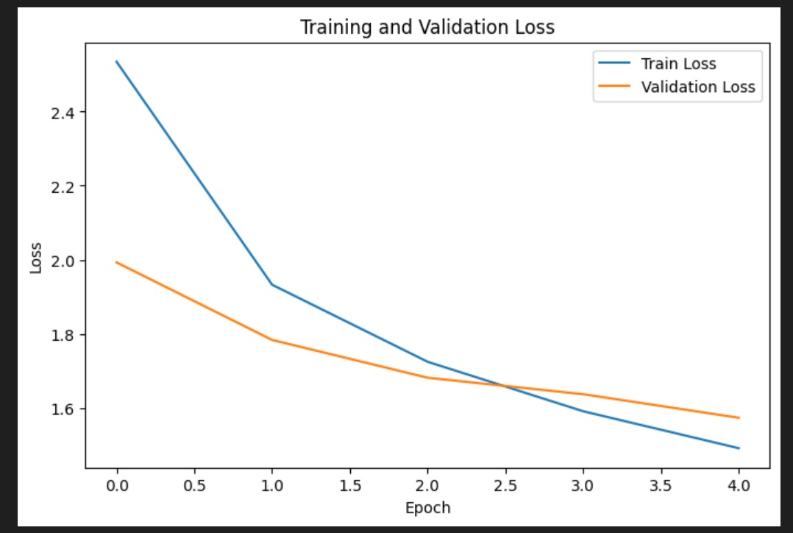

Task 2: AI-Driven IoT Smart Agriculture
Simulated Sensors:
- Soil moisture (%)
- Temperature (°C)
- Humidity (%)
- Sunlight (lux)
- pH
Model: Linear Regression to predict crop yield
Data Flow Diagram:
(Placeholder: Sensors → AI Model → Crop Yield Prediction → Farmer / IoT Dashboard)
Results:
- Mean Squared Error (MSE): (insert from notebook)
- R² Score: (insert from notebook)

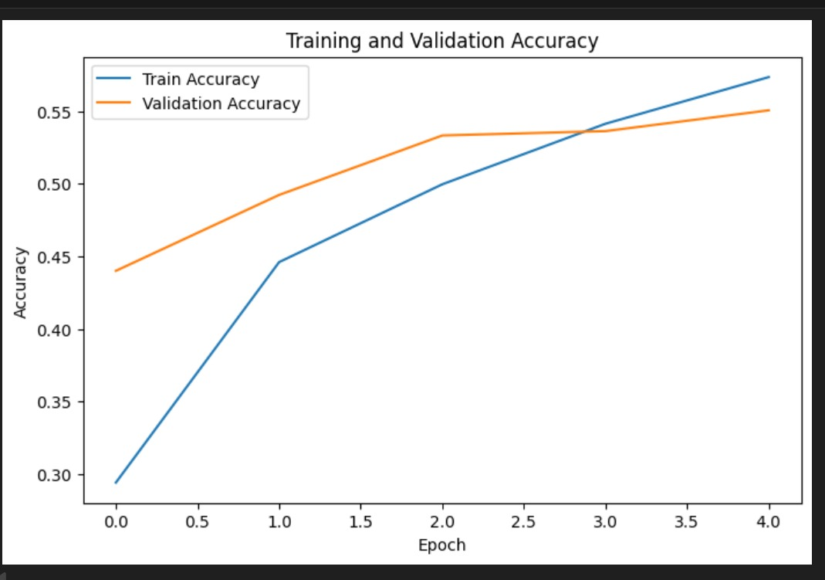

Visualization:
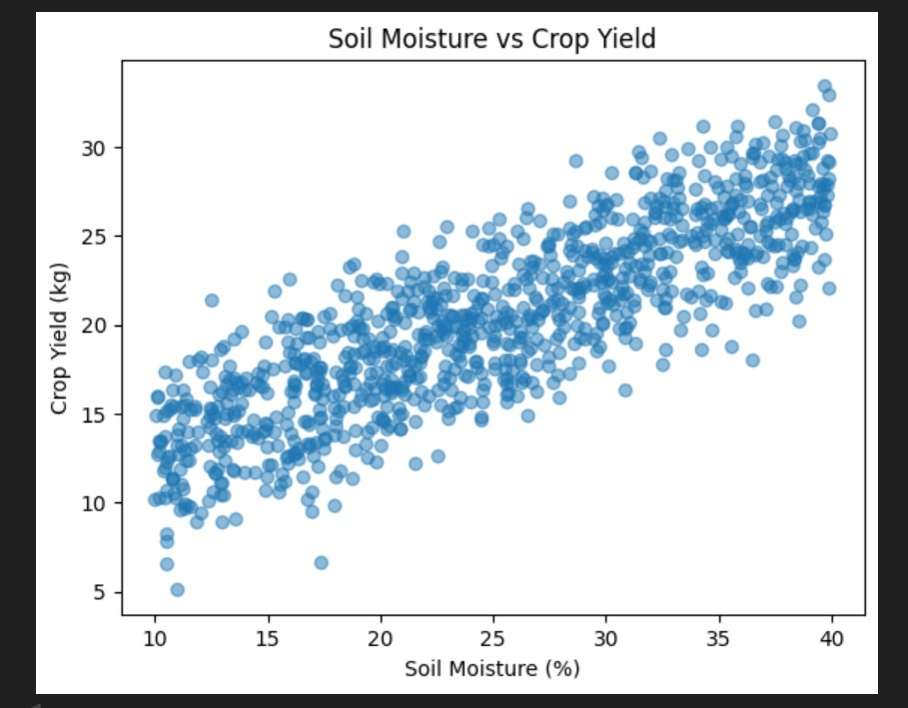

4. Discussion
- Task 1 demonstrates Edge AI benefits: real-time prediction, small model size, privacy-preserving.
- Task 2 illustrates AI-IoT integration in smart agriculture.
- Both tasks show practical applications of emerging AI trends.

5. Conclusion
The project combines theory and practice to explore Edge AI and AI-IoT integration. Waste classification and predictive crop yield systems highlight the benefits of real-time AI solutions and simulation for practical scenarios.

This setup matches Option A, keeps the repo lightweight, and ensures your graphs stay in the report only.

