Project Title:
Designing Responsible and Fair AI Systems: COMPAS Fairness Audit
Course / Assignment:
AI Ethics – PLP Academy
Submitted By:
Marcus-Garvey Kinyenye and Fancy Nateku
Date:
November 20th, 2025

Designing Responsible and Fair AI Systems – COMPAS Fairness Audit
Title: Designing Responsible and Fair AI Systems – COMPAS Fairness Audit
Abstract:
This project audits racial bias in the COMPAS recidivism dataset using IBM’s AI Fairness 360 toolkit. The analysis includes detecting bias in predictions, applying bias mitigation via the Reweighing algorithm, and evaluating fairness metrics before and after mitigation.

Part 1: Theoretical Understanding
Q1: Algorithmic Bias
Algorithmic bias occurs when AI systems produce systematically unfair outcomes for certain groups. Examples:
- COMPAS recidivism scores mispredict higher risk for minority defendants.
- A recruitment AI penalizing female candidates due to biased training data.
Q2: Transparency vs Explainability
- Transparency: The model’s structure and decision logic are open and documented.
- Explainability: The ability to understand why the AI produced a specific prediction.
Both are important for trust and ethical accountability.
Q3: GDPR Impact on AI
GDPR requires data minimization, consent, and the right to explanation for automated decisions. AI developers must ensure data privacy and fairness compliance.
Ethical Principles Matching:
- Justice → Fair distribution of AI benefits and risks
- Non-maleficence → Ensuring AI does not harm individuals
- Autonomy → Respecting user control over data and decisions
- Sustainability → Designing AI to be environmentally friendly

Part 2: Case Study Analysis
Case 1 – Biased Hiring Tool
- Source of bias: historical gender imbalance in training data
- Fixes:
  - Retrain on balanced dataset
  - Remove gender-related features
  - Apply bias mitigation techniques (e.g., reweighing)
- Evaluation Metrics: Disparate Impact, Statistical Parity Difference
Case 2 – Facial Recognition in Policing
- Ethical risks: wrongful arrests, misidentification of minorities, privacy violations
- Policies: Use transparent datasets, independent audits, human-in-the-loop verification

Part 3: Practical Audit
Step 1: COMPAS Prediction Analysis
- Dataset: COMPAS recidivism data
- Model: Logistic regression trained on full dataset
- Graph 1 Placeholder:
- Fairness metrics for COMPAS predictions
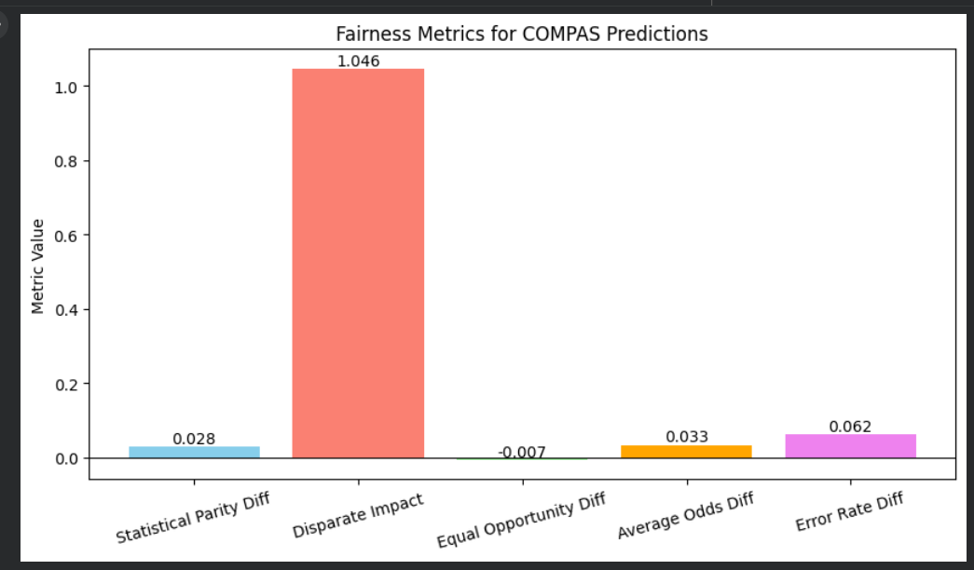
  - This graph shows fairness metrics (Statistical Parity, Equal Opportunity, etc.) before mitigation.
Step 2: Bias Mitigation (Reweighing)
- Applied Reweighing algorithm to reduce bias in dataset
- Graph 2 Placeholder:
Fairness metrics before vs after reweighing
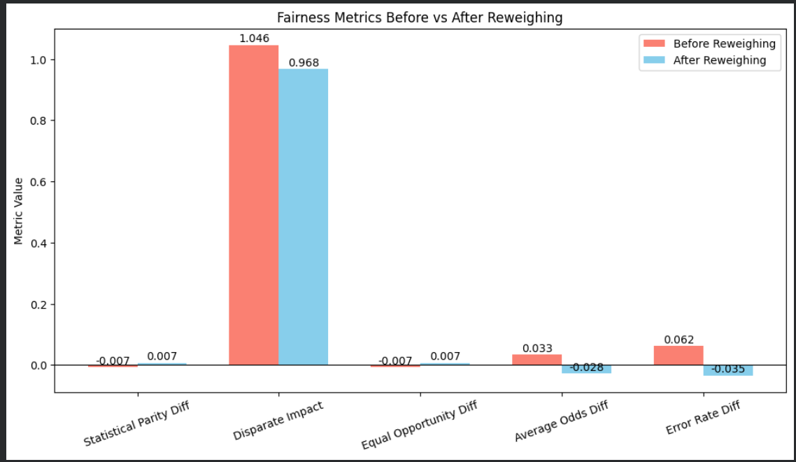
  - Side-by-side bar chart comparing metrics before and after mitigation, demonstrating improvement in fairness.
Observations:
- Certain metrics (Disparate Impact, Equal Opportunity Difference) improved after reweighing.
- Some small residual differences may remain and should be monitored in real deployments.

Part 4: Ethical Reflection
For future projects, I will ensure ethical AI by:
- Auditing datasets for bias before model training
- Applying mitigation techniques like reweighing
- Documenting all fairness assessments
- Making predictions explainable to stakeholders

Bonus Task: Ethical AI in Healthcare
- Obtain informed patient consent before data collection
- Mitigate bias across demographic groups
- Maintain transparency and explainability in AI models
- Keep detailed audit logs for predictions

