🌤️ Weather Now - React Weather App

**Weather Now** is a modern, responsive, and visually engaging weather application built using **React.js**. It provides real-time weather data using the **Open-Meteo API** and showcases custom animations for different weather conditions (sunny, cloudy, and rainy). This project was created as part of a UI challenge and demonstrates skills in **React**, **conditional rendering**, **API integration**, and **CSS animations**.

---

## 🚀 Live Demo

🔗 **stackblitz(https://stackblitz.com/edit/vitejs-vite-drbwb7st?file=src%2FWeatherCard.jsx)**

## 📸 Screenshots

| Sunny | Cloudy | Rainy |

|:--:|:--:|:--:|

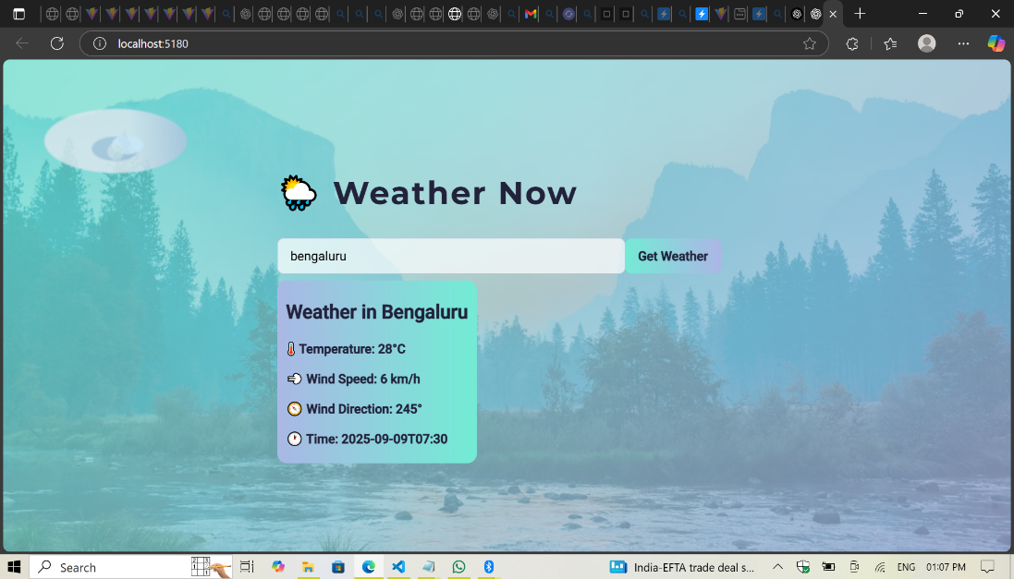

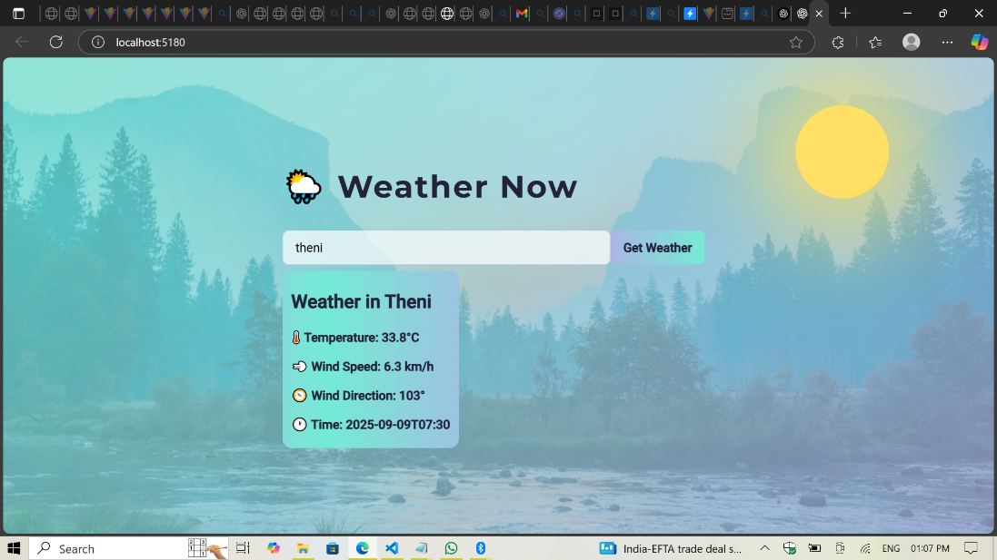

## 🧠 Project Highlights

### ✅ Key Features

- 🔍 **Search for City Weather**: Get real-time weather for any city using the Open-Meteo API.

- 🌈 **Weather Animations**: Unique, animated SVG and CSS backgrounds for:

- ☀️ Sunny

- ☁️ Cloudy

- 🌧️ Rainy

- 🧠 **Smart Condition Detection**: Dynamically determines weather condition based on description & temperature.

- ⚡ **Responsive UI**: Fully mobile-friendly interface using Flexbox and media queries.

---

## 💻 Tech Stack

| Category | Tools / Libraries |

|----------------|-------------------------------------------|

| **Frontend** | React.js, JSX |

| **Styling** | CSS3, SVG Animations |

| **Weather API**| [Open-Meteo API](https://open-meteo.com/) |

| **Deployment** | Netlify / Vercel / GitHub Pages |

---

## 🗂️ Folder Structure

weather-now/

├── public/

│ └── index.html

├── src/

│ ├── components/

│ │ ├── WeatherCard.jsx

│ │ ├── WeatherBackground.jsx

│ ├── styles/

│ │ ├── back.css

│ │ └── ani.css

│ ├── App.js

│ └── index.js

├── README.md

└── package.json

yaml

Copy code

---

## 🧩 Component Breakdown

### 1. `WeatherCard.jsx`

Displays weather information such as:

- City name

- Temperature

- Wind speed & direction

- Time

It uses `WeatherAnimation` to render condition-specific animations.

---

### 2. `WeatherAnimation.jsx`

Renders custom **SVG and CSS animations** based on current weather condition:

- **☀️ Sunny**: Animated sun using SVG `<circle>`

- **☁️ Cloudy**: Moving clouds and smoke effect

- **🌧️ Rainy**: Dropping animated rain using CSS and `<svg>`

---

### 3. `getCondition(data)`

A smart function to derive the weather condition from:

- `description` string

- `temperature` value

- Ensures fallback logic even if API data is partial or vague

---

## 📦 How to Run Locally

```bash

# 1. Clone the repo

git clone https://github.com/your-username/weather-now.git

cd weather-now

# 2. Install dependencies

npm install

# 3. Start the development server

npm start

The app will run at http://localhost:3000

⚙️ Configuration

Update your API endpoint in your main logic (where you fetch data) using Open-Meteo:

js

Copy code

https://api.open-meteo.com/v1/forecast?latitude=xx&longitude=xx&current_weather=true

You can also integrate geolocation or a city-to-lat/long converter like OpenCage.

✨ What I Learned

✅ Handling real-time API integration in React

✅ Smart condition-based rendering logic

✅ Building reusable React components

✅ Creating SVG + CSS animations for UI interactivity

✅ Responsive layout using Flexbox

📚 Future Improvements

🌍 Add geolocation support (auto-detect user's location)

💬 Add weather descriptions and forecasts

🎨 Add dark/light mode toggle

📱 Add PWA support (installable weather app)

👨‍💻 About Me

I’m a passionate frontend developer with strong interest in building interactive UI experiences. This project is part of my learning journey and demonstrates my skills in:

React.js

Web API integration

Frontend animations

UI/UX design principles

📫 Reach me on LinkedIn-https://www.linkedin.com/in/geeta-sree-0290052a7

-