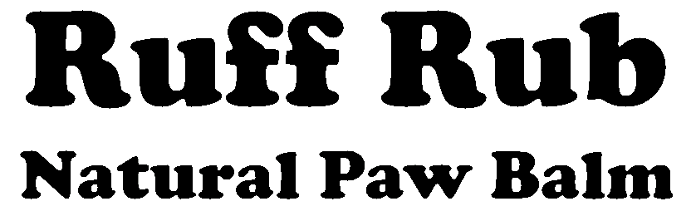

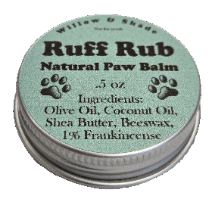 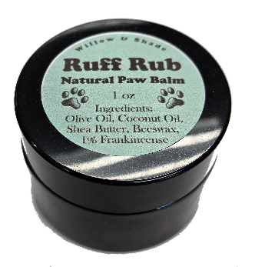

**All-Natural Relief for Dogs’ Paws, Noses & Skin**

**📦 Product Pricing**

| **Product** | **Your Cost (Wholesale)** | **Suggested Retail (MSRP)** | **Your Profit / Unit** |
| --- | --- | --- | --- |
| **0.5oz Tin** | $2.00 | $5.99 | ~$3.99 |
| **1oz Jar** | $3.00 | $8.99 | ~$5.99 |

**💡 Why Carry Ruff Rub?**

* ✅ Zero upfront risk – you only pay for what sells
* ✅ Premium quality – Olive Oil, Shea Butter, Coconut Oil, Beeswax & Frankincense
* ✅ Healthy margins – double your money on every sale
* ✅ Attractive displays – we supply and restock for you
* ✅ Customer demand – natural, safe, pet-parent approved

**📊 Example Profit for Your Shop**

* Sell 10 × 0.5oz tins → $59.90 retail revenue → $39.90 profit
* Sell 10 × 1oz jars → $89.90 retail revenue → $59.90 profit
* **Total: $99.80 profit from just 20 units**

**🔑 Key Program Details**

* We provide FREE display cases stocked with Ruff Rub.
* We stop in regularly to restock & tidy the display.
* Any missing product is considered sold (simple, no tracking needed).
* You set your prices (we recommend MSRP above).

📞 Contact: Matt Hoover  
📧 hoover.matthew0@gmail.com | 📱 717-873-7779  
🌐 willowandshade.com