5COSC020W - Database Systems Coursework

By Mehmet Gilgil

ID: W2046446

Tutorial Group: Sooriya-Arachchi, Chathura Tuesday 11:00 am to 1:00 pm

Contents

Part A: 3

Question 1: 4

Question 2: 5

Question 3: 5

Question 4: 6

Question 5: 9

Question 6: 12

Part B: 13

Question 7: 14

# Part A:

## Question 1:

The diagram produced by ChatGPT is far worse than subpar and quite frankly is entirely inaccurate. In this short essay, I will illustrate the inadequacies of said diagram, demonstrating its flaws and justifying changes I would make to create a high quality conceptual EERD.

My first issue with the diagram is certain entities are completely missing. One example would be the Equipment entity. It is vital to have an entity about equipment in our database. This is because it is imperative to our client to that “a careful record of all the pieces of equipment assigned to each court needs to be kept” and “that the equipment they offer is always top quality”. To fulfil the client’s needs, my database will include an equipment entity that will store information about its type, the court its assigned to and its maintenance.

A major issue with this diagram is with its complete lack of specialisations. First, using a generalised entity called Staff I could avoid repeating common attributes ID and name for Caretaker and Instructor reducing redundancy. In addition, using a specialisation on sessions, to create subtypes of supervised and unsupervised sessions I could capture relationship between an instructor and a session more accurately. Moreover, using specialisation details such as a group session having “up to two instructors” and one-to-one session having “an instructor” can be captured more accurately.

In the AI generated diagram, the multiplicities are entirely wrong, and they fail to capture the terms of engagement of each entity in any given relationship. For starters, each relationship should have a pair of multiplicities, and each multiplicity should only consist of its participation and cardinality. However, in the AI generated diagram there is only one multiplicity per relationship and there is an extra third digit with no apparent meaning. Furthermore, the participation or cardinality is wrong in some of the multiplicities. For example, the participation of “Includes(1:0..n)” is wrong as for booking to exist it needs to be booked against a session. Therefore, it cannot be 0 and must be 1.

The most glaring issue with this diagram is with its relationships. None of the relationships have a reading direction, making the diagram unclear and hard to follow. Some relationships are missing such as the relationship that indicates that a court is in a park. Certain relationships are completely wrong, missing the features required as described in the project brief. For example, in the project brief it states “Racketminster playing sessions are pre-scheduled to run on specific courts”. This would indicate a relationship between a session and court occurrence. However, this relationship is incorrectly replaced by a relationship between booking and court.

The final issue I would like to talk about is about the attributes in the diagram. The diagram contains foreign keys which are not necessary at the conceptual level. On top of that its notation is once again incorrect. Primary keys should be indicated through curly brackets.

Overall, to circumvent such short comings, in my design I would review the source material as well as look over communications with CEO of Racketminster, Francois, in addition to adhering to general rules and notation of producing a conceptual EERD to create clear and effective diagram.

## Question 2:

|  |  |
| --- | --- |
| Entity name | Brief explanation |
| w2046446_Staff | General term which describes all people who work for Racketminster. |
| w2046446_Park | General term which describes the parks used by Racketminster. |
| w2046446_Court | General term which describes the courts used by Racketminster |
| w2046446_Equipment | General term which describes the equipment assigned to each court. |
| w2046446_Maintenance | General term which describes the maintenance scheduled by court caretakers. |
| w2046446_Session | General term which describes the sessions booked by players to play on a court at Racketminster. |
| w2046446_Booking | General term which describes a booking a player creates when they want to reserve a session. |
| w2046446_Player | General term which describes a player at Racketminster. |

## Question 3:

|  |  |  |
| --- | --- | --- |
| General entity | Specialised entity | Brief explanation |
| w2046446_Staff | w2046446_Instructor | A certain type of staff which supervises sessions. |
| w2046446_Staff | w2046446_Caretaker | A certain type of staff which takes care of parks, courts and equipment. |
| w2046446_Caretaker | w2046446_PCT | A certain type of caretaker which takes care of parks. |
| w2046446_Caretaker | w2046446_CCT | A certain type of caretaker that schedules maintenance on courts and equipment. |
| w2046446_Court | w2046446_PBC | A certain type of court where the sport pickleball is played on. |
| w2046446_Court | w2046446_TC | A certain type of court where the sport tennis is played on. |
| w2046446_Session | w2046446_Supervised | A certain type of session where an instructor is present to supervise activities. |
| w2046446_Session | w2046446_Unsupervised | A certain type of session where no instructors are present. |
| w2046446_Supervised | w2046446_One-to-one | A certain type of supervised session where there is one instructor and player. |
| w2046446_Supervised | w2046446_Group | A certain type of supervised session where there are multiple players and up to two instructors. |
| w2046446_Group | w2046446_Fitness | A certain type of group session where players exercise. |
| w2046446_Group | w2046446_Coaching | A certain type of group session where players learn how to play. |
| w2046446_Group | w2046446_Social | A certain type of group session where players can socialise. |

## Question 4:

|  |  |  |  |  |  |
| --- | --- | --- | --- | --- | --- |
| Entity name | Multiplicity | Relationship | Multiplicity | Entity name | Brief justifications for the multiplicity (4 statements for each relationship) |
| w2046446_PCT | 0..* | Maintains | 0..* | w2046446_Park | A park may not have any park caretakers. This may be because the park has been cared for recently and doesn’t currently need a caretaker. |
| A park can have many park caretakers. This may be because the park is too large for one caretaker, or one park caretaker covers for another during their off day. |
| A park caretaker may not maintain any park. This may be because they are new and have not been assigned a park to maintain. |
| A park caretaker can maintain many parks. This may be because their skills are needed at many parks. |
| w2046446_Park | 1..1 | Contains | 0..* | w2046446_Court | A court must be contained in one park. This is because all Racketminster courts are in a park. |
| A court must only be contained in one park. This is because a court is a physical location and can only exist in one park. |
| A park may not contain any courts. This is because it may be a general Ovestminster park without any courts. |
| A park can have many courts. This is because Racketminster may build multiple courts to meet demand. |
| w2046446_CCT | 1..1 | Schedules | 0..* | w2046446_  Maintenance | An instance of maintenance must be scheduled by one court caretaker. This is because the instance of maintenance is created by the court caretaker. |
| An instance of maintenance must only be scheduled by one court caretaker. |
| A court caretaker may not have scheduled any maintenance. This may be because he has just started or is on vacation. |
| A court caretaker may schedule may instances of maintenance. This may be because their area of expertise are required for many courts or equipment. |
| w2046446_Maintenance | 0..* | Scheduled on | 1..1 | w2046446_  Equipment | A piece of equipment may not have any maintenance scheduled against it. This may be because it is brand new and doesn’t require it. |
| A piece of equipment can have many maintenances scheduled against it. This may be because it requires lots of care. |
| An instance of maintenance must be scheduled on one piece of equipment. This because the maintenance was scheduled for that piece of equipment. |
| An instance of maintenance must only be scheduled on one piece of equipment. This is because that maintenance was scheduled for the piece of equipment specifically. |
| w2046446_ Maintenance | 0..* | Scheduled on | 1..1 | w2046446_  Court | A court may not have any maintenance scheduled against it. This may be because it is brand new and doesn’t require it. |
| A court can have many maintenances scheduled against it. This may be because it requires lots of care. |
| An instance of maintenance must be scheduled on one court. This because the maintenance was scheduled for that court. |
| An instance of maintenance must only be scheduled on one court. This is because that maintenance was scheduled for the court specifically. |
| w2046446_Equipment | 0..* | Assigned to | 1..1 | w2046446_Court | A court can may not be assigned any equipment. This may be because the court is closed, or the court is new and hasn’t been assigned any. |
| A court may have many pieces equipment assigned to it. This is because the sports require multiple different pieces of equipment to be played. |
| A piece of equipment must be assigned to a court. |
| A piece of equipment can only be assigned to one court. |
| w2046446_Session | 0..* | Takes place on | 1..1 | w2046446_Court | A court may not have any sessions take place on it. This may be because the weather conditions were poor, and no one wanted to play. |
| A court may have many sessions take place on it. This may be because the court can be used multiple times a day at different times. |
| A session must take place on a court. |
| A session can only take place on one court. |
| w2046446_Booking | 0..* | Reserves | 1..* | w2046446_Session | A session may not have any bookings against it. This may be because the session is not on sale yet. |
| A session may have many bookings against it. This may be because many players booked the same group session. |
| A booking must reserve a session. This is because without a session the booking won’t exist. |
| A booking may reserve many sessions. This may be because it is a block booking. |
| w2046446_Player | 1..* | Creates | 0..* | w2046446_Booking | A booking must be created by at least one player. This is because a booking can only exist if a player creates it. |
| A booking can be created by many players. This is because many players may want to play together. |
| A player may not create any bookings. This may be because the player does not want to play anymore or has taken a break from sports due to injury. |
| A player may create multiple bookings. This is included as we want to be able allow players to make repeat purchases. |
| w2046446_Player | 0..1 | Recommends | 0..* | w2046446_Player | A player may not be recommended by another player. This may be because they discovered Racketminster on their own. |
| A player can at most be recommended by one player. Otherwise, people may abuse the discount policy. |
| A player may not recommend any players. This may be because they want to gatekeep or are lonely. |
| A player can recommend many players. This is because we want as many people as possible to playing at Racketminster. |
| w2046446_Instructor | 1..1 | Supervises | 0..* | w2046446_One-to-one | A one-to-one session must be supervised by an instructor. |
| A one-to-one session can at most be supervised by one instructor. |
| An instructor may not supervise any one-to-one sessions. This may be because they are busy supervising other sessions or are on vacation. |
| An instructor may supervise many one-to-one sessions. |
| w2046446_Instructor | 1..2 | Supervises | 0..* | w2046446_Group | A group session must be supervised by at least one instructor. This is because it is a subtype of supervised session. |
| A group session can at most be supervised by two instructors as these are the rules at Racketminster. |
| An instructor may not supervise any group sessions. This may be because they are busy supervising other sessions or are on vacation. |
| An instructor may supervise many group sessions. |
| w2046446_Unsupervised | 0..1 | Follows on | 0..1 | w2046446_Unsupervised | An unsupervised session may not have any unsupervised session follow on from it. This may be because it is the last session of the day or because it is not part of block booking and the session after is empty. |
| An unsupervised session can at most one session follow on from it. |
| An unsupervised session may not follow on from any unsupervised session. This may be because it is the first session of the day. |
| An unsupervised session can at most follow on from one session. |

## Question 5:

|  |  |  |
| --- | --- | --- |
| Entity name | Attributes for each entity (include PK) | Brief explanation |
| w2046446_Staff | w2046446_staffId{PK}  w2046446_staffName  w2046446_staffNum  w2046446_staffEmail  w2046446_vacation  w2046446_hireDate | Uniquely identifies a staff member  Name of staff member  Telephone number of staff member  Email of staff member  When a member of staff is on vacation  When a member of staff was hired |
| w2046446_Instructor | w2046446_supevisesOn  w2046446_skills | Has inherited attributes from staff  Which session an instructor supervises  The skills which the instructor posses |
| w2046446_Caretaker |  | No specific attributes apart from inherited attributes from staff |
| w2046446_CCT | w2046446_scheduledM | Has inherited attributes from caretaker  When the next scheduled maintenance is |
| w2046446_PCT | w2046446_parkLookedAfter | Has inherited attributes from caretaker  What parks the caretaker is looking after |
| w2046446_Maintenance | w2046446_maintenanceId{PK}  w2046446_maintenanceDate  w2046446_maintenanceTime  w2046446_maintenanceStatus  w2046446_maintenanceLog  w2046446_maintenanceBy | Uniquely identifies of instance of maintenance  Date of which maintenance is scheduled for  Time of which maintenance is scheduled for  Status of maintenance that has been scheduled  Log of maintenances  Who scheduled the maintenance |
| w2046446_Equipment | w2046446_equipmentId{PK}  w2046446_equipmentType  w2046446_equipmentName  w2046446_courtAssignedTo  w2046446_equipmentLastM  w2046446_lastUsed | Uniquely identifies equipment  The type of equipment  Name of the equipment  The court the equipment is assigned to  Last time the equipment was maintained  When it was last used |
| w2046446_Court | w2046446_courtId{PK}  w2046446_parkBelongTo  w2046446_courtCapacity  w2046446_courtLastM  w2046446_equipmentList | Uniquely identifies court  Show which park the court is located at  Shows court capacity  When the court was last maintained  List of all pieces of equipment assigned to the court |
| w2046446_Park | w2046446_parkId{PK}  w2046446_parkName  w2046446_courtNum  w2046446_parkCapacity | Uniquely identifies the park  The parks name  The number of courts it has  The amount of people that can be at the park at once |
| w2046446_PBC |  | No specific attributes apart from inherited attributes from court |
| w2046446_TC |  | No specific attributes apart from inherited attributes from court |
| w2046446_Session | w2046446_sessionId{PK}  w2046446_sessionStartDateTime  w2046446_sessionEndDateTime  w2046446_playerCount  w2046446_sessionCourt  w2046446_sessionStatus | Uniquely identifies session  The date and time when the session starts  The date and time when the session ends  Number of players  Which court the session takes place on  Status of the session |
| w2046446_Unsupervised | w2046446_blockBooked | Has inherited attributes from session  Whether there is a block booking |
| w2046446_Supervised | w2046446_instructorName  w2046446_numOfInstructor | Has inherited attributes from session  Name of instructor supervising the session  Number of instructors supervising a session |
| w2046446_One-to-one |  | No specific attributes apart from inherited attributes from supervised session |
| w2046446_Group |  | No specific attributes apart from inherited attributes from supervised session |
| w2046446_Fitness |  | No specific attributes apart from inherited attributes from group session |
| w2046446_Coaching |  | No specific attributes apart from inherited attributes from group session |
| w2046446_Social |  | No specific attributes apart from inherited attributes from group session |
| w2046446_Booking | w2046446_bookingId{PK}  w2046446_playerOnBooking  w2046446_paymentMethod  w2046446_bookingStatus  w2046446_discount  w2046446_sport  w2046446_bookedSessionStatus | Uniquely identifies a booking  Which players are on a booking  What payment method will be used  Status of the booking  Is there a discount on the booking  What sport will be played  Status of the session that was booked |
| w2046446_Player | w2046446_playerId{PK}  w2046446_playerName  w2046446_playerEmail  w2046446_playerNum  w2046446_recommends  w2046446_recommendBy  w2046446_membershipStatus | Uniquely identifies a player  Player’s name  Player’s email  Player’s telephone number  Players that have been recommended  Who was this player recommended by  Status of membership for player |

## Question 6:

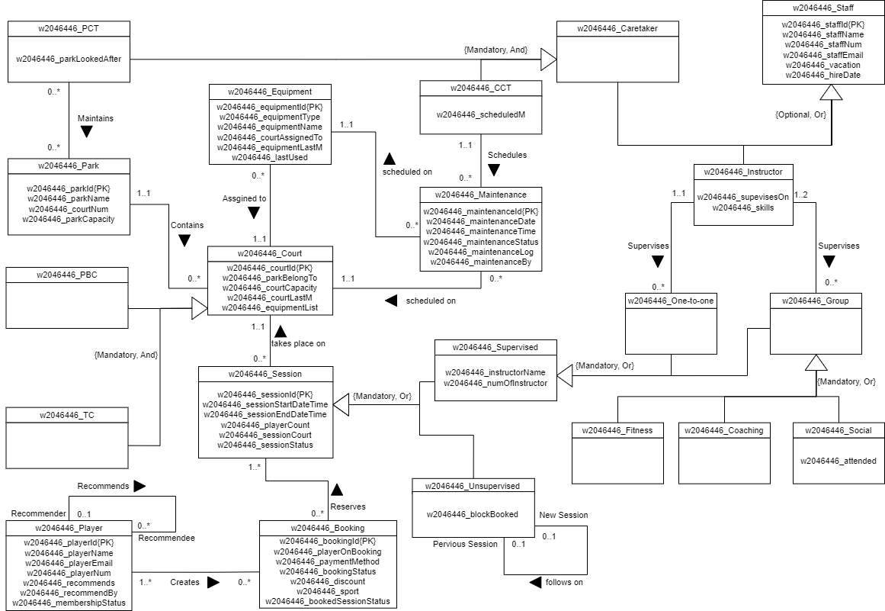

# Part B:

## Question 7:

