# CS 340 README Template

## About the Project/Project Title

The purpose of this project was to create a CRUD module in Python that would connect to the MongoDB and enable the user to search through the data to find animals based off of breed, sex, age, and type of training the animal is best for.

## Motivation for using MongoDb with Dash

The motivation for this project was to help me understand the basics of making and managing databases with MongoDB while using Python to help make the CRUD commands that would work within MongoDb. We also used Dash as the tool for building the dashboard because of its dynamic nature.

## Getting Started

After installing MongoDB on your computer, run the command shell and access mongo. Use the admin database to create an admin account for yourself with a username and password, then make a user account for the AAC database that is allowed to read and write only. Then in Python, create a class AnimalShelter that initializes the usage of the database through Mongo with the read and write user account that you just made. In the create function, include an argument for data and use the “insert” method to add data to the document in the database. In the read function, include an argument for key values and insert them with the “find” method.

## Installation

The applications that were used for the development of this project was Jupyter Notebooks with Python, which both can be found and downloadable on the internet.

## Usage

The main functions of this application is to allow the user to use the RadioButtons to sort through the data based off the breed, age, sex and rescue types of the animals. It will also show the user what percentage of the breeds are in the data frame the user is looking at. The last thing it does is show the user on a map where the animal is located.

### Code Example

Create(self,data)

-inserts the document with a specified key value.

Read(self,data)

-Searches the database for any documents that have the specified key value pair that you are looking for, if none are found returns no results.

Update(self,data,newData,count)

-Searches the database for the “data” in order to replace it with the “newData”

Delete(self,data,count)

-Searches the database for the document that equals the value pair and deletes it.

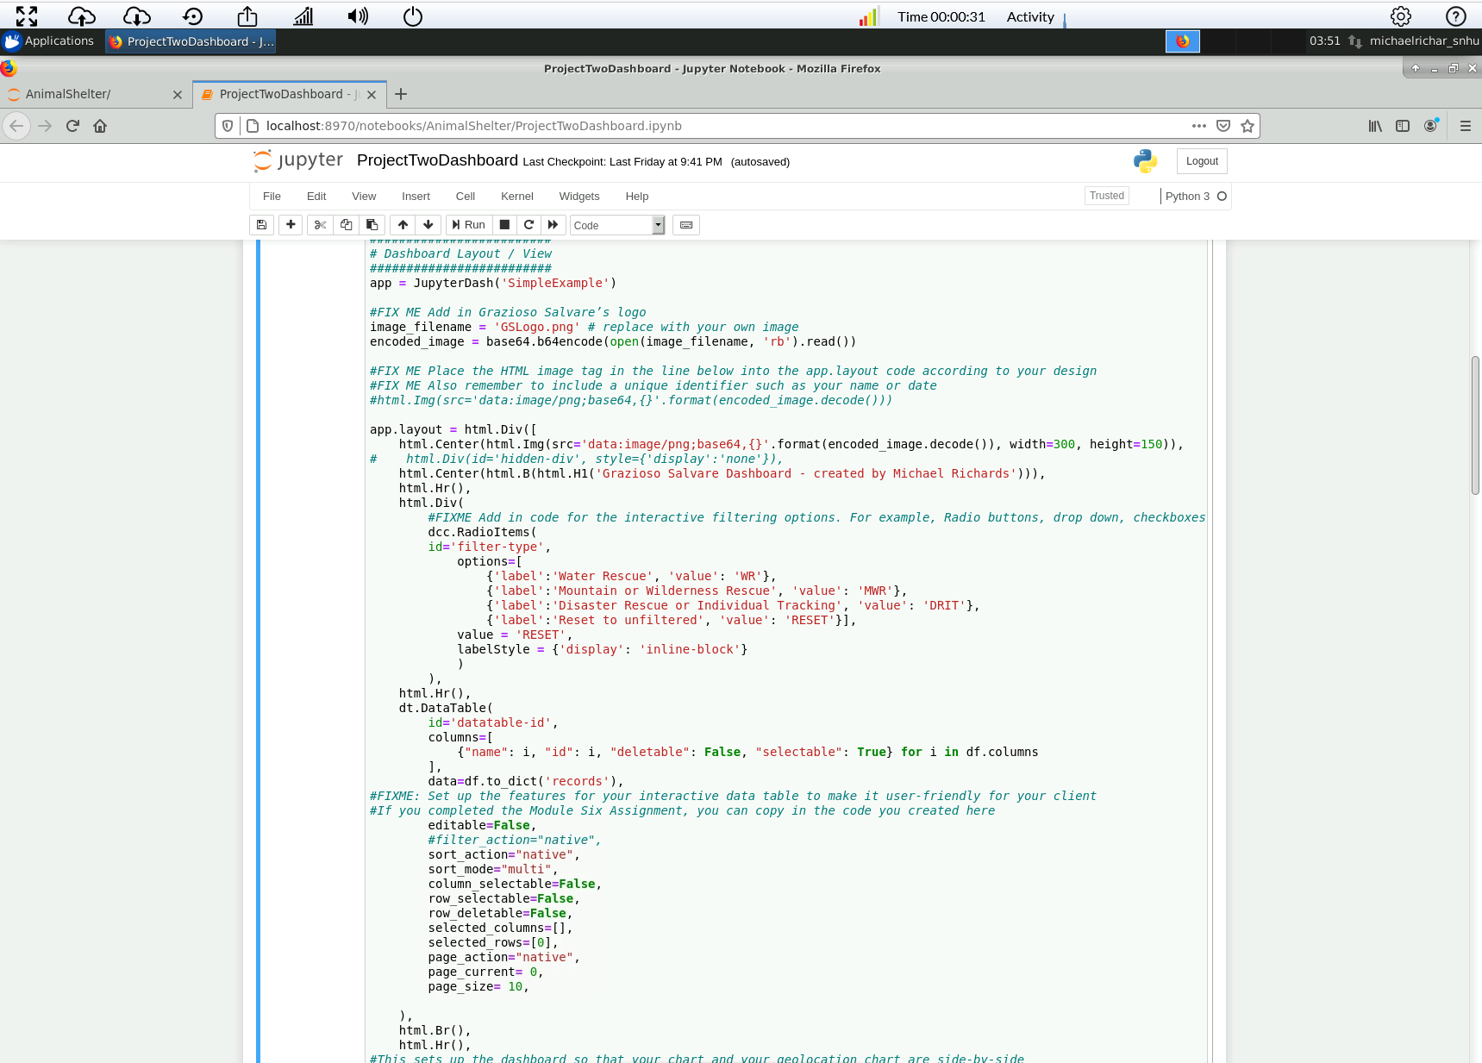

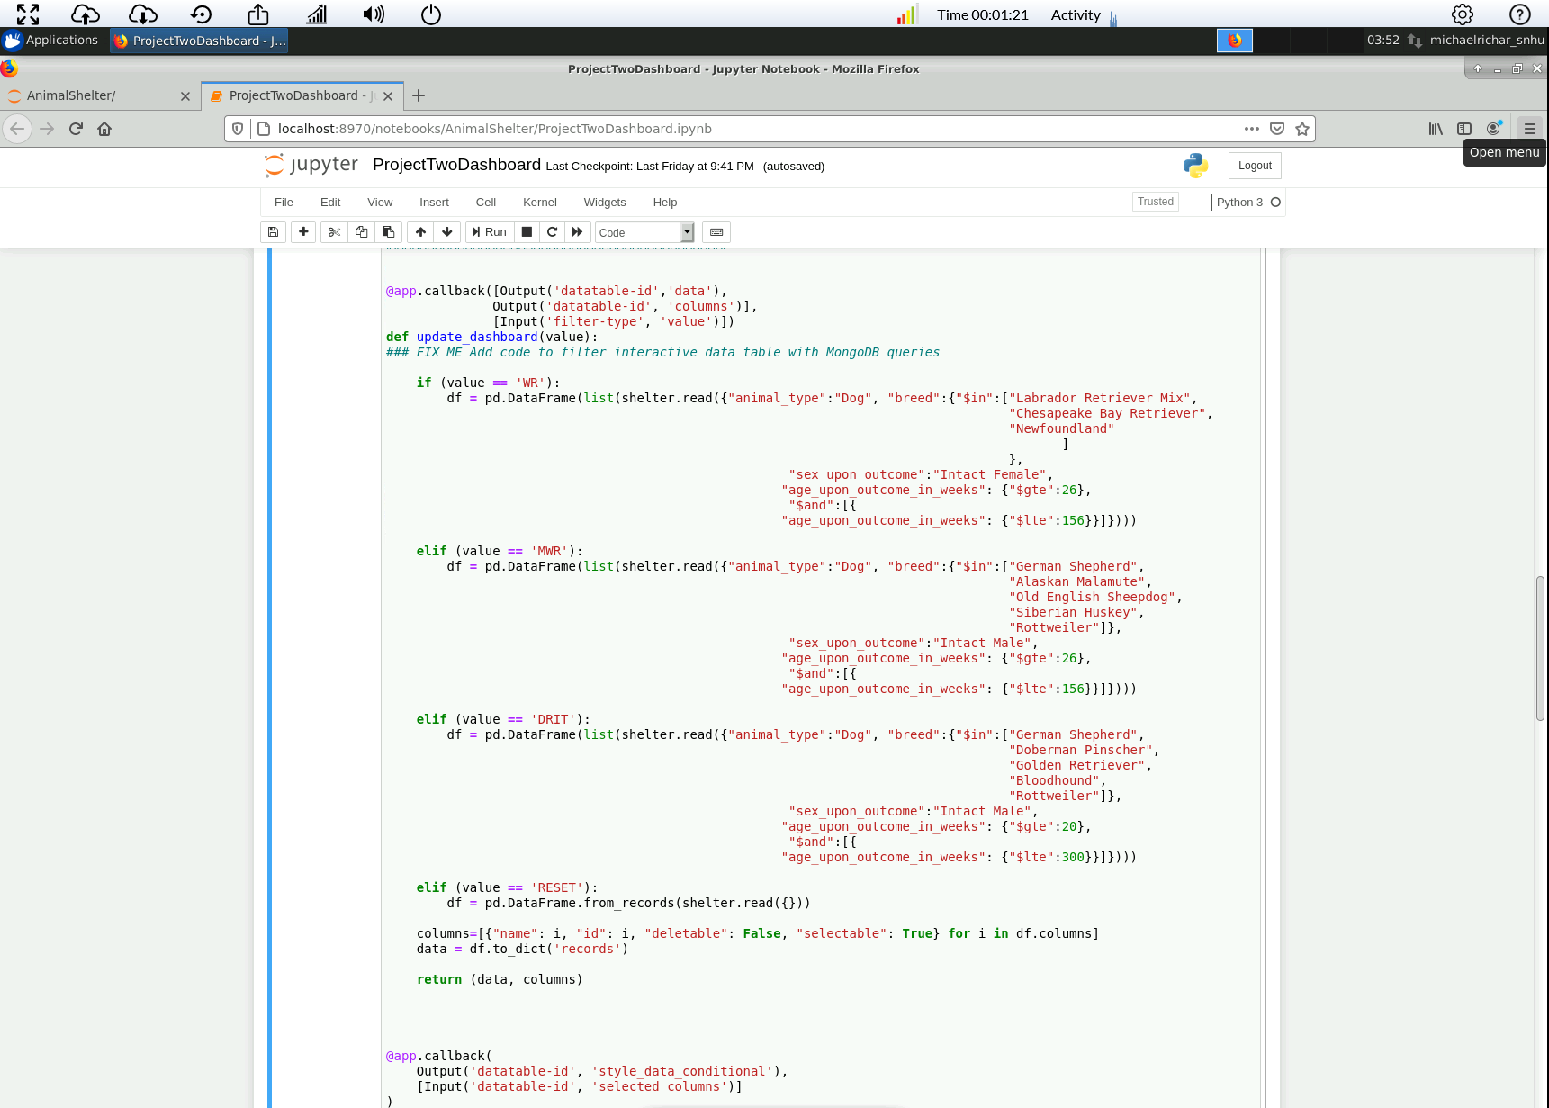

### Tests

The test code should create an object of the AnimalShelter class, initializing it with the user authentication previously made. Using the Create function, create a new document by inserting key value pairs into the document. Then using the Read function, use a key value pair to locate the document that was just created and read said document. Using the Update function, use a key value pair to locate your document that you have created and change something in it for the updated version. Then using the Delete function, use a key value pair to locate and delete your document.

### Screenshots

Import Example:

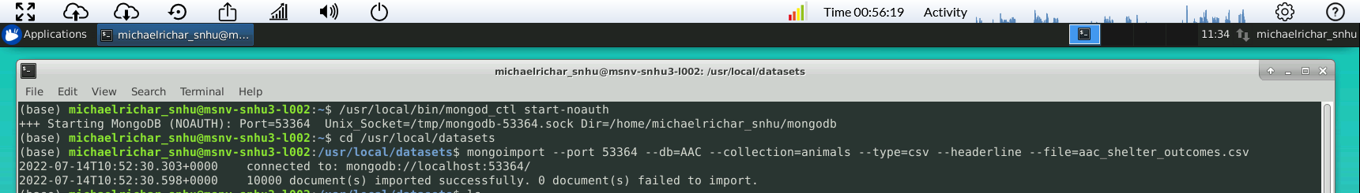

Login for admin and accuser Example:

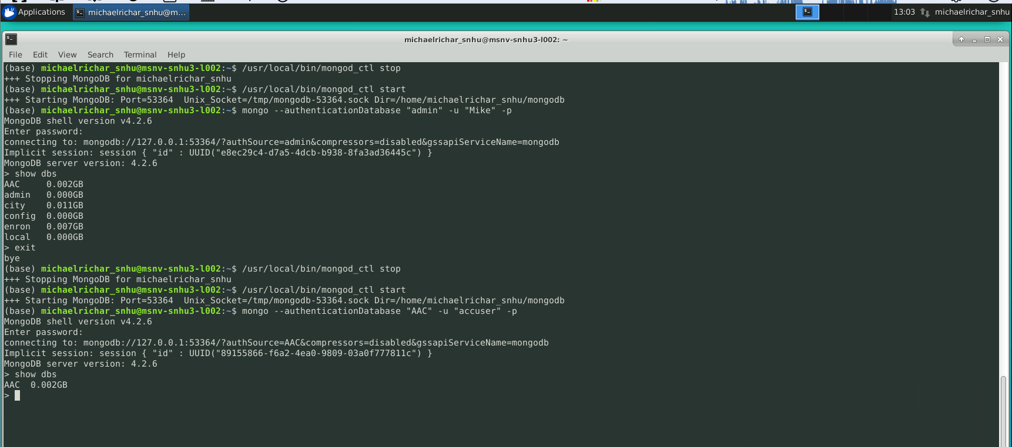

TEST Example:

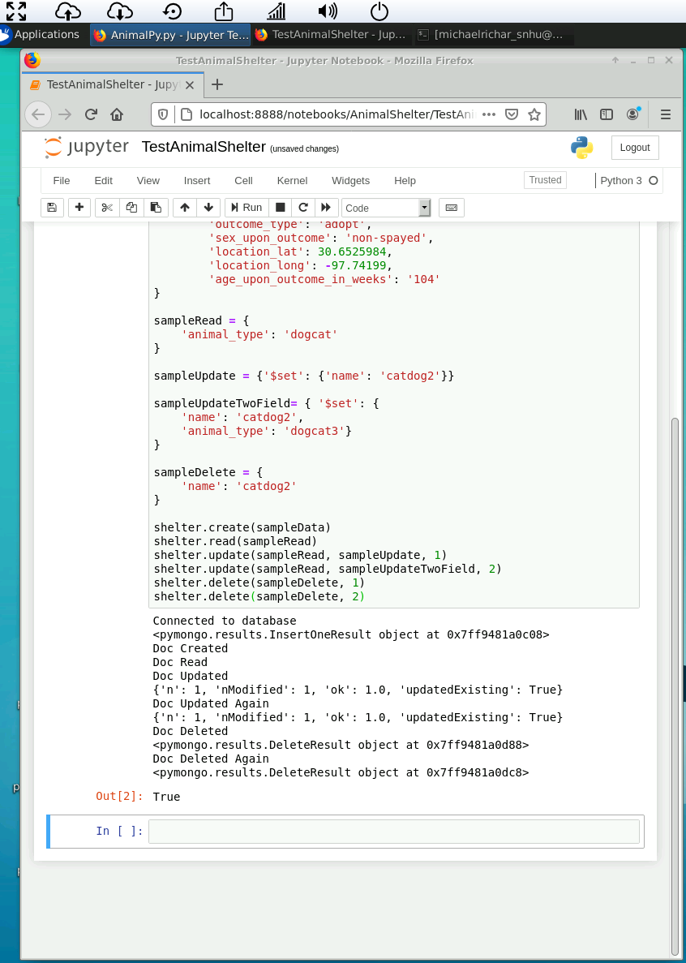

First Load of Data:

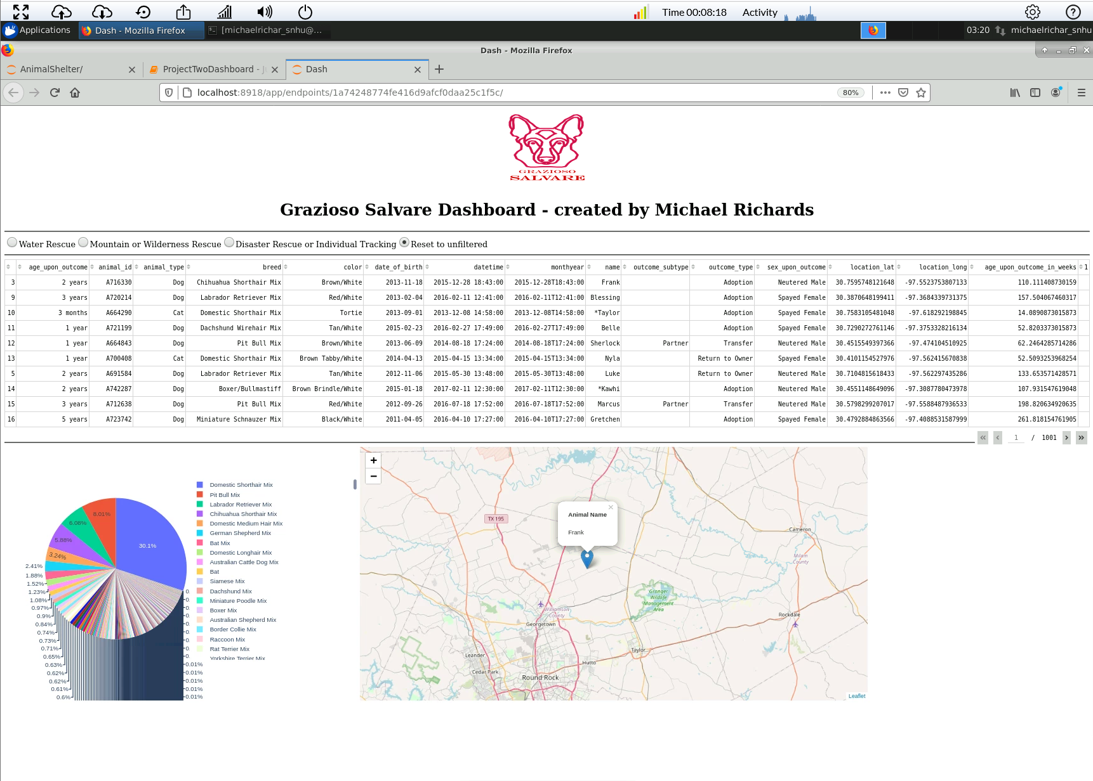

*Water Rescue:*

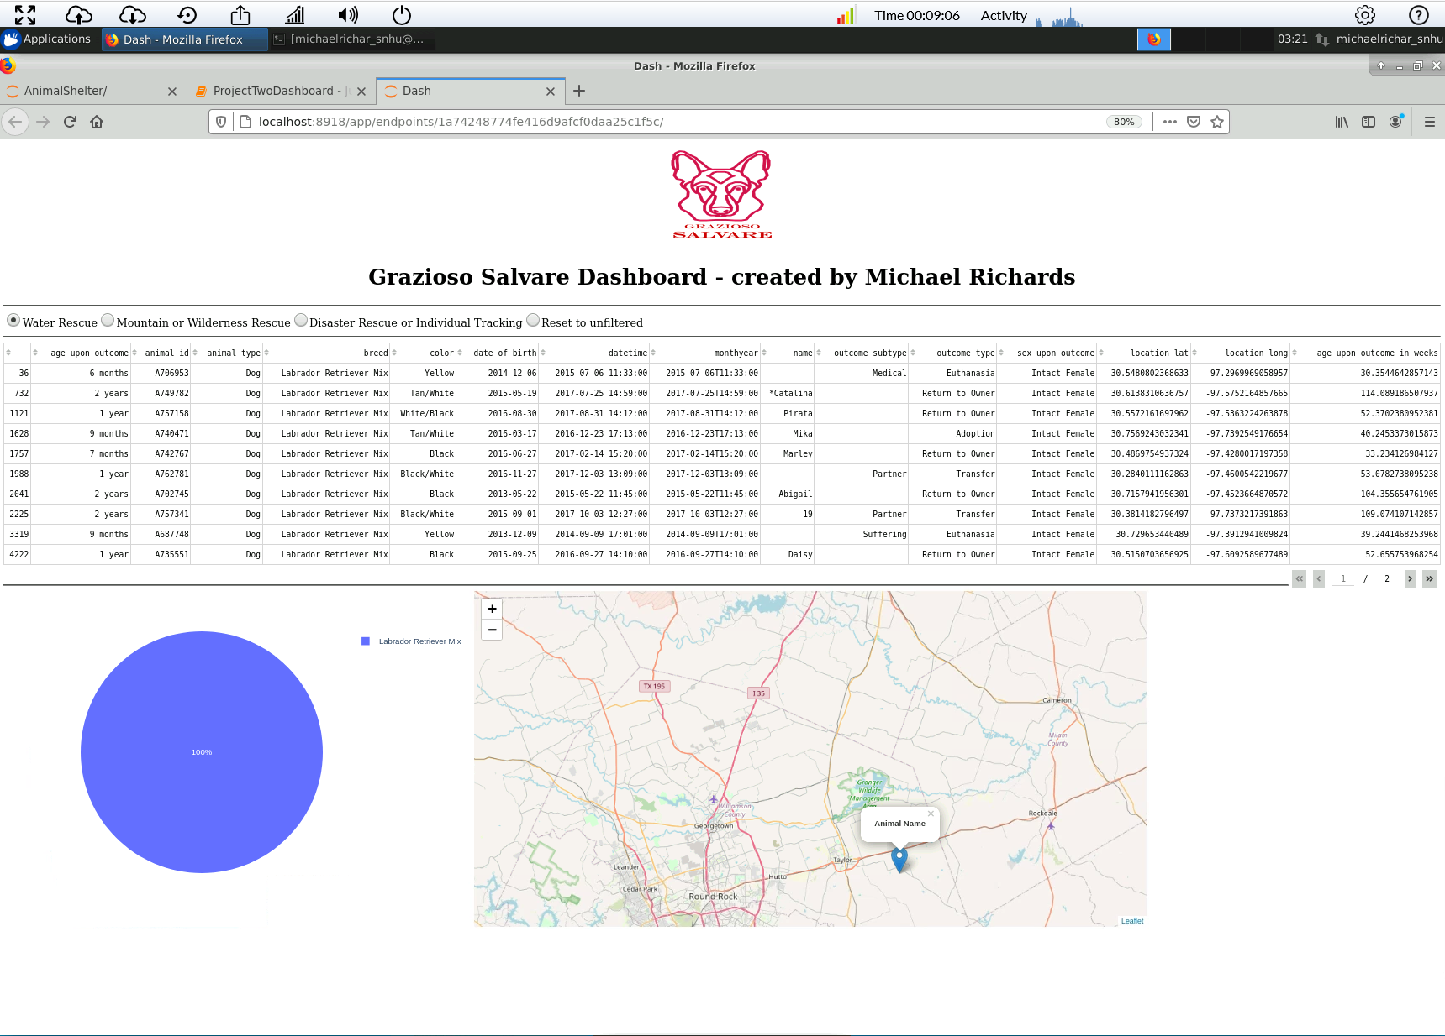

*Mountain or Wilderness Rescue:*

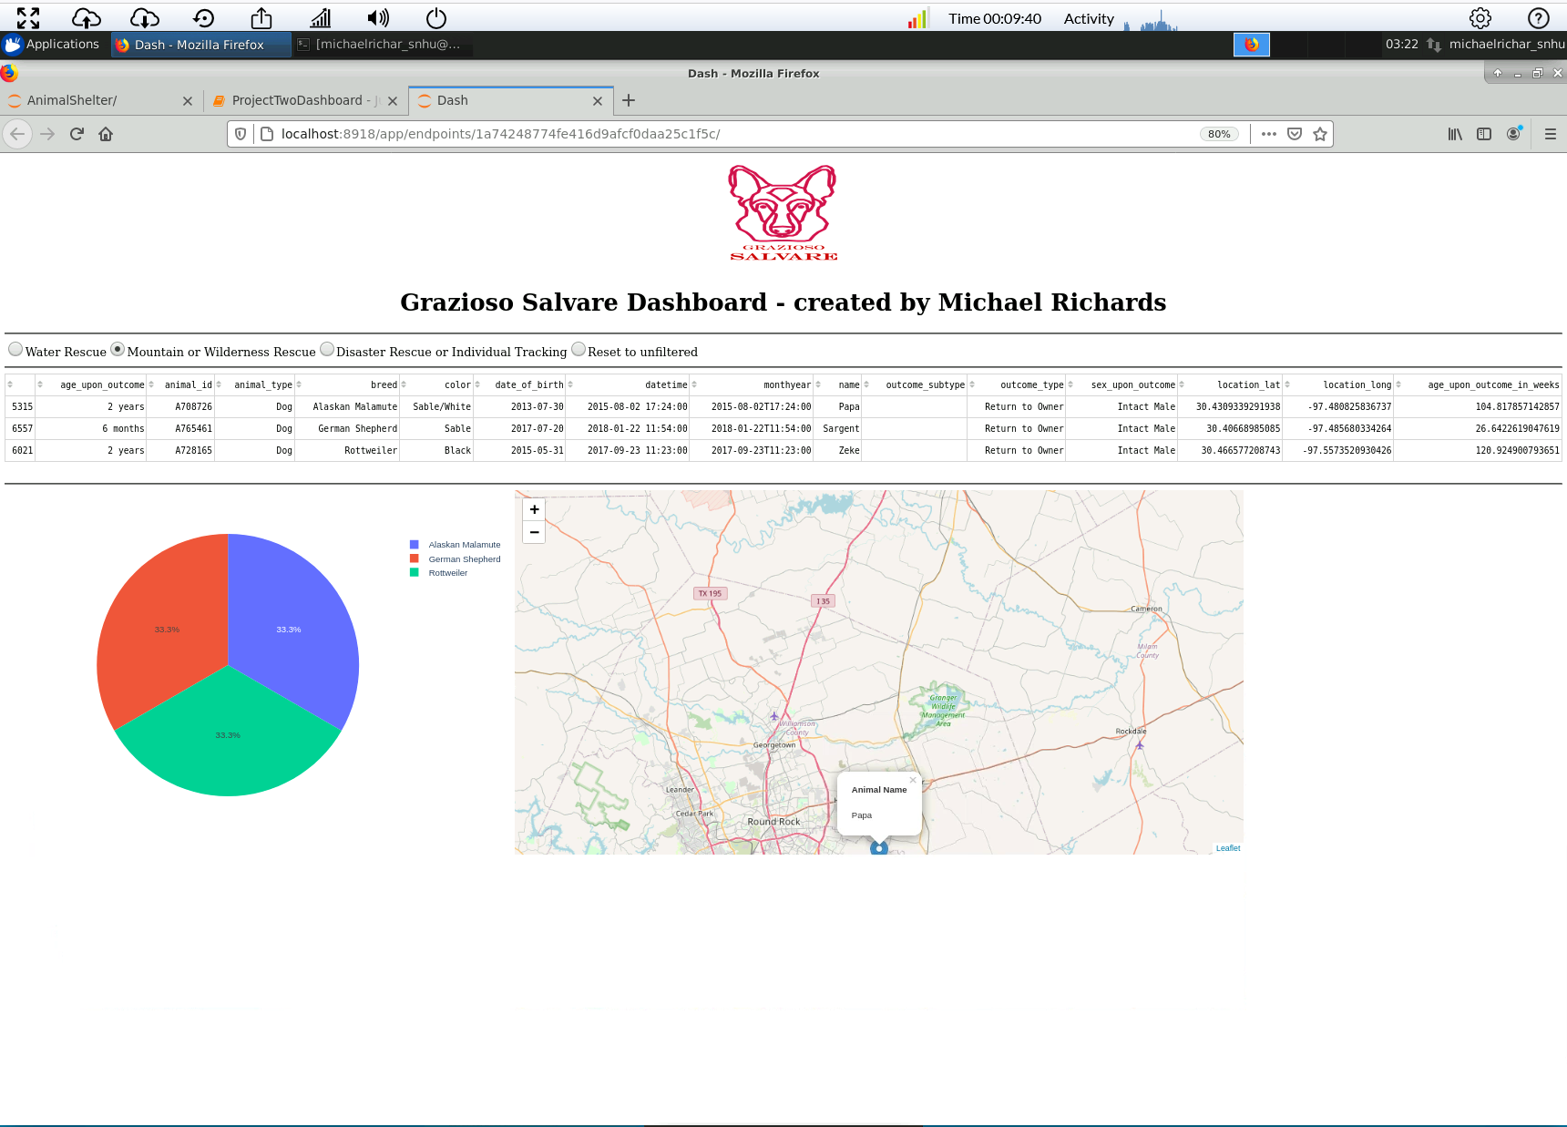

*Disaster Rescue or Individual Tracking:*

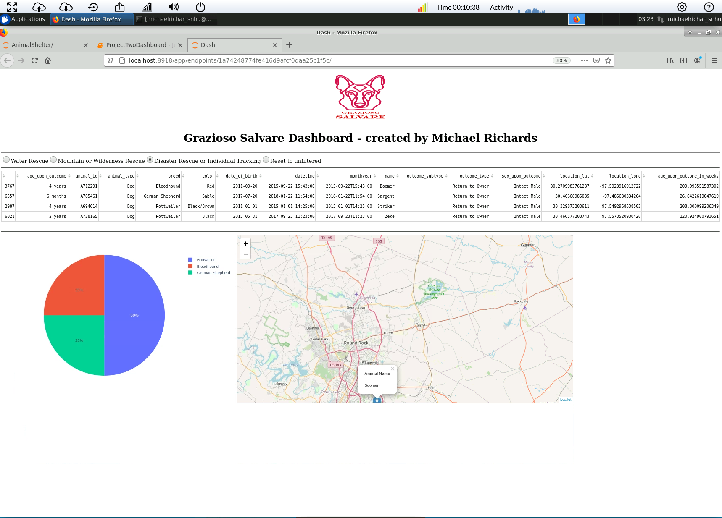

## RESET:

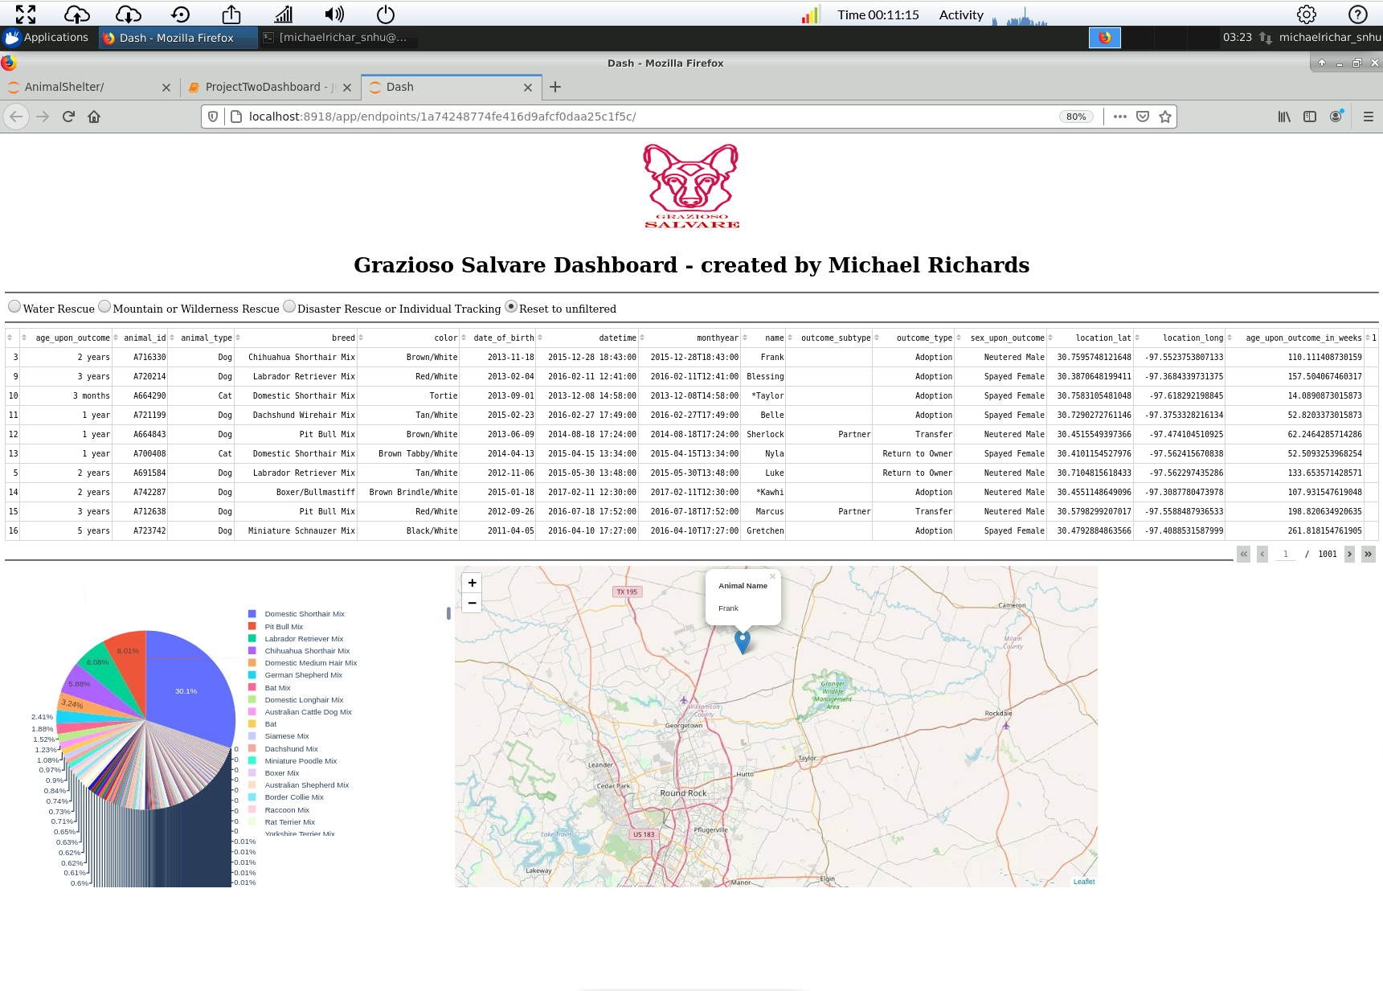

## Contact

Your name: Michael Richards

Your email: michael.richards5@snhu.edu