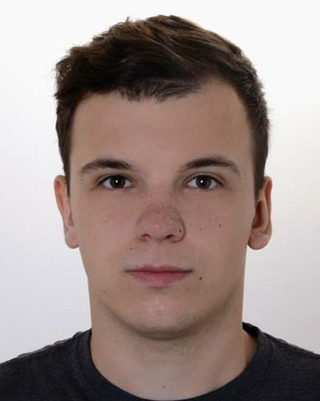

# Contact

E-mail: **dmaliszewski2903@gmail.com**

Telephone number:

**+44 7751 865496**

Date of birth:

**29.03.1997**

Place of birth: **Zielona Góra, PL**

# Skills

**Python**

**Django**

**GIT**

**CSS**

**SQL**

**JavaScript**

**jQuery**

**Linux**

**Windows Server**

**Windows**

**Microsoft Office**

**Assembler**

**Cisco Networking**

**Cisco Routing and Switching**

# Languages

English: Fluent

German: Basic Polish: Mother tongue

# Damian Maliszewski

*After completing a 4-year course with Bachelor of Science, I intend to start my career as a Web developer, Fullstack developer or Cyber security engineer.*

## Employment

04.2019 – 03.2020[11 months]

**Warehouse executive** / Hermes/ Motherwell

10.2018 – 12.2018 [3 months]

**Warehouse Executive** / M&Co/ Inchinan, Szkocja

01.2018 – 04.2018 [4 months]

**Student Placement** / Lenovo Technologies UK/ Glasgow

Krótki opis stanowiska:

Student placement at Lenovo Company based on working with Big Data and basic IT support tasks.

## Education

09.2016 – 09.2020 [4 years]

**University of The West of Scotland**

Bsc Computer Networking (Hons)

Additional information:

2nd Class Degree with Professional placement

09.2013 – 05.2016 [2 years, 9 months]

**III Liceum Ogólnokształcące**

Specjalizacja: Klasa politechniczna

## Certificates

06.2016

**IELTS**

Organization: British Council

Dodatkowe informacje: Certyfikat z języka z angielskiego

## Additional activity

Portfolio:

<https://github.com/MgrMalinovsky>

## Zainteresowania

Programowanie, Technologie, Big Data, branża smartfonowa, matematyka, fizyka, Sporty Ekstremalne, Sporty wytrzymałościowe