EXECUTIVE DECISION REPORT
PBJ_Decision_System — Compliance_as_a_Service
Date: 20260128
VERDICT: NO-GO | RESULT: FAIL | CONFIDENCE: 0%
Confidential — For Decision Makers

Executive Snapshot
Verdict  NO-GO | Confidence  0% | Capital Required  $4,000
Delegatability  0.0/10 | Delivery Target  < 30.0 hrs/engagement | Core Tests  See scorecard below

Primary Reason
To relieve stress, uncertaintity, and to sell peace of mind.

PBJ Core Tests
Ethical  HOLD | Repeatable  FAIL | Profitable  FAIL | Manageable  FAIL

Decision Dashboard
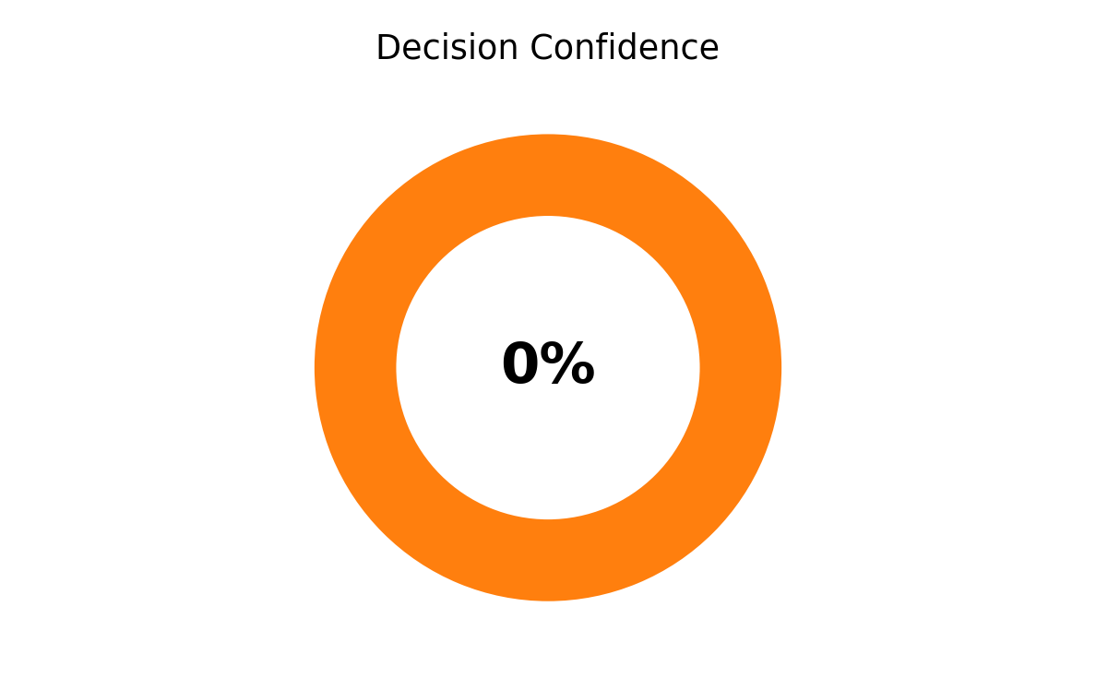 | 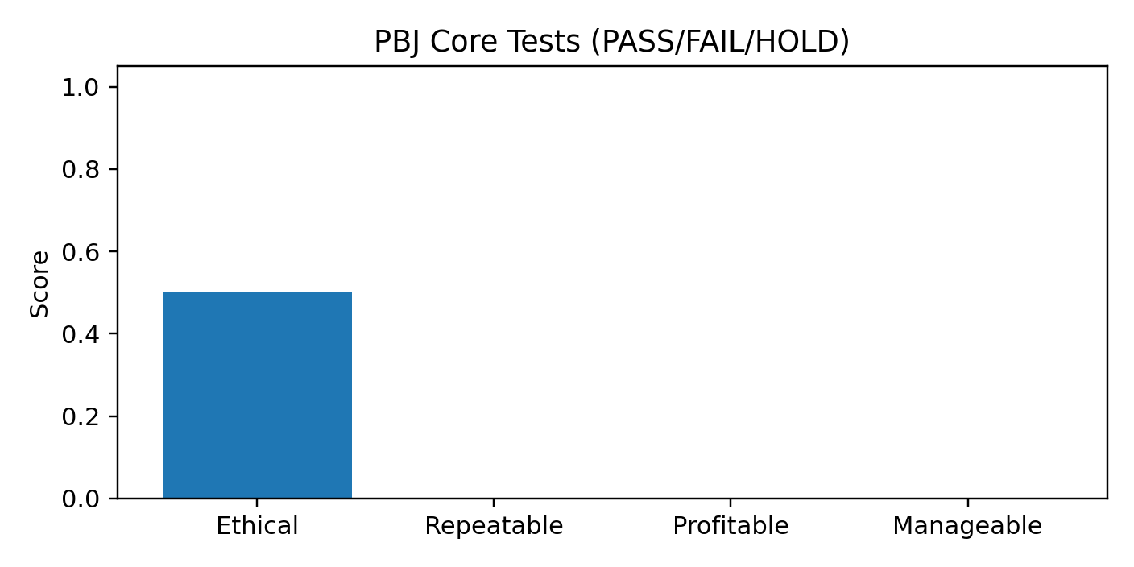
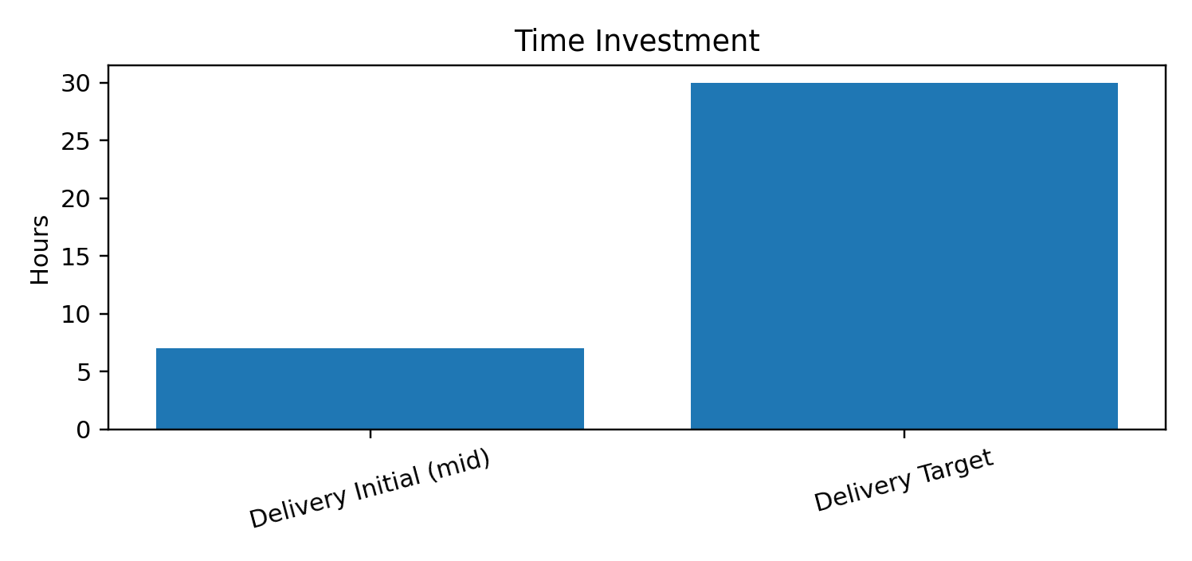 | 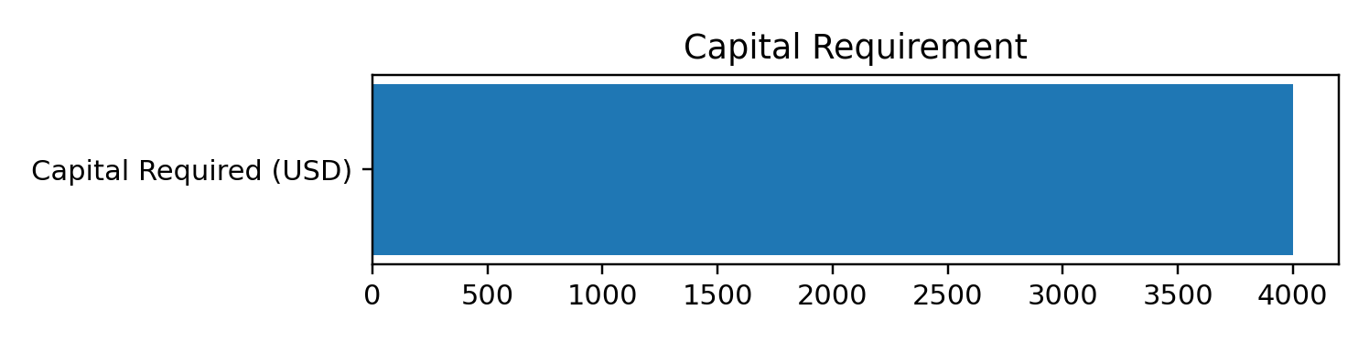

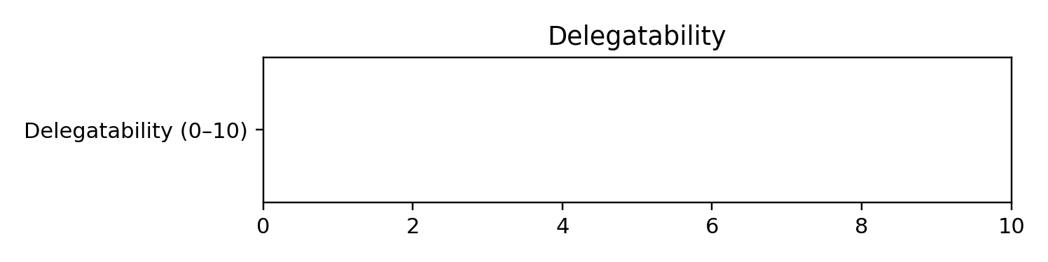

Recommendation (Do This)
- Do not launch as-is. Resolve gating failures and re-run PBJ with updated assumptions.
- Reduce scope or increase repeatability (templates) before selling.

Risks & Kill Switches
- Allowed claims:
- "Audit-ready"
- "Defensible"
- "Pressure-tested"
- "First-pass focused"
- Forbidden claims:

Next Actions (Launch-Ready)
- Perfect the UX and field test
- Generated by PBJ Web Intake (local-first). Canonical PBJ markdown is the source of truth.

Appendix
Canonical PBJ data report is the source of truth (audit-grade).

