EXECUTIVE DECISION REPORT
PBJ_Decision_System — Compliance_as_a_Service
Date: 20260128
VERDICT: HOLD | RESULT: HOLD | CONFIDENCE: 64%
Confidential — For Decision Makers

Executive Snapshot
Verdict  HOLD | Confidence  64% | Capital Required  $0
Delegatability  8.0/10 | Delivery Target  N/A | Core Tests  See scorecard below

Primary Reason
Score: 18/28 with 0 critical FAIL(s). Authorities resolved: 6.

PBJ Core Tests
Ethical  PASS | Repeatable  PASS | Profitable  HOLD | Manageable  HOLD

Decision Dashboard
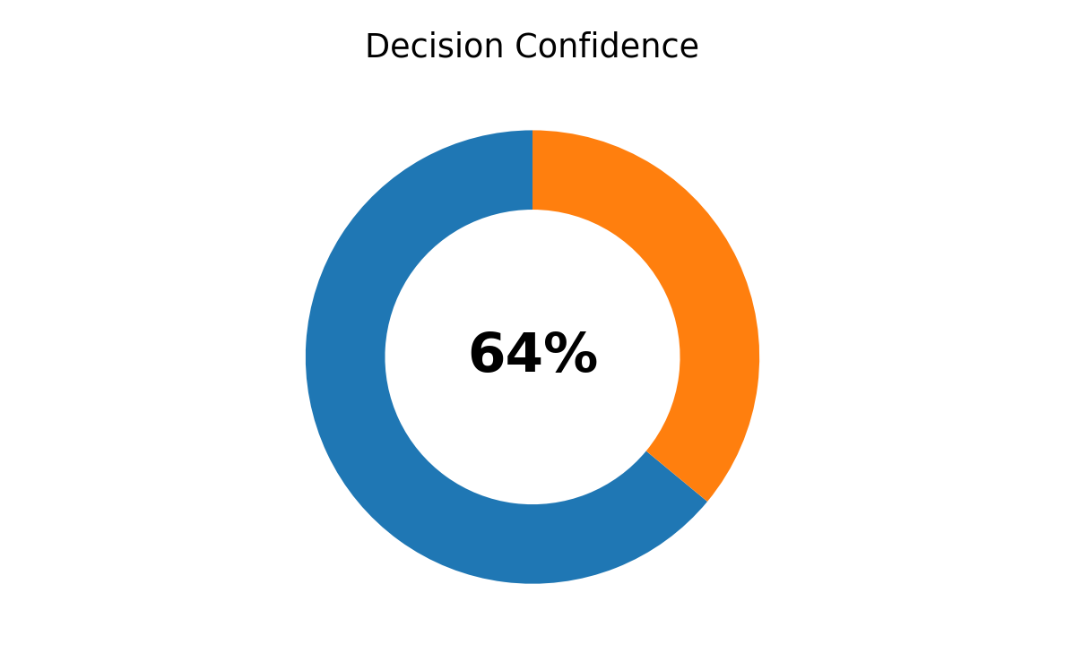 | 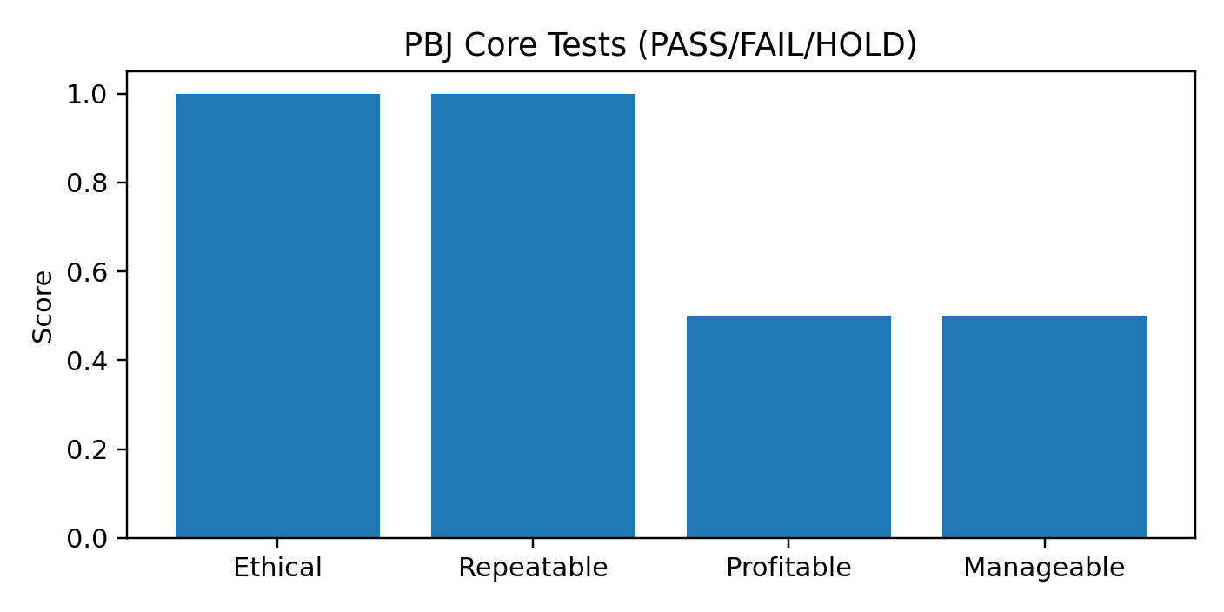
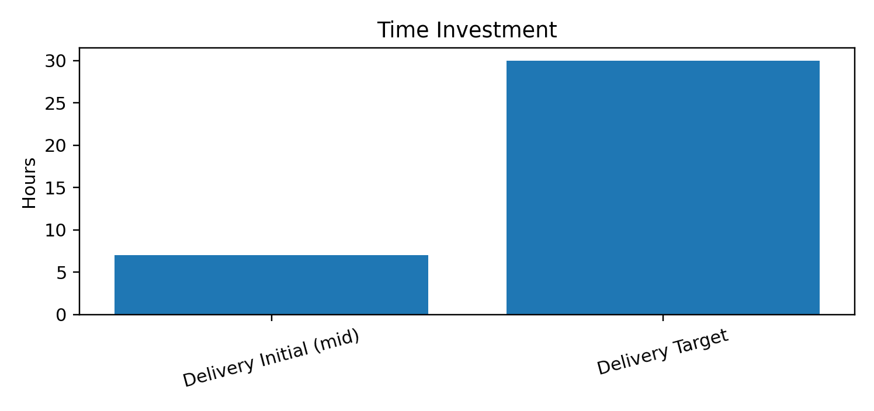 | 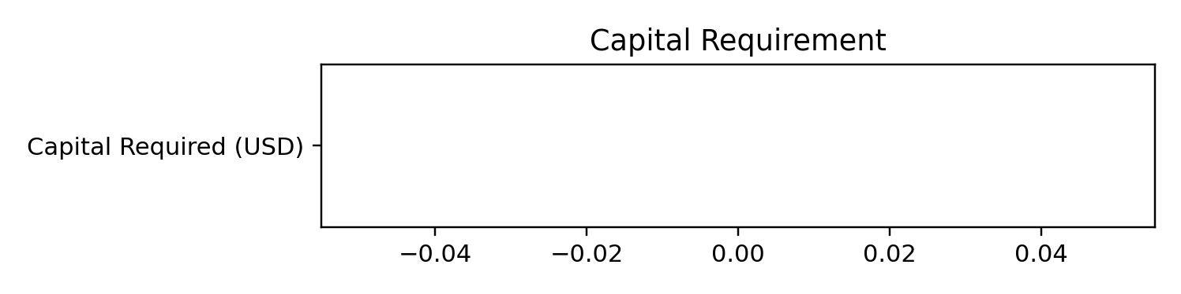

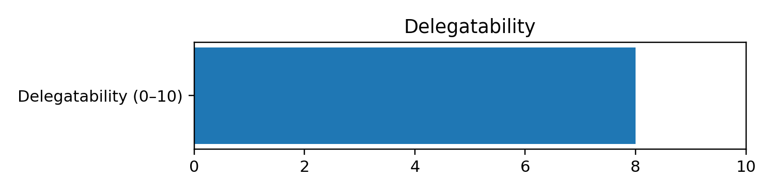

Recommendation (Do This)
- Hold pending resolution of unknowns; run 1 internal dry-run and re-score.
- Tighten kill criteria and ensure delivery time targets are realistic.

Risks & Kill Switches
- See canonical PBJ report for explicit kill-switch criteria.

Next Actions (Launch-Ready)
- See canonical PBJ report for next actions.

Appendix
Canonical PBJ data report is the source of truth (audit-grade).

