PBJ Initiative — Source Register & Audit Flow
Where the Existing PBJ Initiative Fits
Your current ZIP is structurally strong. It already represents a decision lifecycle. What it lacks is epistemic grounding before PBJ logic activates.
Right now the flow is effectively:
INTAKE → PBJ ANALYSIS → GO / NO-GO
To become audit-grade, PBJ needs an upstream evidence layer that PBJ consumes but does not control.

Proposed Structural Upgrade (Minimal Disruption)
We do not replace PBJ.
We wrap it with evidence discipline.
New Pre-PBJ Layer (Added)
/00_source_register/
00_source_register_manifest.md
01_behavioral_sources.md
02_market_economic_sources.md
03_governance_precedents.md
04_regulatory_legal_sources.md
05_contrarian_sources.md
PBJ Becomes a Downstream Consumer
Your existing files remain largely intact, but gain explicit hooks.

File-by-File Fit Analysis
00_pbj_charter.md
Role: PBJ Constitution
- Add section: Epistemic Boundary Conditions
- Declare PBJ is not a source of truth
- Require external sourcing for all scores

01_pbj_intake_statement.md
Role: Question framing
- Add mandatory field:
  - Evidence Sufficiency: [High | Medium | Low | Exploratory]

02_pbj_model_alignment.md
Role: Internal coherence check
- Must explicitly cite which sources PBJ is aligning against

03_pbj_market_reality.md
Role: Reality constraints
- MUST reference:
  - Market sources
  - Economic data
  - Historical analogs
- No citation → INVALID SECTION

04_pbj_risk_reward_roi.md
Role: Risk modeling
- Separate:
  - Evidence-backed risks
  - Assumption-based risks

05_pbj_success_failure_intel.md
Role: Pattern recognition
- Requires comparative case sources
- Failure modes must cite precedent

06_pbj_operating_model_fit.md
Role: Execution realism
- Uses governance & institutional sources

07_pbj_resource_requirements.md
Role: Feasibility
- Evidence type: operational benchmarks

08_pbj_project_plan_to_launch.md
Role: Conditional execution
- Blocked unless Source Register marked COMPLETE

09_pbj_go_no_go_report.md
Role: Verdict
- Must include:
  - Evidence Confidence Score
  - Assumption Density Score

10_pbj_post_decision_actions.md
Role: Learning loop
- Feed real outcomes back into Source Register

NEW: PBJ Source Register (Design)
Purpose
To ensure any reasonable reviewer can:
- Inspect sources
- Challenge assumptions
- Reproduce reasoning
Source Register Rules
- PBJ may weight, not invent
- Conflicting sources must be recorded, not filtered
- Absence of sources is explicitly labeled

BREAK FLOWCHART — FINAL AUDITABLE PROCESS
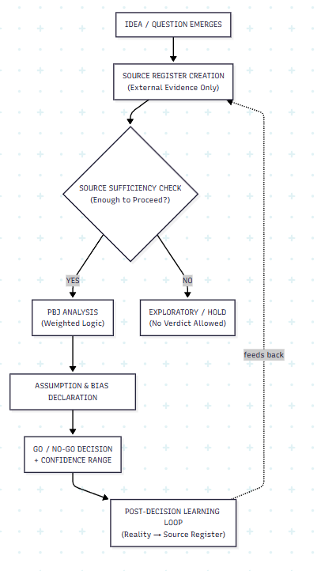

Key Outcome
PBJ is now:
- Auditable (sources precede logic)
- Defensible (judgment is declared)
- Governed (cannot proceed without evidence)
PBJ is no longer "deciding."
It is explaining why a decision was acceptable under known constraints.

Status
PBJ has graduated from framework → decision system.
When ready:
- We can version this as PBJ v2.0 (Audit-Grade)
- Or re-run the governed social network case using this structure

