How to setup the Google Maps Block

# Step One:

Create a Google Maps Block on your page in Umbraco.

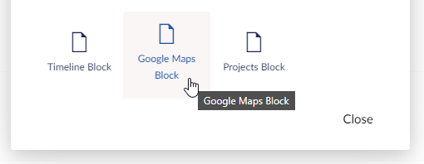

# Step Two:

Fill in the title for your Block.

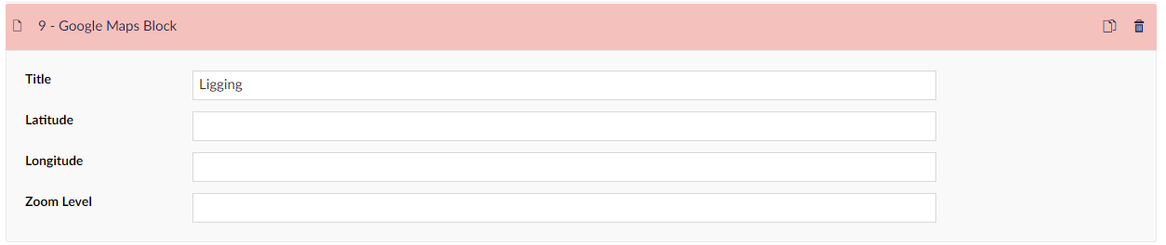

# Step Three:

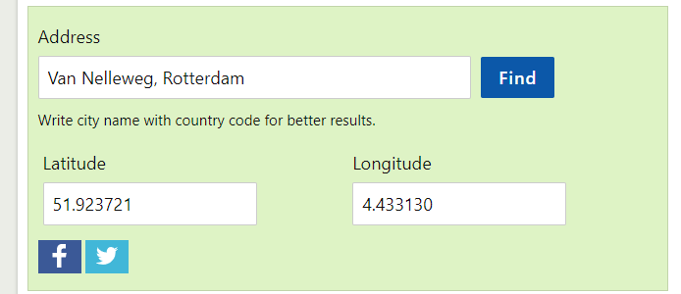Go to <https://www.latlong.net/convert-address-to-lat-long.html> and fill in the address of the project you want to add. Press Find to get the Latitude and Longitude of the address.

# Step Four:

Copy and paste the Latitude and Longitude from the website into the matching fields in Umbraco.

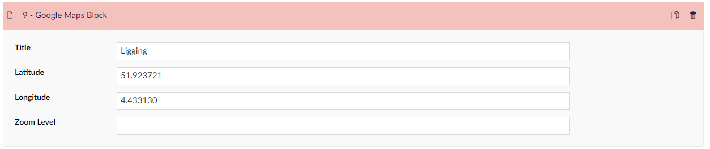

# Step Five:

Set the Zoom Level to **15**, this way you will get a good zoomlevel so map view is not zoomed in too far.

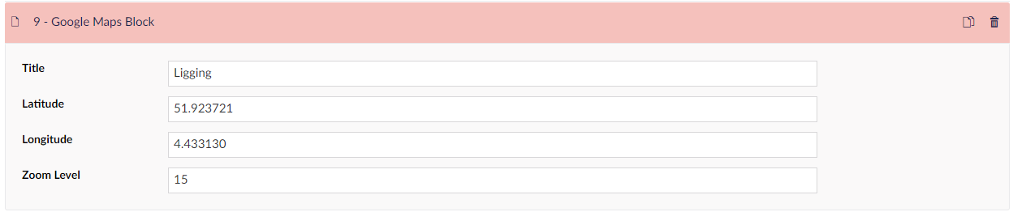

# Step 6:

Save and publish the page and check if the setup worked.

