**User Guide**

**Component:**

**Arduino nano :**The Arduino Nano is a small, complete, and breadboard-friendly board based on the ATmega328 (Arduino Nano 3.x). It has more or less the same functionality of the Arduino Duemilanove, but in a different package. It lacks only a DC power jack, and works with a Mini-B USB cable instead of a standard one. This component is selected because it’s small and it can work with HM-10 BLE module.

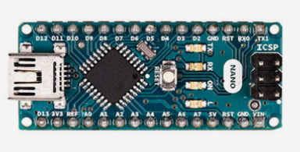

For using this arduino microcontroller, the program must be written on IDE. It can compile and upload arduino sketch to any arduino board.

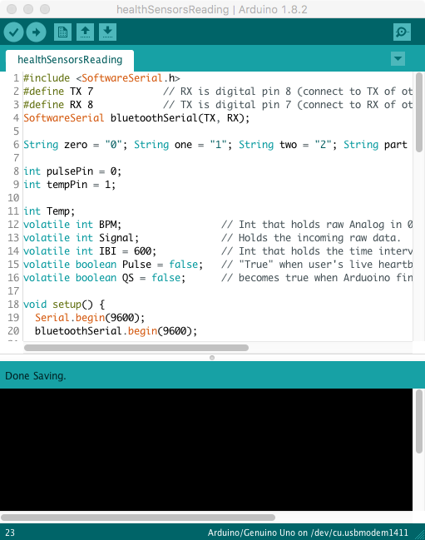

IDE Interface

**LM35 Temperature Sensor:** LM35 is a precision IC temperature sensor with its output proportional to the temperature (in °C). The sensor circuitry is sealed and therefore it is not subjected to oxidation and other processes. With LM35, temperature can be measured more accurately than with a thermistor. It also possess low self heating and does not cause more than 0.1 oC temperature rise in still air. The operating temperature range is from -55°C to 150°C. The output voltage varies by 10 mV in response to every °C rise/fall in ambient temperature, i.e., its scale factor is 0.01V/ °C. For using this sensor just connect output pin to any arduino analog pin and also connect Gnd and 5V to arduino.

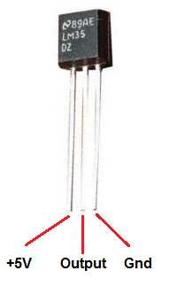

Basic function for convert voltage change in mV to actural tempurature data for LM35:

val = analogRead(tempPin); // reading data from sensor

float mv = ( val/1024.0)*5000; // convert raw data to mV

float cel = mv/10; // convert mV to real tempurature in

Centigrade degree

float farh = (cel*9)/5 + 32; // convert mV to real tempurature in   
 Fahrenheit degree

**SEN-11574 Pulse Sensor:** The Pulse Sensor Amped is a plug-and-play heart-rate sensor for Arduino. It can be used by students, artists, athletes, makers, and game & mobile developers who want to easily incorporate live heart-rate data into their projects.It essentially combines a simple optical heart rate sensor with amplification and noise cancellation circuitry making it fast and easy to get reliable pulse readings. Also, it sips power with just 4mA current draw at 5V so it’s great for mobile applications. This component is selected because it’s the only sensor to easy to find and it’s reading is accurately. For using this heartbeat sensor just connect it’s S pin to any arduino analog pin and also connect ground and 5v to arduino.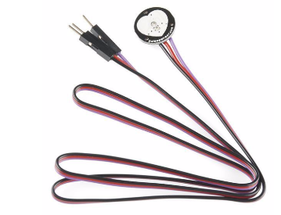

**HM-10 BLE module:** The HM-10 is a readily available Bluetooth 4.0 module based on the Texas Instruments CC2540 and CC2541 Bluetooth low energy (BLE) System on Chip (SoC). This bluetooth module is cost low energy and it be suitable for IOS device like iphone or ipad.

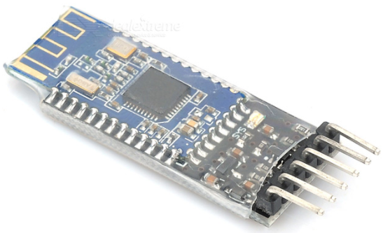

Make sure the device is powered and the sensors are weared then open the HealthMonitor App from your iPhone. Click Scan to see to choose the device name “HEALTH”. Then go back to the main page and hit run to start reading from the device.

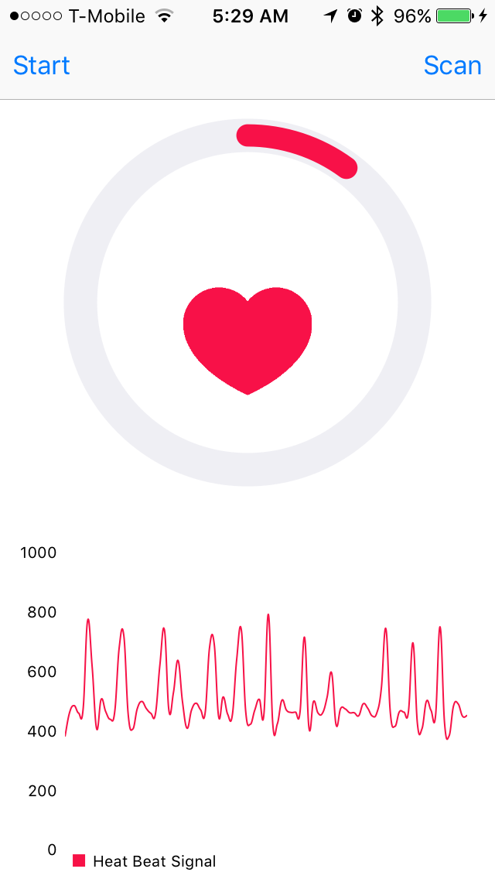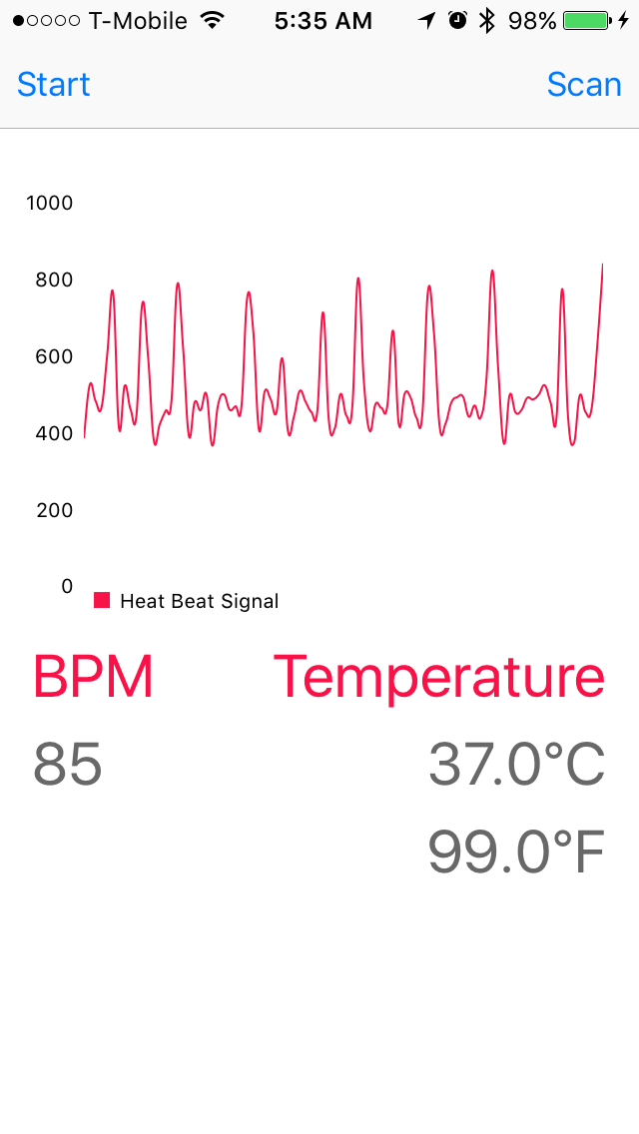

The circular chart represents your overall health condition. When the circular bar is low, your health is normal but when circular bar passes the half of the circle, your health is abnormal. The heart is dynamically change its speed of beating based of the BPM. The chart shows a life signal visualization of heart rate which is beneficial to see the timeline of your activities. Your body temperature and BPM are displayed in numerical values at the bottom of the App.