**How to Run**

**Step 1: what you need**

You will need:

1 x Arduino nano or uno

1 x HM-10 BLE module

1 x SEN-11574 Pulse Sensor

1 x LM35 Temperature Sensor

1 x device running IOS

1 x device running MAC OSX and Xcode

**Step 2: Connect the circuit**

1.Connect 3.3V of Arduino to the VCC of HM-10 BLE module

2.Connect GND of Arduino to the GND of HM-10 BLE module

3.Connect D8 of Arduino to TX of HM-10 BLE module

4.Connect D7 of Arduino to RX of HM-10 BLE module

5.Connect 5.0V of Arduino to the VCC of Pulse Sensor

6.Connect GND of Arduino to the GND of Pulse Sensor

7.Connect A0 of Arduino to the Signal of Pulse Sensor

8.Connect 5.0V of Arduino to the VCC of LM35 Temperature Sensor

9.Connect GND of Arduino to the GND of LM35 Temperature Sensor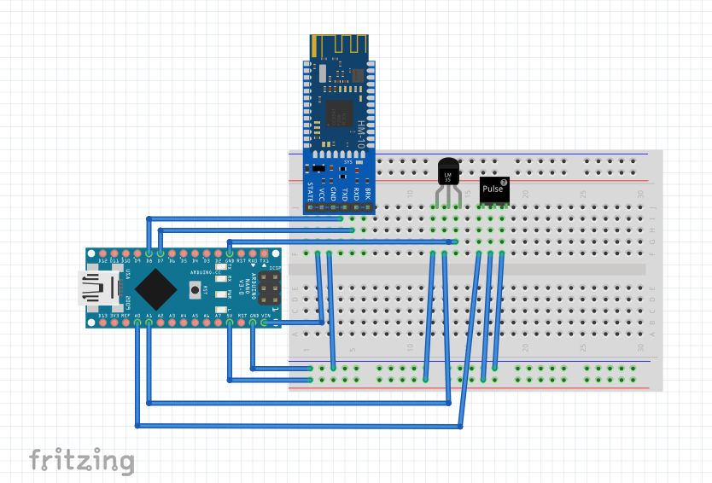

10.Connect A1 of Arduino to the OUT of LM35 Temperature Sensor

Circuit Schematic: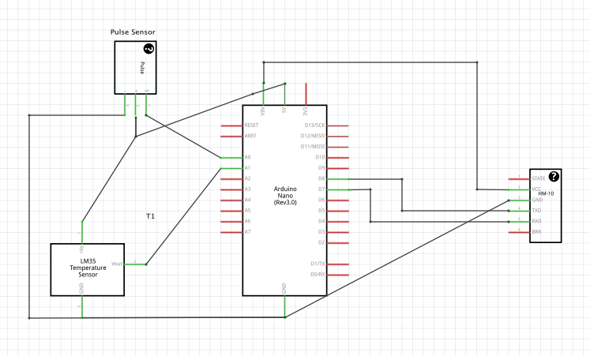

**Step 3: Upload the Arduino Sketch**

Go to our Github repository and download/copy-paste the Arduino sketch to your Arduino IDE. Upload the sketch to your Arduino.

<https://github.com/MhAlghamdi/WirelessHealthMonitoringSystem/tree/master/ArduinoSketch/HealthSensorsReading>

**Step 4: Download the Application and install**

To install the App first you have to have an iPhone that runs iOS 10 version and Xcode to run the code. In Xcode HealthMonitorApp folder, open HealthMonitor.xcworkspace then connect your iPhone to your computer.

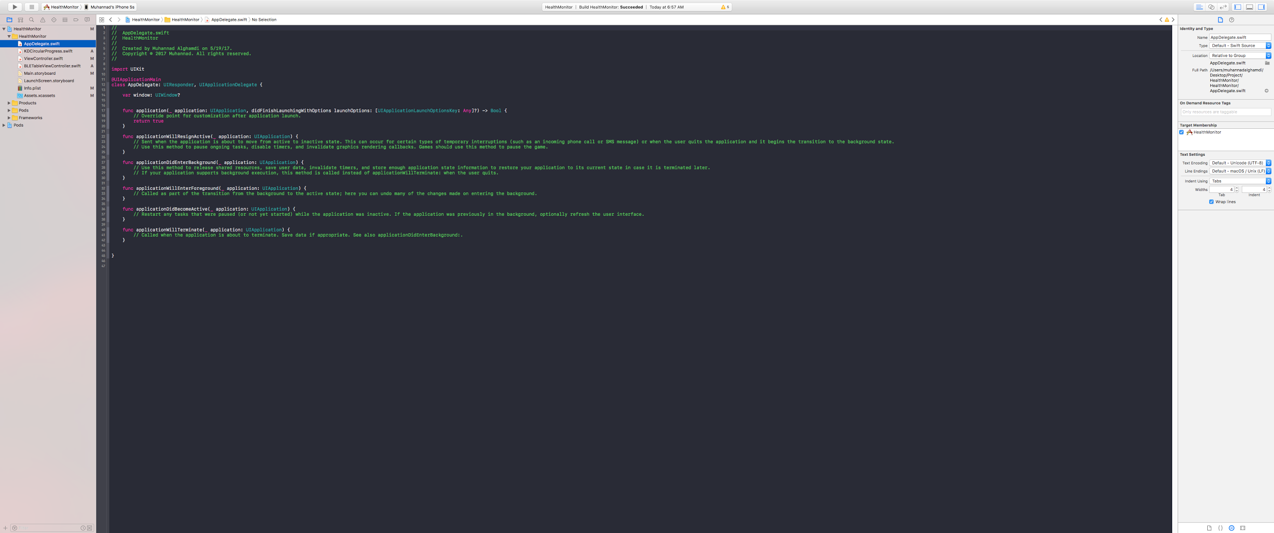

Choose your device name from then hit run. Do not choose a simulater because it has no Bluetooth built in. After the run succeeded, you will see the App named HealthMonitor.

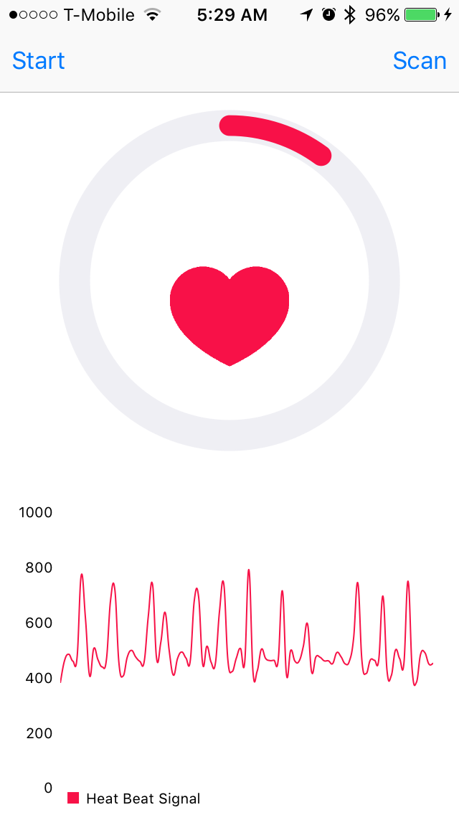

Click Scan to see Bluetooth devices then choose the device name “HEALTH” for our project. Then go back to the main page and hit run to start reading from the device.