Rapport package team

Correlations

2011-04-26 20:25 CET

## Description

This template will return the correlation matrix of supplied numerical variables.

### Introduction

[Correlation](http://en.wikipedia.org/wiki/Correlation_and_dependence) is one of the most commonly used statistical tool. With the help of that we can get information about a possible [linear relation](http://en.wikipedia.org/wiki/Linear_independence) between two variables. According to the definition of the correlation, one can call it also as the standardized [covariance](http://en.wikipedia.org/wiki/Covariance).

The maximum possible value of the correlation (the so-called [correlation coefficient](http://en.wikipedia.org/wiki/Correlation_coefficient)) could be 1, the minimum could be -1. In the first case there is a perfect positive (thus in the second case there is a perfect negative) linear relationship between the two variables, though perfect relationships, especially in the social sciences, are quite rare. If two variables are independent from each other, the correlation between them is 0, but 0 correlation coefficient only means certainly a [linear independency](http://en.wikipedia.org/wiki/Correlation_and_dependence#Correlation_and_linearity).

Because extreme values occur seldom we have rule of thumbs for the coefficients, like other fields of statistics:

* we call two variables highly correlated if the absolute value of the correlation coefficient between them is higher than 0.7 and
* we call them uncorrelated if that is smaller than 0.2.

Please note that [correlation has nothing to do with causal models](http://en.wikipedia.org/wiki/Correlation_does_not_imply_causation), it only shows association but not effects.

### Variable description

*709* variables with *2* cases provided.

There are no highly correlated (r < -0.7 or r > 0.7) variables.

There are no uncorrelated correlated (r < -0.2 or r > 0.2) variables.

### Correlation matrix

|  |  |  |
| --- | --- | --- |
|  | age | edu |
| **age** |  | 0.2185 * * * |
| **edu** | 0.2185 * * * |  |

Correlation matrix

Where the stars represent the [significance levels](http://en.wikipedia.org/wiki/Statistical_significance) of the bivariate correlation coefficients: one star for a [p value](http://en.wikipedia.org/wiki/P-value) below 0.05, two for below 0.01 and three for below 0.001.

On the plot one can see the correlation in two forms: below the [diagonal](http://en.wikipedia.org/wiki/Main_diagonal) visually, above that one can find the coefficient(s).

[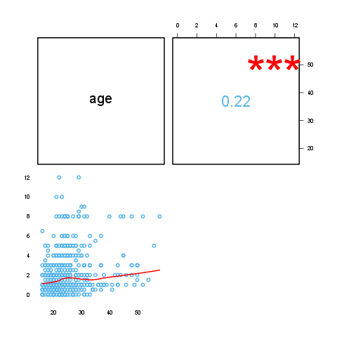](plots/Correlation-1-hires.png)

## Description

This template will return the correlation matrix of supplied numerical variables.

### Introduction

[Correlation](http://en.wikipedia.org/wiki/Correlation_and_dependence) is one of the most commonly used statistical tool. With the help of that we can get information about a possible [linear relation](http://en.wikipedia.org/wiki/Linear_independence) between two variables. According to the definition of the correlation, one can call it also as the standardized [covariance](http://en.wikipedia.org/wiki/Covariance).

The maximum possible value of the correlation (the so-called [correlation coefficient](http://en.wikipedia.org/wiki/Correlation_coefficient)) could be 1, the minimum could be -1. In the first case there is a perfect positive (thus in the second case there is a perfect negative) linear relationship between the two variables, though perfect relationships, especially in the social sciences, are quite rare. If two variables are independent from each other, the correlation between them is 0, but 0 correlation coefficient only means certainly a [linear independency](http://en.wikipedia.org/wiki/Correlation_and_dependence#Correlation_and_linearity).

Because extreme values occur seldom we have rule of thumbs for the coefficients, like other fields of statistics:

* we call two variables highly correlated if the absolute value of the correlation coefficient between them is higher than 0.7 and
* we call them uncorrelated if that is smaller than 0.2.

Please note that [correlation has nothing to do with causal models](http://en.wikipedia.org/wiki/Correlation_does_not_imply_causation), it only shows association but not effects.

### Variable description

*709* variables with *3* cases provided.

The highest correlation coefficient (*0.2273*) is between *edu* and *age* and the lowest (*-0.03377*) is between *leisure* and *age*. It seems that the strongest association (r=*0.2273*) is between *edu* and *age*.

There are no highly correlated (r < -0.7 or r > 0.7) variables.

Uncorrelated (-0.2 < r < 0.2) variables:

* *leisure* and *age* (-0.03)
* *leisure* and *edu* (0.17)

### Correlation matrix

|  |  |  |  |
| --- | --- | --- | --- |
|  | age | edu | leisure |
| **age** |  | 0.2273 * * * | -0.0338 |
| **edu** | 0.2273 * * * |  | 0.1732 * * * |
| **leisure** | -0.0338 | 0.1732 * * * |  |

Correlation matrix

Where the stars represent the [significance levels](http://en.wikipedia.org/wiki/Statistical_significance) of the bivariate correlation coefficients: one star for a [p value](http://en.wikipedia.org/wiki/P-value) below 0.05, two for below 0.01 and three for below 0.001.

On the plot one can see the correlation in two forms: below the [diagonal](http://en.wikipedia.org/wiki/Main_diagonal) visually, above that one can find the coefficient(s).

[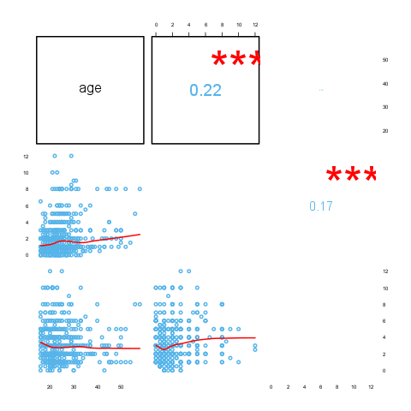](plots/Correlation-2-hires.png)

## Description

This template will return the correlation matrix of supplied numerical variables.

### Introduction

[Correlation](http://en.wikipedia.org/wiki/Correlation_and_dependence) is one of the most commonly used statistical tool. With the help of that we can get information about a possible [linear relation](http://en.wikipedia.org/wiki/Linear_independence) between two variables. According to the definition of the correlation, one can call it also as the standardized [covariance](http://en.wikipedia.org/wiki/Covariance).

The maximum possible value of the correlation (the so-called [correlation coefficient](http://en.wikipedia.org/wiki/Correlation_coefficient)) could be 1, the minimum could be -1. In the first case there is a perfect positive (thus in the second case there is a perfect negative) linear relationship between the two variables, though perfect relationships, especially in the social sciences, are quite rare. If two variables are independent from each other, the correlation between them is 0, but 0 correlation coefficient only means certainly a [linear independency](http://en.wikipedia.org/wiki/Correlation_and_dependence#Correlation_and_linearity).

Because extreme values occur seldom we have rule of thumbs for the coefficients, like other fields of statistics:

* we call two variables highly correlated if the absolute value of the correlation coefficient between them is higher than 0.7 and
* we call them uncorrelated if that is smaller than 0.2.

Please note that [correlation has nothing to do with causal models](http://en.wikipedia.org/wiki/Correlation_does_not_imply_causation), it only shows association but not effects.

### Variable description

*32* variables with *11* cases provided.

The highest correlation coefficient (*0.902*) is between *disp* and *cyl* and the lowest (*-0.8677*) is between *wt* and *mpg*. It seems that the strongest association (r=*0.902*) is between *disp* and *cyl*.

Highly correlated (r < -0.7 or r > 0.7) variables:

* *cyl* and *mpg* (-0.85)
* *disp* and *mpg* (-0.85)
* *hp* and *mpg* (-0.78)
* *wt* and *mpg* (-0.87)
* *disp* and *cyl* (0.9)
* *hp* and *cyl* (0.83)
* *wt* and *cyl* (0.78)
* *vs* and *cyl* (-0.81)
* *hp* and *disp* (0.79)
* *drat* and *disp* (-0.71)
* *wt* and *disp* (0.89)
* *vs* and *disp* (-0.71)
* *qsec* and *hp* (-0.71)
* *vs* and *hp* (-0.72)
* *carb* and *hp* (0.75)
* *wt* and *drat* (-0.71)
* *am* and *drat* (0.71)
* *vs* and *qsec* (0.74)
* *gear* and *am* (0.79)

Uncorrelated (-0.2 < r < 0.2) variables:

* *gear* and *hp* (-0.13)
* *qsec* and *drat* (0.09)
* *carb* and *drat* (-0.09)
* *qsec* and *wt* (-0.17)
* *am* and *vs* (0.17)
* *carb* and *am* (0.06)

### Correlation matrix

|  |  |  |  |
| --- | --- | --- | --- |
|  | mpg | cyl | disp |
| **mpg** |  | -0.8522 * * * | -0.8476 * * * |
| **cyl** | -0.8522 * * * |  | 0.9020 * * * |
| **disp** | -0.8476 * * * | 0.9020 * * * |  |
| **hp** | -0.7762 * * * | 0.8324 * * * | 0.7909 * * * |
| **drat** | 0.6812 * * * | -0.6999 * * * | -0.7102 * * * |
| **wt** | -0.8677 * * * | 0.7825 * * * | 0.8880 * * * |
| **qsec** | 0.4187 * | -0.5912 * * * | -0.4337 * |
| **vs** | 0.6640 * * * | -0.8108 * * * | -0.7104 * * * |
| **am** | 0.5998 * * * | -0.5226 * * | -0.5912 * * * |
| **gear** | 0.4803 * * | -0.4927 * * | -0.5556 * * * |
| **carb** | -0.5509 * * | 0.5270 * * | 0.3950 * |

Correlation matrix (continued below)

|  |  |  |  |
| --- | --- | --- | --- |
|  | hp | drat | wt |
| **mpg** | -0.7762 * * * | 0.6812 * * * | -0.8677 * * * |
| **cyl** | 0.8324 * * * | -0.6999 * * * | 0.7825 * * * |
| **disp** | 0.7909 * * * | -0.7102 * * * | 0.8880 * * * |
| **hp** |  | -0.4488 * * | 0.6587 * * * |
| **drat** | -0.4488 * * |  | -0.7124 * * * |
| **wt** | 0.6587 * * * | -0.7124 * * * |  |
| **qsec** | -0.7082 * * * | 0.0912 | -0.1747 |
| **vs** | -0.7231 * * * | 0.4403 * | -0.5549 * * * |
| **am** | -0.2432 | 0.7127 * * * | -0.6925 * * * |
| **gear** | -0.1257 | 0.6996 * * * | -0.5833 * * * |
| **carb** | 0.7498 * * * | -0.0908 | 0.4276 * |

Table continues below

|  |  |  |  |
| --- | --- | --- | --- |
|  | qsec | vs | am |
| **mpg** | 0.4187 * | 0.6640 * * * | 0.5998 * * * |
| **cyl** | -0.5912 * * * | -0.8108 * * * | -0.5226 * * |
| **disp** | -0.4337 * | -0.7104 * * * | -0.5912 * * * |
| **hp** | -0.7082 * * * | -0.7231 * * * | -0.2432 |
| **drat** | 0.0912 | 0.4403 * | 0.7127 * * * |
| **wt** | -0.1747 | -0.5549 * * * | -0.6925 * * * |
| **qsec** |  | 0.7445 * * * | -0.2299 |
| **vs** | 0.7445 * * * |  | 0.1683 |
| **am** | -0.2299 | 0.1683 |  |
| **gear** | -0.2127 | 0.2060 | 0.7941 * * * |
| **carb** | -0.6562 * * * | -0.5696 * * * | 0.0575 |

Table continues below

|  |  |  |
| --- | --- | --- |
|  | gear | carb |
| **mpg** | 0.4803 * * | -0.5509 * * |
| **cyl** | -0.4927 * * | 0.5270 * * |
| **disp** | -0.5556 * * * | 0.3950 * |
| **hp** | -0.1257 | 0.7498 * * * |
| **drat** | 0.6996 * * * | -0.0908 |
| **wt** | -0.5833 * * * | 0.4276 * |
| **qsec** | -0.2127 | -0.6562 * * * |
| **vs** | 0.2060 | -0.5696 * * * |
| **am** | 0.7941 * * * | 0.0575 |
| **gear** |  | 0.2741 |
| **carb** | 0.2741 |  |

Where the stars represent the [significance levels](http://en.wikipedia.org/wiki/Statistical_significance) of the bivariate correlation coefficients: one star for a [p value](http://en.wikipedia.org/wiki/P-value) below 0.05, two for below 0.01 and three for below 0.001.

On the plot one can see the correlation in two forms: below the [diagonal](http://en.wikipedia.org/wiki/Main_diagonal) visually, above that one can find the coefficient(s).

[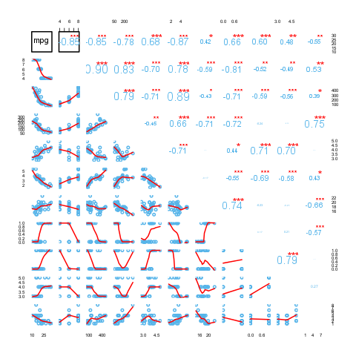](plots/Correlation-3-hires.png)

This report was generated with [R](http://www.r-project.org/) (3.0.1) and [rapport](http://rapport-package.info/) (0.51) in *4.769* sec on x86_64-unknown-linux-gnu platform.

