Rapport package team

Kolmogorov-Smirnov-test

2011-04-26 20:25 CET

## Description

This template will run a Kolmogorov-Smirnov-test

#### Introduction

[Kolmogorov-Smirnov test](http://en.wikipedia.org/wiki/Kolmogorov%E2%80%93Smirnov_test) is one of the most widely used [nonparametric tests](http://en.wikipedia.org/wiki/Non-parametric_statistics). With the help of that in this case we use to check if two continuous variables had the same distribution. We do not test that here, but there is a possibility to use that in the way to check if a sample/variable followed an expected distribution.

#### Distributions

Before we use the K-S test to look at the possible statistical differences, it could be useful to see visually the distributions we want to observe. Below lie the [Cumulative Distribution Functions](http://en.wikipedia.org/wiki/Cumulative_distribution_function) of the variables we compared:

[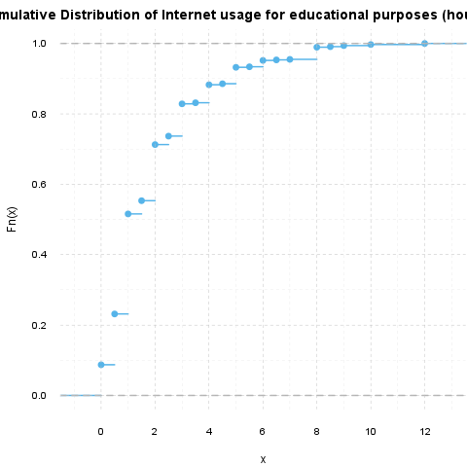](plots/KolmogorovSmirnovTest-1-hires.png)

[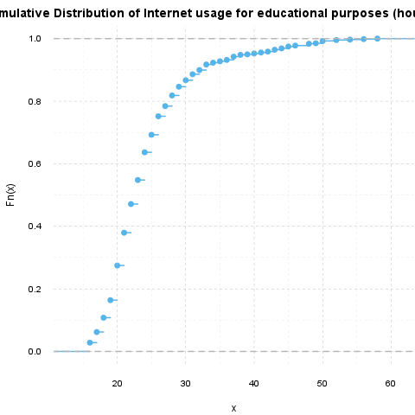](plots/KolmogorovSmirnovTest-2-hires.png)

#### Test results

Now we will test if the Internet usage for educational purposes (hours per day) and the Age had statistically the same distribution.

|  |  |  |
| --- | --- | --- |
| Test statistic | P value | Alternative hypothesis |
| 1 | *0* * * * | two-sided |

Two-sample Kolmogorov-Smirnov test on Internet usage for educational purposes (hours per day) and Age

The requirements of the Kolmogorov-Smirnov Test test was not met, the approximation may be incorrect.

So the variables do not follow the same distribution, according to the Kolmogorov-Smirnov test statistic.

## Description

This template will run a Kolmogorov-Smirnov-test

#### Introduction

[Kolmogorov-Smirnov test](http://en.wikipedia.org/wiki/Kolmogorov%E2%80%93Smirnov_test) is one of the most widely used [nonparametric tests](http://en.wikipedia.org/wiki/Non-parametric_statistics). With the help of that in this case we use to check if two continuous variables had the same distribution. We do not test that here, but there is a possibility to use that in the way to check if a sample/variable followed an expected distribution.

#### Distributions

Before we use the K-S test to look at the possible statistical differences, it could be useful to see visually the distributions we want to observe. Below lie the [Cumulative Distribution Functions](http://en.wikipedia.org/wiki/Cumulative_distribution_function) of the variables we compared:

[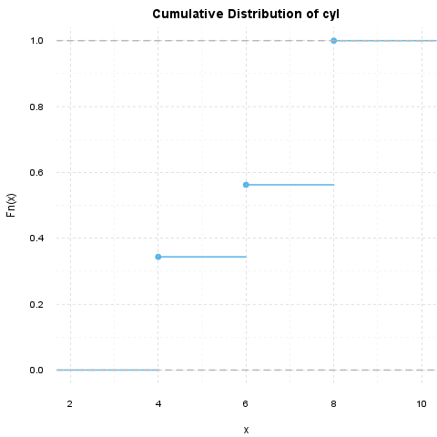](plots/KolmogorovSmirnovTest-3-hires.png)

[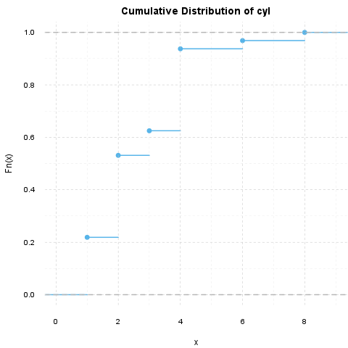](plots/KolmogorovSmirnovTest-4-hires.png)

#### Test results

Now we will test if the cyl and the carb had statistically the same distribution.

|  |  |  |
| --- | --- | --- |
| Test statistic | P value | Alternative hypothesis |
| 0.625 | *7.453e-06* * * * | two-sided |

Two-sample Kolmogorov-Smirnov test on cyl and carb

The requirements of the Kolmogorov-Smirnov Test test was not met, the approximation may be incorrect.

So the variables do not follow the same distribution, according to the Kolmogorov-Smirnov test statistic.

This report was generated with [R](http://www.r-project.org/) (3.0.1) and [rapport](http://rapport-package.info/) (0.51) in *0.729* sec on x86_64-unknown-linux-gnu platform.

