Rapport package team

Multidimensional Scaling

2011-04-26 20:25 CET

## Description

In this template Rapporter will present you Multidimensional Scaling.

### Introduction

[Multidimensional-scaling](http://en.wikipedia.org/wiki/Multidimensional_scaling) is a technique which gives us a visual representation about the distances between the observations.

### MDS

Below you can see a plot, that presents you the distance between the observations, which was calculated based on *Age*, *Internet usage for educational purposes (hours per day)* and *Internet usage in leisure time (hours per day)*.

[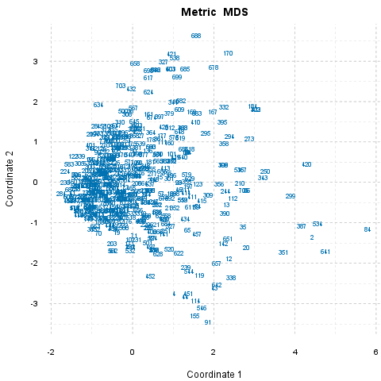](plots/MDS.tpl-1-hires.png)

##### What can be seen here?

###### Outsiders

84 differs the most from the others, and 8 seems to be the most "common" observation, which lie nearest to all other observations.

###### Outsider Pairs

*284* and *84* (8.02) are the "furthest", *280* and *1* (0) are the "nearest" to each other.

###### In General

Now let's see which observations can be said statistically far/similar to each other in general. The *16* pairs with the biggest differences and the *10* pairs with the smallest differences will be presented. In the brackets you can see the amount of the distances between two observations.

There are *17* observations which are the most similar, and equal in the same time, that is a higher number than the wanted *16*, thus will not be reported one-by-one. Set *17* as parameter *max.dist.num* to check the pairs if you are interested.

There are *318* observations which are the most similar and equal in the same time, that is a higher number than the wanted *10*, thus will not be reported one-by-one. Set *318* as parameter *min.dist.num* to check the pairs if you are interested.

## Description

In this template Rapporter will present you Multidimensional Scaling.

### Introduction

[Multidimensional-scaling](http://en.wikipedia.org/wiki/Multidimensional_scaling) is a technique which gives us a visual representation about the distances between the observations.

### MDS

Below you can see a plot, that presents you the distance between the observations, which was calculated based on *Age*, *Internet usage for educational purposes (hours per day)* and *Internet usage in leisure time (hours per day)*.

[](plots/MDS.tpl-1-hires.png)

##### What can be seen here?

###### Outsiders

84 differs the most from the others, and 8 seems to be the most "common" observation, which lie nearest to all other observations.

###### Outsider Pairs

*284* and *84* (8.02) are the "furthest", *280* and *1* (0) are the "nearest" to each other.

###### In General

Now let's see which observations can be said statistically far/similar to each other in general. The *17* pairs with the biggest differences and the *30* pairs with the smallest differences will be presented. In the brackets you can see the amount of the distances between two observations.

According to the used variables (*Age*, *Internet usage for educational purposes (hours per day)* and *Internet usage in leisure time (hours per day)*) the *17* furthest pair of observations are:

* *284* and *84* (8.02)
* *224* and *84* (7.87)
* *230* and *84* (7.84)
* *84* and *68* (7.81)
* *463* and *84* (7.79)
* *583* and *84* (7.79)
* *582* and *84* (7.72)
* *122* and *84* (7.72)
* *460* and *84* (7.72)
* *606* and *84* (7.7)
* *607* and *84* (7.7)
* *128* and *84* (7.69)
* *253* and *84* (7.69)
* *84* and *41* (7.69)
* *269* and *84* (7.65)
* *376* and *84* (7.63)
* *506* and *84* (7.63)

There are *318* observations which are the most similar and equal in the same time, that is a higher number than the wanted *30*, thus will not be reported one-by-one. Set *318* as parameter *min.dist.num* to check the pairs if you are interested.

## Description

In this template Rapporter will present you Multidimensional Scaling.

### Introduction

[Multidimensional-scaling](http://en.wikipedia.org/wiki/Multidimensional_scaling) is a technique which gives us a visual representation about the distances between the observations.

### MDS

Below you can see a plot, that presents you the distance between the observations, which was calculated based on *drat*, *cyl* and *mpg*.

[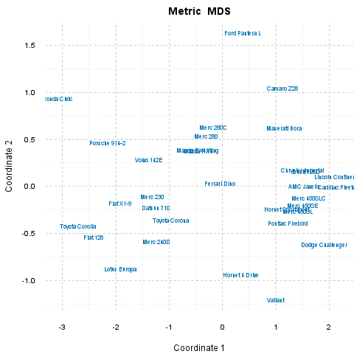](plots/MDS.tpl-2-hires.png)

##### What can be seen here?

###### Outsiders

Honda Civic differs the most from the others, and Ferrari Dino seems to be the most "common" observation, which lie nearest to all other observations.

###### Outsider Pairs

*Honda Civic* and *Cadillac Fleetwood* (5.48) are the "furthest", *Mazda RX4 Wag* and *Mazda RX4* (0) are the "nearest" to each other.

###### In General

Now let's see which observations can be said statistically far/similar to each other in general. The *17* pairs with the biggest differences and the *30* pairs with the smallest differences will be presented. In the brackets you can see the amount of the distances between two observations.

According to the used variables (*drat*, *cyl* and *mpg*) the *17* furthest pair of observations are:

* *Honda Civic* and *Cadillac Fleetwood* (5.48)
* *Honda Civic* and *Lincoln Continental* (5.39)
* *Dodge Challenger* and *Honda Civic* (5.25)
* *Toyota Corolla* and *Cadillac Fleetwood* (5.1)
* *Toyota Corolla* and *Lincoln Continental* (5.04)
* *Honda Civic* and *Merc 450SLC* (4.85)
* *Fiat 128* and *Cadillac Fleetwood* (4.79)
* *Honda Civic* and *Merc 450SE* (4.74)
* *Honda Civic* and *Duster 360* (4.74)
* *AMC Javelin* and *Honda Civic* (4.74)
* *Fiat 128* and *Lincoln Continental* (4.74)
* *Honda Civic* and *Chrysler Imperial* (4.68)
* *Honda Civic* and *Valiant* (4.68)
* *Honda Civic* and *Merc 450SL* (4.67)
* *Dodge Challenger* and *Toyota Corolla* (4.67)
* *Pontiac Firebird* and *Honda Civic* (4.52)
* *Honda Civic* and *Hornet Sportabout* (4.46)

According to the used variables (*drat*, *cyl* and *mpg*) the *30* nearest pair of observations are:

* *Mazda RX4 Wag* and *Mazda RX4* (0)
* *Chrysler Imperial* and *Duster 360* (0.08)
* *Merc 230* and *Datsun 710* (0.13)
* *Lincoln Continental* and *Cadillac Fleetwood* (0.13)
* *Merc 450SL* and *Merc 450SE* (0.15)
* *AMC Javelin* and *Merc 450SLC* (0.15)
* *Pontiac Firebird* and *Hornet Sportabout* (0.15)
* *AMC Javelin* and *Chrysler Imperial* (0.17)
* *AMC Javelin* and *Duster 360* (0.19)
* *Merc 450SLC* and *Merc 450SE* (0.2)
* *Merc 280C* and *Merc 280* (0.23)
* *AMC Javelin* and *Merc 450SE* (0.25)
* *Merc 450SL* and *Hornet Sportabout* (0.28)
* *Merc 280* and *Mazda RX4* (0.3)
* *Merc 280* and *Mazda RX4 Wag* (0.3)
* *Merc 450SLC* and *Duster 360* (0.3)
* *Chrysler Imperial* and *Merc 450SLC* (0.31)
* *Pontiac Firebird* and *Merc 450SL* (0.32)
* *Merc 450SLC* and *Merc 450SL* (0.35)
* *Toyota Corona* and *Datsun 710* (0.35)
* *Toyota Corolla* and *Fiat 128* (0.36)
* *AMC Javelin* and *Merc 450SL* (0.38)
* *Merc 240D* and *Datsun 710* (0.4)
* *Merc 450SE* and *Hornet Sportabout* (0.41)
* *Chrysler Imperial* and *Merc 450SE* (0.41)
* *Volvo 142E* and *Merc 230* (0.42)
* *Merc 450SE* and *Duster 360* (0.44)
* *Maserati Bora* and *Camaro Z28* (0.45)
* *Toyota Corona* and *Merc 230* (0.46)
* *Pontiac Firebird* and *Merc 450SE* (0.46)

This report was generated with [R](http://www.r-project.org/) (3.0.1) and [rapport](http://rapport-package.info/) (0.51) in *3.338* sec on x86_64-unknown-linux-gnu platform.

