Rapport package team

Correlations

2011-04-26 20:25 CET

## Description

This template will return the correlation matrix of supplied numerical variables.

### Variable description

*2* variables provided.

There are no highly correlated (r < -0.7 or r > 0.7) variables.

There are no uncorrelated correlated (r < -0.2 or r > 0.2) variables.

#### Correlation matrix

|  |  |  |
| --- | --- | --- |
|  | age | edu |
| **age** |  | 0.2185 ★★★ |
| **edu** | 0.2185 ★★★ |  |

Correlation matrix

Where the stars represent the [significance levels](http://en.wikipedia.org/wiki/Statistical_significance) of the bivariate correlation coefficients: one star for 0.05, two for 0.01 and three for 0.001.

[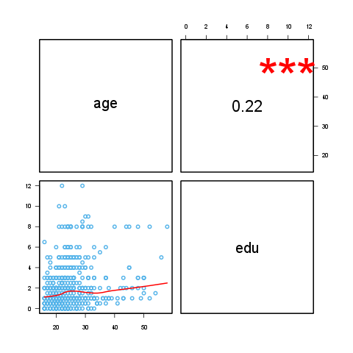](plots/correlations-1-hires.png)

## Description

This template will return the correlation matrix of supplied numerical variables.

### Variable description

*3* variables provided.

The highest correlation coefficient (*0.2273*) is between edu age and the lowest (*-0.03377*) is between leisure age. It seems that the strongest association (r=*0.2273*) is between edu age.

There are no highly correlated (r < -0.7 or r > 0.7) variables.

Uncorrelated (-0.2 < r < 0.2) variables:

* *leisure* and *age* (-0.03)
* *leisure* and *edu* (0.17)

#### Correlation matrix

|  |  |  |  |
| --- | --- | --- | --- |
|  | age | edu | leisure |
| **age** |  | 0.2273 ★★★ | -0.0338 |
| **edu** | 0.2273 ★★★ |  | 0.1732 ★★★ |
| **leisure** | -0.0338 | 0.1732 ★★★ |  |

Correlation matrix

Where the stars represent the [significance levels](http://en.wikipedia.org/wiki/Statistical_significance) of the bivariate correlation coefficients: one star for 0.05, two for 0.01 and three for 0.001.

[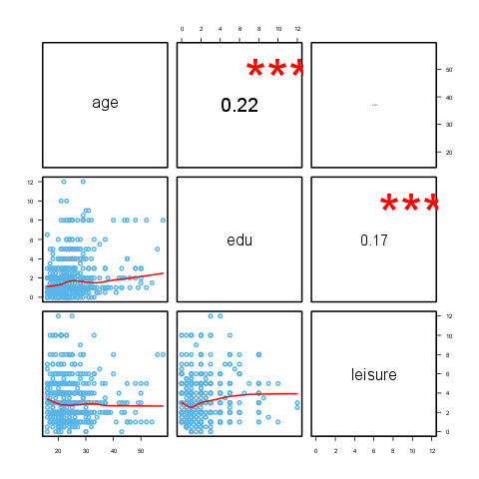](plots/correlations-2-hires.png)

## Description

This template will return the correlation matrix of supplied numerical variables.

### Variable description

*11* variables provided.

The highest correlation coefficient (*0.902*) is between disp cyl and the lowest (*-0.8677*) is between wt mpg. It seems that the strongest association (r=*0.902*) is between disp cyl.

Highly correlated (r < -0.7 or r > 0.7) variables:

* *cyl* and *mpg* (-0.85)
* *disp* and *mpg* (-0.85)
* *hp* and *mpg* (-0.78)
* *wt* and *mpg* (-0.87)
* *disp* and *cyl* (0.9)
* *hp* and *cyl* (0.83)
* *wt* and *cyl* (0.78)
* *vs* and *cyl* (-0.81)
* *hp* and *disp* (0.79)
* *drat* and *disp* (-0.71)
* *wt* and *disp* (0.89)
* *vs* and *disp* (-0.71)
* *qsec* and *hp* (-0.71)
* *vs* and *hp* (-0.72)
* *carb* and *hp* (0.75)
* *wt* and *drat* (-0.71)
* *am* and *drat* (0.71)
* *vs* and *qsec* (0.74)
* *gear* and *am* (0.79)

Uncorrelated (-0.2 < r < 0.2) variables:

* *gear* and *hp* (-0.13)
* *qsec* and *drat* (0.09)
* *carb* and *drat* (-0.09)
* *qsec* and *wt* (-0.17)
* *am* and *vs* (0.17)
* *carb* and *am* (0.06)

#### Correlation matrix

|  |  |  |  |  |
| --- | --- | --- | --- | --- |
|  | mpg | cyl | disp | hp |
| **mpg** |  | -0.8522 ★★★ | -0.8476 ★★★ | -0.7762 ★★★ |
| **cyl** | -0.8522 ★★★ |  | 0.902 ★★★ | 0.8324 ★★★ |
| **disp** | -0.8476 ★★★ | 0.902 ★★★ |  | 0.7909 ★★★ |
| **hp** | -0.7762 ★★★ | 0.8324 ★★★ | 0.7909 ★★★ |  |
| **drat** | 0.6812 ★★★ | -0.6999 ★★★ | -0.7102 ★★★ | -0.4488 ★★ |
| **wt** | -0.8677 ★★★ | 0.7825 ★★★ | 0.888 ★★★ | 0.6587 ★★★ |
| **qsec** | 0.4187 ★ | -0.5912 ★★★ | -0.4337 ★ | -0.7082 ★★★ |
| **vs** | 0.664 ★★★ | -0.8108 ★★★ | -0.7104 ★★★ | -0.7231 ★★★ |
| **am** | 0.5998 ★★★ | -0.5226 ★★ | -0.5912 ★★★ | -0.2432 |
| **gear** | 0.4803 ★★ | -0.4927 ★★ | -0.5556 ★★★ | -0.1257 |
| **carb** | -0.5509 ★★ | 0.527 ★★ | 0.395 ★ | 0.7498 ★★★ |

Correlation matrix (continued below)

|  |  |  |  |  |
| --- | --- | --- | --- | --- |
|  | drat | wt | qsec | vs |
| **mpg** | 0.6812 ★★★ | -0.8677 ★★★ | 0.4187 ★ | 0.664 ★★★ |
| **cyl** | -0.6999 ★★★ | 0.7825 ★★★ | -0.5912 ★★★ | -0.8108 ★★★ |
| **disp** | -0.7102 ★★★ | 0.888 ★★★ | -0.4337 ★ | -0.7104 ★★★ |
| **hp** | -0.4488 ★★ | 0.6587 ★★★ | -0.7082 ★★★ | -0.7231 ★★★ |
| **drat** |  | -0.7124 ★★★ | 0.0912 | 0.4403 ★ |
| **wt** | -0.7124 ★★★ |  | -0.1747 | -0.5549 ★★★ |
| **qsec** | 0.0912 | -0.1747 |  | 0.7445 ★★★ |
| **vs** | 0.4403 ★ | -0.5549 ★★★ | 0.7445 ★★★ |  |
| **am** | 0.7127 ★★★ | -0.6925 ★★★ | -0.2299 | 0.1683 |
| **gear** | 0.6996 ★★★ | -0.5833 ★★★ | -0.2127 | 0.206 |
| **carb** | -0.0908 | 0.4276 ★ | -0.6562 ★★★ | -0.5696 ★★★ |

|  |  |  |  |
| --- | --- | --- | --- |
|  | am | gear | carb |
| **mpg** | 0.5998 ★★★ | 0.4803 ★★ | -0.5509 ★★ |
| **cyl** | -0.5226 ★★ | -0.4927 ★★ | 0.527 ★★ |
| **disp** | -0.5912 ★★★ | -0.5556 ★★★ | 0.395 ★ |
| **hp** | -0.2432 | -0.1257 | 0.7498 ★★★ |
| **drat** | 0.7127 ★★★ | 0.6996 ★★★ | -0.0908 |
| **wt** | -0.6925 ★★★ | -0.5833 ★★★ | 0.4276 ★ |
| **qsec** | -0.2299 | -0.2127 | -0.6562 ★★★ |
| **vs** | 0.1683 | 0.206 | -0.5696 ★★★ |
| **am** |  | 0.7941 ★★★ | 0.0575 |
| **gear** | 0.7941 ★★★ |  | 0.2741 |
| **carb** | 0.0575 | 0.2741 |  |

Where the stars represent the [significance levels](http://en.wikipedia.org/wiki/Statistical_significance) of the bivariate correlation coefficients: one star for 0.05, two for 0.01 and three for 0.001.

[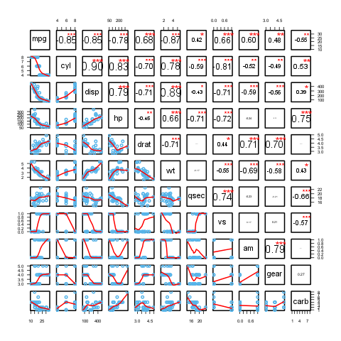](plots/correlations-3-hires.png)

This report was generated with [R](http://www.r-project.org/) (2.15.1) and [rapport](http://rapport-package.info/) (0.4) in *2.209* sec on x86_64-unknown-linux-gnu platform.

