Crosstable

Rapport package team @ https://github.com/aL3xa/rapport

2011-04-26 20:25 CET

## Description

Returning the Chi-squared test of two given variables with count, percentages and Pearson's residuals table.

## Variable description

Two variables specified:

* "gender" ("Gender") with *673* and
* "dwell" ("Dwelling") with *662* valid values.

## Counts

|  |  |  |  |
| --- | --- | --- | --- |
|  | **city** | **small town** | **village** |
| male | 338 | 28 | 19 |
| female | 234 | 3 | 9 |

## Percentages

|  |  |  |  |
| --- | --- | --- | --- |
|  | **city** | **small town** | **village** |
| male | 0.5357 | 0.0444 | 0.0301 |
| female | 0.3708 | 0.0048 | 0.0143 |

### Row percentages

|  |  |  |  |
| --- | --- | --- | --- |
|  | **city** | **small town** | **village** |
| male | 0.8779 | 0.0727 | 0.0494 |
| female | 0.9512 | 0.0122 | 0.0366 |

### Column percentages

|  |  |  |  |
| --- | --- | --- | --- |
|  | **city** | **small town** | **village** |
| male | 0.5909 | 0.9032 | 0.6786 |
| female | 0.4091 | 0.0968 | 0.3214 |

## Chi-squared test

|  |  |  |  |
| --- | --- | --- | --- |
|  | **X-squared** | **df** | **p-value** |
| X-squared | 12.6353 | 2 | 0.0018 |

It seems that a real association can be pointed out between *gender* and *dwell* by the *Pearson's Chi-squared test* (χ=12.6353 at the degree of freedom being 2) at the significance level of 0.0018. Based on Goodman and Kruskal's lambda it seems that *dwell* (λ=0.7602) has an effect on *gender* (λ=0) if we assume both variables to be nominal. The association between the two variables seems to be weak based on Cramer's V (0.1001).

### Pearson's residuals

|  |  |  |  |
| --- | --- | --- | --- |
|  | **city** | **small town** | **village** |
| male | -3.0844 | 3.4312 | 0.7595 |
| female | 3.0844 | -3.4312 | -0.7595 |

### Mosaic chart

[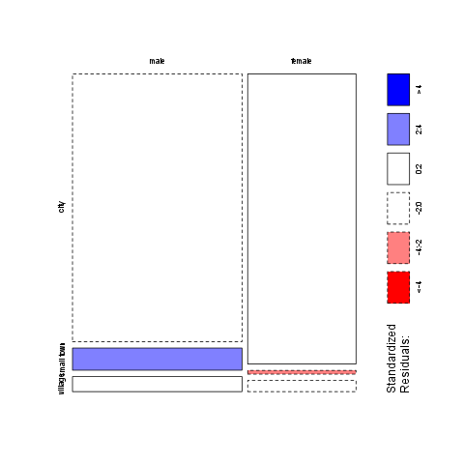](/tmp/RtmpI5pYwT/file5b6cbb48-hires.png)

## Description

Returning the Chi-squared test of two given variables with count, percentages and Pearson's residuals table.

## Variable description

Two variables specified:

* "email" ("Email usage") with *672* and
* "dwell" ("Dwelling") with *662* valid values.

## Counts

|  |  |  |  |
| --- | --- | --- | --- |
|  | **city** | **small town** | **village** |
| never | 12 | 0 | 0 |
| very rarely | 30 | 1 | 3 |
| rarely | 41 | 3 | 1 |
| sometimes | 67 | 4 | 8 |
| often | 101 | 10 | 5 |
| very often | 88 | 5 | 5 |
| always | 226 | 9 | 7 |

## Percentages

|  |  |  |  |
| --- | --- | --- | --- |
|  | **city** | **small town** | **village** |
| never | 0.0192 | 0.0000 | 0.0000 |
| very rarely | 0.0479 | 0.0016 | 0.0048 |
| rarely | 0.0655 | 0.0048 | 0.0016 |
| sometimes | 0.1070 | 0.0064 | 0.0128 |
| often | 0.1613 | 0.0160 | 0.0080 |
| very often | 0.1406 | 0.0080 | 0.0080 |
| always | 0.3610 | 0.0144 | 0.0112 |

### Row percentages

|  |  |  |  |
| --- | --- | --- | --- |
|  | **city** | **small town** | **village** |
| never | 1.0000 | 0.0000 | 0.0000 |
| very rarely | 0.8824 | 0.0294 | 0.0882 |
| rarely | 0.9111 | 0.0667 | 0.0222 |
| sometimes | 0.8481 | 0.0506 | 0.1013 |
| often | 0.8707 | 0.0862 | 0.0431 |
| very often | 0.8980 | 0.0510 | 0.0510 |
| always | 0.9339 | 0.0372 | 0.0289 |

### Column percentages

|  |  |  |  |
| --- | --- | --- | --- |
|  | **city** | **small town** | **village** |
| never | 0.0212 | 0.0000 | 0.0000 |
| very rarely | 0.0531 | 0.0312 | 0.1034 |
| rarely | 0.0726 | 0.0938 | 0.0345 |
| sometimes | 0.1186 | 0.1250 | 0.2759 |
| often | 0.1788 | 0.3125 | 0.1724 |
| very often | 0.1558 | 0.1562 | 0.1724 |
| always | 0.4000 | 0.2812 | 0.2414 |

## Chi-squared test

|  |  |  |  |
| --- | --- | --- | --- |
|  | **X-squared** | **df** | **p-value** |
| X-squared | 14.864 | 12 | 0.249 |

It seems that no real association can be pointed out between *email* and *dwell* by the *Pearson's Chi-squared test* (χ=14.864 at the degree of freedom being 12) at the significance level of 0.249. For this end no other statistical tests were performed.

### Pearson's residuals

|  |  |  |  |
| --- | --- | --- | --- |
|  | **city** | **small town** | **village** |
| never | 1.1493 | -0.8118 | -0.7709 |
| very rarely | -0.4085 | -0.5910 | 1.1955 |
| rarely | 0.2009 | 0.4916 | -0.7985 |
| sometimes | -1.7459 | -0.0210 | 2.4853 |
| often | -1.2822 | 1.9011 | -0.1829 |
| very often | -0.1671 | -0.0048 | 0.2407 |
| always | 2.0982 | -1.2561 | -1.6443 |

### Mosaic chart

[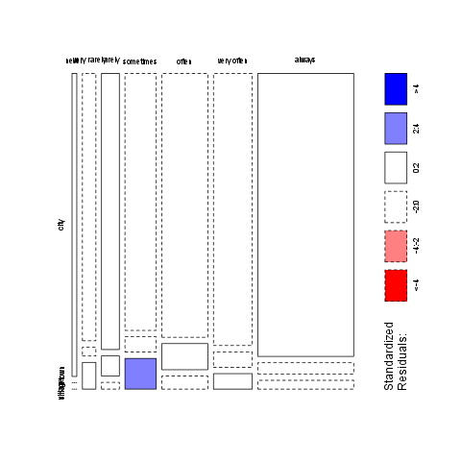](/tmp/RtmpI5pYwT/file5d08b8cf-hires.png)

This report was generated with [R](http://www.r-project.org/) (2.14.0) and [rapport](http://al3xa.github.com/rapport/) (0.2) in 0.382 sec on x86_64-unknown-linux-gnu platform.

